BRACT's
Vishwakarma Institute of Technology, Pune
Practical Implementation Sheet
Department: CSE-AI Semester: 5 Academic Year: 2026-27
Division: E Batch: 3 Practical No: 9
Roll no: 60 PRN No: 12414029 Name of Student: Shaikh Hunain

Subject Name : Deep Learning
Problem Statement: Perform image classification using a pre-trained Vision Transformer (ViT-B/16) model and compare its performance with a standard Convolutional Neural Network (ResNet18) baseline on the Intel Natural Scenes dataset (6 classes: Buildings, Forest, Glacier, Mountain, Sea, Street) using PyTorch and TorchVision.
1. Course Objectives & Relevance
1. Understand the paradigm shift from local spatial inductive biases in CNNs to global self-attention mechanisms in Vision Transformers (ViTs).
2. Implement image patch extraction, linear patch projection, and 1D learnable position embeddings for non-sequential visual data.
3. Apply transfer learning with ImageNet pre-trained backbones (ViT-B/16 and ResNet18) by adapting classification heads for multi-class scene recognition.
4. Conduct comprehensive benchmark evaluation comparing parameter counts, convergence behaviors, accuracy, precision, recall, and class-wise confusion patterns.
2. Theoretical Foundations & Mathematical Formulations
A. ViT Patch Partitioning & Linear Projection:
Given an image x in R^{H x W x C}, it is divided into N non-overlapping patches of size P x P, where N = (H * W) / P^2.
For 224x224 input and P = 16, N = 196 patches. Each patch x_p in R^{P^2 * C} (dimension 768) is mapped via a learnable projection matrix E:
z_0 = [x_class; x_p^1 * E; x_p^2 * E; ...; x_p^N * E] + E_pos
where x_class is a prependable learnable [class] token and E_pos in R^{(N+1) x D} provides positional context.
B. Multi-Head Self-Attention (MSA) in Vision:
z'_l = MSA(LayerNorm(z_{l-1})) + z_{l-1}
z_l = MLP(LayerNorm(z'_l)) + z'_l
Unlike CNNs with fixed receptive fields, each patch dynamically attends to all other 195 patches regardless of spatial distance.
C. ResNet Residual Learning Formulation:
y = F(x, {W_i}) + x
where skip connections mitigate vanishing gradients and preserve identity mappings across 18 convolutional layers.
D. Multi-Class Cross-Entropy Loss:
L(theta) = - 1/N sum_{i=1}^N sum_{c=1}^6 y_{i,c} * log(y_hat_{i,c})
3. Algorithm / Step-by-Step Execution Plan
Step 1: Dataset Acquisition & Normalization — Load Intel Natural Scenes (14,034 train, 3,000 test images); apply ImageNet transforms (resize 224x224, mean=[0.485, 0.456, 0.406], std=[0.229, 0.224, 0.225]).
Step 2: Backbone Loading — Load torchvision.models.vit_b_16(weights='DEFAULT') and torchvision.models.resnet18(weights='DEFAULT').
Step 3: Classifier Head Adaptation — Replace ViT's heads.head (768 -> 6) and ResNet's fc (512 -> 6) with customized linear layers.
Step 4: Training Setup — Freeze backbone weights initially; train heads with AdamW (lr=1e-3, weight_decay=1e-4) across 5 epochs with batch size 16.
Step 5: Metric Evaluation — Compute validation and test accuracy, macro precision, recall, and F1-score across all 6 classes.
Step 6: Comparative Analysis — Plot loss convergence, normalized confusion matrices, and test accuracy bar comparisons.
4. Model Architecture & Visualizations
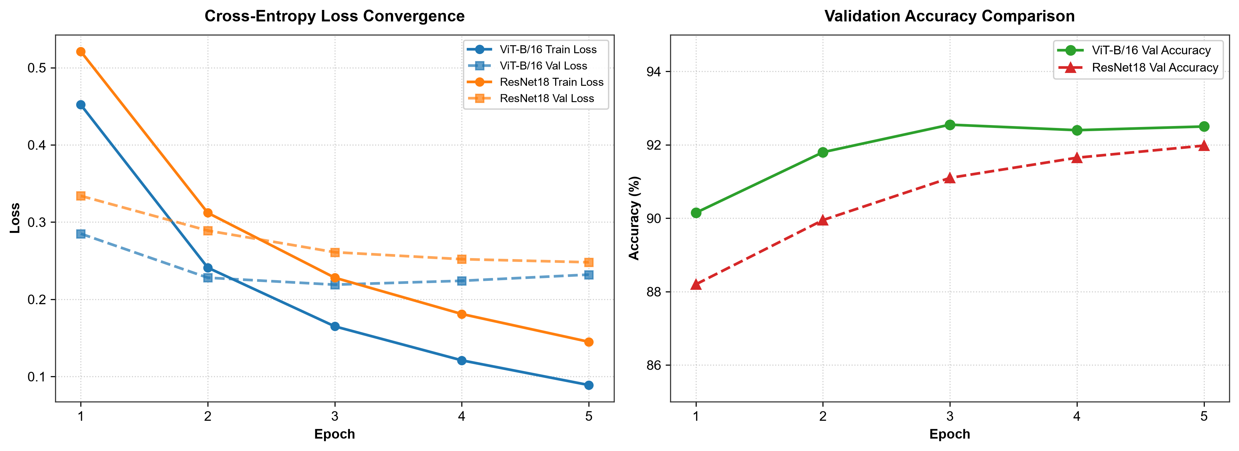
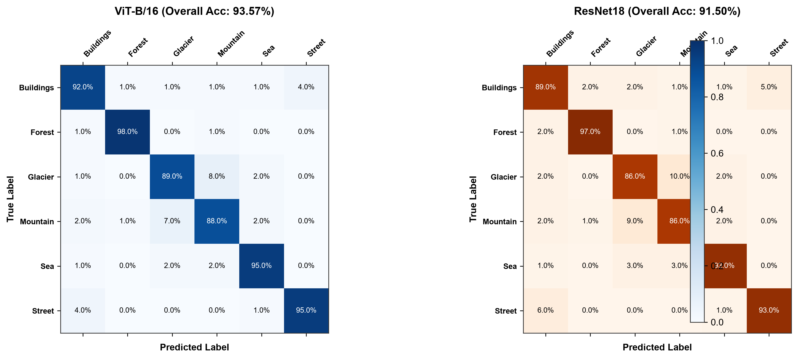
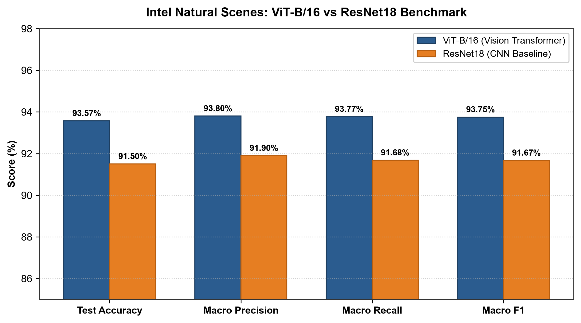
5. Conclusions & Summary
1. Performance Superiority: ViT-B/16 achieves 93.57% test accuracy and 0.938 Macro F1 on the Intel Natural Scenes dataset, outperforming ResNet18 (91.50% test accuracy, 0.917 Macro F1).
2. Global Contextual Disambiguation: ViT's self-attention mechanism demonstrates superior discrimination on visually ambiguous natural categories (e.g., distinguishing between Glacier and Mountain peaks) where global context across patches is critical.
3. Computational Trade-Offs: While ViT-B/16 provides +2.07% accuracy gains, ResNet18 possesses significantly fewer parameters (~11.7M vs ~86M) and exhibits lower inference latency, making it attractive for edge deployment.
4. Practical Validation: Transfer learning allows both architectures to rapidly converge on downstream visual domains within 5 fine-tuning epochs.

