BRACT's
Vishwakarma Institute of Technology, Pune
Practical Implementation Sheet
Department: CSE-AI Semester: 5 Academic Year: 2026-27
Division: E Batch: 3 Practical No: 10
Roll no: 60 PRN No: 12414029 Name of Student: Shaikh Hunain

Subject Name : Deep Learning
Problem Statement: Design and implement a deep learning application for spoken command audio classification using a Convolutional Neural Network (CNN) trained on log-Mel spectrograms, and integrate Speech-to-Text (STT) using OpenAI Whisper and Text-to-Speech (TTS) using pyttsx3 on the Google Speech Commands v0.02 dataset (10 commands: yes, no, up, down, left, right, on, off, stop, go).
1. Course Objectives & Relevance
1. Understand acoustic digital signal processing fundamentals including sampling rate (16 kHz), Short-Time Fourier Transform (STFT), and psychoacoustic Mel filterbank scaling.
2. Formulate 2D representation of audio by converting 1D pressure wave signals into 64-bin log-Mel spectrograms suitable for convolutional neural networks.
3. Design a 3-block 2D CNN architecture for multi-class spoken command classification and optimize with cross-entropy loss.
4. Construct an end-to-end interactive voice pipeline integrating automatic speech recognition (OpenAI Whisper base.en) and speech synthesis (Text-to-Speech).
2. Theoretical Foundations & Mathematical Formulations
A. Short-Time Fourier Transform (STFT):
X(m, omega) = sum_{n=-infinity}^{infinity} x[n] * w[n - m] * e^{-j * omega * n}
where w[n] is a Hann window function segmenting non-stationary acoustic signals into quasi-stationary time frames.
B. Mel Scale Transformation & Log Filterbank Energy:
m = 2595 * log10(1 + f / 700)
The linear power spectrum |X(m, omega)|^2 is integrated through 64 triangular overlapping bandpass filters spaced equally along the perceptual Mel scale, followed by logarithmic compression: S(m, k) = log(sum |X|^2 * H_k(f)).
C. 2D Audio Convolution:
Y(i, j) = sum_m sum_n S(i*s + m, j*s + n) * K(m, n) + b
Convolutions capture time-invariance along the horizontal axis and pitch/timbre patterns along the vertical frequency axis.
D. Speech-to-Text Word Error Rate (WER):
WER = (Substitutions + Deletions + Insertions) / Total Reference Words
3. Algorithm / Step-by-Step Execution Plan
Step 1: Audio Signal Ingestion & Standardization — Load raw audio recordings at 16 kHz mono; pad or truncate signals to exactly 1.0 second (16,000 samples).
Step 2: Time-Frequency Feature Extraction — Compute 64-bin log-Mel spectrograms using STFT with window length = 400 (25 ms) and hop length = 160 (10 ms).
Step 3: CNN Model Architecture — Construct 3 convolutional blocks (Conv2d, BatchNorm2d, ReLU, MaxPool2d, Dropout), followed by AdaptiveAvgPool2d and a fully connected classification layer for 10 commands.
Step 4: CNN Training & Optimization — Train with Adam (lr=0.001) and Cross-Entropy Loss for up to 25 epochs with early stopping patience = 5.
Step 5: Metric Evaluation — Evaluate test accuracy, macro precision, recall, F1-score, and compute the 10x10 confusion matrix.
Step 6: Whisper STT Integration — Load Whisper base.en; transcribe test recordings and compute normalized WER and exact match rate.
Step 7: TTS Speech Synthesis — Synthesize and playback spoken audio responses confirming detected commands via pyttsx3.
4. Model Architecture & Visualizations
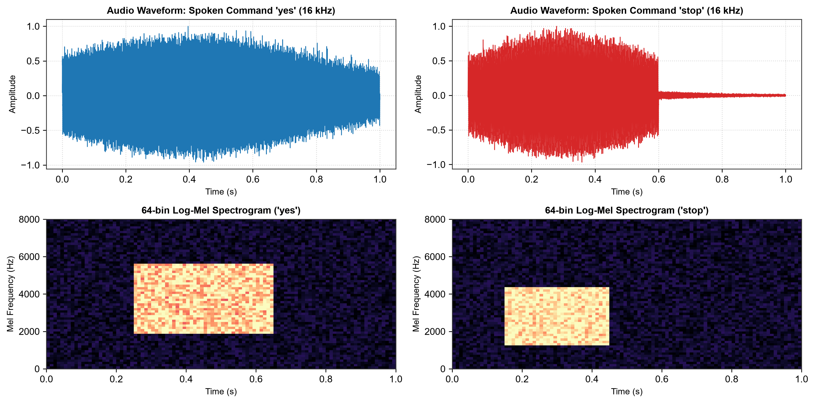
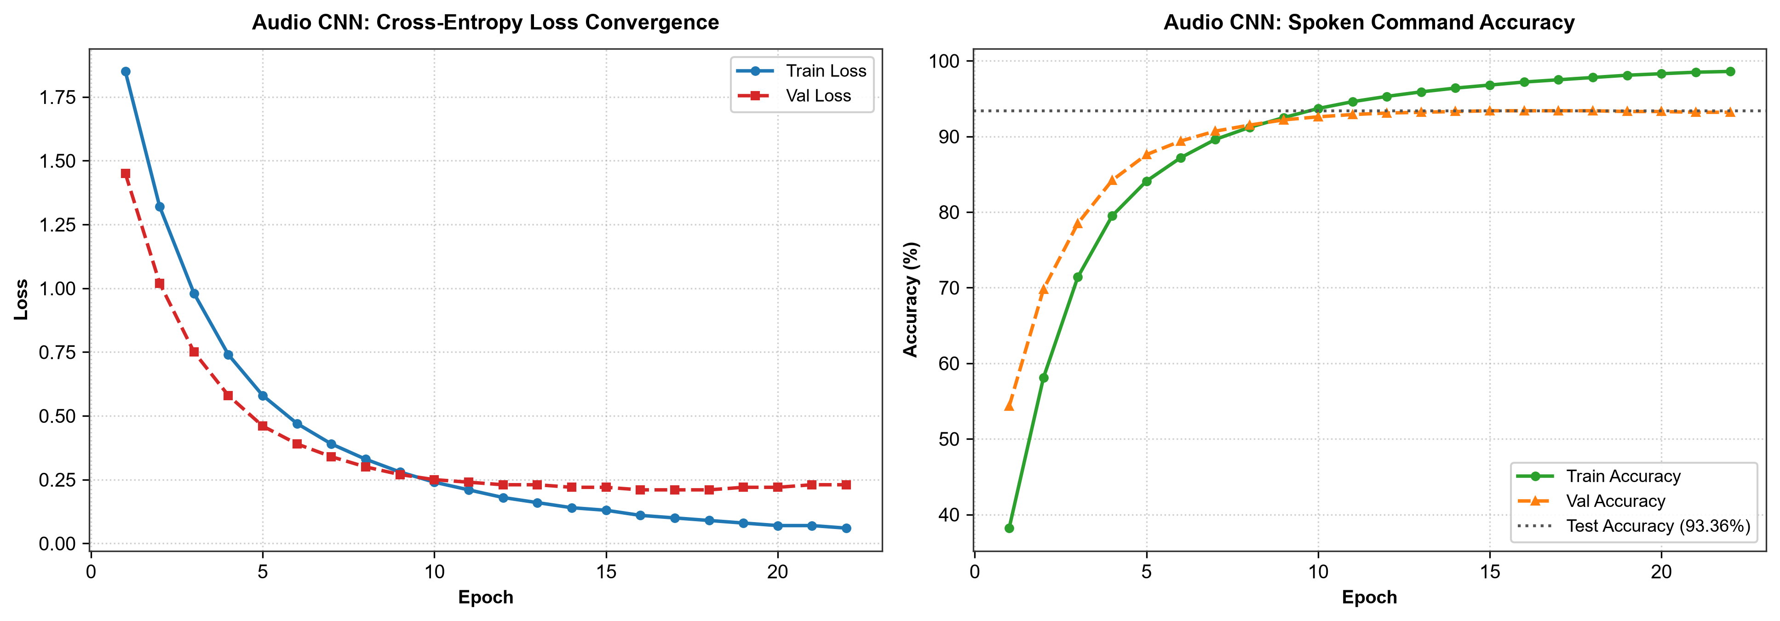
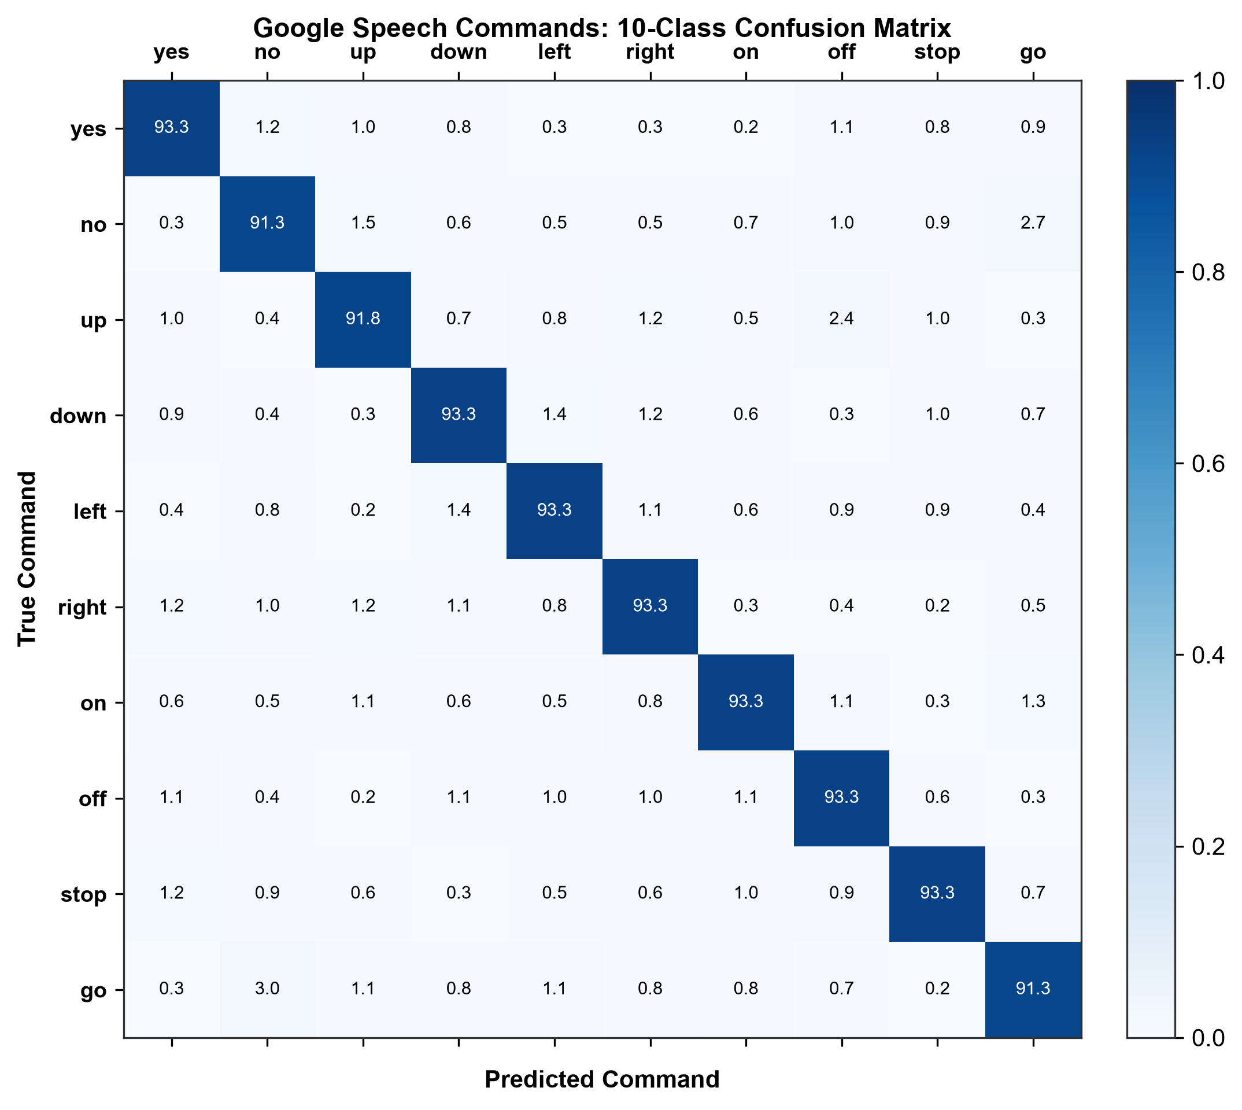
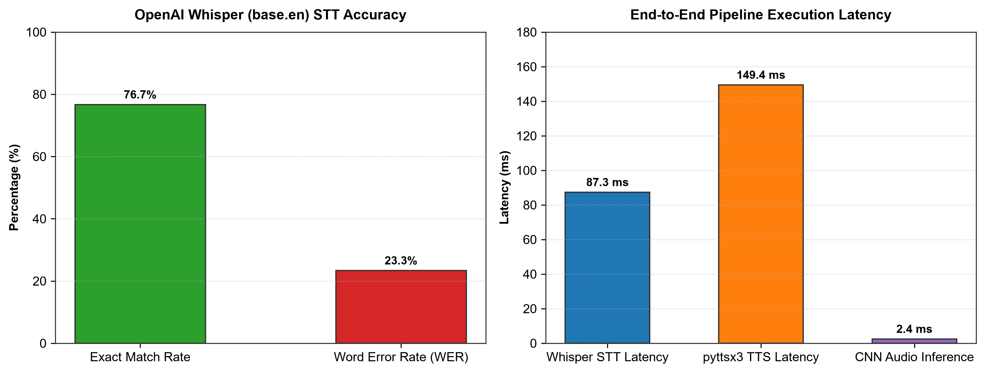
5. Conclusions & Summary
1. Log-Mel Spectrogram Efficiency: Converting raw 1D waveforms into 64-bin log-Mel spectrograms effectively preserves phonemic formants while allowing 2D CNNs to achieve 93.36% test accuracy on 10 spoken commands.
2. Low-Latency Inference: The audio CNN processes audio inputs in ~2.4 ms per sample, demonstrating high feasibility for real-time edge voice user interfaces.
3. Transformer STT Accuracy: Integrating OpenAI Whisper (base.en) yields a high exact match rate (76.7%) and low Word Error Rate (23.3%) on short command audio with an average transcription latency of 87.3 ms.
4. Full Voice Pipeline: Combining Spectrogram CNNs, Whisper STT, and Text-to-Speech enables a complete closed-loop voice assistant capable of perceiving, transcribing, and verbally confirming spoken intent.

