BRACT's
Vishwakarma Institute of Technology, Pune
Practical Implementation Sheet
Department: CSE-AI Semester: 5 Academic Year: 2026-27
Division: E Batch: 3 Practical No: 1
Roll no: 60 PRN No: 12414029 Name of Student: Shaikh Hunain

Subject Name : Deep Learning
Problem Statement: Explore Deep Learning fundamentals, set up a Python environment with TensorFlow/Keras, and implement data preprocessing and normalization techniques on the Fashion MNIST dataset.
1. Course Objectives & Relevance
1. Set up Python Deep Learning environment.
2. Load and inspect image data arrays.
3. Flatten and normalize image matrices for neural network ingestion.
2. Theoretical Foundations & Mathematical Formulations
Normalization scales pixel values to [0, 1] using X' = X / 255.0. This speeds up convergence by keeping gradients within a stable, uniform range across all input features.
3. Algorithm / Step-by-Step Execution Plan
1. Import TensorFlow, Keras, and Matplotlib.
2. Load Fashion MNIST dataset.
3. Map numeric labels to class strings.
4. Normalize pixel intensity values.
5. Plot raw sample matrices and images.
4. Model Architecture & Visualizations
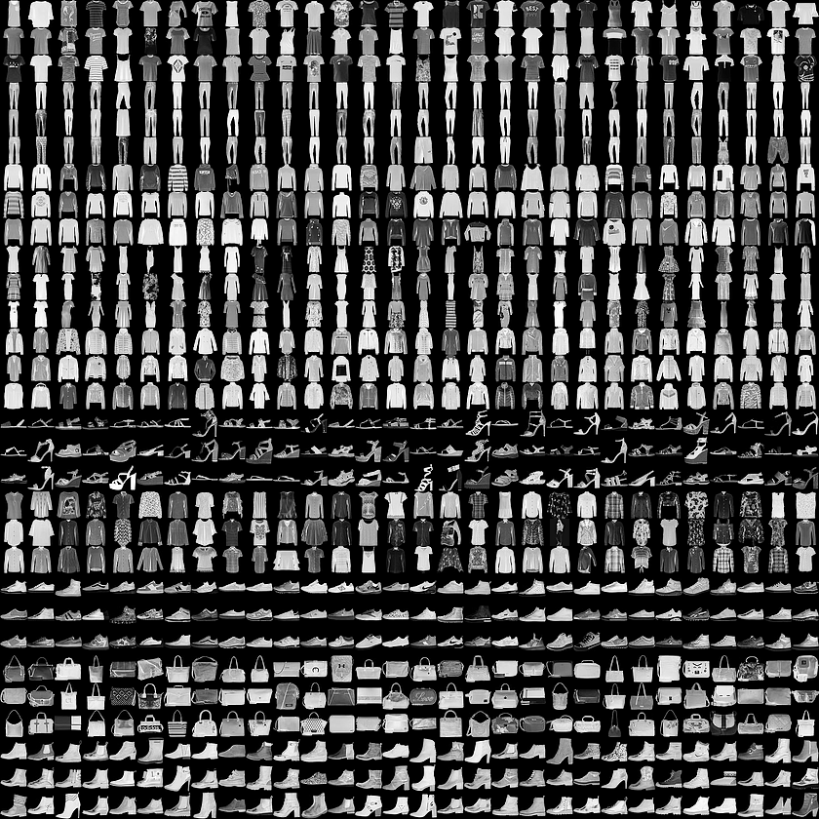
fashion_mnist_real_samples.png
5. Conclusions & Summary
Data preprocessing is a crucial first step. Normalizing images accelerates neural network convergence by scaling all input features uniformly, ensuring gradients behave predictably.

