BRACT's
Vishwakarma Institute of Technology, Pune
Practical Implementation Sheet
Department: CSE-AI Semester: 5 Academic Year: 2026-27
Division: E Batch: 3 Practical No: 2
Roll no: 60 PRN No: 12414029 Name of Student: Shaikh Hunain

Subject Name : Deep Learning
Problem Statement: Implement a Single-Layer Perceptron (SLP) from scratch using NumPy to classify the Iris dataset, observing the effects of weights, biases, and the step activation function.
1. Course Objectives & Relevance
1. Understand Single-Layer Perceptron mechanics and limits.
2. Implement manual weights and bias updates without automatic differentiation.
3. Observe linear decision boundaries.
2. Theoretical Foundations & Mathematical Formulations
Perceptron update rule: W = W + learning_rate * (y_true - y_pred) * x
Activation function (Step): f(z) = 1 if z >= 0 else 0.
3. Algorithm / Step-by-Step Execution Plan
1. Filter Iris dataset to 2 classes to ensure binary classification.
2. Initialize weights and bias to zero.
3. Apply perceptron update rule for a set number of epochs.
4. Plot the resulting decision boundary over the scatter plot.
4. Model Architecture & Visualizations
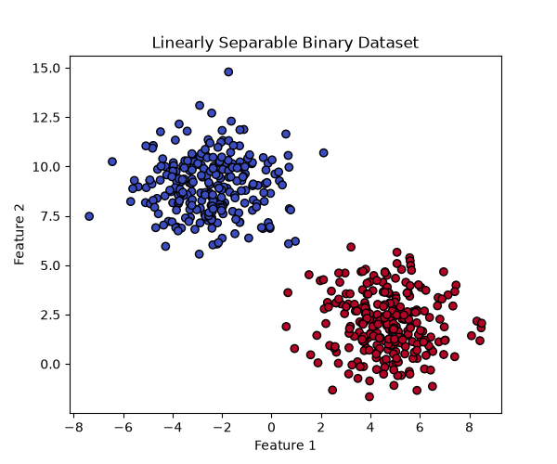
dataset_scatter.png
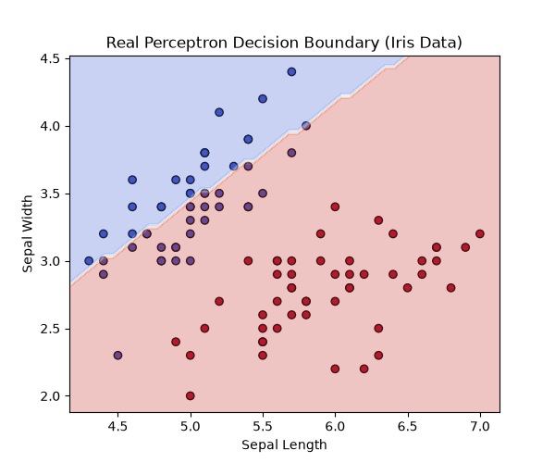
iris_decision_boundary.png
5. Conclusions & Summary
Single-Layer Perceptrons can perfectly classify linearly separable data, as visually proven by the distinct linear decision boundary separating the two Iris classes.

