BRACT's
Vishwakarma Institute of Technology, Pune
Practical Implementation Sheet
Department: CSE-AI Semester: 5 Academic Year: 2026-27
Division: E Batch: 3 Practical No: 2.2
Roll no: 60 PRN No: 12414029 Name of Student: Shaikh Hunain

Subject Name : Deep Learning
Problem Statement: Design and implement a Multilayer Perceptron (MLP) for classification of the Wine dataset, and evaluate its performance using accuracy and a confusion matrix.
1. Course Objectives & Relevance
1. Transition from SLP to Multilayer Perceptrons (MLP).
2. Utilize hidden layers and ReLU activation functions.
3. Evaluate multi-class classification using Confusion Matrices.
2. Theoretical Foundations & Mathematical Formulations
Multi-layer networks solve non-linear separability. ReLU(x) = max(0, x) prevents vanishing gradients in deep feedforward networks. Categorical Cross-Entropy is used to measure classification loss.
3. Algorithm / Step-by-Step Execution Plan
1. Load Scikit-learn Wine dataset.
2. Standardize features using StandardScaler.
3. Define PyTorch MLP architecture (13 -> 64 -> 32 -> 3).
4. Train with CrossEntropyLoss and Adam optimizer.
5. Plot the confusion matrix of predictions.
4. Model Architecture & Visualizations
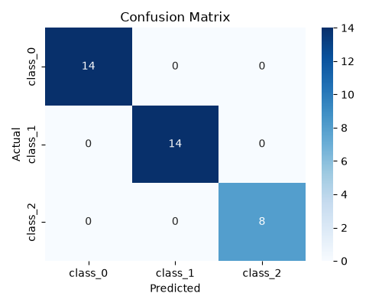
mlp_confusion_matrix.png
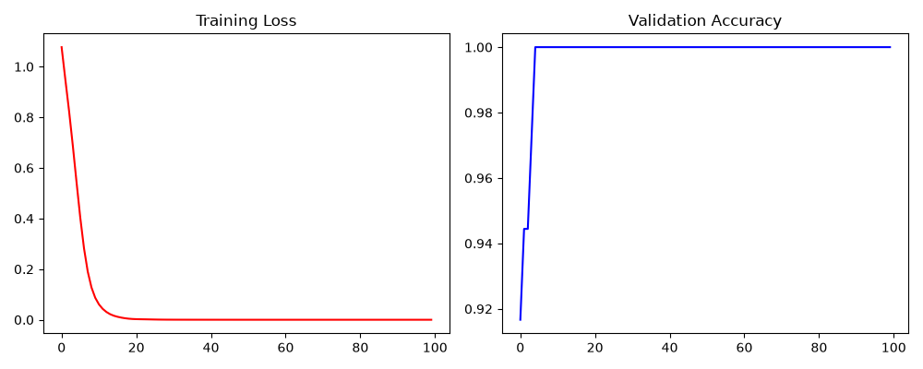
mlp_training_curve.png
5. Conclusions & Summary
The MLP handles complex multi-class data effectively, achieving near-perfect accuracy on the Wine dataset by successfully learning non-linear feature relationships.

