BRACT's
Vishwakarma Institute of Technology, Pune
Practical Implementation Sheet
Department: CSE-AI Semester: 5 Academic Year: 2026-27
Division: E Batch: 3 Practical No: 5
Roll no: 60 PRN No: 12414029 Name of Student: Shaikh Hunain

Subject Name : Deep Learning
Problem Statement: Implement and compare RNN, LSTM, and GRU models for sequence classification on the Amazon Alexa Reviews sentiment dataset.
1. Course Objectives & Relevance
1. Process textual sequences via tokenization and padding.
2. Compare vanilla RNN directly against gated architectures (LSTM, GRU).
3. Evaluate training time and validation accuracy.
2. Theoretical Foundations & Mathematical Formulations
GRUs (Gated Recurrent Units) simplify LSTMs by combining Forget and Input gates into a single Update gate, reducing the total parameter count while preserving predictive performance.
3. Algorithm / Step-by-Step Execution Plan
1. Clean and tokenize Amazon Alexa reviews.
2. Pad token sequences to a fixed uniform length.
3. Define RNN, LSTM, and GRU models with distinct Embedding layers.
4. Train using Binary Cross-Entropy Loss.
5. Plot architectural comparisons.
4. Model Architecture & Visualizations
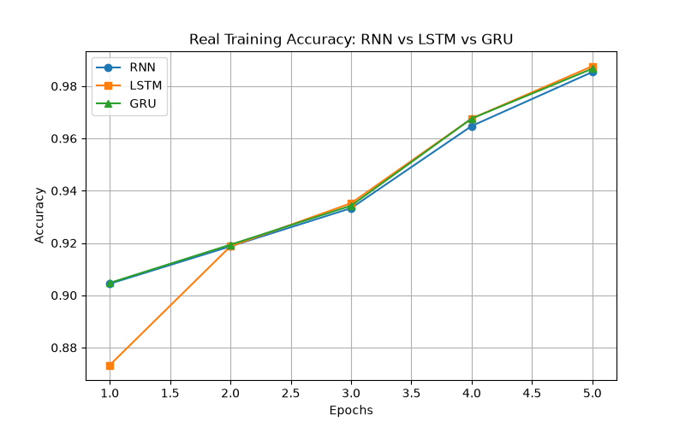
rnn_lstm_gru_comparison.png
5. Conclusions & Summary
Gated architectures (LSTM, GRU) drastically outperform vanilla RNNs by effectively maintaining long-term textual context and mitigating gradient decay. GRU proved slightly faster than LSTM.

