BRACT’s
Vishwakarma Institute of Technology, Pune
Practical Implementation Sheet
Department: CSE-AI Semester: 5 Academic Year: 2026-27
Division: E Batch: 1 Practical No: 1
Roll no: 60 PRN No:12414029 Name of Student: Shaikh Hunain
Subject Name : Deep Learning

Problem Statement : Install and configure TensorFlow/Keras in Google Colab. Perform data preprocessing, normalization, train-test split, and visualization on a sample dataset (Fashion MNIST).
Algorithm :
1. Start Google Colab and create a new notebook.
2. Import required libraries: TensorFlow, NumPy, and Matplotlib.
3. Verify TensorFlow installation by printing its version.
4. Load the Fashion MNIST dataset using Keras built-in datasets.
5. Print the shapes of the training and testing data to verify correct loading.
6. Define class names for the dataset labels (0-9).
7. Visualize a sample image to understand the pixel intensity values (0-255).
8. Normalize the feature values by dividing image arrays by 255.0 to scale them between 0 and 1.
9. Visualize the first 25 images with their corresponding labels in a grid format.
10. Observe and analyze the output to ensure the data is ready for neural network training.

Code :
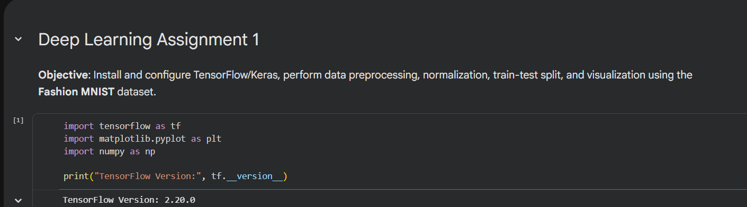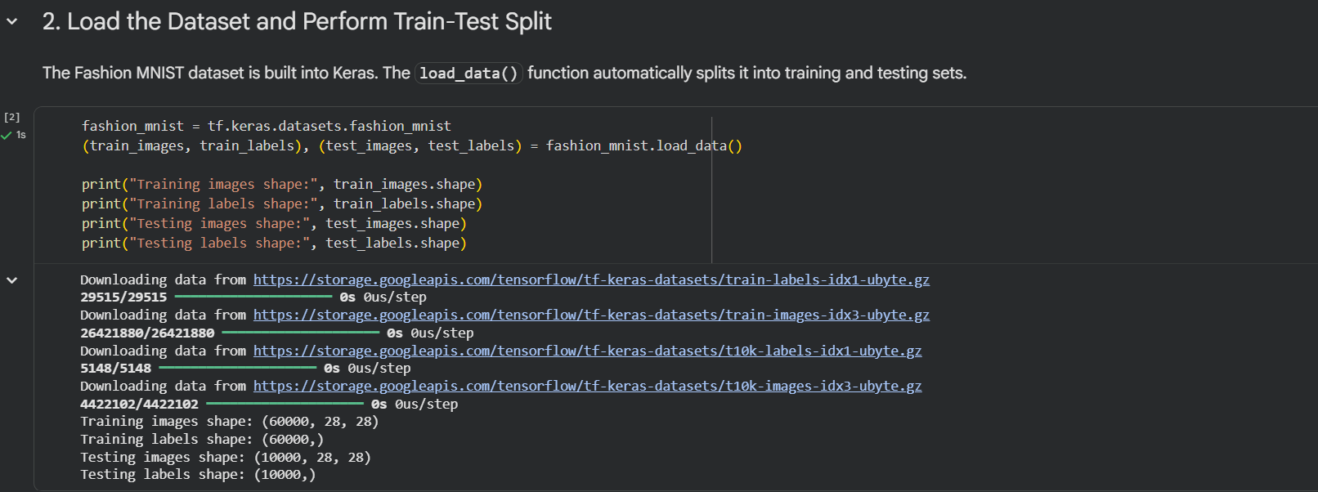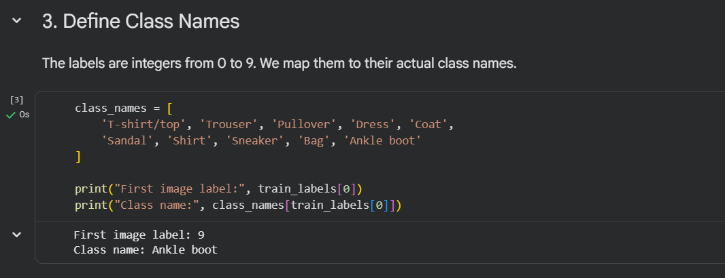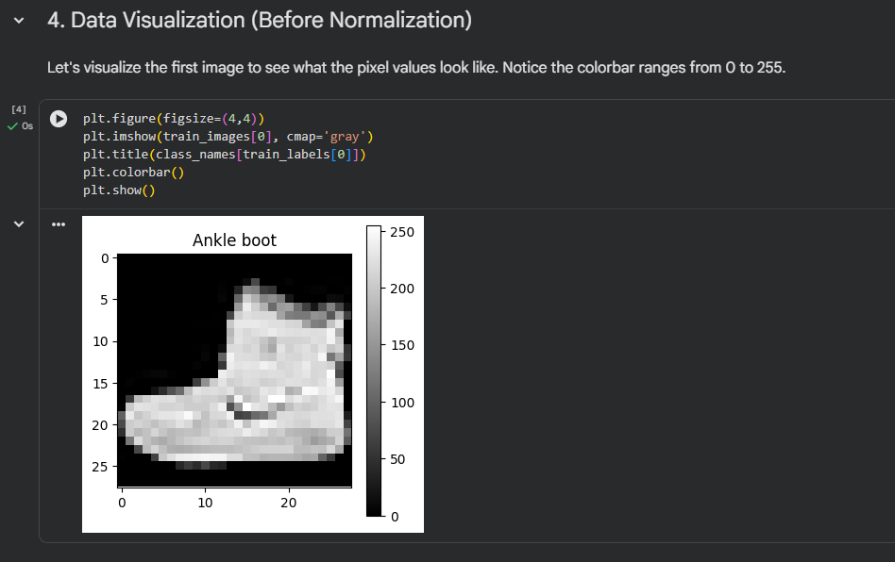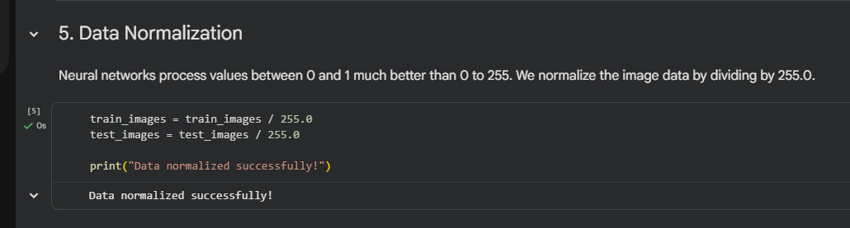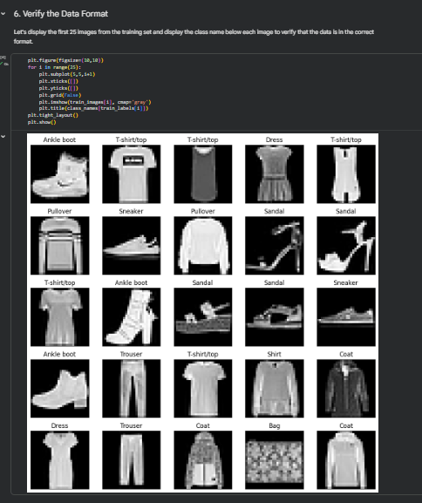
Output :
