1523. Count Odd Numbers in an Interval Range
Count Odd Numbers in an Interval Range - LeetCode
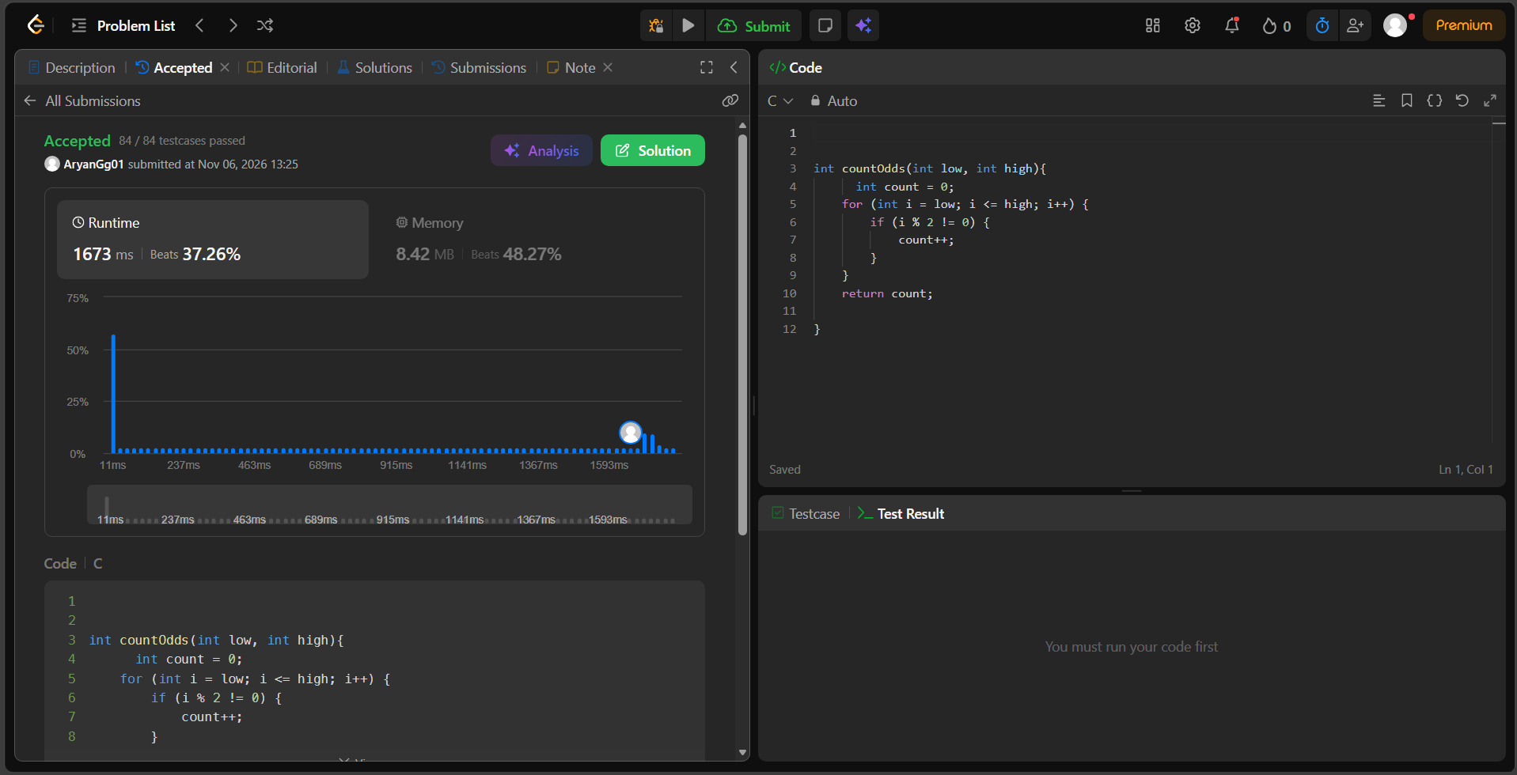

int countOdds(int low, int high){
int count = 0;
for (int i = low; i <= high; i++) {
if (i % 2 != 0) {
count++;
}
}
return count;

}

