2169. Count Operations to Obtain Zero
Count Operations to Obtain Zero - LeetCode
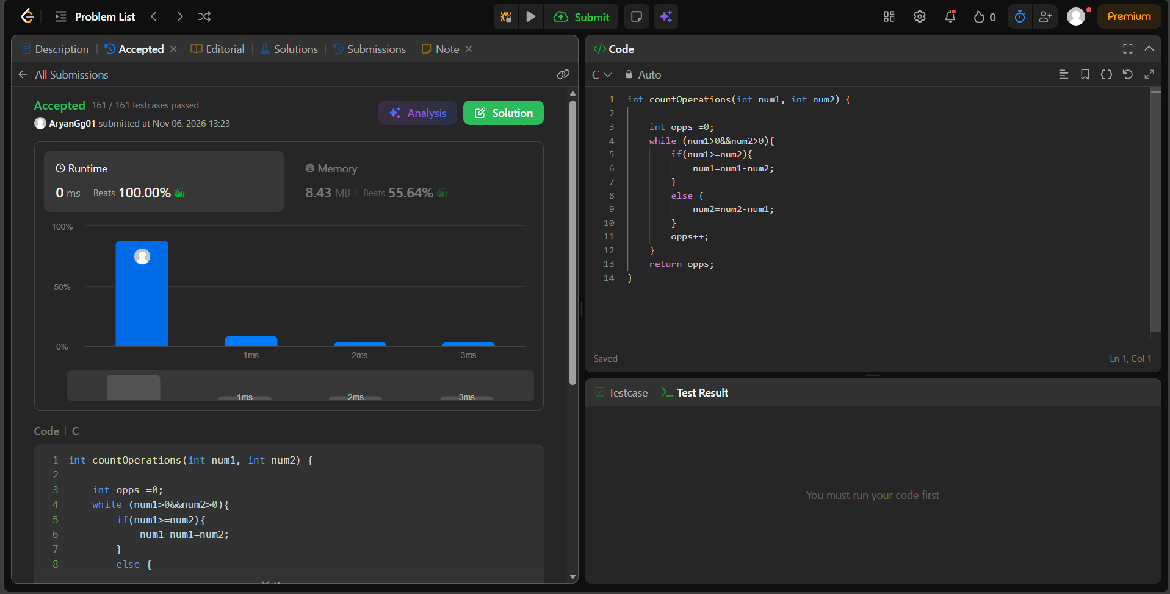
int countOperations(int num1, int num2) {

int opps =0;
while (num1>0&&num2>0){
if(num1>=num2){
num1=num1-num2;
}
else {
num2=num2-num1;
}
opps++;
}
return opps;
}

