507. Perfect Number
Perfect Number - LeetCode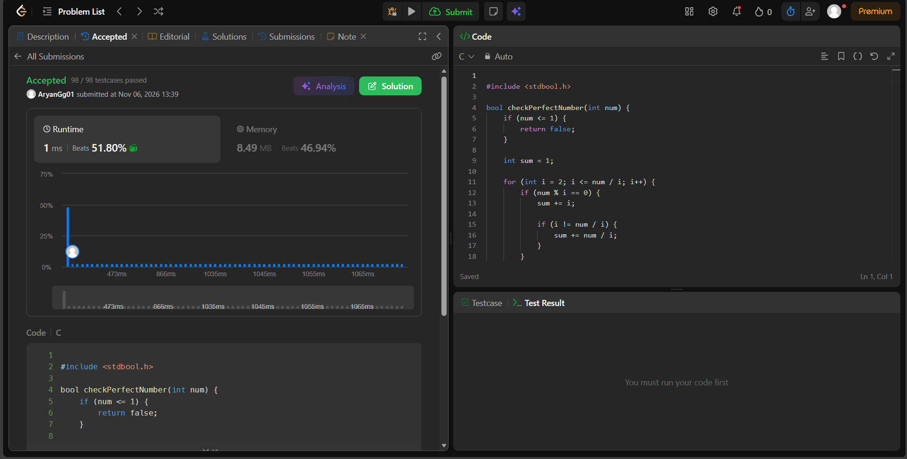
#include <stdbool.h>

bool checkPerfectNumber(int num) {
if (num <= 1) {
return false;
}

int sum = 1;

for (int i = 2; i <= num / i; i++) {
if (num % i == 0) {
sum += i;

if (i != num / i) {
sum += num / i;
}
}
}

return sum == num;
}

