7. Reverse Integer
Reverse Integer - LeetCode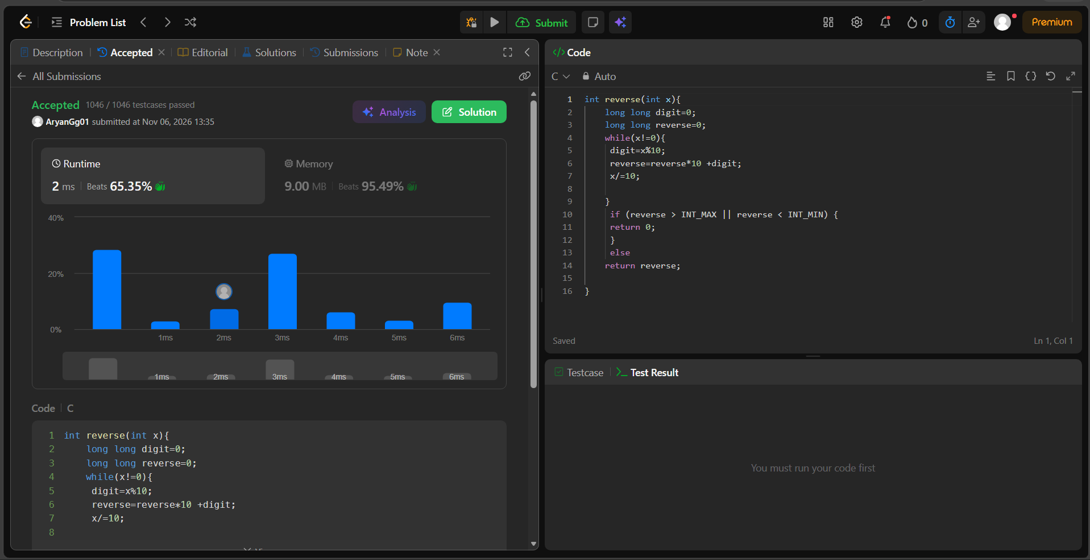int reverse(int x){
long long digit=0;
long long reverse=0;
while(x!=0){
digit=x%10;
reverse=reverse*10 +digit;
x/=10;

}
if (reverse > INT_MAX || reverse < INT_MIN) {
return 0;
}
else
return reverse;

}

