9. Palindrome Number
Palindrome Number - LeetCode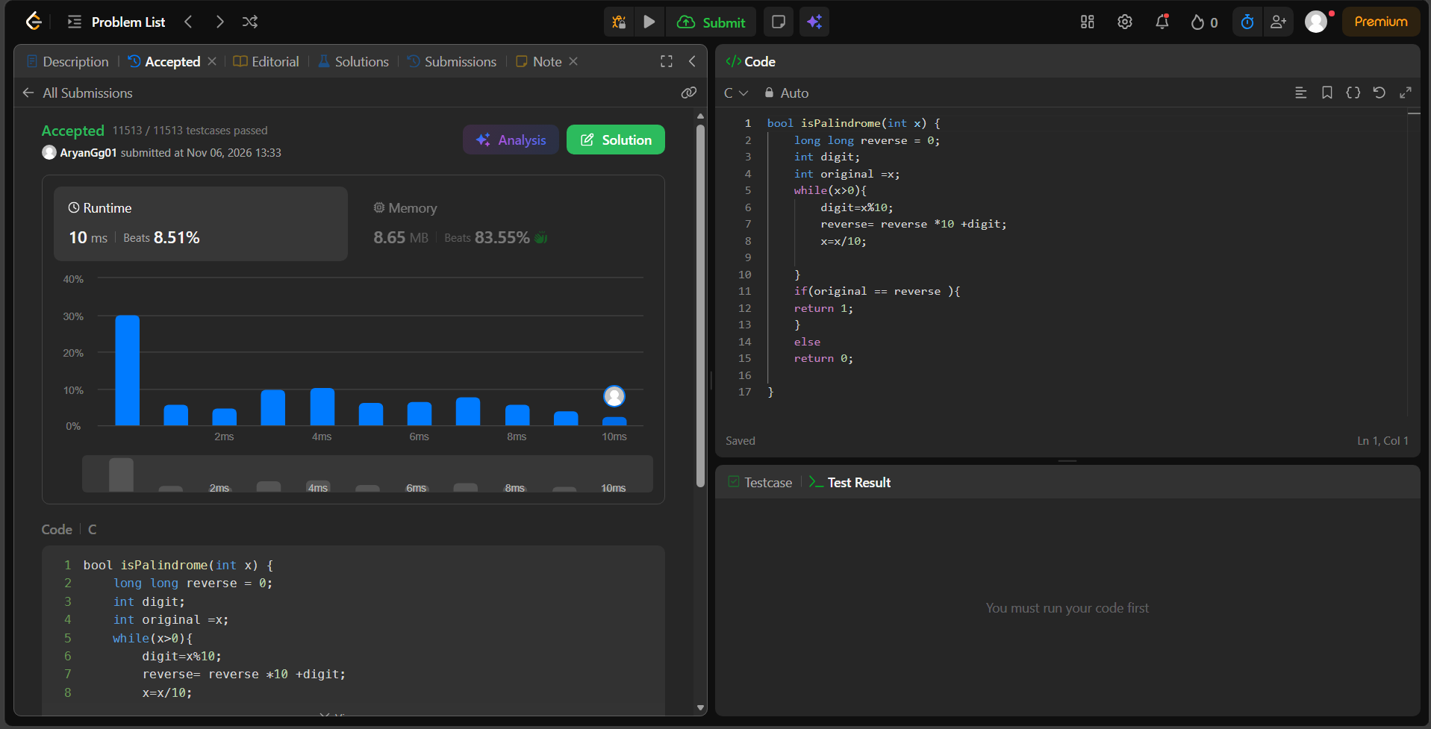bool isPalindrome(int x) {
long long reverse = 0;
int digit;
int original =x;
while(x>0){
digit=x%10;
reverse= reverse *10 +digit;
x=x/10;

}
if(original == reverse ){
return 1;
}
else
return 0;
}

