Count Divisors
Count Divisors | Basics of Input/Output & Basic Programming Practice Problems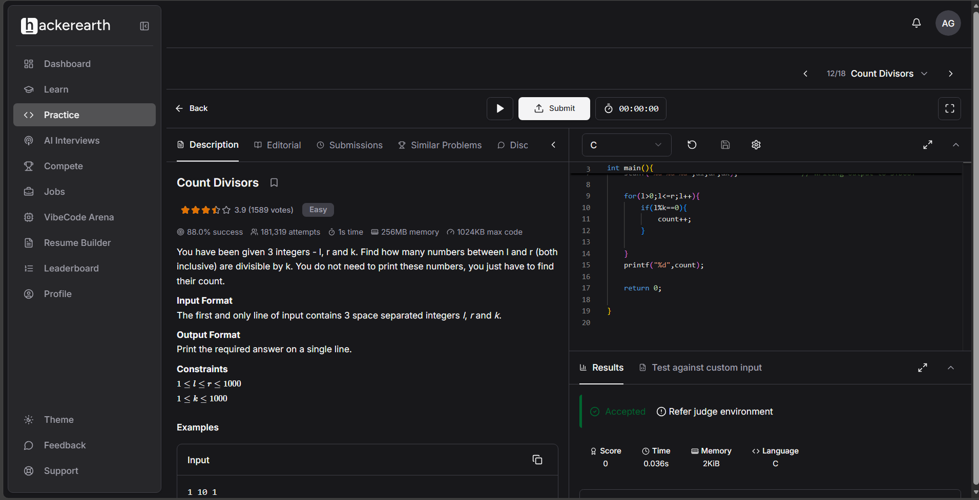#include <stdio.h>

int main(){
int num;
int count=0;
int l,r,k;
scanf("%d %d %d",&l,&r,&k); // Writing output to STDOUT

for(l>0;l<=r;l++){
if(l%k==0){
count++;
}

}
printf("%d",count);

return 0;

