Digit sum
A.Digit Sum | Practice Problems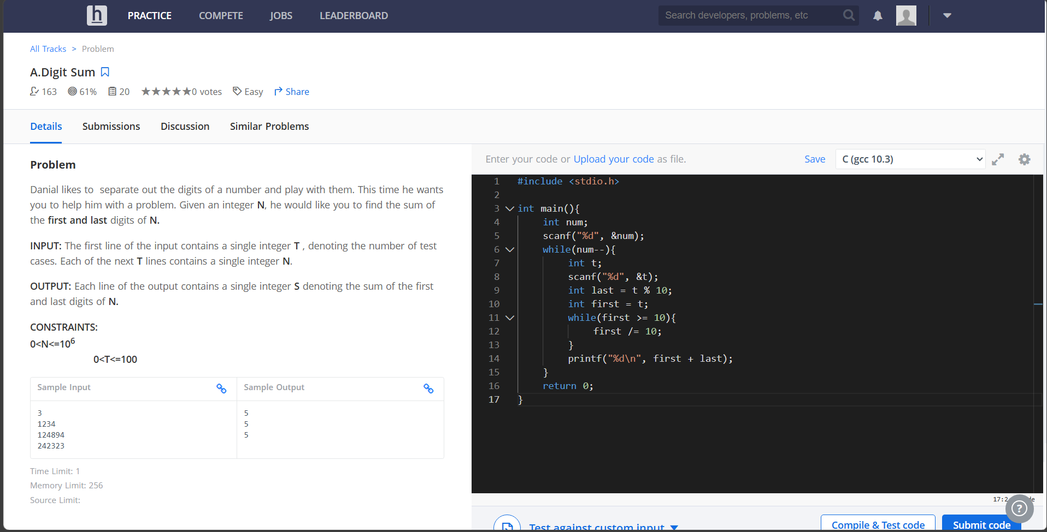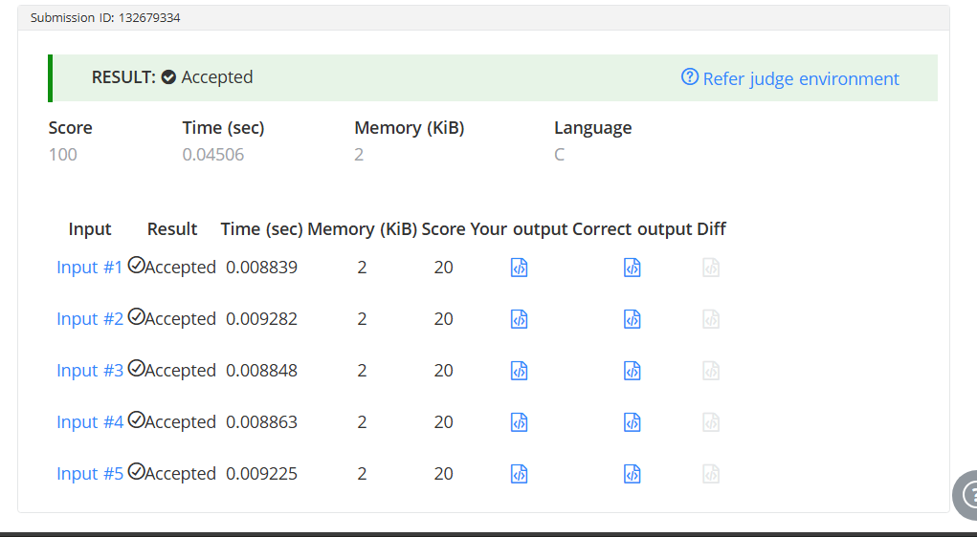#include <stdio.h>

int main(){
int num;
scanf("%d", &num);
while(num--){
int t;
scanf("%d", &t);
int last = t % 10;
int first = t;
while(first >= 10){
first /= 10;
}
printf("%d\n", first + last);
}
return 0;
}

