Factorial!
Factorial! | Basics of Input/Output & Basic Programming Practice Problems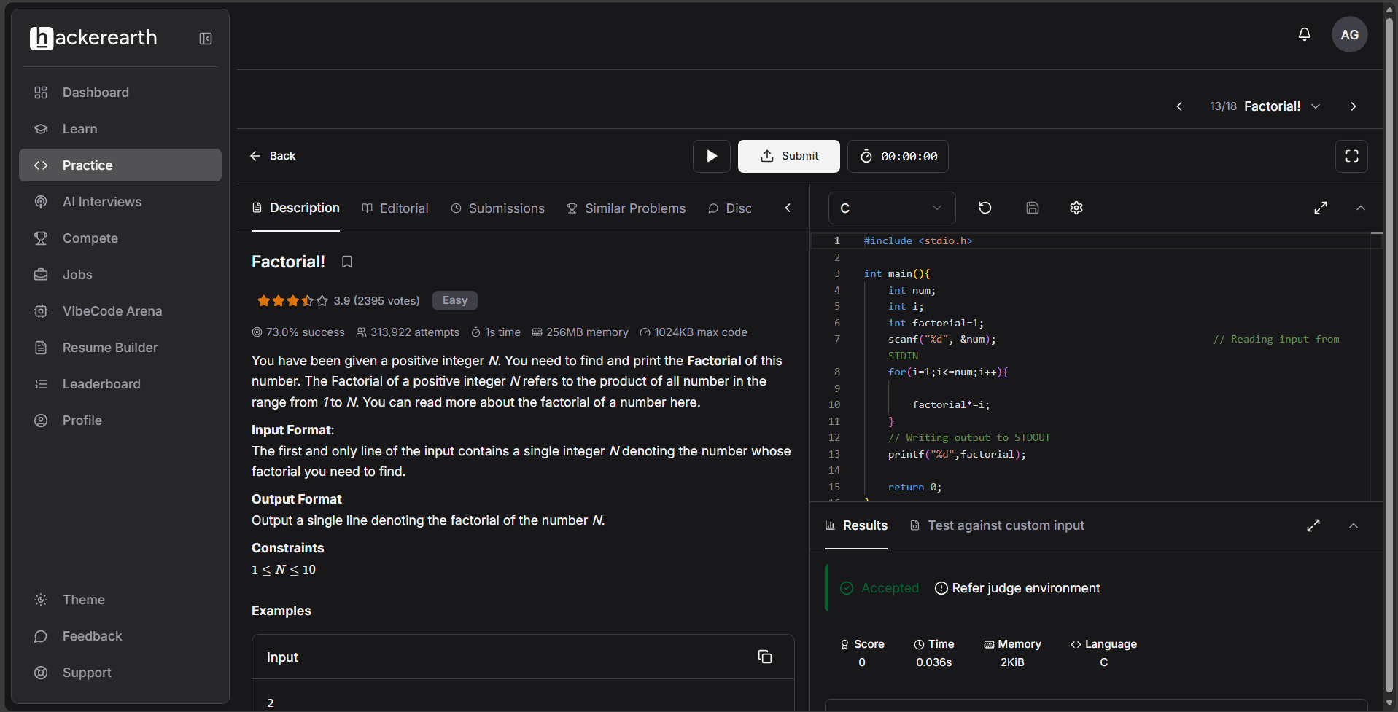#include <stdio.h>

int main(){
int num;
int i;
int factorial=1;
scanf("%d", &num); // Reading input from STDIN
for(i=1;i<=num;i++){

factorial*=i;
}
// Writing output to STDOUT
printf("%d",factorial);

return 0;
}

