Prime Numbers
Prime Numbers | Practice Problems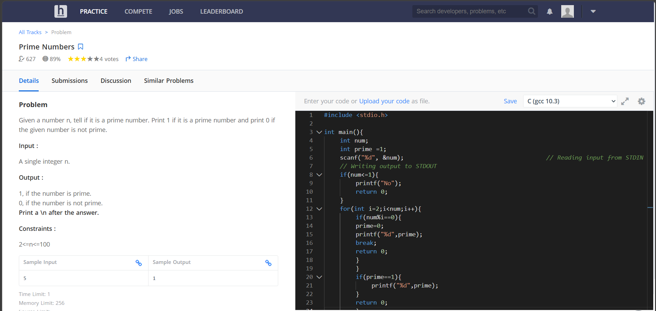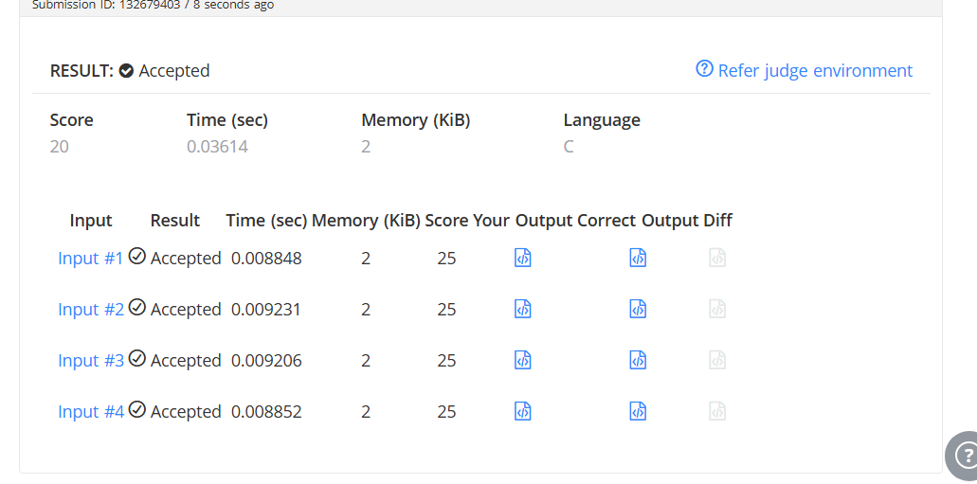#include <stdio.h>

int main(){
int num;
int prime =1;
scanf("%d", &num); // Reading input from STDIN
// Writing output to STDOUT
if(num<=1){
printf("No");
return 0;
}
for(int i=2;i<num;i++){
if(num%i==0){
prime=0;
printf("%d",prime);
break;
return 0;
}
}
if(prime==1){
printf("%d",prime);
}
return 0;
}

