Roy and Profile Picture
Roy and Profile Picture | Basics of Input/Output & Basic Programming Practice Problems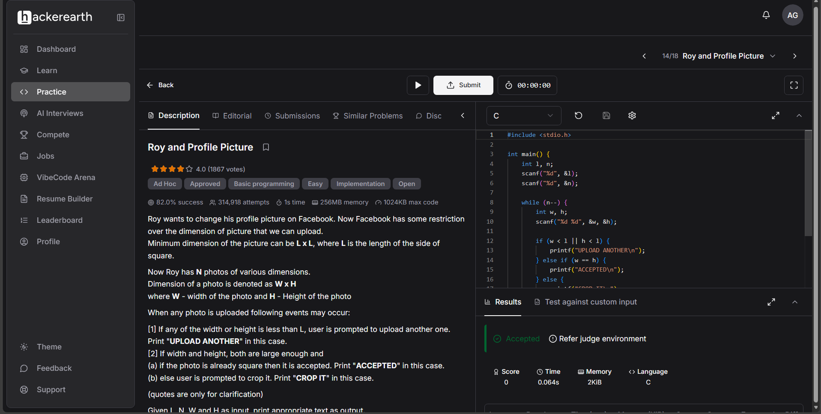#include <stdio.h>

int main() {
int l, n;
scanf("%d", &l);
scanf("%d", &n);

while (n--) {
int w, h;
scanf("%d %d", &w, &h);

if (w < l || h < l) {
printf("UPLOAD ANOTHER\n");
} else if (w == h) {
printf("ACCEPTED\n");
} else {
printf("CROP IT\n");
}
}

return 0;
}

