Read from STDIN,Write to STDOUT
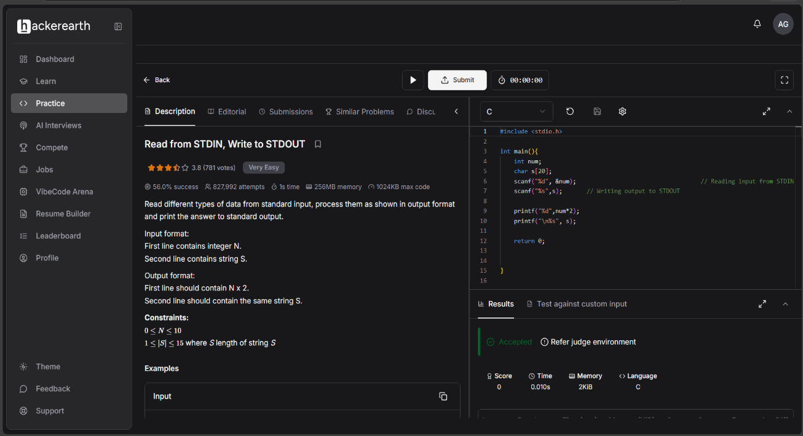
Read from STDIN, Write to STDOUT | Basics of Input/Output & Basic Programming Practice Problems

#include <stdio.h>

int main(){
int num;
char s[20];
scanf("%d", &num); // Reading input from STDIN
scanf("%s",s); // Writing output to STDOUT

printf("%d",num*2);
printf("\n%s", s);

return 0; }

