Conditional Statements in C
Conditional Statements in C | HackerRank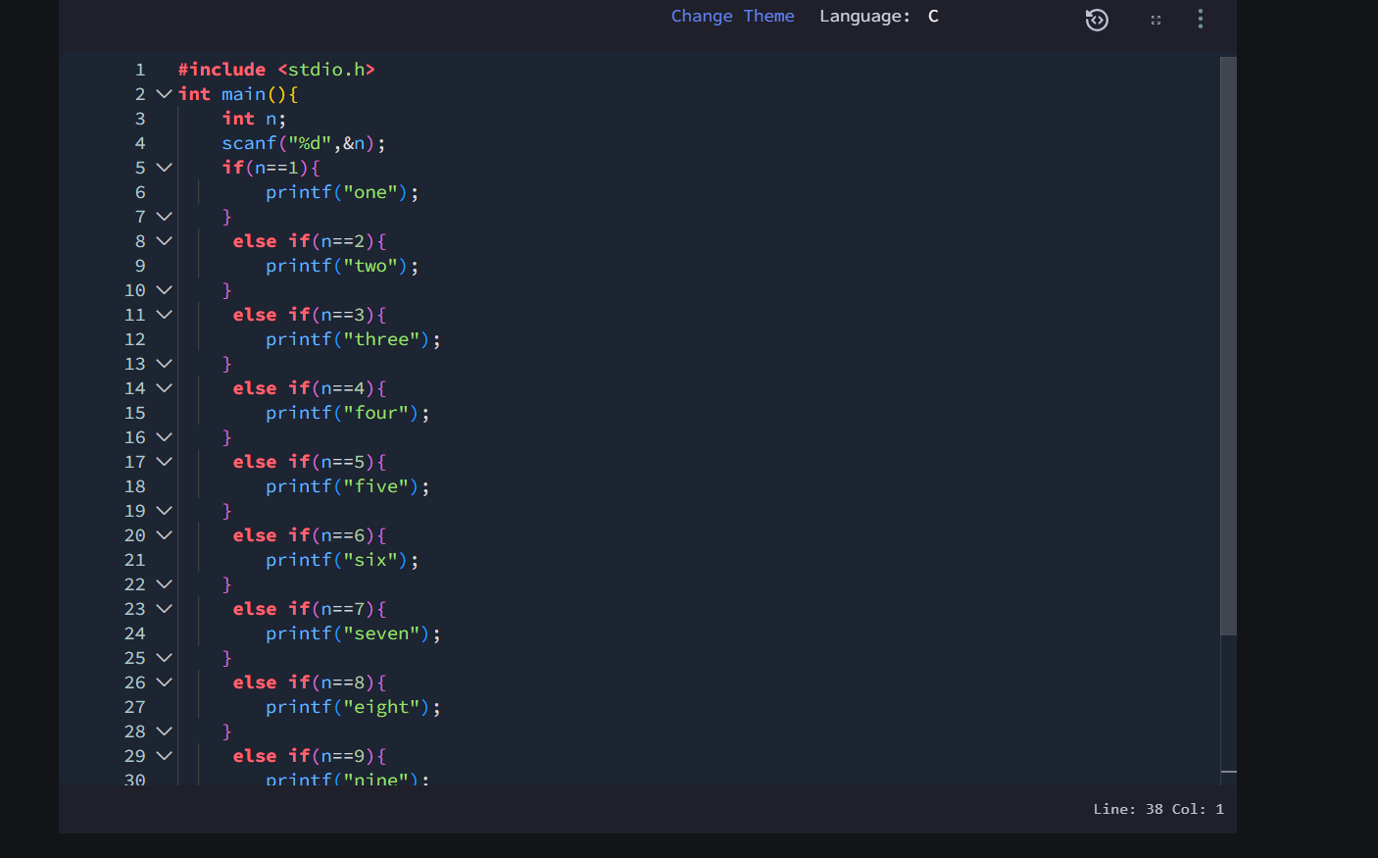#include <stdio.h>
int main(){
int n;
scanf("%d",&n);
if(n==1){
printf("one");
}
else if(n==2){
printf("two");
}
else if(n==3){
printf("three");
}
else if(n==4){
printf("four");
}
else if(n==5){
printf("five");
}
else if(n==6){
printf("six");
}
else if(n==7){
printf("seven");
}
else if(n==8){
printf("eight");
}
else if(n==9){
printf("nine");
}
else{
printf("Greater than 9");
}

return 0;
}

