For Loop in C
For Loop in C | HackerRank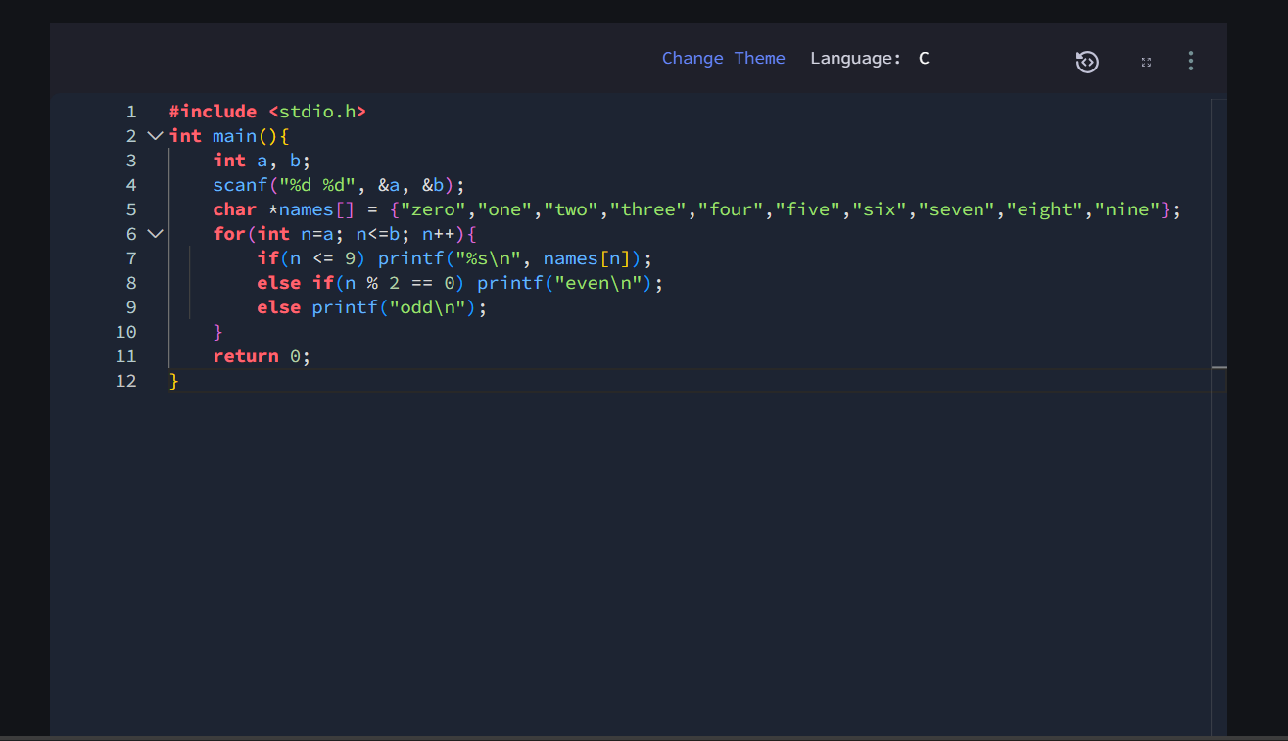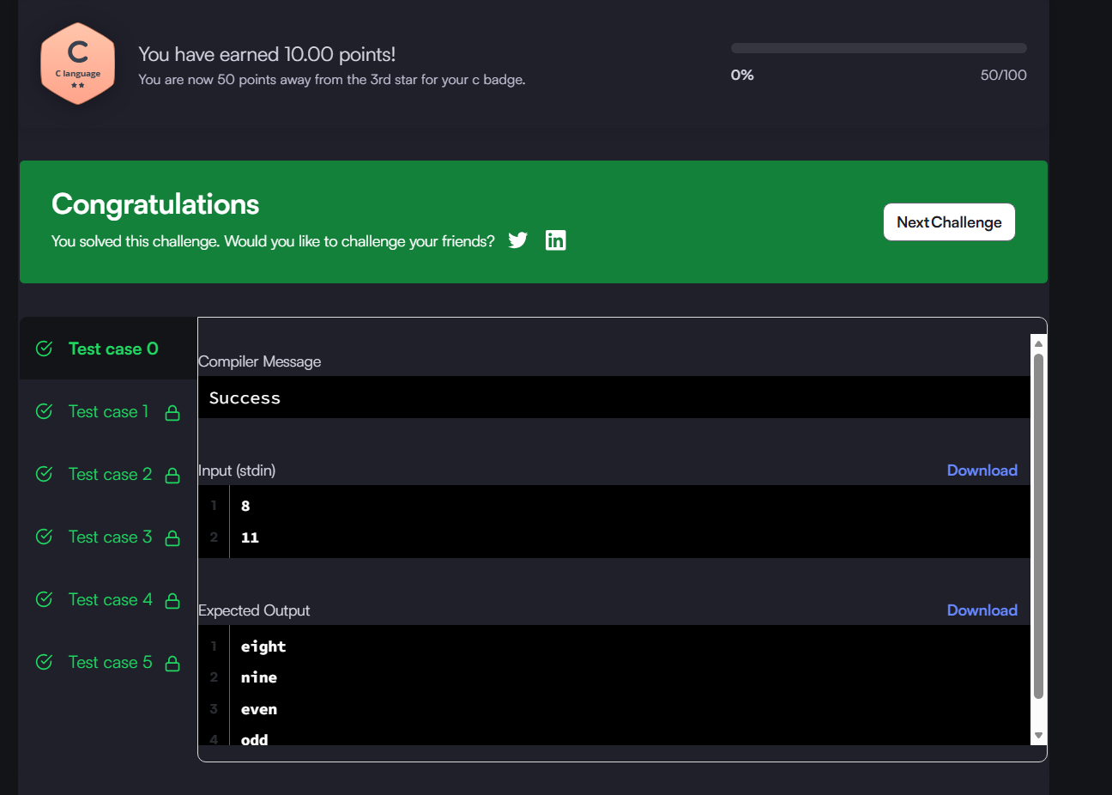#include <stdio.h>
int main(){
int a, b;
scanf("%d %d", &a, &b);
char *names[] = {"zero","one","two","three","four","five","six","seven","eight","nine"};
for(int n=a; n<=b; n++){
if(n <= 9) printf("%s\n", names[n]);
else if(n % 2 == 0) printf("even\n");
else printf("odd\n");
}
return 0;
}

