Grading Students
Grading Students | HackerRank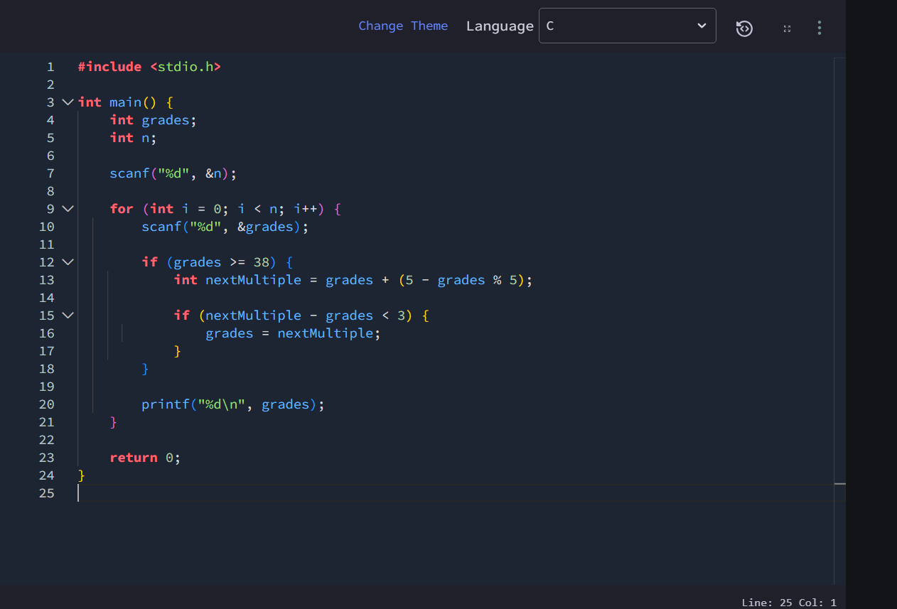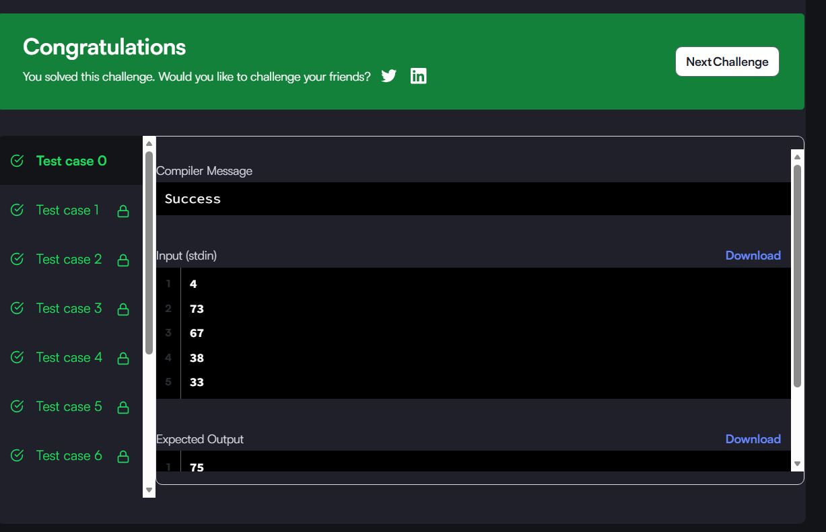#include <stdio.h>

int main() {
int grades;
int n;

scanf("%d", &n);

for (int i = 0; i < n; i++) {
scanf("%d", &grades);

if (grades >= 38) {
int nextMultiple = grades + (5 - grades % 5);

if (nextMultiple - grades < 3) {
grades = nextMultiple;
}
}

printf("%d\n", grades);
}

return 0;
}

