Number Line Jumps
Number Line Jumps | HackerRank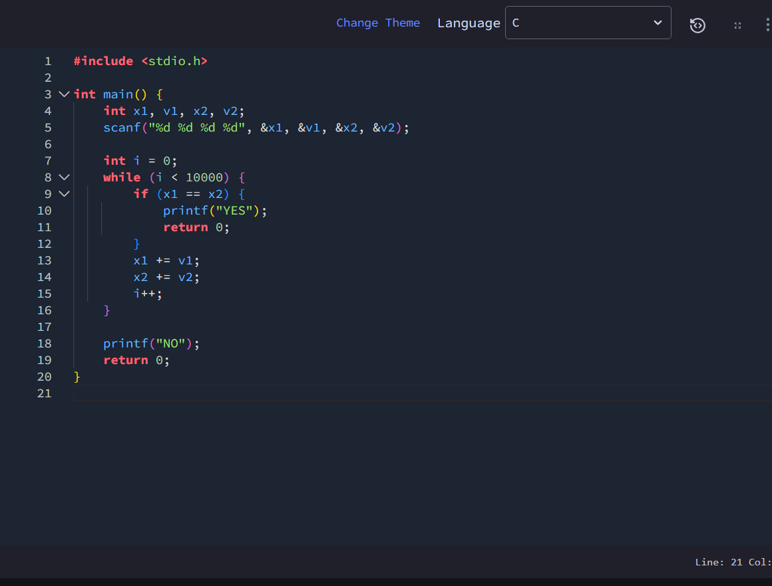
#include <stdio.h>

int main() {
int x1, v1, x2, v2;
scanf("%d %d %d %d", &x1, &v1, &x2, &v2);

int i = 0;
while (i < 10000) {
if (x1 == x2) {
printf("YES");
return 0;
}
x1 += v1;
x2 += v2;
i++;
}

printf("NO");
return 0;
}

