Printing Pattern Using Loops
Printing Pattern Using Loops | HackerRank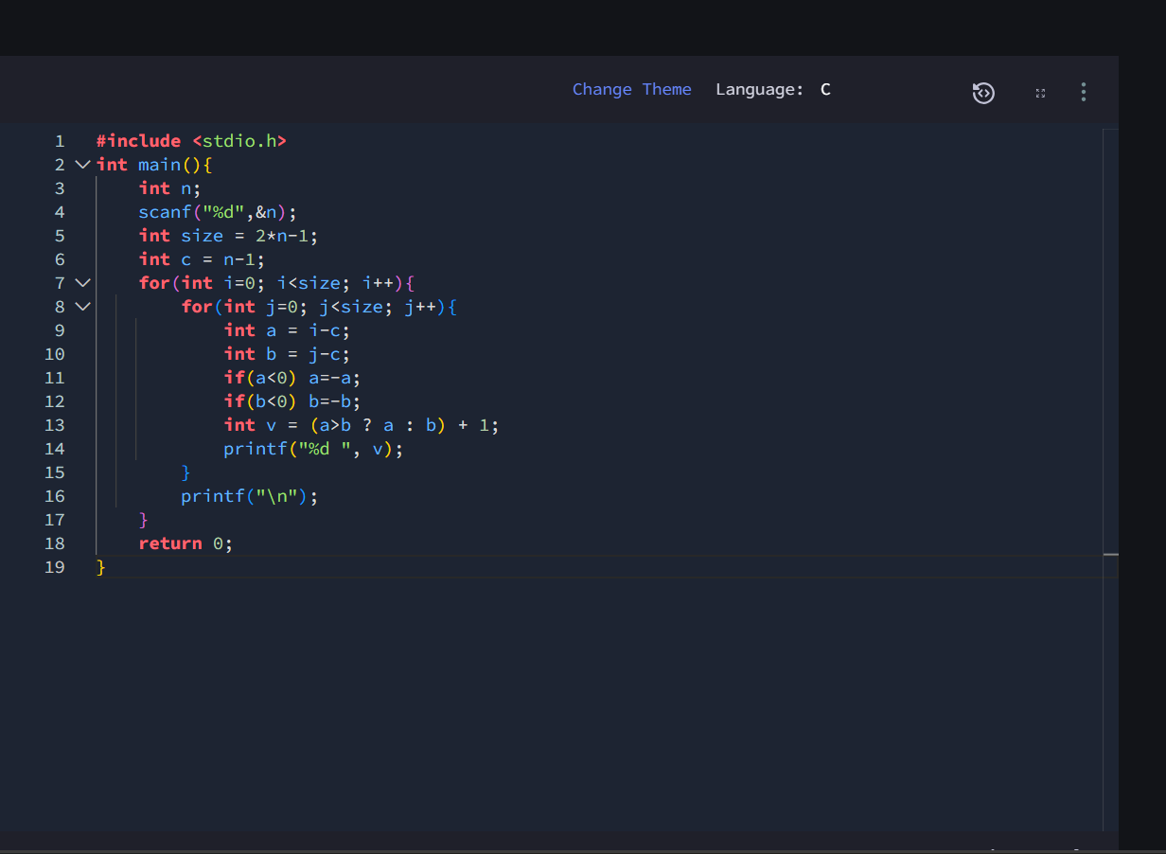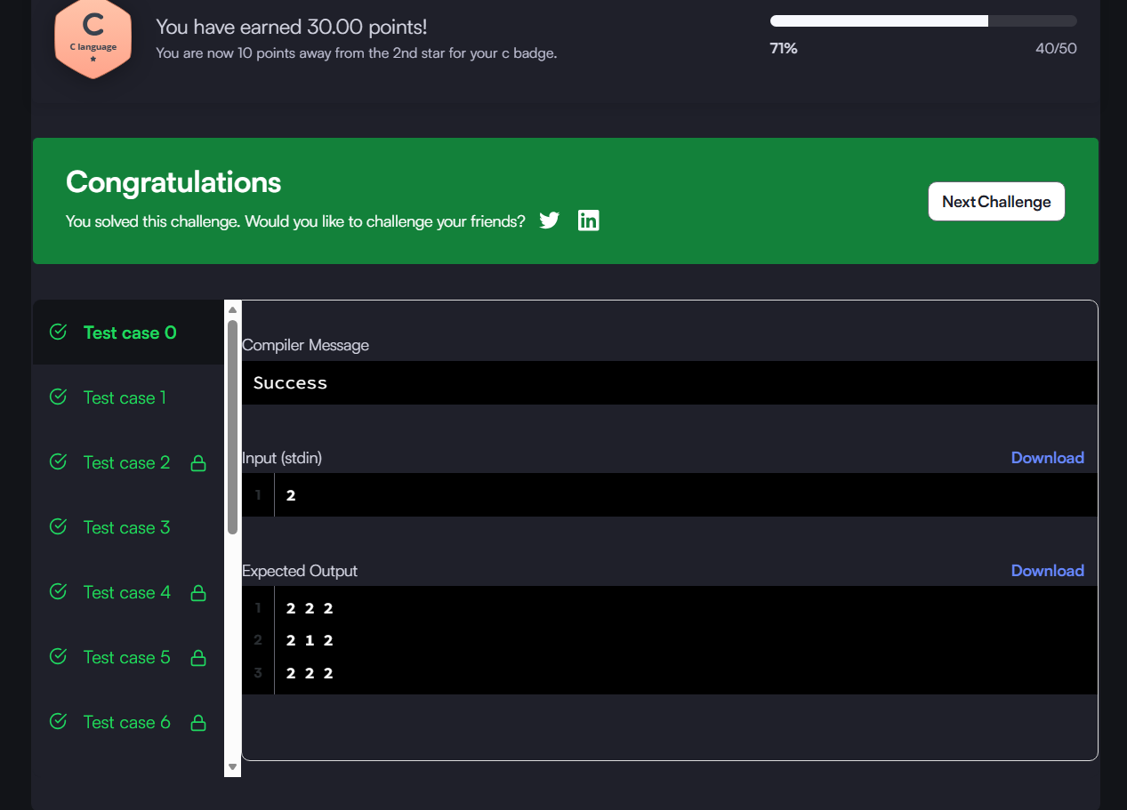#include <stdio.h>
int main(){
int n;
scanf("%d",&n);
int size = 2*n-1;
int c = n-1;
for(int i=0; i<size; i++){
for(int j=0; j<size; j++){
int a = i-c;
int b = j-c;
if(a<0) a=-a;
if(b<0) b=-b;
int v = (a>b ? a : b) + 1;
printf("%d ", v);
}
printf("\n");
}
return 0;
}

