1281. Subtract the Product and Sum of Digits of an Integer
Subtract the Product and Sum of Digits of an Integer - LeetCode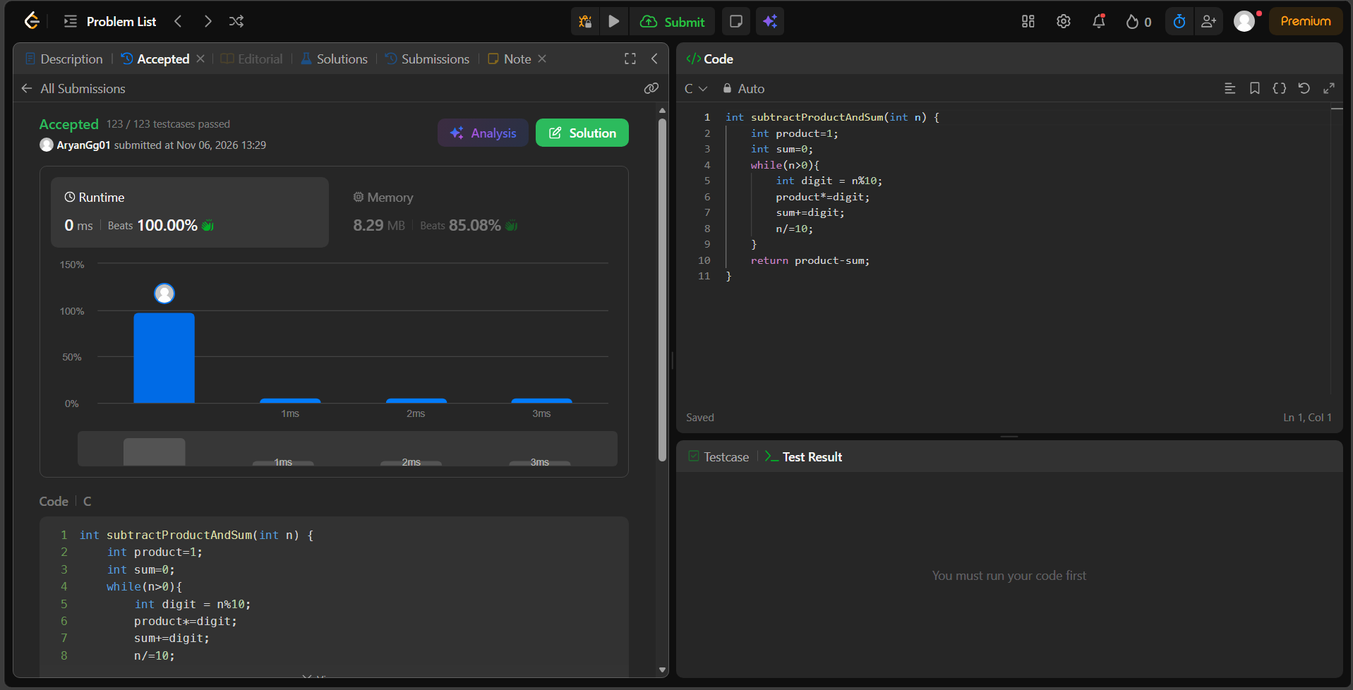int subtractProductAndSum(int n) {
int product=1;
int sum=0;
while(n>0){
int digit = n%10;
product*=digit;
sum+=digit;
n/=10;
}
return product-sum;
}

