231. Power of Two
Power of Two - LeetCode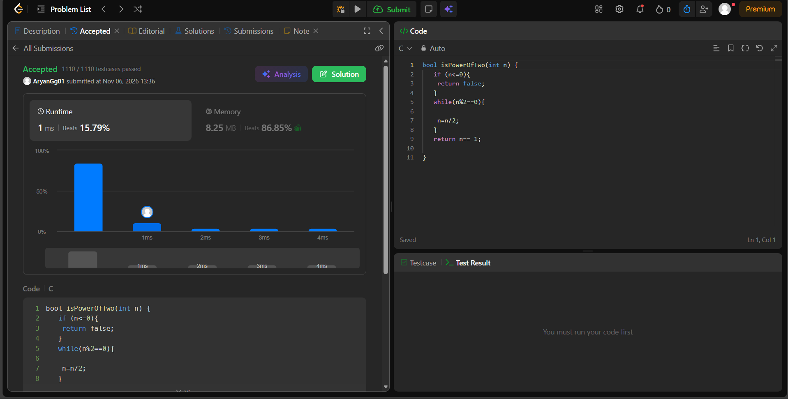bool isPowerOfTwo(int n) {
if (n<=0){
return false;
}
while(n%2==0){

n=n/2;
}
return n== 1;

}

