2413. Smallest Even Multiple
Smallest Even Multiple - LeetCode
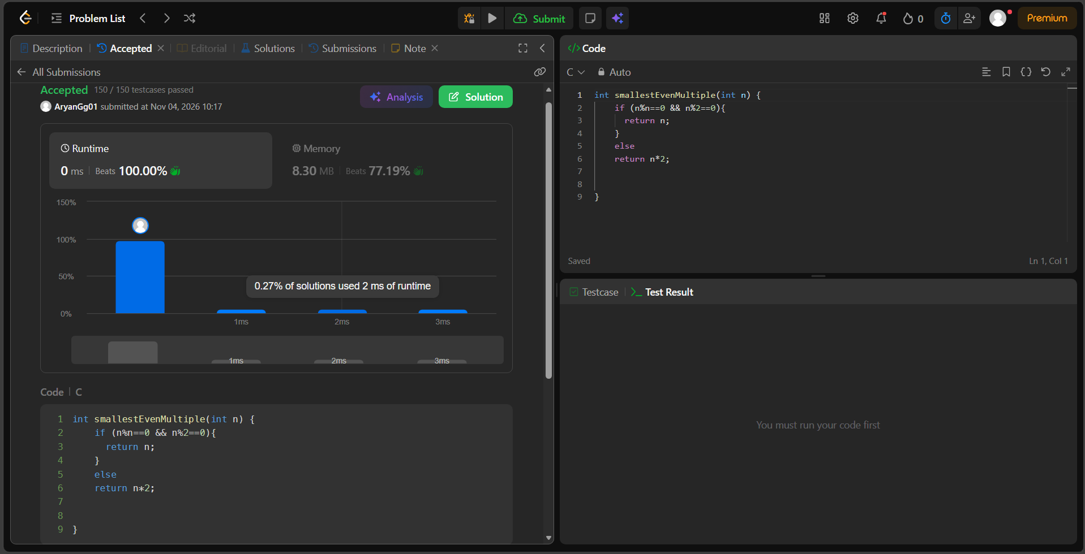
int smallestEvenMultiple(int n) {
if (n%n==0 && n%2==0){
return n;
}
else
return n*2;

}

