2520. Count the Digits That Divide a Number
Count the Digits That Divide a Number - LeetCode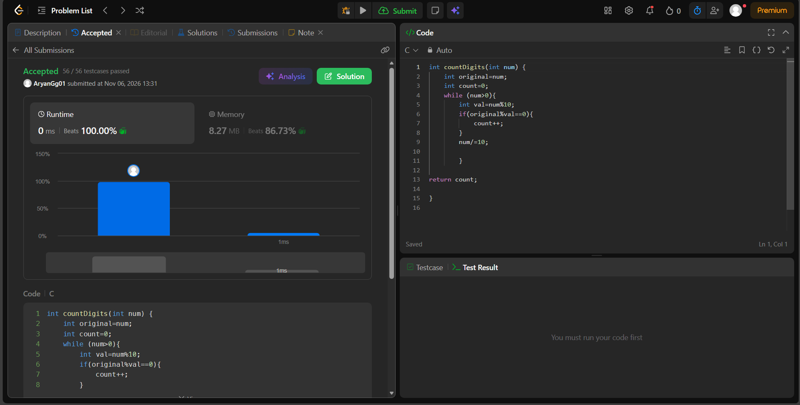int countDigits(int num) {
int original=num;
int count=0;
while (num>0){
int val=num%10;
if(original%val==0){
count++;
}
num/=10;

}

return count;

}

