2651. Calculate Delayed Arrival Time
Calculate Delayed Arrival Time - LeetCode
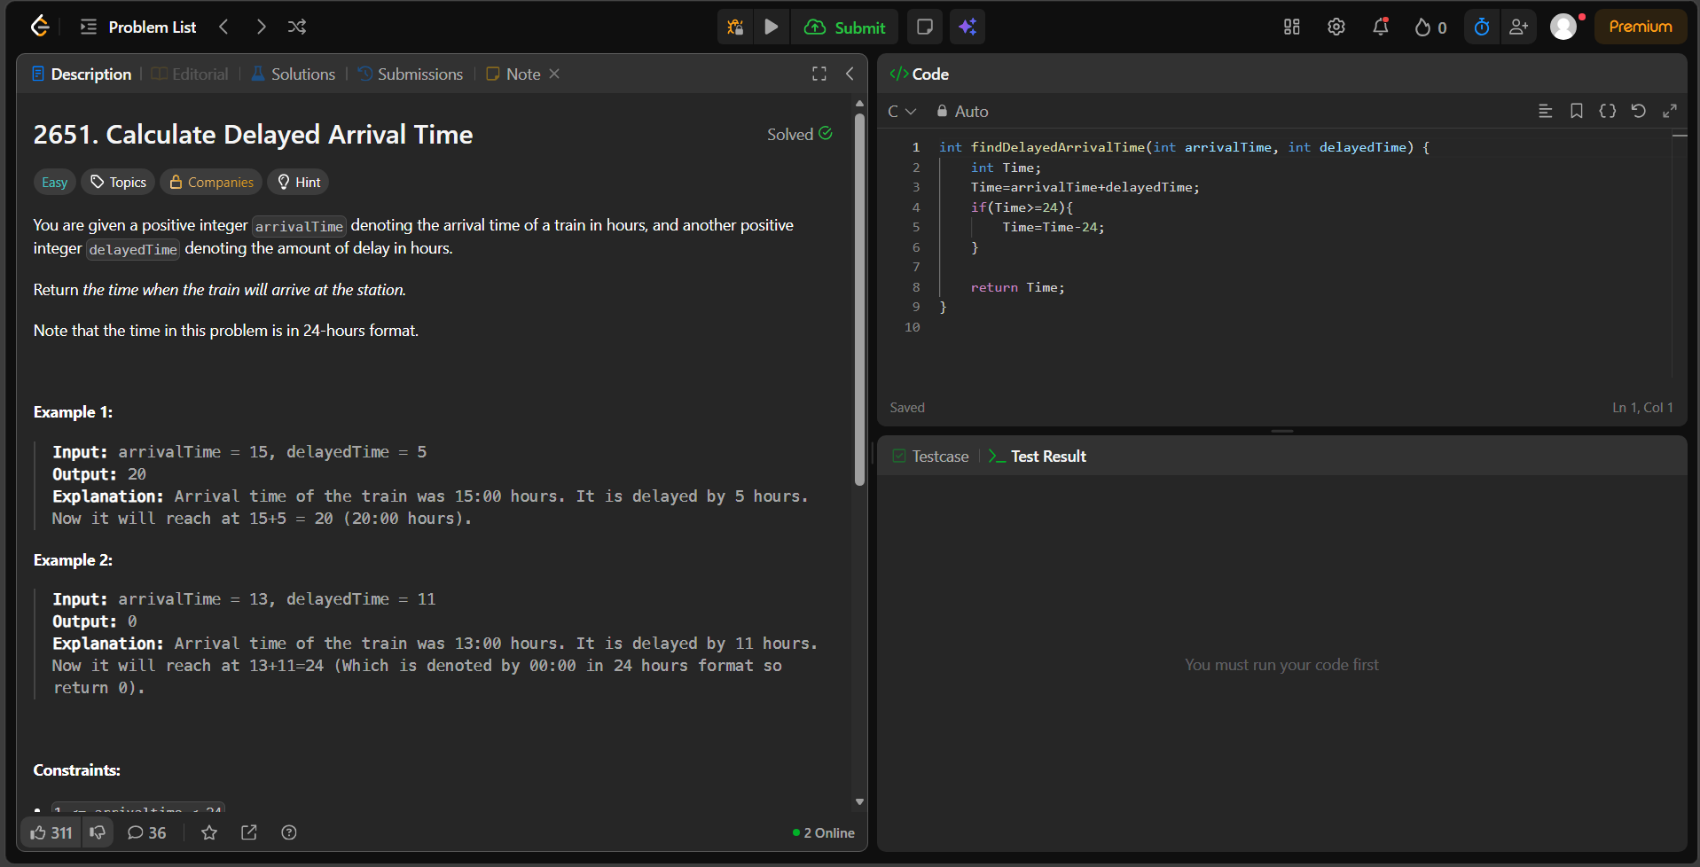

int findDelayedArrivalTime(int arrivalTime, int delayedTime) {
int Time;
Time=arrivalTime+delayedTime;
if(Time>=24){
Time=Time-24;
}

return Time;
}

