2739. Total Distance Traveled

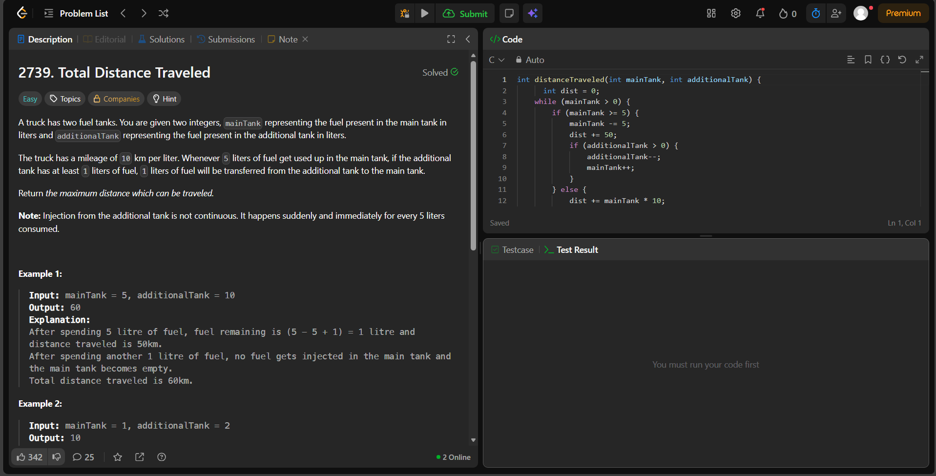
Total Distance Traveled - LeetCode

int distanceTraveled(int mainTank, int additionalTank) {
int dist = 0;
while (mainTank > 0) {
if (mainTank >= 5) {
mainTank -= 5;
dist += 50;
if (additionalTank > 0) {
additionalTank--;
mainTank++;
}
} else {
dist += mainTank * 10;
mainTank = 0;
}
}
return dist;}

