326. Power of Three
Power of Three - LeetCode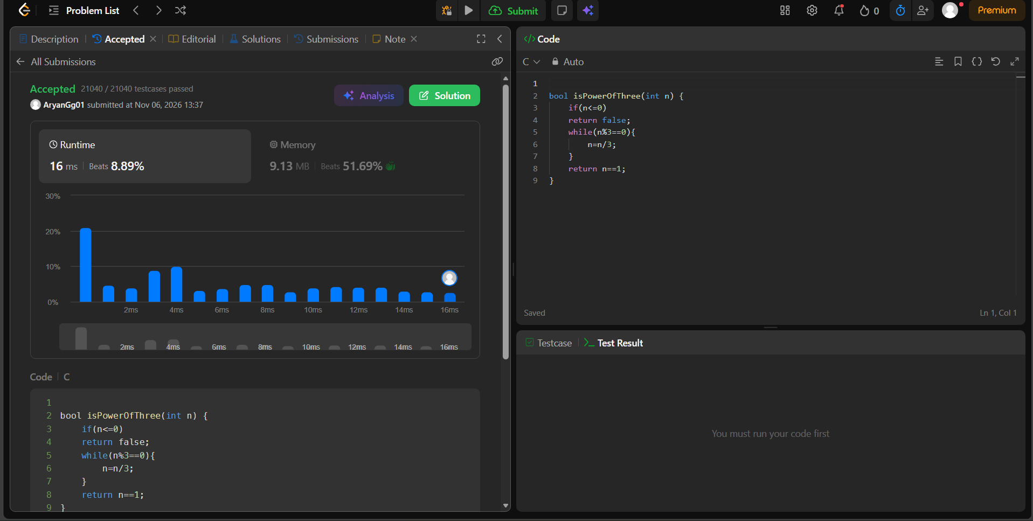bool isPowerOfThree(int n) {
if(n<=0)
return false;
while(n%3==0){
n=n/3;
}
return n==1;
}

