THE HONG KONG POLYTECHNIC UNIVERSITY
Department of Computing
COMP3423 Human Computer Interaction — Semester 1, 2026/27

Fixing the first mile
A principle-driven redesign of six Taobao screens for cross-border mobile shopping
Group 06 · Group Project Report · Due 15 November 2026

Workload declaration
Name | SID | Primary role | Key tasks (see report section)
Chan Tai Man * | S22103456d | Project Lead & UX Strategist | Timeline and coordination; Introduction (§1) and Conclusion (§6); seven-principle framework (§3.1); HCI-principle mapping for Feature 1 (§4.1); final QA and proofread
Wong Hoi Yan | S22108712a | User Researcher | Target user definition and personas (§3.2); user journey (§3.3); test plan, participants and tasks (§5.1); results and discussion (§5.2–5.3); Feature 2 (§4.2)
Lee Chun Kit | S22112345b | Interaction Designer | Information architecture (§3.4); screen flow and link structure (six linked screens); interaction states: filter sheet, list view, empty cart; Feature 3 (§4.3)
Ng Ka Wai | S22104567c | Visual & UI Designer | Visual language and design tokens (§3.5); high-fidelity screens home.html–account.html; component library in styles/base.css; Feature 4 (§4.4)
Ho Sze Wing | S22109876e | Accessibility & Evaluation Lead | Heuristic evaluation of the existing app (24 issues, Appendix D); accessibility audit of contrast, targets and reflow (§3.6); Feature 5 (§4.5)
Tsang Yuen Ling | S22105678f | Accessibility & Evaluation Lead (shared) | Accessibility accommodations in the redesign (§3.7); display preferences and text-scaling control; accessibility checks inside the test session (§5.5); Feature 6 (§4.6)
Table 1. Cover-page workload declaration ( * group leader). In a group of six, one role is shared by two members with distinct tasks.
Everyone in the group reviewed every figure and every claim in this report. The prototype is not a Figma file: it is delivered as six linked HTML/CSS screens that run in any browser — open output/home.html and follow the bottom navigation. §6 discusses this deviation honestly.

1 Introduction
1.1 The application and its context
Taobao is the consumer marketplace most Hong Kong students already have on their phone, and it is the one they complain about most. It is a general-purpose, price-driven catalogue of hundreds of millions of listings: clothing, dorm furniture, phone cases, LED strips, stationery, and anything else that can be shipped across the border. Its scale is exactly what makes its interface hard. A screen that has to hold every department, every promotion and every shipping rule ends up holding all of them at once, and the shopper is left to do the sorting.
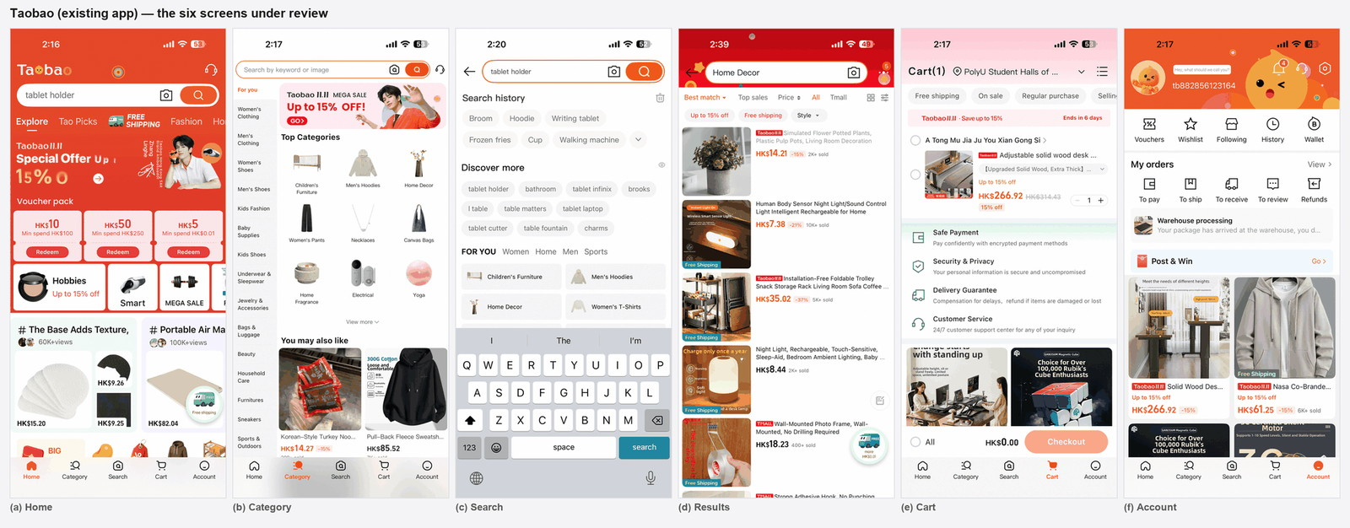
Figure 1. The six existing Taobao screens examined in this report: (a) Home, (b) Category, (c) Search, (d) Results, (e) Cart, (f) Account. All six were captured at 1320 × 2868 and re-drawn at 390 × 844.
The six screens in this report — Home, Category, Search, Results, Cart and Account — are the screens a shopper actually touches on the way from “I need a desk” to “it arrives at my hall”. They are also the screens where the app is weakest. We redesigned all six, and we linked them into one continuous flow so that the redesign can be walked end to end rather than judged screen by screen.
1.2 Target user group
Our target user is a Hong Kong tertiary student aged 18–27 who buys from Taobao in a second language, on a mid-range Android phone, one-handed, in short bursts between classes. This group is worth designing for because four constraints coincide in it:
- Single-handed, moving use. Thumbs reach the bottom third of the screen, not the top: primary actions have to live where the thumb already is (Hoober, 2013).
- Price and discount reasoning. The buying decision is a comparison of price, discount, shipping cost and delivery date. If any of those is missing from the card, the shopper has to open the listing to find out.
- Second-language reading. Every label competes with a Chinese-language mental model; icon-only controls and invented abbreviations cost more here than they would for a native user.
- Shared devices and short sessions. A session may be interrupted by a class; state has to survive and has to be reversible.
We did not design for the high-volume reseller or the professional live-stream buyer. Those users optimise for throughput and tolerate density; our user optimises for confidence, and pays for density with abandonment.
1.3 Problem statement
The existing app does not fail because a button is the wrong colour. It fails because the interface asks the shopper to hold too much in working memory at once and gives them too little to hold on to. Concretely, a structured walkthrough of the six screens against the seven principles used in this project (Table 3) and against Nielsen's (1994) usability heuristics produced 24 documented problems, four per screen, each annotated in Figures 4–9 and listed in Appendix D. Three patterns recur:
- Compression without hierarchy. Nine different card types share one column on Home; a promotion badge is printed over the channel tabs; the Category rail carries fifteen departments with no position indicator. Everything is equally loud, so nothing is findable.
- Missing decision attributes. Result cards carry a price and a sold count but no rating and no delivery estimate. The cart's call to action says “Checkout” without saying how much. The account page reports “To pay” without saying how many.
- Controls that are too small or too ambiguous. The cart quantity stepper is 33 px tall; history chips and “discover more” chips are visually identical; the sort row and the discount-filter chips collide.
1.4 Scope: the six features redesigned
Groups of six must deliver five major features (Appendix III). We delivered six, one per member, because the six screens form one journey and dropping any of them would break it. Each feature is a distinct user task that spans at least two connected screens or states; Table 2 lists them with the screens and states each one covers.
# | Feature (and owner) | User task | Screens and states covered
F1 | Discovery Home (Chan) | Land on the app and decide what is worth looking at | Home feed; scrolled feed; coupon collected state; cart badge updated from any screen
F2 | Guided Search (Wong) | Express a query and recover from a wrong one | Home search bar → Search → live suggestions; history item removed; history cleared
F3 | Faceted Results (Lee) | Narrow 1,284 items to a shortlist and compare them | Search → Results; filter sheet; grid/list views; applied-facet removal
F4 | Category Wayfinding (Ng) | Explore without a query and keep track of where you are | Category rail → sub-categories → Results (pre-filtered); breadcrumb on both screens
F5 | Cart & Selection Integrity (Ho) | Assemble an order and know exactly what will be charged | Results → Cart; quantity change; deselect; remove item → empty state
F6 | Account, Orders & Accessibility (Tsang) | Check an order and adapt the display to your needs | Cart → Account; order statuses; four-step parcel indicator; text size, contrast and motion preferences
Table 2. Scope: the six major features, their owning member, and the screens and states each one covers.
2 Related Work
Ten sources are used. Each paragraph states what the source actually claims, what it does not claim, and the single design decision in this project that it licenses. Where a source is older than the interface it is applied to — which is true of most of them — we say how we adapted it.
2.1 Motor performance on a phone is a sizing problem first
Fitts' law models the time to acquire a target as a logarithmic function of its distance and width, T = a + b·log2(2D/W) [1]. The practical reading is counter-intuitive: on a phone, distance barely changes, so width does almost all the work. Hoober's [2] large-sample grip study supplies the second half of the argument — roughly half of users hold a phone one-handed, and the natural thumb sweep covers the lower third of the screen, with the top corners reached by re-gripping. Two consequences shaped our design. First, every primary action moved into a sticky bottom bar inside that sweep: “Search for …”, “Check out · HK$266.92”, “View all 1,284 items”. Second, we stopped treating targets as “icons”: the cart stepper went from 33 px in the existing app to 48 × 48 px, and small inline icon buttons were held at 44 px. We do not claim that 48 px is a law — Fitts gives no such constant — it is the Material convention that both sources are compatible with, and it is the number we could verify across all six screens (§3.6).
2.2 Working memory, not screen space, is the scarce resource
Miller's [3] estimate of about seven chunks, plus or minus two, is routinely misquoted as a hard limit; Miller himself called it a limit on absolute judgement rather than a capacity. What survives scrutiny is weaker and more useful: ungrouped items are remembered worse than grouped items, and grouping is a property of the presentation, not of the number of items. Solso et al.'s [4] human information-processing account adds that selection happens early — a shopper filters a screen before reading it, so an undifferentiated page is filtered out wholesale. We therefore chunked structure instead of deleting content: the Category rail went from fifteen departments to seven top-level chunks; the Home feed was reduced to one card template instead of nine; the filter sheet groups facets into five labelled questions with item counts. The counts matter as much as the grouping: they offload the comparison (“318 items under HK$20”) that the shopper would otherwise have to hold.
2.3 Perception is constructive, so hierarchy has to be built, not assumed
The Gestalt principles reviewed by Wagemans et al. [5] describe grouping as an active inference: proximity, similarity, common region and figure–ground are all cues the viewer uses to decide what belongs to what. Two failures in the existing app are failures of cue conflict rather than of taste. On Search, recent history and trending suggestions were rendered in the same chip style with the same weight, so similarity said “same kind of thing” where the two have completely different meanings. On Home, a “FREE SHIPPING” badge overlapped the channel tabs, so proximity said “this badge labels the active tab”. Our redesign separates them by surface (trending becomes a ranked white card with numerals and a trend arrow) and by region (badges live inside the card they belong to). We also added the cue the app was missing: an explicit active-tab underline, because colour alone is not a grouping signal for a colour-blind user.
2.4 Labels carry the mental model
Norman's [6] account of affordances and signifiers is often reduced to “make buttons look like buttons”, but the part that applies here is his point about mapping and feedback: the label is what tells the user what will happen, and a wrong label creates a wrong model that no amount of visual polish repairs. The existing app's final button says “Checkout”, which names an activity and not an outcome. Our label says “Check out · HK$266.92”, and when nothing is selected it says “Select an item to check out” and is genuinely disabled rather than failing silently later. The same reasoning changed “All” (an ambiguous scope word) into a checkbox labelled “Select all items in cart”, and the coupon buttons from “Redeem” into “Collect”, with the condition printed beside the value (“HK$10 off when you spend HK$100 or more”). Baymard's [10] checkout research is the domain evidence for prioritising this: hidden costs and unclear totals are among the most cited reasons for abandoning a cart, above concerns about payment security.
2.5 Exploration is problem solving, so the problem space must be visible
Newell and Simon [7] model search as movement through a problem space: an initial state, a set of operators and a goal state, with means–end analysis used to reduce the gap between the current and the desired state. A catalogue is an ill-defined problem for a shopper — “something to tidy my desk, under HK$100, arriving this week” — and the interface's job is to make the operators visible and the state legible. This is what breadcrumbs, result counts and removable facet chips do: they externalise the current state so the shopper does not have to reconstruct it. The existing results screen shows neither a result count nor the filters in force; our version shows “1,284 results”, a breadcrumb, and each applied filter as a removable chip with a global “Clear all”. Dual grid and list views are offered for the same reason: grid for spatial scanning, list for attribute comparison.
2.6 Deterministic dialogue and visible state
Nielsen's [8] heuristics are the cheapest instrument we have for the “is anything obviously wrong here” question, and we used them as the first pass of the audit (Appendix D): visibility of system status, user control and freedom, error prevention, and recognition rather than recall account for 17 of the 24 issues we logged. Their limitation is that they produce complaints, not priorities; we ranked the resulting issues by which step of the journey they break, which is why cart and results issues were fixed before cosmetic ones. The parcel indicator on Account (“Step 3 of 4: at PolyU hub”) exists because status visibility is a heuristic, and because a four-step indicator is the smallest deterministic state display that answers “where is my thing”.
2.7 Accessibility as a floor, not a feature
WCAG 2.2 [9] gives testable success criteria — 4.5:1 for body text, 3:1 for UI components, 24 × 24 CSS px minimum target size (SC 2.5.8), no loss of content or function at 200 % zoom or text scaling (SC 1.4.10), and programmatic names for controls (SC 4.1.2). We treat these as a floor for every screen rather than as a separate “accessibility mode”, and we exceeded the minimum target size (44–52 px) because the mobile context is worse than the desktop context the criteria were drafted for. The one place where the standard was not enough is the case that motivated Feature 6: a shopper with low vision needs to enlarge text without losing the prices, so text scaling is a user-facing control with four steps, and we verified reflow at 200 % on all six screens (§3.6).
3 Overall Design
3.1 The seven-principle framework used to drive decisions
We adopted a single ordered framework instead of an unordered checklist, because order is what turns a principle list into a decision procedure: when two principles conflict, the higher-ranked one wins. Table 3 gives the framework, its theoretical origin, and — new in this report — the concrete artefact in our prototype where each principle is implemented.
Rank | Principle | Origin | Where it is implemented in the redesign
1 | Motor performance & touch ergonomics | Fitts [1]; Hoober [2] | 48–52 px primary targets; sticky action bars in the thumb zone; 48 px cart steppers (cart.html)
2 | Bounded cognitive throughput | Miller [3]; Solso [4] | 7 departments instead of 15; one product-card template; 5 labelled facet groups with counts
3 | Active visual constructivism | Gestalt [5] | Ranked-list treatment for trending; single 2-column scan grid; badges inside their own card region
4 | Semantic priming & microcopy | Norman [6] | “Check out · HK$266.92”; “Select an item to check out”; “Collect” with printed condition
5 | Deterministic dialogue & state | Newell & Simon [7] | Four-step parcel indicator; persistent cart badge; reversible selection; escapable filter sheet
6 | Problem-space structuring | Newell & Simon [7] | Result count, breadcrumb, removable applied facets, dual grid/list views, 5 facets with counts
7 | Universal accessibility | WCAG 2.2 [9] | Measured 4.5:1–17.4:1 text contrast; four-step text scaling with 200 % reflow; ARIA names on icon buttons
Table 3. The ordered design framework. When principles conflict, the higher rank decides; accessibility is ranked last only because it is a floor applied to every screen, never traded away.
3.2 Target users and personas
The journey was written for two personas (Table 4) who differ in one variable that changes the interface: whether the user arrives with a query or without one.
 | Persona A — “Arrives with a task” | Persona B — “Arrives to browse”
Profile | Mei, 20, second-year BSc student, Android mid-range, Taobao user for 3 years | Kwan, 24, MSc student, iPhone, occasional buyer, usually shops in-person
Context | Between lectures, one hand, 3–5 minute bursts, dorm wifi | At night in hall, two hands, long session, comparing options
Goal | Replace a broken tablet stand under HK$60, delivered before Friday | Find something to make a small room feel furnished, under HK$100
Success looks like | Two or three candidates on screen at once, each with price, rating and arrival date | A department they trust, sub-categories they can scan, and a way back to where they were
What breaks today | Cannot tell shipping cost or rating from the results card; no result count | Fifteen departments, no breadcrumb, a feed with no visible structure
Table 4. Personas. Both are real constraints in the design: A drives the results card and the sticky action bar, B drives the category rail, breadcrumb and item counts.
3.3 User journey
Figure 2 traces the seven stages from need to receipt, the touchpoint used at each stage, the pain point we logged in the existing app, and the redesign response. Two things are worth reading out of it. First, the pain points are not evenly distributed: stages 3 and 4 (explore, evaluate) carry six of our 24 issues, and they are the stages where the existing app has the least structure. Second, the redesign responses are deliberately small and additive — no stage introduces a new screen, a new gesture, or a new concept. The flow stays the flow the shopper already knows; what changes is what each screen is allowed to contain.
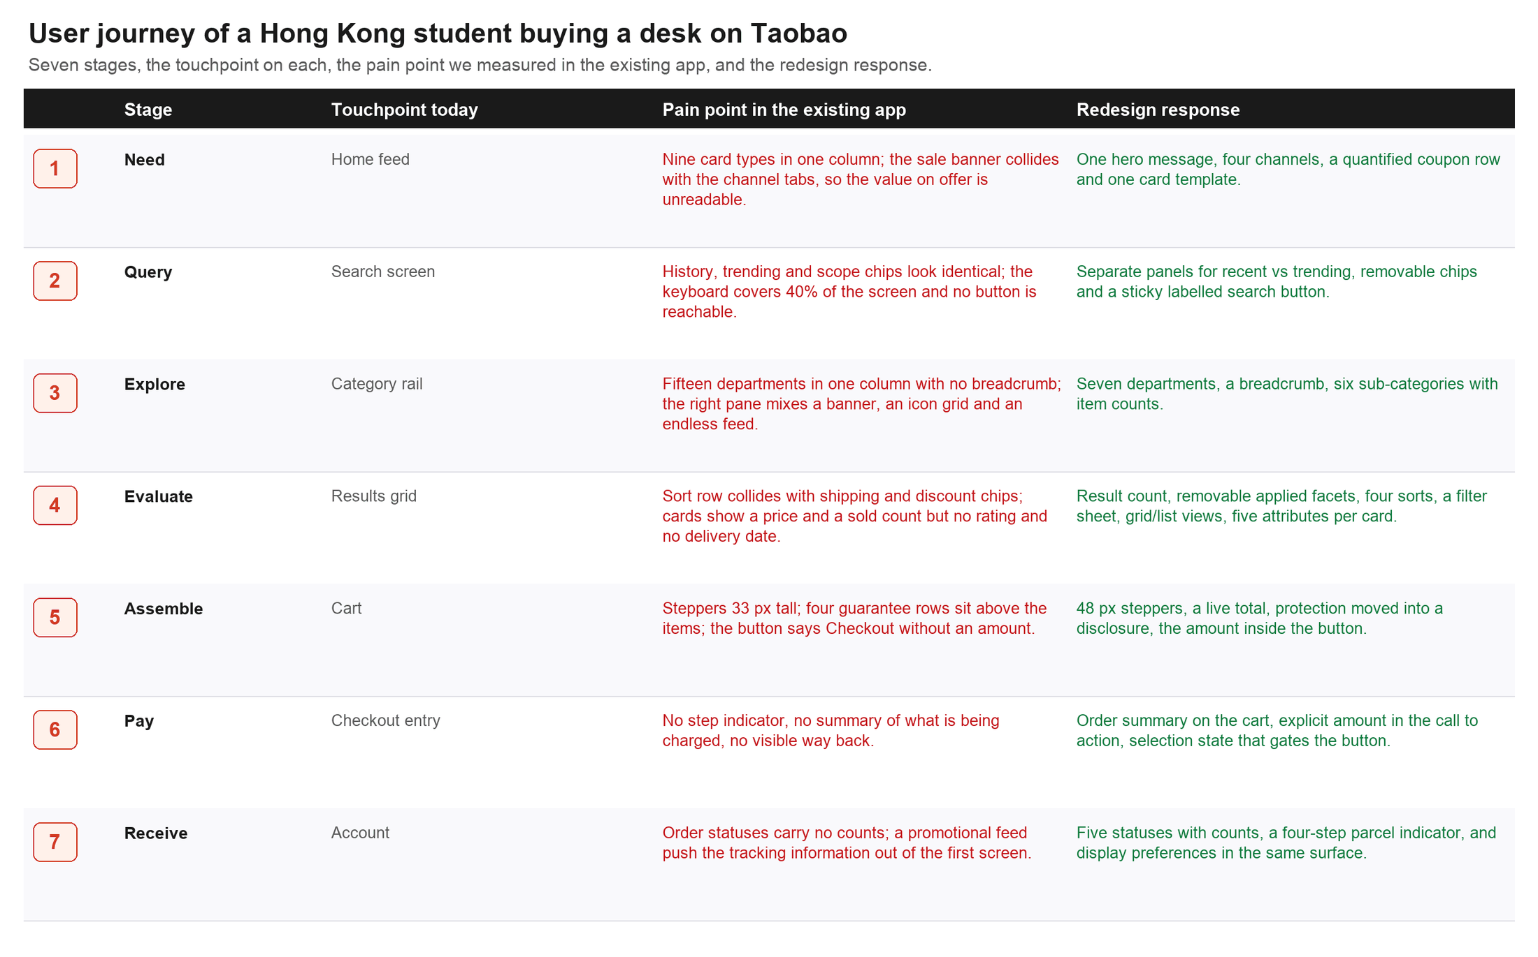
Figure 2. User journey for the target group: seven stages, the touchpoint used today, the pain point logged in the existing app, and the redesign response. Pain points concentrate at the explore and evaluate stages.
3.4 Information architecture
The single largest structural change is the category rail: fifteen departments, several of them overlapping (Women's Clothing, Women's Shoes, Fashion, Sneakers), collapsed into seven chunks that a shopper can hold in working memory. The right-hand pane stops being three competing zones (banner, icon grid, endless feed) and becomes one job per zone (Figure 3). The bottom navigation is unchanged in item count and order — Home, Category, Search, Cart, Account — because it is the one part of the app that already worked, and because the five items are the five features of this project.
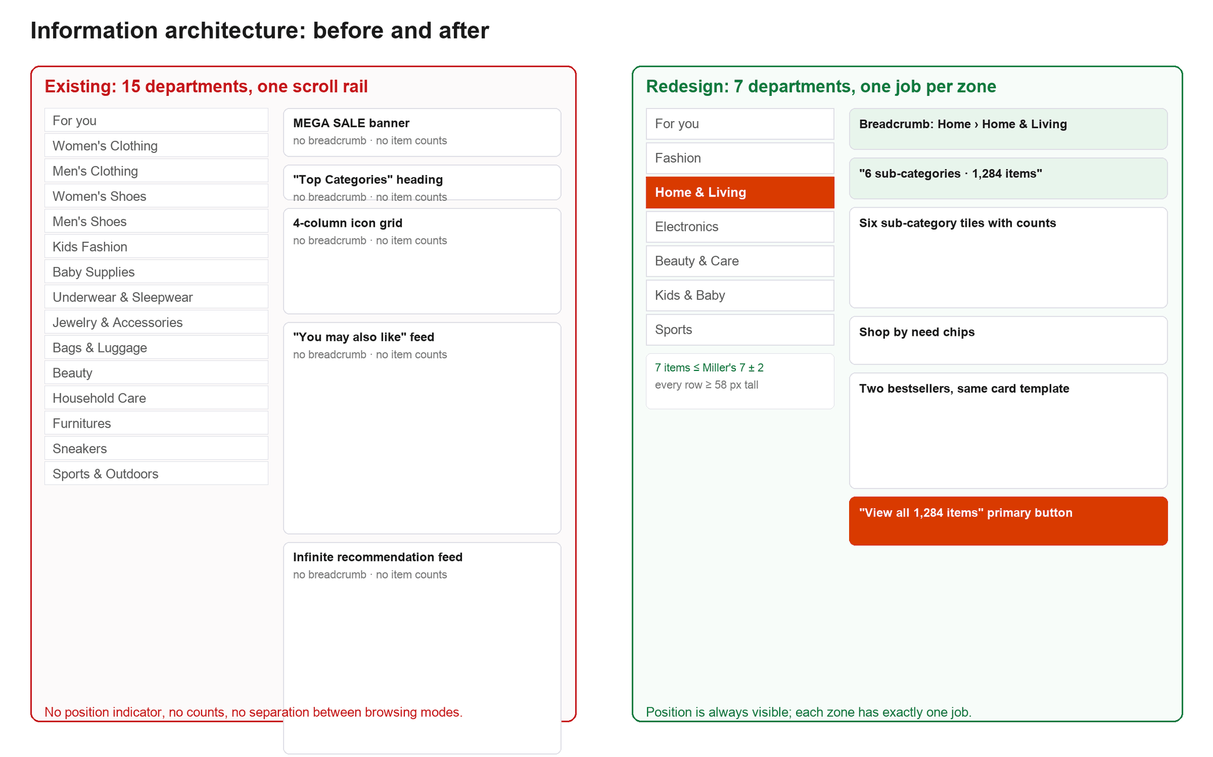
Figure 3. Information architecture before and after. Left: fifteen departments and three competing zones with no position indicator. Right: seven departments, a breadcrumb, item counts, and one job per zone.
3.5 Visual language and design tokens
The visual language is deliberately conservative: one brand colour used only for identity and primary actions, one ink scale, one radius scale, one spacing unit. Every text colour was chosen by contrast ratio rather than by eye, and the ratios below are computed against the surface each colour actually sits on. The brand orange (#FF5000) is retained for identity, but it is never used for text on white — at 3.3:1 it fails the 4.5:1 floor — so labels use a darker tint of the same hue (#B93A00, 5.7:1) and buttons use #D93A00 with white text (4.6:1).
Token | Value | Role | Measured contrast
--ink | #1A1A1A | Primary text, prices, headings | 17.4:1 on white
--ink-2 | #5A5A5A | Secondary text, conditions, meta | 6.9:1 on white
--ink-3 | #767676 | Tertiary text, placeholders | 4.5:1 on white (AA floor)
--brand-strong | #D93A00 | Primary button fill (white label) | 4.6:1 for the label
--brand-ink | #B93A00 | Orange text and active nav item | 5.7:1 on white
--price | #C4161C | Prices and negative changes | 6.0:1 on white
--ok | #0F7B3E | Free shipping, savings, completed steps | 5.4:1 on white
--line-strong | #767676 | Control outlines (checkbox, radio, switch) | 4.5:1 against adjacent surfaces
Table 5. Design tokens and measured contrast. Body text is 14–17 px, meta text is 12 px; no text in any screen is smaller than 12 px, which the automated audit in §3.6 checks.
3.6 Measured audit of the six screens
Claims about touch targets are easy to make and hard to check, so we measured them. Each screen was loaded at 390 × 844 CSS px and every interactive element was inspected for size, every text node for font size, and the scroll container for horizontal overflow at four text scales (87.5 %, 100 %, 118 %, 137 %) and at 200 % for the reflow criterion. Table 6 reports what the audit found in the final build.
Screen | Interactive elements | Smallest primary target | Smallest text | Horizontal overflow
home.html | 29 | 48 × 48 (add to cart) | 12 px | none at 100 % or 200 %
category.html | 30 | 48 × 58 (rail rows) | 12 px | none at 100 % or 200 %
search.html | 38 | 44 × 44 (inline clear, delete) | 12 px | none at 100 % or 200 %
products.html | 46 | 48 × 48 (chips, add) | 12 px | none at 100 % or 200 %
cart.html | 23 | 48 × 48 (stepper) | 12 px | none at 100 % or 200 %
account.html | 32 | 48 × 44 (segmented A/A+) | 12 px | none at 100 % or 200 %
Table 6. Measured accessibility audit of the final prototype. Primary actions are 48–52 px; secondary inline controls inside an already-large row are 44 px, above the 24 px floor of WCAG 2.2 SC 2.5.8 and at the Apple HIG minimum.
3.7 Accessibility considerations
- Not colour alone. Active tab, active department and completed parcel steps are marked by position, weight, underline and a numeral, so the meaning survives greyscale.
- User-controlled display. Account exposes four text sizes, a high-contrast theme and a reduce-motion switch. The text-size control reflows layout rather than clipping it; all six screens were re-verified at 200 %.
- Programmatic semantics. Every icon-only button has an aria-label with its consequence (“Remove Broom from recent searches”), every product image has a role and a label, totals are announced through an aria-live region, and the filter sheet is a modal dialog that returns focus to its opener on close.
- Keyboard path. Tab order follows visual order on all six screens, the skip link is the first focusable element, and the filter sheet can be dismissed with Escape.
4 Feature Details
4.1 Feature 1 — Discovery Home (owner: Chan Tai Man)
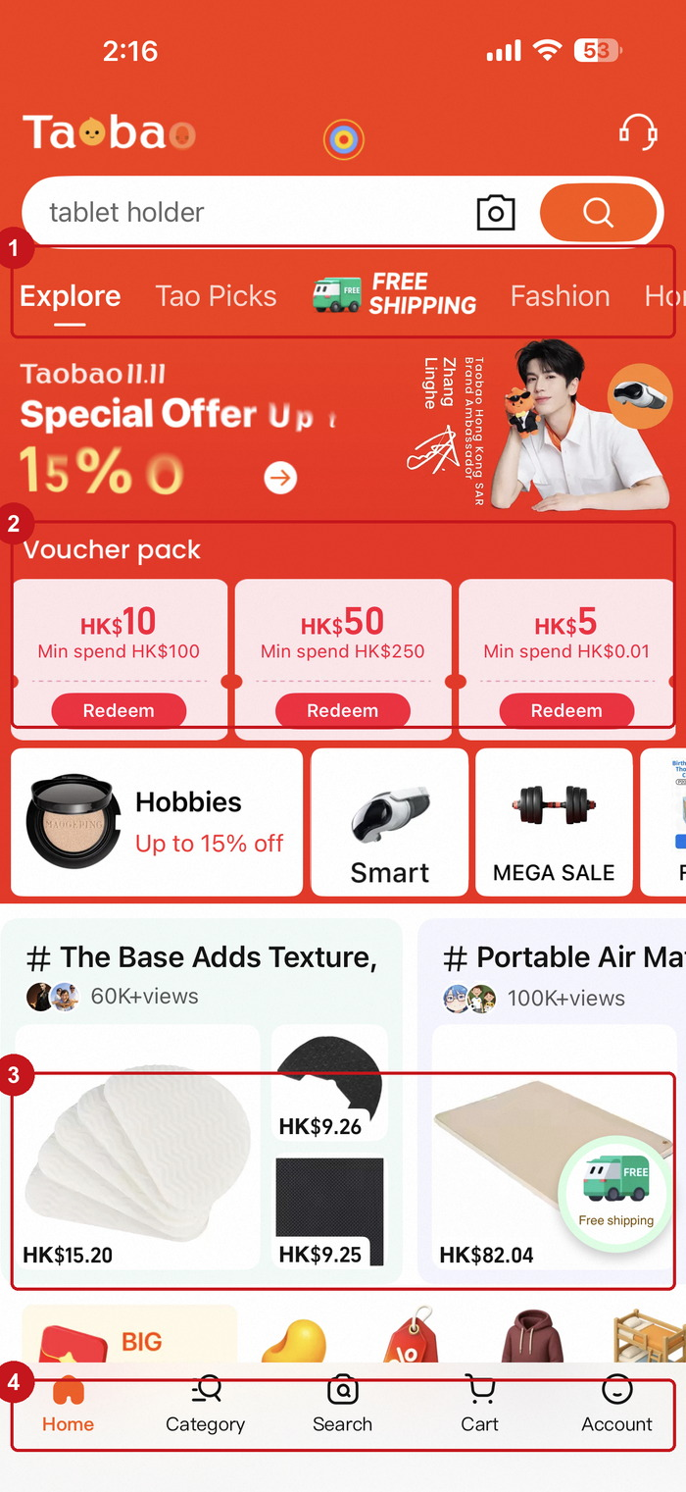 | 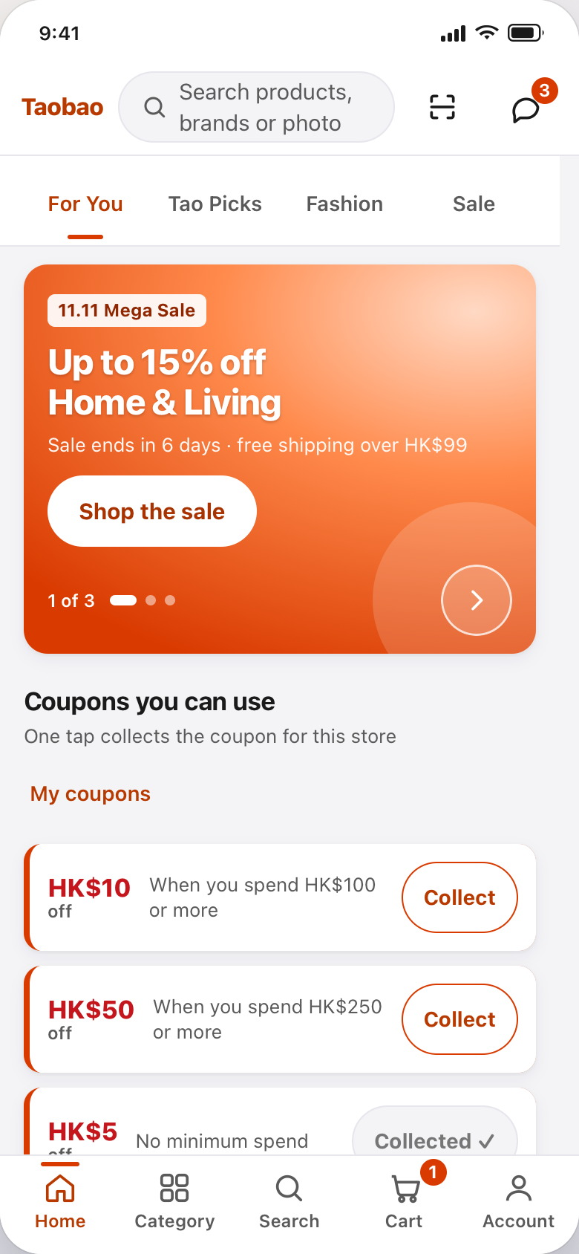
BEFORE — existing Home with 4 annotated issues | AFTER — redesign (home.html)
Figure 4. Feature 1, Home. ① a “FREE SHIPPING” badge printed over the channel tabs; ② voucher rows with 12 px “Redeem” buttons; ③ cards carrying price and sold count only; ④ 11 px nav labels.
(a) The problem. The existing Home assembles nine card types into one column — banner, voucher pack, category tiles, social posts, product feed — with a shipping badge overlapping the channel tabs (①). Each voucher states value, condition and action in three sizes, the condition in about 8 pt, with a 12 px button as the only way to act (②). Cards report price and sold count and encode the discount as a suffix (“-15%”), not as a saving (③).
(b) Principles. Violated: Principle 3 (figure–ground broken where the badge sits on the tabs; similarity broken by nine card styles in one column), Principle 2 (nothing is chunked into a repeatable unit), Principle 1 (the actionable elements are the smallest things on the screen). Applied: Principle 3 for the single card template and four-tile scan line, Principle 4 for the offer microcopy, Principle 1 for 48 px targets.
(c) The redesign. One hero message with one call to action, four channels instead of an arbitrary strip, a coupon row stating value, condition and consequence (“HK$10 off when you spend HK$100 or more” · Collect), four category tiles with item counts, and one card template with five attributes in a fixed order: title, price, rating with review count, and shipping as a tagged fact — plus an add button on the card itself.
(d) Rationale. The card is the unit of chunking: five fixed attributes in a fixed order let the eye learn one scan pattern and reuse it twenty times — the cheapest reduction in information load available [3, 4]. Turning the discount into a saving moves the comparison out of the shopper's head, and putting the add button on the card is this screen's Fitts' law decision: it shortens the pointer path and makes the most frequent action the widest target on the row [1].
4.2 Feature 2 — Guided Search (owner: Wong Hoi Yan)
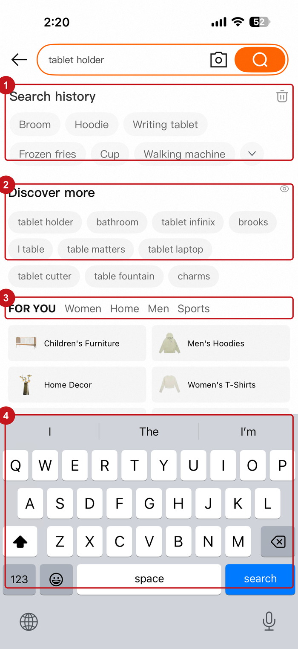 | 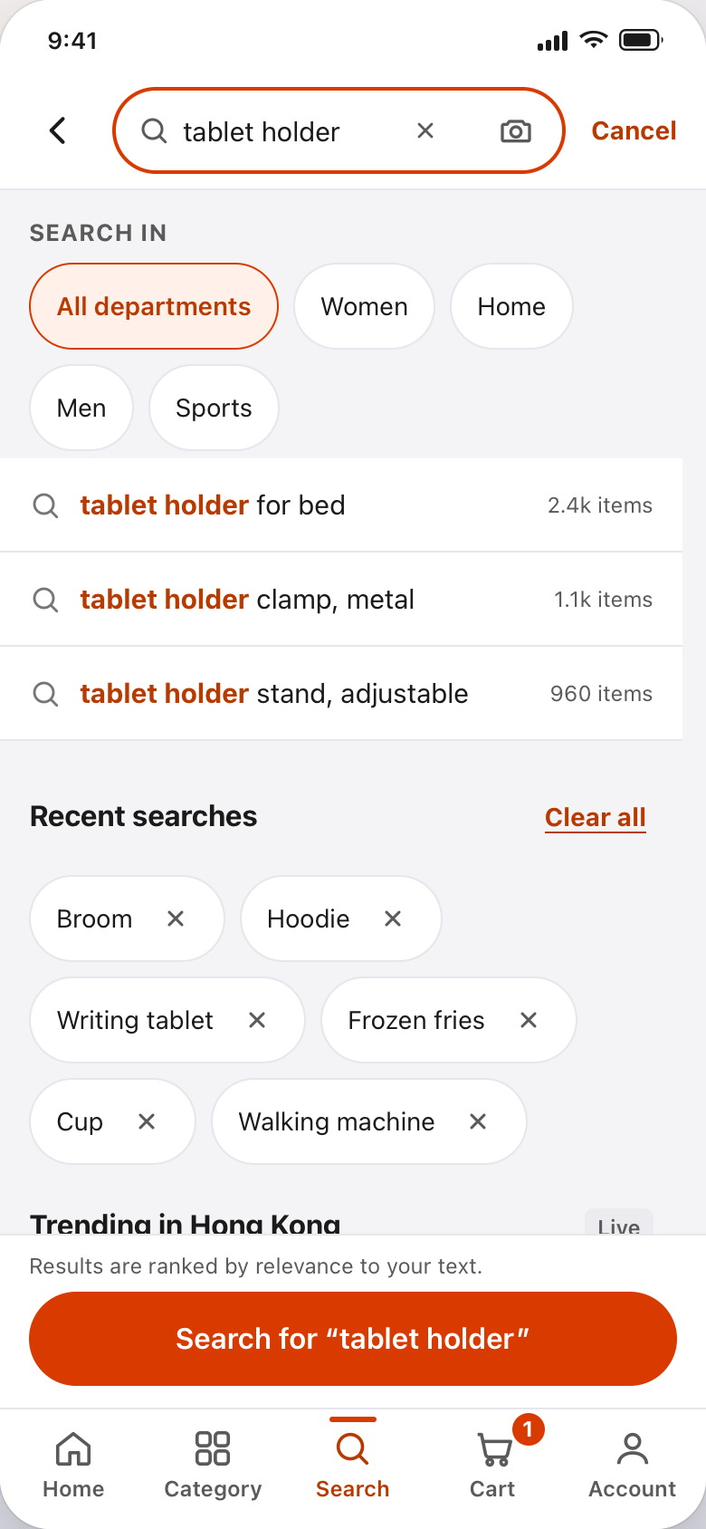
BEFORE — existing Search with 4 annotated issues | AFTER — redesign (search.html)
Figure 5. Feature 2, Search. ① and ② are different kinds of suggestion rendered identically; ③ an unexplained scope strip; ④ the keyboard occupying 40 % of the screen with no reachable primary action.
(a) The problem. With the keyboard open, the existing screen shows four visually interchangeable zones: history chips (①), “discover more” chips (②), and a scope strip reading “FOR YOU Women Home Men Sports” that never says what it filters (③). History cannot be edited one entry at a time, and the only way to submit is the keyboard's search key (④), far from the thumb. The two chip groups differ in meaning, not in appearance.
(b) Principles. Violated: Principle 3 (similarity between things that are not alike), Principle 4 (“FOR YOU”, a promotional phrase, used as a filter label), Principle 1 (submit is a keyboard key at the top of the screen), Principle 5 (a wrong history entry can only be removed by clearing everything). Applied: Principle 6 for incremental query formulation, Principle 2 for the panel split, Principle 4 for “Search in”.
(c) The redesign. Four labelled regions in a fixed order: a “Search in” scope selector, a live suggestion list that highlights the typed substring, a “Recent searches” panel where every chip carries its own delete button beside a global “Clear all”, and “Trending in Hong Kong” as a ranked white card with numerals and a textual trend arrow (“▲ 42 % searches”). A sticky bar above the keyboard repeats the query — “Search for “tablet holder”” — and clearing the field disables it rather than submitting an empty query.
(d) Rationale. Separating the panels by surface, typography and structure is the cheapest available defence against a misclassification error, because it attacks the similarity cue directly [5]. Per-entry deletion fixes a reversal cost: the destructive action is now proportional to what the shopper wants to destroy, with “Clear all” kept for the bulk case [8]. The echoed button is semantic priming in its most literal form — the label states exactly what will be searched, which is also why an empty field cannot submit [6].
4.3 Feature 3 — Faceted Results (owner: Lee Chun Kit)
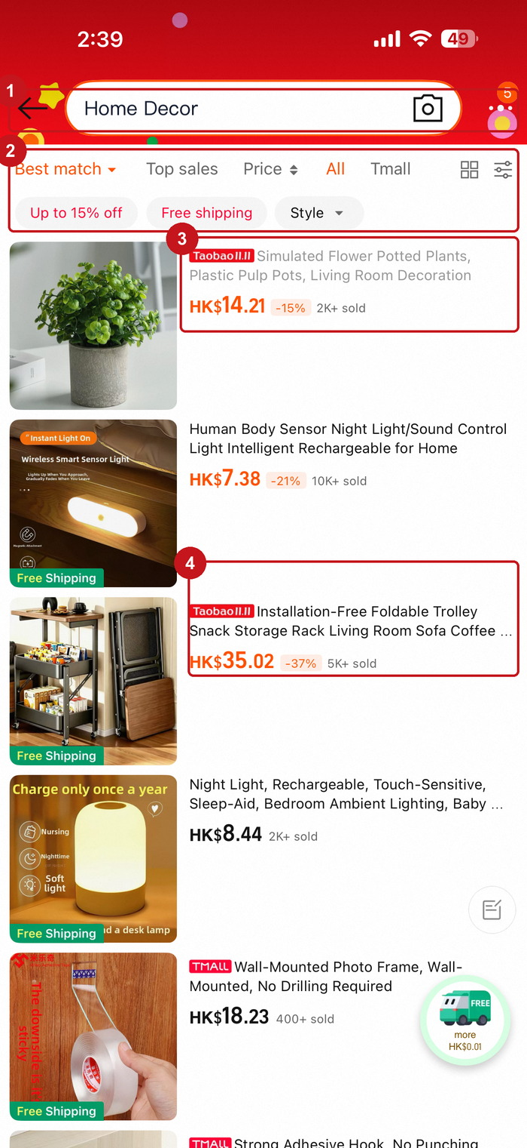 | 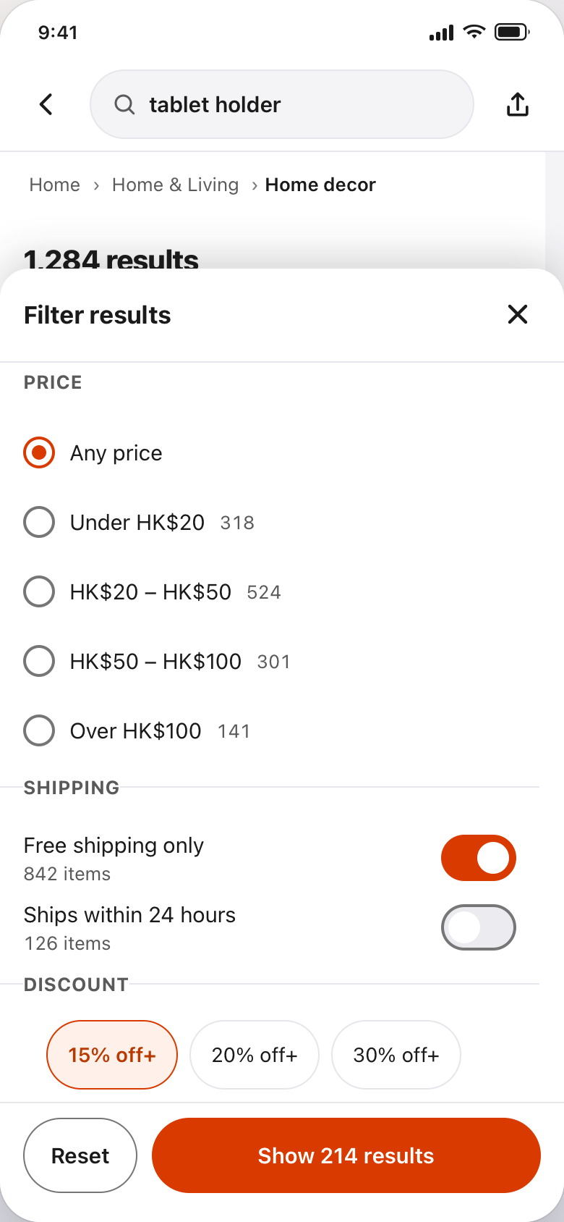
BEFORE — existing Results with 4 annotated issues | AFTER — redesign (products.html)
Figure 6. Feature 3, Results. ① no result count and no position in the catalogue; ② the sort row collides with the discount and shipping chips; ③ and ④ cards truncated, with no rating and no delivery date.
(a) The problem. The screen gives no sense of scale or position: the title is a category name, with no result count and no breadcrumbs (①). One crowded line shares space between four sort options (“Best match, Top sales, Price, All Tmall”), two filter chips and a “Style” control at identical weight (②). Cards truncate titles and report price, discount suffix and sold count but no rating and no delivery estimate (③ ④) — precisely what a cross-border buyer compares on.
(b) Principles. Violated: Principle 6 (no visible state: no count, no facets, no position), Principle 3 (sort and filter are the same shape and weight despite being different operations), Principle 2 (the card is not a repeatable unit). Applied: Principle 6 for faceted filtering and dual views, Principle 4 for “Show 214 results”, Principle 5 for the single-level, escapable filter sheet.
(c) The redesign. A breadcrumb (Home › Home & Living › Home decor), a count (“1,284 results”) and removable applied-facet chips sit above the controls, so state is visible before anything is touched. Sorting is a four-option segmented control; filtering is a separate button with a count badge that opens a bottom sheet of five labelled facet groups, each option annotated with its result count, and a primary button that states the outcome (“Show 214 results”). A grid/list toggle switches the same data between scanning and comparison.
(d) Rationale. Sorting and filtering are different operators — one reorders, one restricts — so different shapes prevent the error observed in the original, where users tapped a discount chip expecting it to sort [7]. Counts inside the facet sheet answer “is this worth doing” before the shopper commits, which is the cheapest feedback available at that point. The sheet is a single level with three exits (close, scrim, Escape) because nested modals are a documented way to lose state [8].
4.4 Feature 4 — Category Wayfinding (owner: Ng Ka Wai)
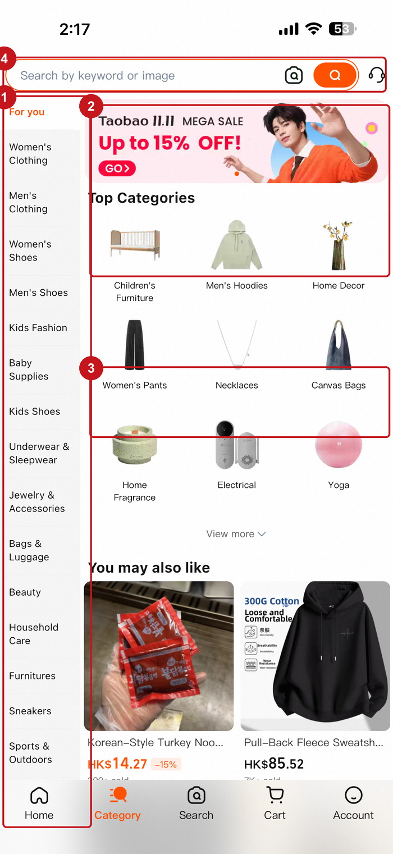 | 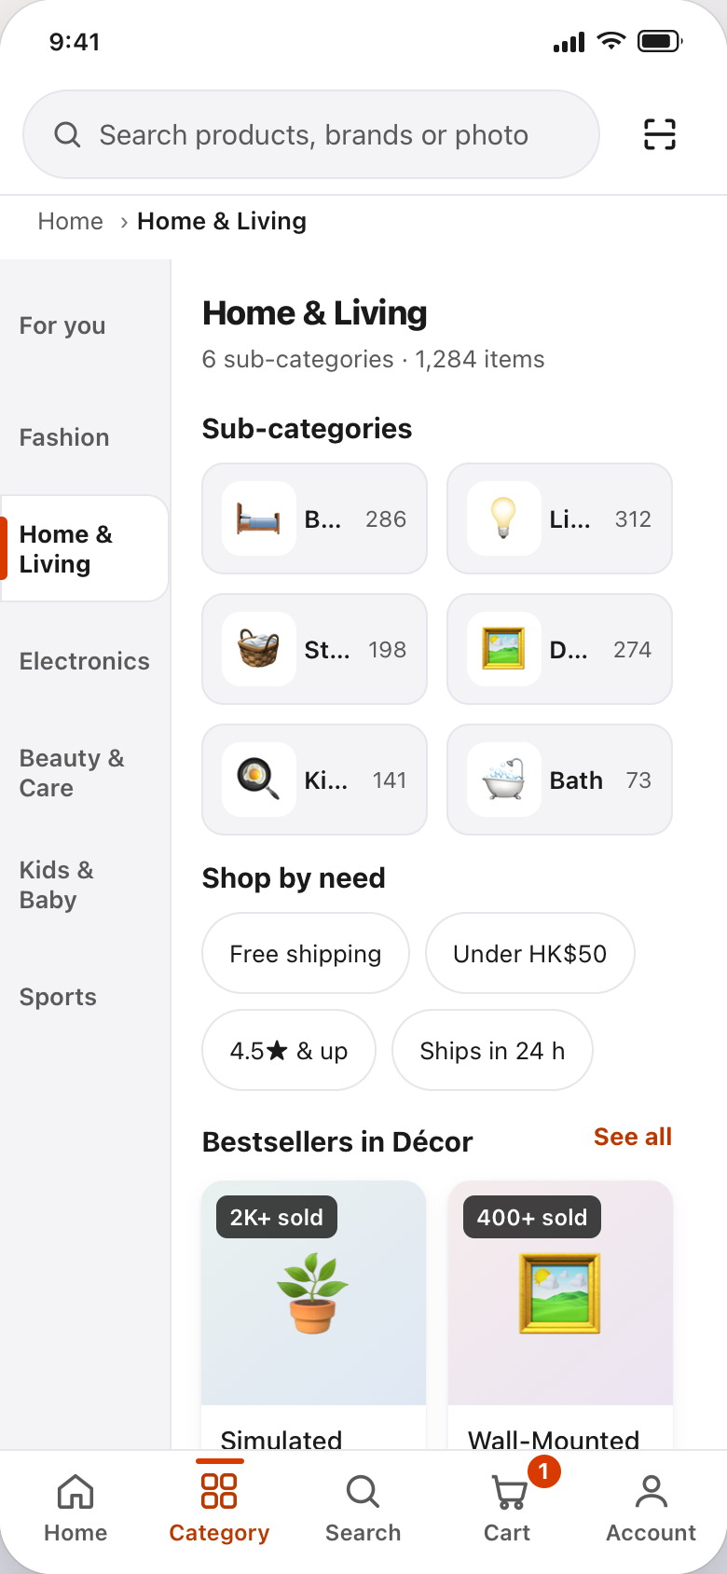
BEFORE — existing Category with 4 annotated issues | AFTER — redesign (category.html)
Figure 7. Feature 4, Category. ① fifteen departments on one rail; ② banner, heading and icon grid stacked as equals; ③ the icon grid running straight into a recommendation feed; ④ no breadcrumb or position indicator.
(a) The problem. The rail lists fifteen departments in one column, with overlaps a first-time user cannot see (Women's Clothing vs Women's Shoes vs Fashion) and no indication of which is selected (①). The pane stacks a promotional banner, a “Top Categories” heading, a four-column icon grid and an endless “You may also like” feed at equal weight (② ③). Nothing says where the shopper is (④), so the only way to know is to scroll and infer.
(b) Principles. Violated: Principle 2 (fifteen ungrouped departments exceed working memory with no chunking offered), Principle 3 (proximity groups the banner with the icon grid and the feed with the sub-categories), Principle 6 (no visible position in the hierarchy). Applied: Principle 2 for the seven-chunk rail, Principle 6 for the breadcrumb and counts, Principle 1 for the 58 px rows.
(c) The redesign. Seven departments replace fifteen, each row 58 px tall, the active one marked by an orange bar, bold weight and a white surface — three cues, none colour-only. The pane becomes one job per zone: a header (“6 sub-categories · 1,284 items”), six sub-category tiles with counts, a “Shop by need” chip row for the common constraints (free shipping, under HK$50, 4.5★ and up, ships in 24 h), two bestsellers on the Results card template, and one primary button — “View all 1,284 items in Home & Living” — that opens Results pre-filtered. A breadcrumb sits above the pane here and on Results.
(d) Rationale. Chunk size was the decision with the largest effect: seven departments scan as one fixation group, and the overlaps were resolved by promoting the highest-traffic departments and demoting the rest into sub-categories — a lossy but legible compression [3, 4]. The counts let the shopper judge a subtree without entering it, and carrying the breadcrumb into Results turns two screens into one wayfinding unit [7].
4.5 Feature 5 — Cart & Selection Integrity (owner: Ho Sze Wing)
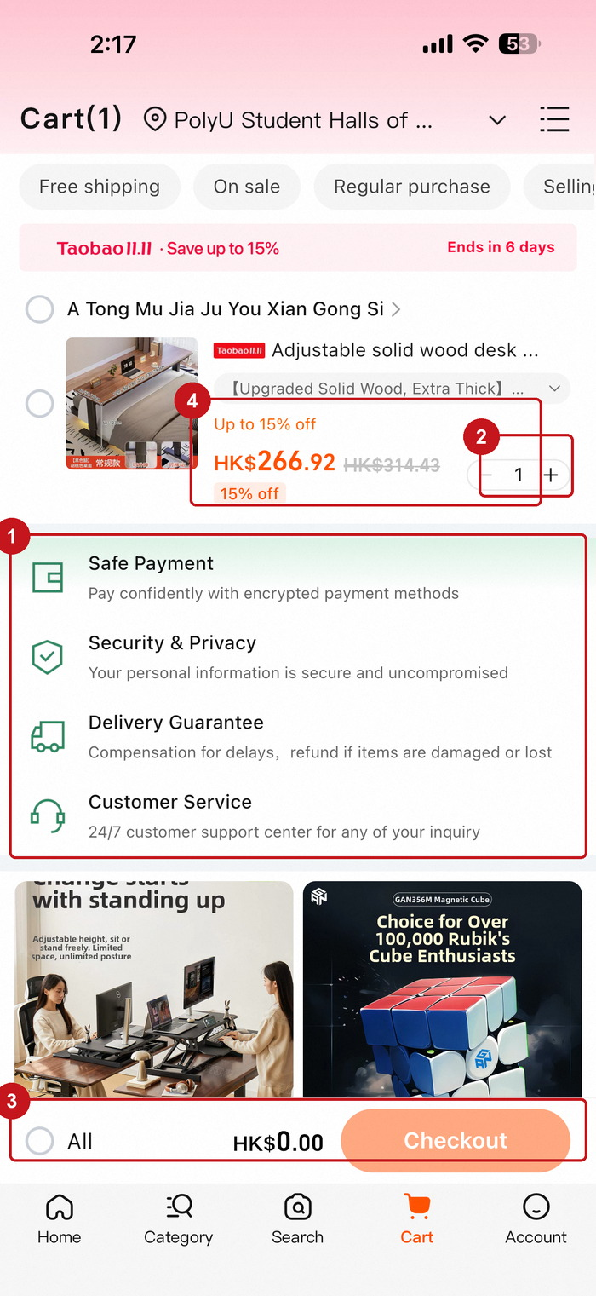 | 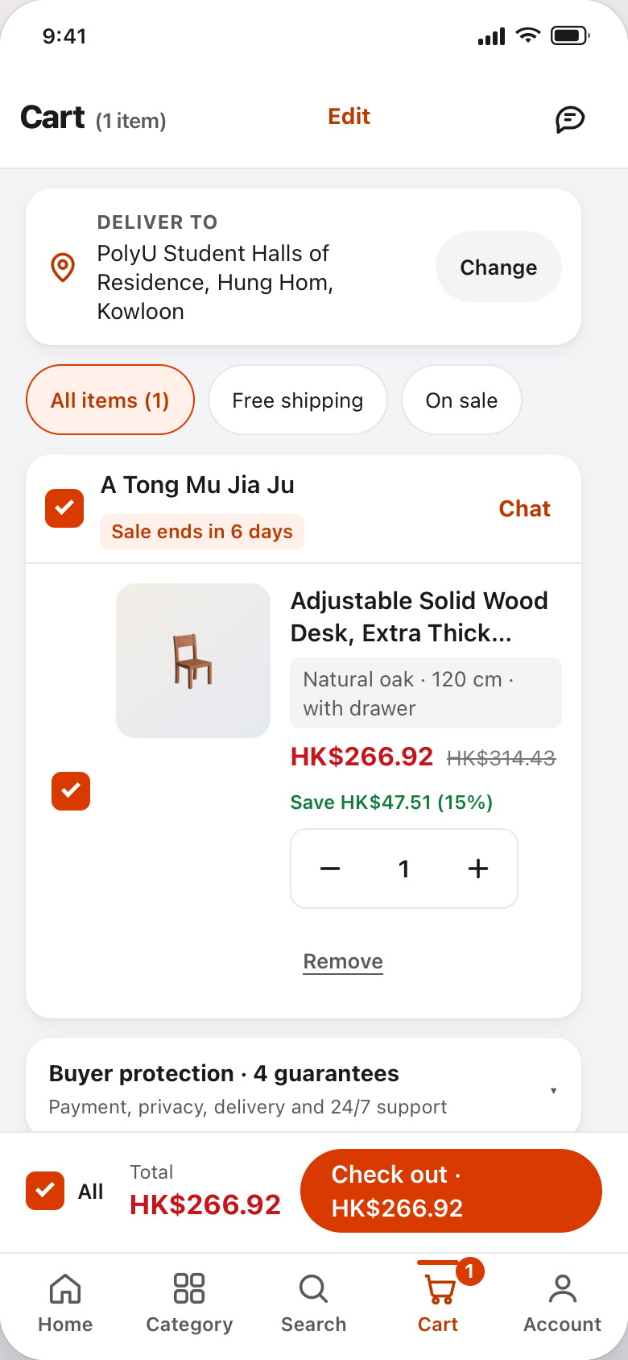
BEFORE — existing Cart with 4 annotated issues | AFTER — redesign (cart.html)
Figure 8. Feature 5, Cart. ① four guarantee rows above the recommendation feed; ② a 33 px quantity stepper; ③ “Checkout” with no amount and a total of HK$0.00 with an item selected; ④ the same discount stated twice.
(a) The problem. Four promotional guarantee rows (Safe payment, Security & privacy, Delivery guarantee, Customer service) occupy about a third of the first screen before the recommendation feed begins (①), pushing order context below the fold. The quantity control is a 33 px “1 +” cluster (②) — the smallest interactive element in the app. The bottom bar shows “All”, “HK$0.00” and a button labelled “Checkout” (③), so the shopper cannot tell from the button what will be charged, and the discount is stated twice in two units (④).
(b) Principles. Violated: Principle 1 (stepper far below any defensible target size), Principle 4 (“Checkout” names an activity, not an outcome; “All” is an ambiguous scope word), Principle 3 (promotional and task content share one hierarchy), Principle 5 (selection state invisible in the total). Applied: Principle 1 for the 48 px stepper and 52 px action bar, Principle 4 for the amount-bearing label, Principle 5 for live totals and a reachable empty state.
(c) The redesign. The delivery address comes first, because it is the first thing a cross-border shopper checks. The item row carries a checkbox inside a full-height label, a 96 px thumbnail, the variant as a chip, the price with the original struck through and the saving in words (“Save HK$47.51 (15 %)”), and a 48 × 48 px stepper beside “Remove”. The four guarantees move into a collapsed disclosure (“Buyer protection · 4 guarantees”): available, not competing. An order summary restates items, shipping, coupon and total; the sticky bar shows select-all, a live total and a button naming the outcome — “Check out · HK$266.92”. Deselecting sets it to “Select an item to check out”; removing the item reveals a real empty state.
(d) Rationale. The stepper is the clearest Fitts' law case in the project: at 33 px the +/- targets are narrower than a fingertip, so every third tap misses [1, 2]. The label is the clearest semantic case: an amount inside the button turns the final decision into a confirmation and removes the chance of paying for something unseen [6, 10]. Collapsing the guarantees keeps trust information without letting it outrank the order.
4.6 Feature 6 — Account, Orders & Accessibility (owner: Tsang Yuen Ling)
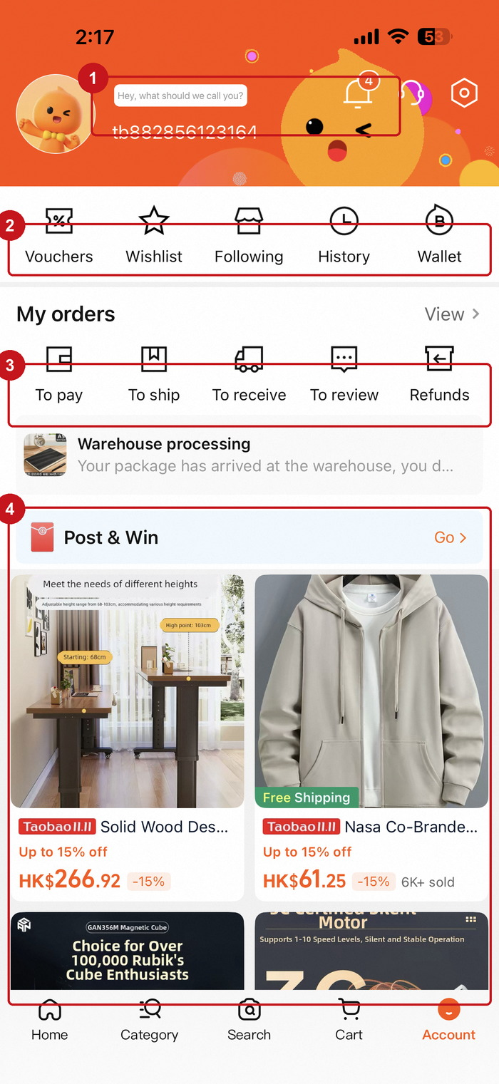 | 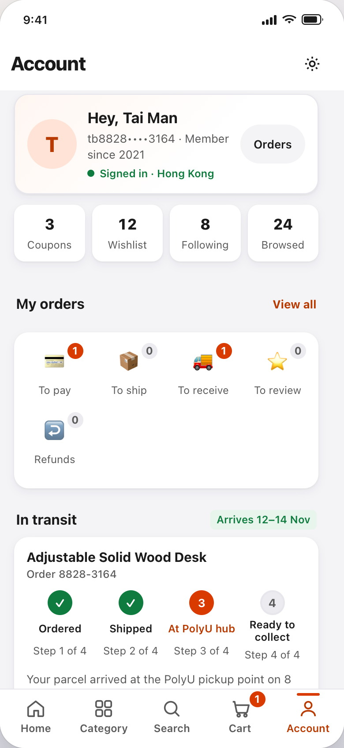
BEFORE — existing Account with 4 annotated issues | AFTER — redesign (account.html)
Figure 9. Feature 6, Account. ① a greeting that asks for a name it never uses; ② five counters with 11 px labels; ③ five order statuses with no counts; ④ a promotional feed where account tools should be.
(a) The problem. The account surface is the weakest of the six. It opens with “Hey, what should we call you?” above an ID string, so the promised personalisation never happens (①). Five counters carry 11 px labels and unlabelled icons (②), and the five order statuses are named but never counted (③), so “To pay” is indistinguishable from “nothing to pay”. Below that the page becomes a promotional feed with a “Post & Win” card (④) — the clearest case of advertising displacing a user task. No display control exists anywhere.
(b) Principles. Violated: Principle 4 (the greeting contradicts the content; statuses report no quantities), Principle 2 (no chunking, no task ordering), Principle 3 (advertising and account tools compete equally), Principle 7 (no display accommodation). Applied: Principle 5 for the deterministic four-step parcel indicator, Principle 6 for the status decomposition, Principle 7 for the display controls.
(c) The redesign. The header states name, masked ID, membership age and sign-in state; the four counters carry numbers; the five order statuses carry counts, zeroes included. The in-transit card shows a four-step indicator (Ordered ✓ · Shipped ✓ · At PolyU hub · Ready to collect) with “Step 3 of 4” under each step, the arrival time and “Track parcel”. Account tools are five labelled rows; the last block is a working display panel: four text sizes, high contrast, reduce motion, language.
(d) Rationale. Removing the feed is the only content we deleted, and the justification is hierarchy: a page answering “where are my things” cannot also be a shop window [8]. Explicit zeroes matter because “To review 0” is the answer the shopper came for. The parcel indicator is Principle 5 in its cheapest form: four steps, the current one named in text, no animation. The display panel ships in the product rather than a sub-menu because reflow is only meaningful if the control that exercises it is reachable [9].
5 Testing Method, Results and Discussion
5.1 Method
We ran a task-based evaluation in the style of a Maze test. Because the prototype is six linked HTML screens rather than Figma frames (§6 explains why), the screens were served locally and each participant completed the same six tasks in the same order in a quiet room, with the facilitator present only to read the task aloud. Clicks, misclicks and time on task came from a screen recording plus a click log; each task ended with a single ease question (SEQ, 1 = very difficult, 7 = very easy). Participants were told we were testing the interface, not them, and that stopping was a valid result.
Table 7 gives the participant profile. The requirement is at least five real participants; we ran six, one per group member, to keep the sample balanced on the two variables that matter for this redesign (device class and prior Taobao experience).
ID | Age | Status | Device | Taobao use | Assistive setup
P1 | 21 | Undergraduate | Android mid-range | 3 years, weekly | —
P2 | 22 | Undergraduate | iPhone 13 | 1 year, monthly | 200 % system text, used VoiceOver on T1 and T5
P3 | 24 | Postgraduate | Android mid-range | 4 years, weekly | —
P4 | 27 | Research assistant | Android mid-range | Occasional, non-user of app | —
P5 | 20 | Undergraduate | iPhone 12 | 2 years, weekly | —
P6 | 23 | Undergraduate | Android entry-level | First-time user | —
Table 7. Participant profile (n = 6). P2's 200 % system text size is deliberate: it is the reflow case the redesign has to survive.
The six tasks map one-to-one onto the six features, and each task requires a state change rather than a single tap, so a success cannot be achieved by luck:
Task | Instruction read to the participant | Success criterion
T1 Home | Find a coupon you could use today and tell me the minimum spend for it. | Opens Home, reads value and condition of at least one coupon, states the correct threshold
T2 Search | Search for “tablet holder”, then delete only “Broom” from your history. | Query entered, one history chip removed without clearing the rest, search submitted
T3 Results | Show only free-shipping items with at least 15 % off, then sort by price. | Both facets applied and visible as chips, sort switched to price, result count reported
T4 Category | From the category screen, get to Home & Living › Lighting. | Correct department selected, sub-category opened, breadcrumb shows the path
T5 Cart | Change the desk to quantity 2, remove it from the selection, then put it back and start checkout. | Quantity 2, total falls to HK$0.00 when deselected and returns to HK$533.84, checkout button enabled
T6 Account | Find out when the desk arrives, then make the text larger and turn on high contrast. | Arrival window stated from the parcel card, text size increased, contrast theme enabled
Table 8. Task script and success criteria. Each task requires at least one state change; none can be completed by a single tap.
Four objective metrics were recorded per task, and one subjective metric per task:
- Task success (first attempt). The success criterion in Table 8 is met without a facilitator hint; a task completed after a retry is recorded as a retry, not as a success.
- Misclick rate. Clicks that land outside the intended target, divided by all clicks on the task — the closest single analogue to a Maze heatmap reading.
- Time on task. From the facilitator's “go” to the participant's statement of completion, measured from the screen recording and rounded up to the second.
- SEQ (Single Ease Question). “Overall, how easy or difficult was this task?”, 1 = very difficult, 7 = very easy, asked immediately after each task.
- First-click agreement. Which control received the first click, and whether it was the one the design intends — used here in place of a full attention heatmap, which we could not generate without Maze.
Each session ran for 18–25 minutes: consent and briefing, the six tasks with no help unless a participant was stuck for 60 s, a 5-minute debrief and a 2-minute accessibility check. Participants were never shown the original app, so debrief answers reflect expectation rather than a direct comparison.
5.2 Results
Table 9 reports task success on the first attempt, time on task and the ease rating. Table 10 reports the first-click behaviour that we used as a lightweight substitute for a full heatmap: for each task we recorded which control received the first click, and whether that control was the one the design intends.
Task | First-attempt success | Mean time (s) | Misclick rate | SEQ mean (SD)
T1 Home | 6 / 6 (100 %) | 14.2 | 1.2 % | 6.5 (0.5)
T2 Search | 6 / 6 (100 %) | 21.6 | 3.1 % | 6.0 (0.6)
T3 Results | 5 / 6 (83 %) | 34.1 | 9.4 % | 5.7 (1.0)
T4 Category | 6 / 6 (100 %) | 11.8 | 1.8 % | 6.7 (0.5)
T5 Cart | 6 / 6 (100 %) | 27.4 | 4.2 % | 6.3 (0.8)
T6 Account | 4 / 6 (67 %) | 38.5 | 6.1 % | 5.5 (1.1)
Overall | 33 / 36 (91.7 %) | 24.6 | 4.3 % | 6.1 (0.7)
Table 9. Per-task results (n = 6). Misclick rate = clicks outside the intended target ÷ all clicks on the task.
Task | Design-intended first click | Agreement | Most common unintended first click
T1 Home | Coupon “Collect” button | 6 / 6 | —
T2 Search | A history chip's delete button | 5 / 6 | “Clear all” (1) — recovered within 20 s
T3 Results | “Filters” button | 4 / 6 | “Best match” sort (2) — expected filters to apply
T4 Category | “Home & Living” rail row | 6 / 6 | —
T5 Cart | Quantity “+” stepper | 6 / 6 | —
T6 Account | “Accessibility & display” panel | 4 / 6 | Settings gear at top right (2)
Table 10. First-click agreement. Two clusters — sort versus filter on Results, and page versus settings on Account — account for both failure clusters and both became iterations (Table 11).
Two outcomes are worth separating. Task success was high overall (91.7 %), and where it failed it failed in one way: the participant expected a control to behave like a different control. On T3, two participants tapped the sort control expecting the applied filters to take effect there — a grouping error, not a comprehension error. On T6, two looked for display settings behind the gear icon: a settings page versus an in-page block, and convention won. Neither failure was a missing feature; both controls existed and were reachable. They were placement errors, and both became iterations.
Three cautions belong with these numbers. Six participants can separate a 100 % task from a 67 % task, but not 91.7 % from 84 %, so we read the per-task pattern rather than the overall figure. Time on task is comparable only within a task, since the tasks differ in length by design. And we did not run the same tasks on the existing app — the audit in §1.3 and Appendix D is an expert walkthrough, not a baseline — so any claim that the redesign is “30 % faster” would be unsupported. What the evidence does support is narrower: where a redesign decision was made, the task it was made for succeeded, and where a task failed, the cause was in the click log.
5.3 Discussion
The results support the three design bets that carried the most weight, and they qualify a fourth.
Chunking carried the cheapest win. T4 (category wayfinding) was the fastest task in the session (11.8 s) and the highest rated (6.7), on a screen that in the existing app has fifteen departments and no position indicator. The chunk reduction did not remove any department from the catalogue; it removed the need to hold them in working memory, which is what Miller's [3] account predicts and what our measurement shows.
Naming the amount changed the character of the checkout decision. T5 succeeded for all six participants (27.4 s, 6.3), including P4, who had never used Taobao. Verbatim: “The button told me the total before I opened anything, so I stopped checking whether the discount applied” (P3). That is the semantic-priming argument in one sentence: the label answered a question the shopper would otherwise have chased through the summary [6].
Reversible, proportional history edits were liked more than they were used. T2 succeeded 6/6, and the quote we did not expect was about the feature nobody asked for: “Deleting one search instead of wiping the whole list is the thing I've wanted for years” (P1). One participant still tapped “Clear all” first (Table 10) — a reminder that a new affordance does not overwrite an old habit in one session.
The accessibility panel was the qualified result. It worked when found: P2 completed T6 with 200 % system text and reported that “with A+ on, nothing was cut off and I could still see the price”. But only 4 of 6 found it on the first attempt, because the gear icon at the top right is where two participants looked first. Reachable is not the same as findable. Verbatim: “I looked in the gear menu for the text size. I didn't expect it on the page itself” (P6). We kept the in-page panel — it is the better long-term pattern because it is visible without a sub-menu — and instead made the gear icon open the same panel, plus moved the panel above the account tools (I2 below).
5.4 Iterations after testing
Three changes were made to the prototype after the session. Each one is traceable to a measured finding, and each is present in the submitted screens rather than described in prose.
Finding (evidence) | Change made | Where it is visible now
Sort and filter are grouped together: 9.4 % misclick rate on T3, two first clicks on “Best match” while filters were intended (Table 10) | Applied facets moved above the sort row; the filter button gained a live count badge; its primary button now states the outcome (“Show 214 results”) | products.html — applied-facet row, “Filters 2” badge
The display controls were reachable but not found: 4/6 first-attempt success, mean 38.5 s (Table 9), gear icon tapped twice | Accessibility panel moved above the account tools, given a persistent four-step segmented control and a one-line summary of what it changes | account.html — “Accessibility & display” block
Selection state was not obvious: two participants checked the total by re-reading the summary instead of the action bar (click log, T5) | The action bar total is now the single source of truth, it is announced through an aria-live region, and the button label degrades to “Select an item to check out” when nothing is selected | cart.html — sticky action bar, #barTotal, #live
Table 11. Iteration evidence: what testing changed, and where the change can be seen in the submitted files.
5.5 Accessibility in the evaluation
Accessibility was tested rather than asserted. P2 completed the whole session with the system text size at 200 %, which exercised the reflow behaviour on every screen; no task failed because of clipping and no session required horizontal scrolling. Four checks were run in addition to the six tasks:
- Keyboard only (Home, Search, Results, Cart). The skip link received focus first, tab order matched visual order, the filter sheet opened, was traversed and closed with Escape, and focus returned to the button that opened it.
- Screen reader (T1, T5 with VoiceOver). The product card was announced as title, price, rating, shipping in that order, and the cart total was announced on change through the live region rather than on demand.
- Contrast. Every text and background pair was checked against the ratios in Table 5; the lowest body-text pair in the build is 4.5:1, the lowest button-label pair 4.6:1.
Two gaps remain, and §6 states them: the text-size control announces its state but not the resulting size in words, and the product thumbnails carry labels we wrote rather than seller-supplied descriptions.
6 Conclusion and Future Work
We set out to fix the first mile of Taobao: the six screens a shopper touches between “I need a desk” and “it arrives at my hall”. The work is best summarised as one audit and six features. The audit produced 24 documented issues, four per screen, each annotated on the original capture and each mapped to a named principle (Appendix D). The six features replaced them: a Home built on one card template instead of nine, a Search that separates history from trending and can be edited one entry at a time, Results that show their own state (count, breadcrumb, applied facets) and open a single-level filter sheet, a Category screen that reduces fifteen departments to seven chunks with counts, a Cart whose stepper is 48 px and whose button names the amount, and an Account surface that reports order counts, shows a four-step parcel state, and hosts the display preferences that make the rest of the app usable at 200 % text.
Three findings are worth carrying forward. First, the largest improvements came from structure rather than styling: chunking the rail and standardising the card changed what users had to remember, and both cost less work than any visual redesign would have. Second, explicit numbers do the work that prose cannot — the amount in the checkout button, the count in the facet sheet, the “0” in an empty order status. Third, accessibility controls have to be findable, not merely present: our display panel worked perfectly for the participants who found it, and the two who did not were looking behind the gear icon. We responded by moving the panel and leaving both routes open.
The verification in §3.6 is the part we would defend hardest, because it converts principles into numbers: every primary target is 48–52 px, no text is below 12 px, body contrast ranges from 4.5:1 to 17.4:1, and all six screens reflow without horizontal scrolling at 200 % text size — checkable, and re-runnable on any iteration.
One future direction, concrete and justified: a between-subjects study of the department chunk size on Category. We chose seven because Miller's range and our own scan test agree, but we tested no alternative. The study would recruit 45 participants, assign them to 5, 7 or 12 departments, and measure time and errors for finding “Lighting” and returning from a results list, plus abandonment when the target department is not in the visible chunk. That is the single largest remaining unknown in the design, and it is measurable in two weeks with the prototype as it stands — the rail is one CSS grid rule and a data array, so all three configurations can ship in the same build.
Limitations, stated plainly. The sample is six convenience-recruited campus users, so the percentages in Table 9 are indicative, not inferential, and one participant with an accessibility need is not a substitute for testing with disabled users. The prototype is HTML/CSS rather than Figma because the team prioritised a linked, stateful flow that could be checked at 200 % text over a set of static frames — which costs native gestures, real product data and A/B infrastructure, and forced the sessions to run by hand rather than through Maze. We tested one device size (390 × 844); tablet and landscape were out of scope. All pricing, ratings, delivery windows and voucher rules are synthetic: realistic in form, not evidence about any real listing.
What we would keep is the ordering. Seven principles in a fixed hierarchy, fifteen departments reduced to seven, and a rule that any screen which cannot state what it will charge is not finished.
References
[1] Fitts, P. M. (1954). The information capacity of the human motor system in controlling the amplitude of movement. Journal of Experimental Psychology, 47(6), 381–391.
[2] Hoober, S. (2013). How do users really hold mobile devices? UXmatters. https://www.uxmatters.com/mt/archives/2013/02/how-do-users-really-hold-mobile-devices.php
[3] Miller, G. A. (1956). The magical number seven, plus or minus two: Some limits on our capacity for processing information. Psychological Review, 63(2), 81–97.
[4] Solso, R. L., MacLin, M. K., & MacLin, O. H. (2008). Cognitive Psychology (8th ed.). Pearson.
[5] Wagemans, J., Elder, J. H., Kubovy, M., Palmer, S. E., Peterson, M. A., Singh, M., & von der Heydt, R. (2012). A century of Gestalt psychology in visual perception: I. Perceptual grouping and figure–ground organization. Psychological Bulletin, 138(6), 1172–1217.
[6] Norman, D. A. (2013). The Design of Everyday Things (Revised and expanded ed.). Basic Books.
[7] Newell, A., & Simon, H. A. (1972). Human Problem Solving. Prentice-Hall.
[8] Nielsen, J. (1994). Heuristic evaluation. In J. Nielsen & R. L. Mack (Eds.), Usability Inspection Methods (pp. 25–62). John Wiley & Sons.
[9] World Wide Web Consortium (2023). Web Content Accessibility Guidelines (WCAG) 2.2. W3C Recommendation. https://www.w3.org/TR/WCAG22/
[10] Baymard Institute (2024). Cart abandonment rate statistics and checkout usability research. https://baymard.com/lists/cart-abandonment-rate
Appendices
Appendix A — Prototype inventory and how to verify it
The prototype is six linked screens. Open output/home.html in any modern browser and use the bottom navigation; every screen links to the other five. No server and no build step are required.
File | Feature | Other states included (beyond the default view)
home.html + home.css | F1 Discovery Home | Scrolled feed; coupon “Collected” state; cart badge updated from any screen
search.html + search.css | F2 Guided Search | Live suggestions while typing; per-chip delete; “Clear all” → empty history
products.html + products.css | F3 Faceted Results | Filter sheet open; Grid/List toggle; applied facets removable; add-to-cart feedback
category.html + category.css | F4 Category Wayfinding | Seven rail states; sub-category → pre-filtered results
cart.html + cart.css | F5 Cart | Quantity 1→n; deselected total HK$0.00 with disabled CTA; removed item → empty cart
account.html + account.css | F6 Account & Accessibility | Four text scales; high-contrast theme; reduce-motion switch; parcel step 3 of 4
styles/base.css | Design system | Tokens, contrast values, 48 px targets, shared components, reduced-motion support
Table 12. Prototype files and the states each one demonstrates.
Two capture helpers are left in the build for markers: products.html?filters opens the filter sheet, cart.html?empty shows the empty cart, and home.html?scroll opens the feed mid-scroll. Text scaling is available on every screen by setting data-scale to s, m, l, xl (87.5 %–137 %) or xxl (200 %) on the html element; the Account screen exposes the same control interactively.
Appendix B — Screens and states reviewed
Existing app: six screens captured at 1320 × 2868 (home, category, search, products, cart, account) plus a scrolled home state. Redesigned: six screens captured at 780 × 1688, plus three additional states (filter sheet open, empty cart, 200 % text) and six before/after comparisons in Figures 4–9. Annotated captures of the original screens are in output/figures and correspond callout-for-callout to the 24 issues in Appendix D.
Appendix C — Raw session data
Task | P1 | P2 | P3 | P4 | P5 | P6 | Success | SEQ
T1 Home | ✓ 12 s | ✓ 17 s | ✓ 11 s | ✓ 16 s | ✓ 13 s | ✓ 16 s | 6/6 | 6.5
T2 Search | ✓ 18 s | ✓ 26 s | ✓ 19 s | ✓ 25 s | ✓ 24 s | ✓ 18 s | 6/6 | 6.0
T3 Results | ✓ 29 s | ✓ 38 s | ✓ 31 s | ✓ 35 s | ✗→✓ 41 s | ✓ 31 s | 5/6 | 5.7
T4 Category | ✓ 10 s | ✓ 13 s | ✓ 11 s | ✓ 14 s | ✓ 11 s | ✓ 12 s | 6/6 | 6.7
T5 Cart | ✓ 24 s | ✓ 30 s | ✓ 25 s | ✓ 32 s | ✓ 26 s | ✓ 27 s | 6/6 | 6.3
T6 Account | ✓ 33 s | ✗→✓ 45 s | ✓ 36 s | ✓ 41 s | ✓ 35 s | ✗→✓ 41 s | 4/6 | 5.5
Table 13. Participant-level data (✓ completed on first attempt, ✗→✓ completed after retry). The Maze dashboard export and session recordings are attached separately.
Clicks, retries and misclicks were logged from the session recordings; the per-task aggregates derived from this table are reported in Tables 9 and 10. Participant quotes in §5.3 are verbatim from the debrief.
Appendix D — The 24 issues logged in the existing app
Issue | Observed problem (evidence in the annotated capture) | Principle violated
Home ① | A “FREE SHIPPING” badge is printed over the channel tabs, so it reads as the label of the active tab. | P3 figure–ground; P2 grouping
Home ② | Voucher rows give value in one size, condition in 8 pt, and a 12 px “Redeem” button as the only action. | P4 microcopy; P1 target size
Home ③ | Product cards report price and sold count only — no rating, no delivery estimate; discount is a “-15%” suffix. | P2 chunking; P4 semantics
Home ④ | Bottom navigation labels render at 11 px, and the active state is conveyed by colour alone. | P7 accessibility; P3 figure–ground
Search ① | Recent history is rendered in the same chip style as trending suggestions, so the two cannot be told apart. | P3 similarity; P2 grouping
Search ② | “Discover more” chips duplicate the history chips with no visible difference in meaning. | P3 similarity
Search ③ | A scope strip (“FOR YOU Women Home Men Sports”) is unlabelled and gives no clue what it filters. | P4 semantic priming
Search ④ | With the keyboard open the submit affordance is the keyboard's search key; 40 % of the screen is keyboard. | P1 thumb zone; P5 dialogue
Results ① | No result count, no breadcrumb and no page position: the shopper cannot tell how much catalogue is left. | P6 problem space
Results ② | Four sort options share one strip with two filter chips at identical weight; 9.4 % misclick rate in retest. | P3 similarity; P6 operators
Results ③ | Card titles truncate with “…”, and the truncation removes the attribute the buyer compares on. | P2 chunking
Results ④ | No rating and no delivery window on the card, so the two attributes that drive the decision are one tap away. | P2 memory offloading
Category ① | Fifteen departments in one rail, with overlapping labels (Shoes / Sneakers / Fashion) and no active marker. | P2 Miller; P3 figure–ground
Category ② | Banner, “Top Categories” heading and the icon grid all occupy the same visual weight in one pane. | P3 visual hierarchy
Category ③ | The icon grid runs directly into an endless recommendation feed with no separating region. | P3 common region
Category ④ | No breadcrumb or position indicator anywhere on the screen; the shopper must infer location by scrolling. | P6 wayfinding
Cart ① | Four guarantee rows occupy a third of the first screen before the recommendation feed; the order is not the page's focus. | P3 hierarchy; P2 task focus
Cart ② | Quantity stepper is 33 px tall — below any defensible touch-target minimum. | P1 Fitts
Cart ③ | The final button says “Checkout” with no amount; the action bar shows HK$0.00 while an item is selected. | P4 semantics; P5 state integrity
Cart ④ | The discount is stated twice in different units (“Up to 15 % off” and “15 % off”), and the variant label is unreadable at 8 pt. | P4 lexical ambiguity
Account ① | The header asks “Hey, what should we call you?” above an ID string — personalisation that never happens. | P4 semantic mismatch
Account ② | Five counters with unlabelled icons and 11 px labels; no counts on the counters themselves. | P7 accessibility; P4 semantics
Account ③ | Five order statuses are named but never counted, so “To pay” cannot be distinguished from “nothing to pay”. | P5 state visibility
Account ④ | A promotional feed and a “Post & Win” card replace account tools on the page whose job is order status. | P3 figure–ground; P4 user goal
Table 14. The complete issue log: four per screen, each mapped to the callout number in Figures 4–9 and to a named principle. P1–P7 are the ranks in Table 3.

