Eigenvalue Results
- Recall the eigenvalue decomposition: If A = V D V⁻¹, where the diagonal entries of the diagonal matrix D are the eigenvalues of A and the columns of V are the eigenvectors of A.
- Defn: A is similar to B if A = S B S⁻¹ for a non-singular matrix S.
- Thm: Similar matrices have the same eigenvalues.
- Thm: If A is symmetric all its eigenvalues are real.
- Thm: If A is symmetric A = V D V⁻¹ = V D V^{T}, where D is diagonal and V is orthogonal. Therefore the eigenvectors of a symmetric matrix are orthogonal.
- Thm: The eigenvectors of a (real) nonsymmetric matrix are real or come in complex conjugate pairs. Ex: 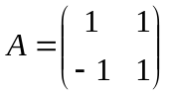 has eigenvalues 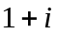 and 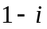.
- Defn: A (real) matrix is normal if A^{T} A = A A^{T}. Note: A symmetric matrix is normal but a normal matrix may not be symmetric. Ex: is not symmetric but is normal.
- Defn: A complex matrix is normal if A^{H}A = A A^{H} where A^{H} = complex conjugate of A^{T}.
- Defn: Q is orthogonal if Q is a real matrix and if Q^{T} Q = I.
- Defn: Q is unitary if Q^{H} Q = I. Note: An orthogonal matrix is nitary but a unitary matrix may not be orthogonal. Ex: 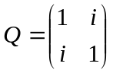 is unitary but not orthogonal. (This Q happens to also be normal.)
- Thm: If A is normal, then A = V D V⁻¹ = V D V^{H} where D is diagonal and V is unitary. Ex: for the normal matrix, A = V D V^{H} with 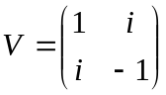, 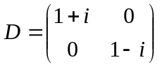.
- Defn: An n by n matrix is defective if it does not have n linearly independent eigenvectors. In this case the eigenvalue decomposition A = V D V⁻¹ with D diagonal and V nonsingular is not possible. Ex: 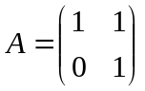 is defective.
- A matrix that is not defective is called diagonalizable. In this case the eigenvalue decomposition A = V D V⁻¹ with D diagonal and V nonsingular always exists.
- Thms: If n by n matrix A has n distinct eigenvalues then it is diagonalizable. If A is normal then it is diagonalizable. If A is symmetric then it is diagonalizable.
- Remark: If A is defective one can decompose A using Jordan form. (However note that Jordan form is not a numerically stable decomposition.)
- Thm: For any matrix A, A can be decomposed into its Schur decomposition A = V T V⁻¹ = V T V^{H} where V is unitary and T is triangular with diag(T) = eigenvalues of A. (This is numerically stable.)
- Accuracy of eigenvalues: Given a matrix  and a nearby matrix 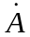 let be an eigenvalue of A and be the eigenvalue of that is closest to . Assume that A is diagonalizable so that A = V D V⁻¹ is possible. Thm: 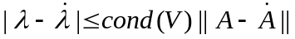
- Remark: If A is symmetric or more generally if A is normal then cond(V) = 1 and eigenvalues can be calculated accurately.
- Remark: If A is far from a symmetric matrix or more generally far from a normal matrix then cond(V) can be large. In this case eigenvalues are difficult to calculate accurately. Ex: 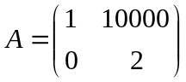 is far from a symmetric matrix. For this matrix the eigenvalue decomposition 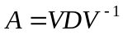 has 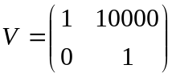 and 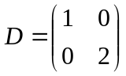 so that the eigenvalues are 1 and 2. Here 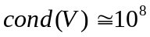 is large and so small inaccuracies in A will lead to large changes in the corresponding eigenvalues. For example 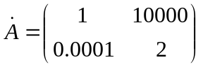is a small change in A and whereas the eigenvalues of are 0.38 and 2.26 which are not close to the eigenvalues of A.
- Remark: The set of eigenvalues of A is called the spectrum of A. For matrices that are far from normal matrices the concept of psuedospectra is important (see http://web.comlab.ox.ac.uk/projects/pseudospectra/ )
- Thm. If Av = v and A^{H} w = conj() w for unit vectors v, w then 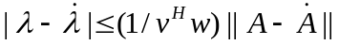. So get larger errors if w (eigenvector of A^{H}) and v (eigenvector of A) are almost orthogonal.

