|  |  |
| --- | --- |
| Input | Output |
| def filehandling():  file = open ("debashish.txt","w+")  while True:  line = raw_input("enter sentence ")  file.write(line)  ch = raw_input ("want to enter more data file (Y/N)")  if ch.upper()== 'N':  break | filehandling()  enter sentence My name is Debashish  want to enter more data file (Y/N) Y  enter sentence The world is a beautiful place to live in  want to enter more data file (Y/N) Y  enter sentence The quick brown fox jumps over the lazy dog  want to enter more data file (Y/N) Y  enter sentence I want to be a nuclear engineer  want to enter more data file (Y/N) N |

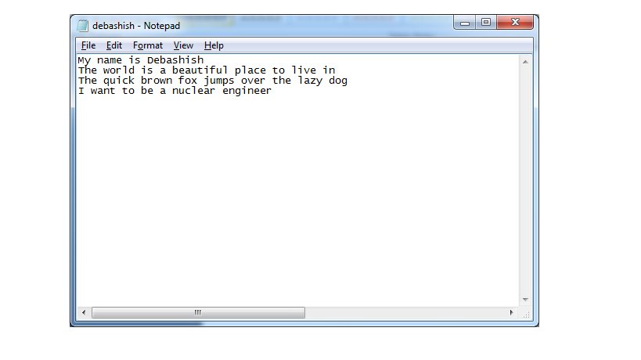

|  |  |
| --- | --- |
| Input | Output |
| def main():  fp=open('debashish.txt','r')  st=fp.read()  print 'The contents of file are-',st  fp.close()  main() | The contents of file are- My name is Debashish  The world is a beautiful place to live in  The quick brown fox jumps over the lazy dog  I want to be a nuclear engineer |
| def main():  fp=open('debashish.txt','r')  n_c,n_w=0,0  nst=''  st=fp.read()  print 'Original string-',st  for i in range(len(st)):  n_c+=1  if st[i]==' ':  n_w+=1  if st[i]=='a' or st[i]=='A':  nst+='#'  else:  nst+=st[i]  print st[i],' ',  print  print 'Number of characters=',n_c  print 'Number of words=',n_w+1  print 'Modified string-',nst  main() | Original string- My name is Debashish  The world is a beautiful place to live in  The quick brown fox jumps over the lazy dog  I want to be a nuclear engineer  M y n a m e i s D e b a s h i s h  T h e w o r l d i s a b e a u t i f u l p l a c e t o l i v e i n  T h e q u i c k b r o w n f o x j u m p s o v e r t h e l a z y d o g  I w a n t t o b e a n u c l e a r e n g i n e e r  Number of characters= 138  Number of words= 26  Modified string- My n#me is Deb#shish  The world is # be#utiful pl#ce to live in  The quick brown fox jumps over the l#zy dog  I w#nt to be # nucle#r engineer |
| def main():  fp=open('debashish.txt','r')  st=fp.read()  st1=st.split(' ')  n1,n2=0,0  for i in range(len(st1)):  if st1[i].lower()=='the':  n1+=1  elif st1[i].lower()=='these':  n2+=1  st2=st.swapcase()  print st1[i],' ',  print  print 'String after swaping case-',st2  print "Number of 'the'-",n1  print "Number of 'these'-",n2  main() | My name is Debashish  The world is a beautiful place to live in  The quick brown fox jumps over the lazy dog  I want to be a nuclear engineer  String after swaping case- mY NAME IS dEBASHISH  tHE WORLD IS A BEAUTIFUL PLACE TO LIVE IN  tHE QUICK BROWN FOX JUMPS OVER THE LAZY DOG  i WANT TO BE A NUCLEAR ENGINEER  Number of 'the'- 1  Number of 'these'- 0 |

|  |  |
| --- | --- |
| Input | Output |
| def main():  ct=0  fp=open('debashish.txt','r')  st=fp.readlines()  for i in range(len(st)):  print st[i]  if st[i][0].lower()=='t':  ct+=1  print 'Number of lines=',len(st)  print "Number of lines starting with 't'=",ct  main() | My name is Debashish  The world is a beautiful place to live in  The quick brown fox jumps over the lazy dog  I want to be a nuclear engineer  Number of lines= 4  Number of lines starting with 't'= 2 |
|  |  |