**False Data Injection Attacks on IoT and Deep Learning-enabled Predictive Analytics**

**Z5364422 | Harrison Faure**

**Abstract**

*This section is the abstract, which should concisely summarise your report including the aim, motivations, methodology and observations (or achievements) and conclusions in a single paragraph. Define all symbols used in the abstract. Do not cite references in the abstract. The abstract should be no more than 400 words in length.*

*The abstract should appear at the beginning of your paper. It should be one paragraph long (not an introduction) and complete in itself (no reference numbers). It should indicate subjects dealt with in the paper and state the objectives of the investigation. Newly observed facts and conclusions of the experiment or argument discussed in the paper must be stated in summary form; readers should not have to read the paper to understand the abstract. The abstract should be bold, indented 3 picas (1/2”) on each side, and separated from the rest of the document by two blank lines. The font used should be Times New Roman, 10-point size, Bold.*

NEEDS TO BE DONE

**Contents**

Table of Contents

I. Introduction 2

**A.** **Industry 4.0, Predictive Maintenance & False Data Injection Attacks** 2

**B.** **Research Focus** 2

**C.** **Expected Outcomes** 3

**D.** **Aim** 3

**E.** **Scope** 3

II. Literature Review 3

**A.** **Industry 4.0** 3

**B.** **Predictive Maintenance** 4

**C.** **Security and Reliability** 5

**D.** **Machine Learning** 5

**E.** **Deep Learning** 6

**F.** **Transformer Models** 7

**G.** **Challenges / Knowledge Gaps** 7

III. Approach 7

**A.** **Overview** 7

**B.** **System Architecture and Model Development** 8

**C.** **Data Collection and Preparation** 8

**D.** **Model Training and Validation** 8

**E.** **Implementation and Performance Evaluation** 8

**F.** **Feedback and iterative improvement** 8

IV. Results 8

V. Conclusion 9

VI. Future Work 9

References 10

**Nomenclature**

|  |  |
| --- | --- |
| Acronym | Expanded Form |
|  |  |
|  |  |
|  |  |
|  |  |

# **Introduction**

This report outlines an approach to using advanced Deep Learning [DL] models within the framework of Industry 4.0 to develop a Predictive Maintenance [PdM] system. The report utilises the C-MAPSS dataset provided by NASA to predict the Remaining Useful Life [RUL] of a turbofan engine, which will increase reliability and enhance operational efficiency across different industrial applications.

PdM systems are important applications within the shift towards Industry 4.0 [I4], as industries seek to increase automation and efficiency. Robust and accurate PdM systems are a catalyst within this shift as well as the increase of IoT devices comes with the potential for cyber security vulnerabilities [1]. The need to safeguard the integrity of these PdM systems is of increasing priority.

## **Industry 4.0, Predictive Maintenance & False Data Injection Attacks**

The fourth revolution in manufacturing and industry is characterized using a combination of technologies that blur the lines between physical, biological, and digital spheres. The creation of smart factories is facilitated by advanced communication and information technologies, including cyber-physical systems, The Internet of Things [IoT], cloud computing and big data analytics. Real-time data collection and analysis is achieved through the integration of these technologies, which enables enhanced connectivity and automation in the manufacturing process. [1]

PdM uses data analysis tools and techniques to predict equipment failures before they occur and detect anomalies, making it an advanced strategy for maintenance. PdM is data-driven and condition-based, which minimizes unplanned downtime, reduces maintenance costs, extends equipment life, and increases operational efficiency. PdM systems have been enhanced by using DL models such as Gated Recurrent Units [GRU], Long Short-Term Memory [LSTM], Recurrent Neural Networks [RNN], and Convolutional Neural Networks [CNN] to model complex patterns in real-time and historical data as well as transformer models [2].

PdM is a component of advanced analytics and IoT technology designed to optimize and automate maintenance processes. There should be seamless integration between IoT devices and PdM structures, allowing for real-time health assessment and risk management for certain industrial assets.

Having devices connected to the IoT exposes industrial networks to a variety of cybersecurity attacks. For this specific report, the focus is on False Data Injection Attacks [FDIA], which involve the injection of malicious data that is erroneous into the system. These attacks can lead to incorrect decision-making and predictions. FDIA attacks can take the form of intermitted attacks, which may sporadically introduce outliers to disrupt system operations, or continuous attacks, which aim to mimic degradation patterns in the equipment attempting to disrupt the system over time whilst remaining realistic [5]. Maintaining the reliability of PdM systems will involve mitigating and understanding the risks of FDIA attacks as well as developing the DL models to be capable of countering and detecting these attacks.

## **Research Focus**

The project focuses on researching, evaluating, and refining the application of DL models selected based on their proven capabilities in handling time series and sequential data to predict the RUL of a NASA turbofan.

In addition to the research project, transformer architecture utilizes self-attention mechanisms to directly link all points in a sequence. This improves and offers better performance in situations where long-range dependencies are of high importance. Handling sequential data without the need for a recurrent structure could provide substantial improvement in how PdM tasks are approached in the future.

The primary objectives of the research task are to:

1. Implement the following DL models – LSTM, GRU, CNN, RNN, and Transformer models.

2. Utilise the implementation to predict the RUL of the NASA Turbofan from the CMAPSS data.

3. Evaluate the of the models during different FDIA scenarios

4. Experiment with different combinations of processing algorithms and input data to further increase the efficiency of the DL models

## **Expected Outcomes**

The research project should provide contributions to the field of PdM by creating advancements in the application of DL technologies in industrial settings. The project will also cover the potential issue of cybersecurity vulnerabilities in PdM systems by investigating FDIA. The study will increase understanding of the fortification against such attacks and their impact on the integrity and predictions of predictive models. The relevance of this aspect is high given the drastic increase in the integration of IoT devices in industrial settings, which comes with a heightened risk of vulnerabilities.

The research project is anticipated to produce a PdM framework that is more robust, secure, and accurate. The results and produced work should minimize downtime and increase operational efficiency while reducing maintenance costs. This may directly impact the profitability and sustainability of heavy machine-based industries as the PdM systems lead to more reliable decision-making.

## **Aim**

The aim of this project is to predict RUL by developing and evaluating advanced DL models and utilising NASA’s CMAPSS dataset. The project will utilise and investigate the integration of transformer architecture, LSTM, GRU, CNN, as well as hybrid deep learning models to enhance the effectiveness and overall efficiency of PdM systems. The project will observe the impact of FDIA on the predictive accuracy of the models, therefore aiming to establish robust DL methods that, under various cyber threat scenarios, maintain high predictive accuracy. On top of this, the project aims to refine training processes and contribute new insights to the field of PdM.

## **Scope**

The research project explores the implementation of advanced DL algorithms to predict RUL using sensor data. The dataset utilised is the NASA C-MAPSS dataset, which stores sensor data for a turbofan. LSTM and GRU implementations are used to investigate the efficiency of long-term dependencies, and CNN are used to process time series data. Hybrid Deep Learning [HDL] models such as CNN-LSTM are also investigated to see if the RUL prediction is augmented by capturing special and temporal data dependencies. Transformer models have also been implemented to provide a broad spectrum of different RUL predictions to test factors such as robustness as well as the transformers’ ability to handle sequential data effectively.

The focus on FDIA will investigate cybersecurity vulnerabilities within ‘Internet of Things’ [IoT] devices and the DL architectures mentioned when utilised in PdM. FDIA attacks have the potential to skew RUL, and machinery health predictions and both continuous attack and interim attack scenarios are within the scope of the research project. Comparison of the performance of the DL models under normal conditions and after FDIA attacks focussing on resilience to the FDIA attacks and overall robustness – maintaining accuracy in different scenarios

The research will help propose new DL techniques or improvements to existing techniques that enhance resilience to cyber-attacks without decreasing the overall predictive accuracy.

# **Literature Review**

The literature review will build on the preliminary concepts introduced earlier as well as examine current and past literature to establish a knowledge base supporting PdM within Industry 4.0. The review will support understanding the current technologies, and therefore, the contributions of this research will fit.

The gaps in the current research are outlined by examining existing literature from a broad range of sources. A comprehensive view will be formulated from the academic literature to support the progression of this research, guiding the research's direction and outlining the significance of the proposed enhancements.

## **Industry 4.0**

1. Overview:

Industry 4.0 is a pivot in industrial production that is pioneered by the integration of digital technologies into manufacturing environments [1]. Evaluate the transformation brought about by the deployment of IoT devices, aiming to facilitate data generation and connectivity. This revolutionises 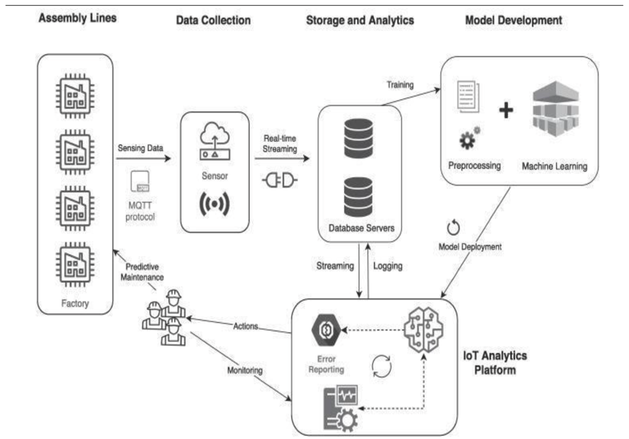industry practices by enhancing operational efficiency and decision-making through real-time data insights. These advancements have created a new era of data generation and interconnected devices enhancing decision-making through data analysis [7].

1. Evolution:

Industry 4.0 has evolved since being brought forward and is closely linked with the advancement and integration of IoT devices across different industries [1]. outlines the rapid advancement of IoT devices to lead significant changes and offer new opportunities with innovative system reliability and maintenance approaches. Industry 4.0 via IoT devices has become an integral part of various industries such as smart cities, healthcare, manufacturing, and transportation [7].

1. Core Technologies:

[1] outlines the two core technologies within Industry 4.0, DL, Time Series Analysis [TSA], Neural Networks [NN], and Machine Learning [ML], describing how IoT devices generate large amounts of sensor data. This data is then analysed through TSA and DL for PdM to prevent unexpected failures and optimize system performance [8], demonstrating how NN and ML techniques such as LSTM have been utilized within Industry 4.0 and are effective at ensuring proactive system maintenance.

1. Manufacturing Impact

Reliability and efficiency of operations have a large impact on manufacturing that is brought forward by Industry 4.0. The approach outlined in Industry 4.0 helps to decrease maintenance costs pre-emptively by predicting and fixing potential problems before they occur [1].

## **Predictive Maintenance**

1. Overview

PdM enhances the efficiency and maintenance of IoT devices leveraging TSA and DL. [1] explains that different data types such as sensor data, error logs, and historical maintenance records can be used within PdM to help optimize resource utilization aiming to reduce maintenance downtime. Generally, this approach will involve data pre-processing to extract features, normalize, and clean the data.

1. Contextual importance

PdM addresses the need for an innovative approach to maintenance by increasing the uninterrupted functionality of IoT devices whilst increasing their reliability [1]. PdM aims to maximise the potential benefits of the interconnected IoT devices within different industries through predicted interventions that minimise downtime and maximise productivity. [8] emphasizes the performance of LSTM in handling time series data, which is directly applicable to PdM problems within the Industry 4.0 setting. Using advanced algorithms (such as OC-SVM and SVDD), the accuracy of anomaly detection can be improved, which is critical to effective PdM [21, 33].

1. Foundations

PdM uses DL and TSA to determine temporal patterns of which decomposition (time series) and statistical analysis can be used to identify trends. [1] identifies commonly used deep learning models such as RNN and LSTM which are used to predict maintenance needs based on historical data. LTSM are powerful dynamic classifiers that approach problems related to vanishing gradients to ensure more reliable and consistent performance. [2] Transformer-based models can also be utilised within PdM leveraging DL to increase reliability. Transformer models can provide a different approach to PdM using positional encoding to handle time series data. [14] These models will identify complex patterns and relationships from time-series data for an integrated approach to anticipating maintenance. [1, 29] The accuracy of the PdM system model is determined after training the model, where the test samples are used as inputs to the models, and the network will then compare the reconstructed values against the input values. From these comparative statistics, such as R squared, the accuracy rate is obtained from an average calculation of the mean error squared values [12].

## **Security and Reliability**

1. Cyber-security concerns

[5] Highlights the susceptibility of IoT PdM systems to cyber-attacks focussing on FDIA. The vulnerability of PdM systems to FDIA is critical as they directly impact the reliability and accuracy of predictive capabilities, leading to potential catastrophic consequences. [6] notes that the community has addressed the potential concerns by developing CPS [cyber-physical systems] which utilize DL within the IoT. Another security concern highlighted in [27] alongside the timing attacks is the threat of chronological data patterns, which can be exploited to reverse engineer encryption.

1. Management Strategies

Statistical and hybrid approaches are methods that can be employed to counteract these attacks, which use anomaly detection and behaviour analysis to spot inconsistencies and data analysis. [5,25] Strategies include a feedback design that is preventative against denial-of-service attacks [DOS] and FDIA attacks are explored in [6], demonstrating how both ‘active’ and ‘passive’ defence systems are vital. [10] also states that “Extensive research has been performed on the detection and mitigation of FDI attacks in cyber-physical systems (CPS) domain. Unfortunately, the effect of FDIA on a PdM system is yet not explored.”

1. Reliability

FDIA attacks threaten the reliability and accuracy of PdM systems by the introduction of these errors, which mimic normal sensor input and are, therefore, hard to detect. This puts emphasis on the robustness of the countermeasures needed in these PdM models [5]. FDIA attacks are subtler than DOS attacks and are, therefore, more difficult to detect, requiring advanced detection mechanisms [6]. Data integrity is crucial for the reliability of ML models as the compromised data can lead to erroneous predictions [27]. It is important to combat these cyber-attacks with a resilient cyber strategy that is dynamic and incorporates continuous adjustment to technical measures and new threats. [22]

## **Machine Learning**

1. Fundamentals

ML algorithms are used in the context of Industry 4.0 and PdM to predict part and equipment failures through sensor data analysis. DL is categorized as an ML algorithm, and the fundamental advantage of the pair is its ability to handle and learn from large amounts of data. This is done with the intention of making accurate predictions surrounding system failures, which enables proactive management strategies. [3] In PdM, ML focuses on data-driven methods that handle the multivariate nature of data collected in condition-based maintenance. [11] investigates DL models such as RNNs and determines that they excel in their ability to extract features and predict trends automatically from the data. [9] discusses the fundamental applications of RNNs – LSTM and GRU designed for handling time series data, giving insights on the fundamentals of machine learning and the ability to handle the sequential nature of data without reducing the dimensionality.

1. Advantages

Traditional approaches before Industry 4.0 have struggled for decades, and ML has provided a clear advantage in the context of predictive maintenance. ML Algorithms offer reduced downtime through their greater data handling capabilities as well as a greater ability to predict system behaviour early, providing warnings before catastrophic damage. [3] The ability of RNNs to detect subtle anomalies that traditional methods may miss is found to be an advantage in [9] of ML approaches to PdM. The capability of RNNs and LSTMs is an advantage where the behaviour of the machinery can have significant variety, making DL models and, by extension, an ML approach far superior to traditional methods.

## **Deep Learning**

1. Definition

DL falls under the categorization of ML algorithms and utilizes multi-layer neural networks to learn from large amounts of data. DL networks are “capable of learning rich and complex representations of data, which are used for a variety of predictive tasks” [3]. DL's advantage is that it can automatically discover the representations needed for the classification of raw data or feature detection, reducing manual feature extraction or eliminating it entirely [3].

1. RNN

RNNs or recurrent neural networks involve connections between nodes that, within a temporal sequence, form a direct graph. RNNs will display dynamic behaviour, unlike feed-forward neural networks, and use their internal memory to process sequences of inputs, making them desirable for anomaly detection where the order of the data points is important [3]. RNN-based methods may generally draw components from LSTM and GRU to help analyse signal data sequences emphasizing the importance of LSTM within PdM [11]. Handling dynamic and complex fault detection scenarios was demonstrated to be an advantage of RNNs in [19], which are common in PdM scenarios.

1. CNN

Convolutional neural networks use the mathematical operator, ‘convolution’ to capture spatial hierarchies in data and apply filters that produce feature maps. In doing so, CNNs become highly effective at the recognition of objects in visual contexts and for processing data that has a known topology. [3] The use of CNNs to analyse time series data is highlighted in [11] by extracting spatial hierarchies, making CNNs suitable for PdM approaches where sensor data is utilised. [24] compared CNN’s fault detection capabilities and indicated that CNNs are important for data analysis and processing in PdM tasks.

1. LSTM

The long short-term memory approach is an extension of RNNs used to avoid long-term dependency problems, making them effective on data with long intervals and delays. LSTMs have greater use in problems involving the prediction of outcomes for sequential data as they solve the vanishing gradient problem, which is prevalent in RNNs. [3] The gradient problem is defined as “A condition where the gradient of the loss function shrinks exponentially as it is backpropagated through the network’s layers during training”. One of the most powerful hybrid models is the RNN [LSTM-RNN], which is a powerful hybrid classifier for handling time series data. LTSM-RNN is effective in PdM situations as it efficiently handles pattern recognition over time [2]. This hybrid was developed as RNN is ineffective with the vanishing gradient problem, and LSTMs help take the long-term dependencies into account [4].

1. GRU

Gated recurrent units are highly efficient in handling sequential data under constant monitoring conditions. They also address the vanishing gradient problem but with a simpler design that uses an ‘update gate’ rather than ‘forget and input gates’ which helps to capture dependencies. [11] notes that GRUs are known to be more robust whilst learning complex temporal dynamics, which makes them desirable for PdM tasks and forecasting [11]. GRU applications are found to be advantageous in applications that involve constant monitoring and prediction of system states, making them useful in PdM applications where long-term data trends are the focus [24].

1. Applications

DL algorithms are applicable to PdM tasks as high-dimensional sensor data is utilised to determine anomalies, trends, and/or predict failure. These DL models are useful to process and learn from complex datasets with minimal manual intervention and minimal pre-processing [3]. NASA’s C-MAPSS dataset was utilised within [10] for predicting RUL using GRU, CNN, and LSTM and found that GRU-based PdM models consistently out-perform some recent literature on RUL prediction. [10,17] “The practical applications of neural networks has been shown to effectively handle the detection of faults and service time of mechanical hardware” [16], which specifically references CNN and RNN implementations within mechanical systems operations.

1. Hybrid Learning Models

[20] demonstrates the applications of a couple of hybrid DL models such as GRU-LSTM parallel and CNN-LSTM, and it was found that GRU-LSTM obtained the lowest RMSE whilst CNN-LSTM had the best computational efficiency.

## **Transformer Models**

1. Overview

Transformers are. generally used for natural language processing [NPL] and computer vision and are used in many time series analysis applications [27]. Transformers can have the ability to model long-term and short-term behaviours simultaneously which is a unique capability that may be applicable to PdM systems. [34]

1. Transformer Architecture

Default transformer architecture contains encoder and decoder layers utilising a sequence-to-sequence model that uses an encode-decoder configuration designed to learn to encode the source in a fixed-length representation [27, 13]. Both the encoders and decoders are composed of multiple identical blocks to help with modelling [32]. This is done because the length of the two sequences is not necessarily the same size, aiming to decode the target sequence in an ‘auto-regressive’ manner [27, 28]. It was found in [34] that transformers can be used to reduce the error in accumulation during forecasting, leading to greater efficiency and reducing errors over long forecast horizons. [34] states that “Transformers can use a mechanism with a mask to ensure consistent behaviour during training and forecasting” establishing how transformers use sequential data to maintain accuracy.

1. Application

Transformer applications have improved long-term and multivariate time series forecasting, and their effectiveness on complex forecasting tasks has greatly approved the approach [27]. Different transformer approaches are used for different applications – the Informer achieves O(LlogL) in time complexity and memory usage and is shown to be effective in Long-Sequence Time-Series Forecasting [LSTF] applications [36]. In [15], a probabilistic transformer model that utilises state space models was implemented within a fault detection environment to handle uncertainty and was shown to be effective within the study. For network modifications at both high (architecture) and low level (module), the overarching aim is to improve the overall performance of time series modelling [32].

1. Informer Transformers

The Informer approach is particularly advantageous for long-range dependencies with long sequential inputs. The Informer will utilise a self-attention mechanism to significantly reduce memory utilisation and computation power needed. [36] used an informer transformer in a PdM system that used a generative style decoder to take a long sequential output using only one forward step – this avoided excessive error spreading during the inference phase.

## **Challenges / Knowledge Gaps**

1. Current Limitations

Despite advancements in IoT and DL technologies, FDIA remains a prevalent form of cyber-attack that is a significant challenge to overcome [27]. PdM systems remain vulnerable as FDIA attacks directly impact the reliability of the predictive capabilities, leading to poor performance and faulty components [27]. As per [10], the effect of FDIA on PdM systems has not yet been explored and is a limitation of the current research. This is due to FDIA attacks being a subtler form of cyber-attack and requiring advanced detection mechanisms.

1. Emerging Technologies

Current research demonstrates the use of advanced DL models such as CNN, GRU, and LSTM in improving the reliability of PdM systems but does not fully explore other potential models, such as transformers and RNN, in the context of PdM and FDIA [24]. Therefore, the development of more robust cybersecurity measures for IoT-based PdM systems is necessary to safeguard against increasingly sophisticated FDIA attacks [25].

1. Future trends

The integration of IoT devices and AI-powered learning algorithms will create PdM systems that are highly adaptive to operational changes and the environment they exist in, as well as secure these devices [33].

# **Approach**

## **Overview**

This section addresses the methodology and reasoning behind how the approach to this research is structured and builds on the foundational concepts addressed in the literature review. This section will delineate the steps taken to achieve the research objectives – the development and evaluation of the machine learning models for predicting RUL under different scenarios. There is a direct connection between the gaps identified in current research in the literature review, which are used to inform where the research will collect results. The approach is structured broadly with the following steps:

1. Model selection and training – As of the interim report, basic forms of this have been completed and are included in the results.  
2. Data preparation.  
3. Implementation of advanced models.  
4. FDIA attack simulation.  
5. Performance evaluation.  
6. Iterative improvement and feedback.  
7. Drafting recommendations and framework.

## **System Architecture and Model Development**

The selected models include CNN, RNN, LSTM, GRU, and Transformers (Informer as of interim report) based on their proven capabilities in handling time series data. CNNs are used for extracting spatial hierarchies, LSTM and GRU are used for comparisons in handling long-term dependencies, and transformers are used for handling long-range interactions without constant recurrence [10,13].

## **Data Collection and Preparation**

The multivariate time series input data is taken from the NASA C-MAPSS, which includes various sensor data and operational settings from a NASA turbofan engine with the intention of predicting the RUL of this engine. Normalization, feature engineering, and handling of missing values are the main components of the data pre-processing, which will prepare the dataset for efficient learning from the neural networks.

## **Model Training and Validation**

The architectures will be configured to the strengths of each approach used for sequence prediction tasks, which will involve tuning layers, parameters and units to balance performance and complexity. A backpropagation algorithm will then be utilised to train the models effectively using drop-batch normalization or a similar technique. The models will then be tested and compared using subsets of the data to demonstrate their generalization capabilities and predictive accuracy.

## **Implementation and Performance Evaluation**

The models will be simulated under various normal operation environments as well as various simulated FDIA attack scenarios to test their feasibility and robustness in real-world PdM systems. The evaluation metrics include RMSE – root mean squared error, MSE – mean squared error, and accuracy to RUL. There will also be a resilience test to FDIA situations for robustness comparison. There will be a need to benchmark against available results from other studies to identify performance gaps for improvement.

## **Feedback and iterative improvement**

Optimization and refinement of the algorithms used is the focus of the feedback stage, and the final implementation should show evidence of iteration. From the results, the aim is to produce some recommendations for enhancing PdM systems and the potential for drafting a preliminary cyber security framework. This framework would focus on FDIA in PdM systems for use in Industry 4.0 scenarios. This targets the “critical need for security in IoT-enabled predictive maintenance systems” [27].

# **Results**

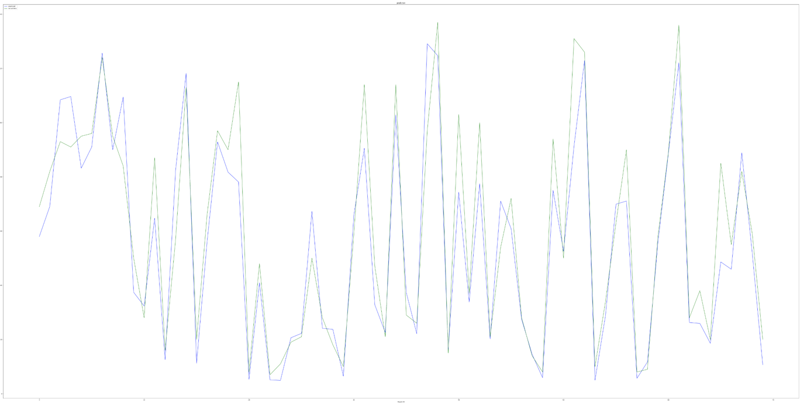

Cnn results – I am well aware that this graph is garbage and will need to be fixed before submission.

I am planning to have  
  
LSTM Results

GRU Results

# **Conclusion**

*The conclusions should summarise the main findings of your thesis project including a brief reference to the supporting evidence and to the initial aims. Note that the Conclusions and Recommendations sections are the last sections of the paper that should be numbered. The acknowledgements and references should be listed without numbers.*

NEEDS TO BE DONE

# **Future Work**

*This section should discuss and recommend directions for future work that will build on and extend your research and perhaps resolve some of the issues that you have encountered in your work.*

WHAT NEEDS TO BE DONE

EXTENSIONS

Integration of Real-Time Data Simulation: Consider incorporating a real-time data simulation to continuously test the models beyond the initial dataset. This could provide deeper insights into the models' performance in real-world scenarios.

Cross-Validation with External Datasets: To enhance the validity of the results, cross-validate the findings with external datasets from similar industrial applications. This would help generalise the results across different types of machinery and conditions.

Advanced Anomaly Detection Techniques: Implement more sophisticated anomaly detection techniques that can dynamically adapt to new types of cyber threats, thereby improving the models' resilience to FDIA.

Comparative Analysis of Additional DL Models:

- Transformer models or attention mechanisms. This could provide insights into even more effective or efficient predictive models.

Dataset Enrichment:

- Enhance the C-MAPSS dataset with additional data sources, including real-world operational data from different machinery or environments, to test the models' generalizability and robustness across various scenarios. For example, there is increasing interest in health monitoring data on batteries, wind turbines, and other critical assets.

Preliminary Cybersecurity Framework Development:

- Draft a cybersecurity framework tailored explicitly for PdM systems in IoT environments.

- Identifying key vulnerabilities

- Proposing data integrity verification mechanisms

- Developing preliminary guidelines for secure data transmission and processing.

Advanced FDIA Simulation and Resilience Testing:

- Sophisticated attack patterns that mimic real-world cyber threats more closely.

Integration of Anomaly Detection Techniques:

- Incorporate anomaly detection techniques to identify unusual data patterns that could indicate a cyber-attack.

# **References**

1. Advanced Deep Learning Techniques in Industry 4.0 Applications
2. Predictive Maintenance Strategies with Deep Learning Models
3. Utilizing NASA's C-MAPSS Dataset for Predictive Maintenance in Aerospace
4. Deep Learning for RUL Prediction: Models and Applications
5. Cybersecurity Challenges in Predictive Maintenance Systems
6. Securing IoT Devices in Industry 4.0: Challenges and Solutions
7. Machine Learning Innovations in Industry 4.0
8. Trends in Industrial Automation and Predictive Maintenance
9. The Role of Data Analytics in Predictive Maintenance
10. Evaluating Machine Learning Algorithms for Industrial Applications
11. Implementation of LSTM and GRU Networks for Predictive Maintenance
12. Hybrid Deep Learning Models for Real-Time Predictive Systems
13. Transformers in Predictive Maintenance: A New Approach
14. Impact of IoT Integration on Predictive Maintenance Effectiveness
15. Machine Learning Techniques for Fault Prediction
16. Deep Learning Applications in Mechanical Systems Monitoring
17. Utilization of Convolutional Neural Networks in Industrial Settings
18. Predictive Maintenance Techniques Using Hybrid Models
19. Role of Artificial Intelligence in Modern Manufacturing
20. Challenges in Implementing Deep Learning Solutions in Industry
21. Effectiveness of Predictive Maintenance in Reducing Downtime
22. Comparative Study of Predictive Algorithms in Industry
23. Advancements in Sensor Technology for Predictive Maintenance
24. Application of Transformers for Time Series Analysis in Industry
25. IoT Security Measures in Predictive Maintenance Frameworks
26. Deep Learning Models: From Theory to Industrial Implementation
27. Strategies for Enhancing Cybersecurity in Predictive Systems
28. Overview of False Data Injection Attacks and Their Mitigation
29. Technological Innovations in Predictive Maintenance
30. Predictive Maintenance in the Aerospace Sector
31. Challenges of Data Management in Industrial Predictive Maintenance
32. Deep Learning for Predicting Machinery Failure
33. Integration of Predictive Maintenance into Industry 4.0 Systems
34. Developing Robust Machine Learning Models for Industry Applications
35. Artificial Intelligence in Industrial Predictive Maintenance
36. Cybersecurity in Industry 4.0: Protecting Against Data Breaches