**Bitcoin Tracker**

This is a simple app that allows you to track the price of Bitcoin in real-time. It uses the Cryptocompare API to fetch the latest price information and displays it in a Tkinter window.

**Diagram**

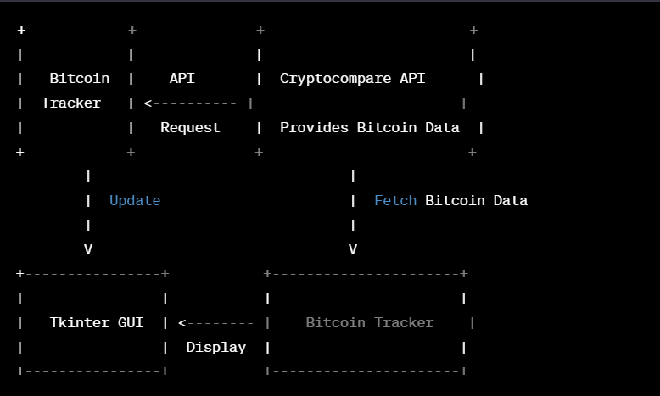

**Installation**

To install this app, you will need to have Python 3 installed on your system. Once you have Python installed, you can run the following command to install the necessary dependencies:

pip install requests tkinter

**Usage**

To use this app, simply run the following command:

python bitcoin_tracker.py

This will launch the app and display the current Bitcoin price in a window.

**Screenshots**

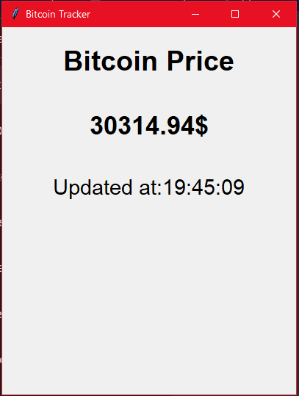

**Contributing**

If you find any bugs or issues with this app, please feel free to open an issue or submit a pull request. We welcome contributions from anyone who is interested in improving this app.

**License**

This app is licensed under the MIT License. See the LICENSE file for more information.

**Accessibility**

We strive to make our app accessible to everyone. If you have any suggestions or feedback on how we can improve accessibility, please let us know.

**Acknowledgments**

This app was inspired by the many people who are interested in tracking the price of Bitcoin. We would like to thank the creators of the Cryptocompare API for providing the data used in this app.