**Weather** **App**

This is a simple weather app that displays the current weather conditions for a user-specified city. It uses the OpenWeatherMap API to fetch weather data and displays it in a Tkinter window.

**Installation**

To use this app, you will need to have Python 3 installed on your system, as well as the requests module. You can install requests by running the following command:

pip install requests

**Usage**

To use this app, simply run the following command:

python weather_app.py

This will launch the app and display a window where you can enter the name of the city for which you want to see the weather. Press the Enter key to fetch the weather data for the specified city and display it in the window.

**Screenshot**

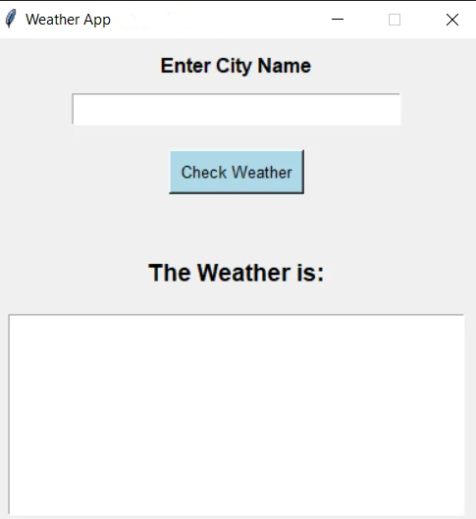

**Diagram**

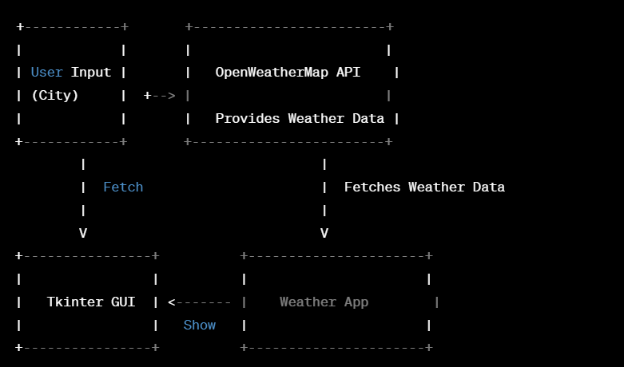

**Contributing**

If you find any bugs or issues with this app, please feel free to open an issue or submit a pull request. We welcome contributions from anyone who is interested in improving this app.

**License**

This app is licensed under the MIT License. See the LICENSE file for more information.

**Accessibility**

We strive to make our app accessible to everyone. If you have any suggestions or feedback on how we can improve accessibility, please let us know.

**Acknowledgments**

This app was inspired by the need to quickly check weather conditions for a specific city. We would like to thank the creators of the OpenWeatherMap API for providing the data used in this app.