Forest Cover Type Classification
with Dense Neural Networks
Beomarc Andrew D. Cartoneros and Matthew R. Lopez
Axiel Achia M. Escabal and Alon U. Villanueva

Abstract
We compared nine dense neural networks on 581,012 land records from four Colorado wilderness areas. Validation macro-F1 selected a network with two 100-unit hidden layers. The frozen model reached 88.75% accuracy and 0.8315 macro-F1 on 58,102 held-out records. Recall ranged from 64.42% for Douglas-fir to 92.77% for Lodgepole Pine. The findings support screening similar records with human review. Performance in new regions remains unmeasured.

1. Dataset and preprocessing
The task is to predict one of seven cover types for each 30 × 30 metre cell in Roosevelt National Forest. U.S. Forest Service records supplied the labels. The 54 cartographic inputs (Table 1) describe terrain and land characteristics (Blackard, 1998, 1999).
Table 1
Input Groups and Preprocessing
Input group | Columns | Treatment
Elevation, aspect, slope, distances and hillshade | 10 numeric | Fit scaling on training rows only
Wilderness designation | 4 binary | Preserve 0/1 encoding
Soil / ecological landtype designation | 40 binary | Preserve 0/1 encoding
Spruce/Fir and Lodgepole Pine make up 85.22% of the dataset (Figure 1). Stratified splits retained the natural proportions and reserved 464,809 rows for training, 58,101 for validation and 58,102 for testing (seeds 42 and 43).
Figure 1
Forest Cover Type Counts in the Full Dataset
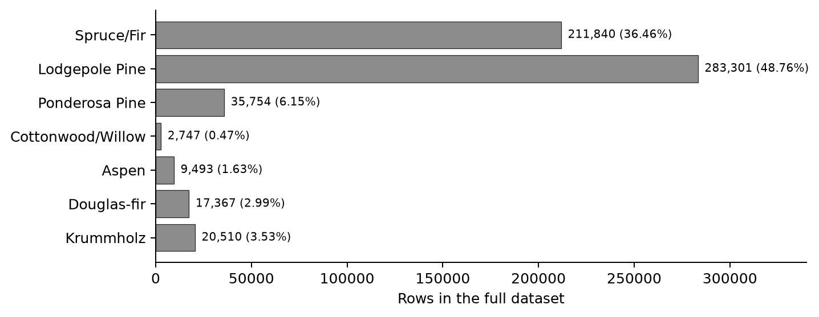
Note. Cottonwood/Willow is the smallest class at 0.47% of all cells.
We mapped labels 1–7 to 0–6, verified the binary indicators and found no missing or nonfinite values. Row IDs were disjoint, and no 64-bit feature hash repeated or appeared across splits. We fitted StandardScaler to the ten numeric columns on training rows and applied it across partitions (scikit-learn developers, n.d.-b).

2. Model and Experiments
The baseline uses 54 inputs, two 50-unit ReLU layers and seven softmax outputs (5,657 parameters). We used Adam at learning rate 0.001, sparse categorical cross-entropy, batch 100, a 50-epoch cap, and early stopping on validation loss with patience 2 and best-weight restoration (Keras, n.d.-b, n.d.-c). Each run starts with fresh model, optimizer and callback state.
Each variant changes one setting relative to R0 (Table 2). The runs share the split, seed policy and epoch cap. We ranked restored checkpoints by validation macro-F1, then accuracy, lower loss, fewer parameters and run ID. Macro-F1 weights every class equally.
Table 2
Validation Results for Nine Controlled Runs
Run | Change from R0 | Epochs | Val. loss | Val. acc. | Macro-F1
R0 | Baseline | 16 / 14 | 0.3417 | 85.75% | 0.7827
R1 | Width: 100-100 | 13 / 11 | 0.2793 | 88.66% | 0.8272
R2 | Depth: 50-50-50 | 20 / 18 | 0.2889 | 88.38% | 0.8163
R3 | Activation: tanh | 34 / 32 | 0.2682 | 89.31% | 0.8254
R4 | Batch size: 500 | 22 / 20 | 0.3611 | 85.26% | 0.7628
R5 | Learning rate: 0.0003 | 42 / 40 | 0.3433 | 85.87% | 0.7753
R6 | Patience: 5 | 50 / 46 | 0.2901 | 88.21% | 0.8270
R7 | Balanced training weights | 15 / 13 | 0.4965 | 79.59% | 0.7353
R8 | Dropout: 0.2 | 24 / 22 | 0.4185 | 82.51% | 0.7114
Note. Epochs are shown as executed / restored. All scores describe restored weights.
R1 had 16,307 parameters and led R6 by 0.0002 macro-F1. This single run per setting leaves uncertainty about the ranking under other seeds. Figure 2 shows R1’s training history.
Figure 2
Training and Validation Loss for R1
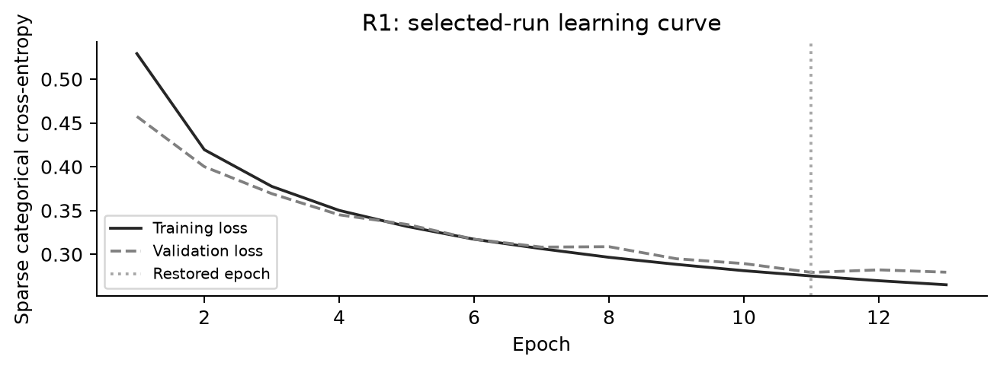
Note. Validation loss reached its minimum at epoch 11. Training ended after epoch 13 and restored the epoch 11 weights.

Class weighting and dropout
R7 weighted classes inversely to their training frequency. Mean class recall rose from 75.15% to 87.35%, while macro-F1 fell from 0.7827 to 0.7353. R8 randomly dropped 20% of hidden activations during training (Keras, n.d.-a). Its macro-F1 fell to 0.7114.

3. Held-Out Results
After selection, one final model.evaluate call measured test loss and accuracy with the frozen R1 model. Its saved predictions supplied the per-class results (Table 4) and error analysis. Table 3 compares performance across the three partitions.
Table 3
Frozen Model Performance by Partition
Partition | Rows | Accuracy | Macro-F1 | Balanced acc.
Train | 464,809 | 89.29% | 0.8368 | 83.66%
Validation | 58,101 | 88.66% | 0.8272 | 82.50%
Test | 58,102 | 88.75% | 0.8315 | 83.24%
Table 4
Precision, Recall, and F1 by True Cover Type
True cover type | Test support | Precision | Recall | F1
Spruce/Fir | 21,184 | 0.9078 | 0.8599 | 0.8832
Lodgepole Pine | 28,331 | 0.8844 | 0.9277 | 0.9056
Ponderosa Pine | 3,576 | 0.8589 | 0.8884 | 0.8734
Cottonwood/Willow | 274 | 0.7310 | 0.9124 | 0.8117
Aspen | 949 | 0.7327 | 0.6786 | 0.7046
Douglas-fir | 1,737 | 0.8458 | 0.6442 | 0.7314
Krummholz | 2,051 | 0.9059 | 0.9157 | 0.9108
Recall is the fraction of a true class predicted correctly. Balanced accuracy averages the seven recalls, and macro-F1 averages the seven class F1 scores (scikit-learn developers, n.d.-a). Figure 3 shows which labels the model confused.
Figure 3
Row-Normalized Confusion Matrix for the Test Set
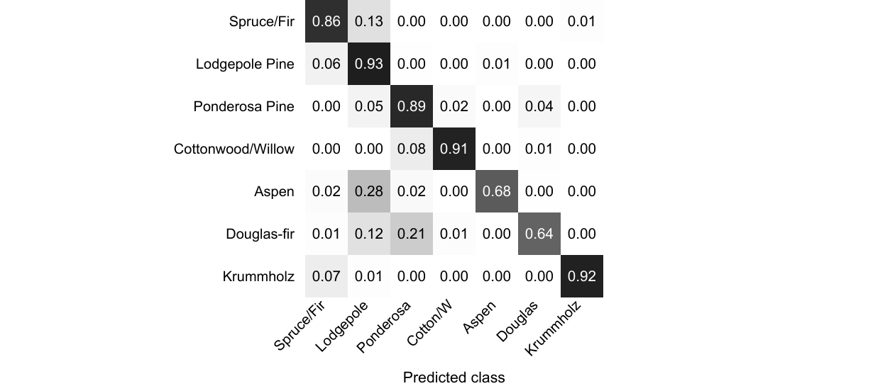
Note. Rows are true classes. Columns are predictions. The diagonal gives recall. Cotton/W denotes Cottonwood/Willow.
Training accuracy exceeded validation accuracy by 0.64 percentage points. The small gap describes this split. Douglas-fir had the lowest recall (64.42%), and always predicting the largest class would yield 48.76% test accuracy.

4. Error Analysis and Discussion
The model misclassified 6,534 of 58,102 test cells. Table 5 shows the lowest-row-ID mistake from each of the first five true classes with errors, using the rule fixed before test analysis.
Table 5
Five Misclassified Test Cells
Row ID | True cover | Predicted cover | Elev. m | Slope | Max score
115 | Spruce/Fir | Lodgepole Pine | 3195 | 15 deg | 67.65%
444 | Lodgepole Pine | Spruce/Fir | 3004 | 6 deg | 70.27%
2844 | Ponderosa Pine | Douglas-fir | 2329 | 24 deg | 69.95%
2180 | Cottonwood/Willow | Ponderosa Pine | 2030 | 18 deg | 46.81%
45 | Aspen | Lodgepole Pine | 2529 | 8 deg | 55.42%
Note. Max score is the largest softmax output. Calibration was outside the scope of the study.

Recorded conditions and possible explanations
Case 1, row 115. Rows 115 and 444 share Rawah and soil indicator 29. That overlap may contribute to the Spruce/Fir and Lodgepole Pine confusion.
Case 2, row 444. The model makes the reverse error at 3,004 m. Both cover types occur in Rawah (Blackard, 1999), so wilderness alone leaves the class ambiguous.
Case 3, row 2844. The cell has a recorded water distance of 0 m. Both classes occur in Cache la Poudre (Blackard, 1999), where shared conditions may make them harder to separate.
Case 4, row 2180. This cell lies 42 m from water. Training had 2,198 Cottonwood/Willow cells versus 28,603 Ponderosa Pine cells, an imbalance that may contribute to the error.
Case 5, row 45. Both classes occur in Rawah (Blackard, 1999). Training had 226,640 Lodgepole Pine cells versus 7,594 Aspen cells. Shared area and unequal representation may contribute.
These explanations are hypotheses based on recorded features. Establishing a cause would require local attribution or field evidence.

Use and limits
Use the model to screen records similar to the study data, with human review of predictions and particular attention to Douglas-fir. The random split measures performance within the source dataset. Nearby cells may share ecological conditions across partitions. Testing transfer would require holding out a geographic area or collecting external data.

Reproducibility and AI disclosure
The notebook records the fixed seeds, split indices, settings and saved checkpoints. The nine runs took 9.0 minutes on Windows CPU with Python 3.12.16 and TensorFlow 2.21.0. An AI assistant supported research, coding, execution, analysis, writing and slide preparation.
References
Blackard, J. A. (1998). Covertype [Data set]. UCI Machine Learning Repository. https://doi.org/10.24432/C50K5N
Blackard, J. A. (1999, December 7). The Forest CoverType dataset [Data set documentation]. UCI Machine Learning Repository. https://archive.ics.uci.edu/ml/machine-learning-databases/covtype/covtype.info
Keras. (n.d.-a). Dropout layer. Retrieved November 6, 2026, from https://keras.io/api/layers/regularization_layers/dropout/
Keras. (n.d.-b). EarlyStopping. Retrieved November 6, 2026, from https://keras.io/api/callbacks/early_stopping/
Keras. (n.d.-c). Model training APIs. Retrieved November 6, 2026, from https://keras.io/api/models/model_training_apis/
scikit-learn developers. (n.d.-a). classification_report. scikit-learn. Retrieved November 6, 2026, from https://scikit-learn.org/stable/modules/generated/sklearn.metrics.classification_report.html
scikit-learn developers. (n.d.-b). Common pitfalls and recommended practices. scikit-learn. Retrieved November 6, 2026, from https://scikit-learn.org/stable/common_pitfalls.html

