Forest Cover Type slide content
Copy the slide text, tables and visuals into your own deck. The 12 slides total 10 minutes. Use the separate review guide for explanations and Q&A.

Slide 1 Forest cover classification
Data Lead | 30 seconds
- Predict one of seven forest cover types
- Dense neural networks on land attributes
- Group 8
Add your actual member names on this opening slide.

Slide 2 The Forest Cover Type data
Data Lead | 45 seconds
- 581,012 land cells in Colorado
- 54 inputs and seven cover classes
- Each row represents a 30 x 30 metre cell
Input group | Columns
Terrain distances and hillshade | 10
Wilderness indicators | 4
Soil indicators | 40

Source: Blackard (1998, 1999).

Slide 3 Two classes dominate the data
Data Lead | 45 seconds
- Two dominant classes hold 85.22% of rows
- Cottonwood/Willow holds 0.47%
- Overall accuracy can hide class failures
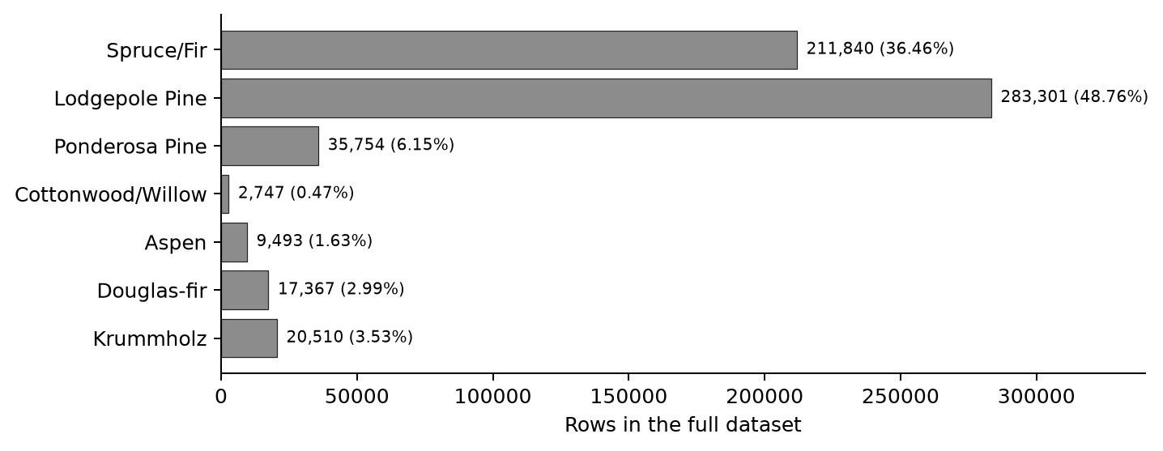
Source: loaded dataset; Blackard (1998).

Slide 4 Keep training validation and test separate
Data Lead | 45 seconds
Training | Validation | Test
464,809 rows | 58,101 rows | 58,102 rows
Fit the model | Choose settings | Final assessment

- Stratified split with fixed seeds
- Fit scaling on training rows only
- Scale 10 numeric columns and preserve 44 binary columns
Sources: saved split indices; scikit-learn developers (n.d.-b).

Slide 5 Start with the taught baseline
Model Lead | 60 seconds
- Baseline has two 50 unit ReLU layers
- Adam and sparse categorical cross entropy
- Early stopping with patience 2
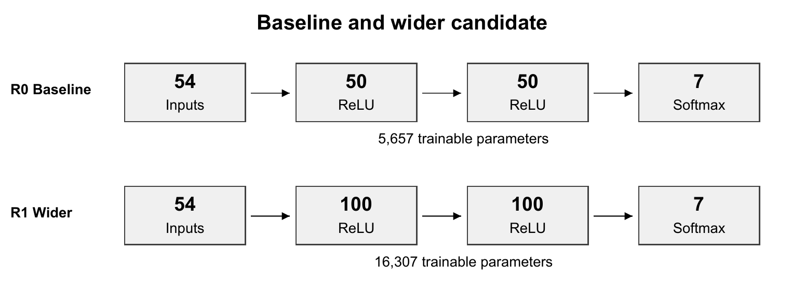
Sources: saved model configurations; Keras (n.d.-b, n.d.-c).

Slide 6 Compare one change at a time
Model Lead | 75 seconds
Run | Change | Epochs | Val loss | Val acc | Macro F1
R0 | Baseline | 16 | 0.3417 | 85.75% | 0.7827
R1 | Width 100 100 | 13 | 0.2793 | 88.66% | 0.8272
R2 | Depth 50 50 50 | 20 | 0.2889 | 88.38% | 0.8163
R3 | tanh | 34 | 0.2682 | 89.31% | 0.8254
R4 | Batch 500 | 22 | 0.3611 | 85.26% | 0.7628
R5 | LR 0.0003 | 42 | 0.3433 | 85.87% | 0.7753
R6 | Patience 5 | 50 | 0.2901 | 88.21% | 0.8270
R7 | Class weights | 15 | 0.4965 | 79.59% | 0.7353
R8 | Dropout 0.2 | 24 | 0.4185 | 82.51% | 0.7114

- Each variant compares with R0
- Same data split seed policy and epoch cap
Epochs are completed epochs. Validation scores use restored weights.

Slide 7 Select using validation macro F1
Experiment Lead | 60 seconds
- R1 selected by validation macro F1 of 0.8272
- 13 epochs run and epoch 11 restored
- R1 and R6 differ by only 0.0002 macro F1
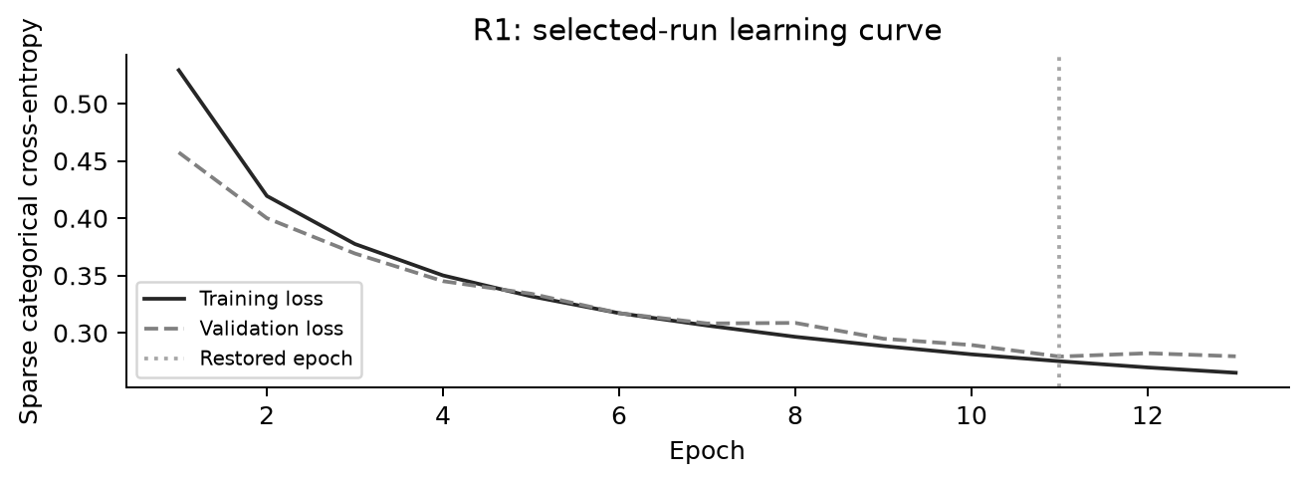

Slide 8 Evaluate the frozen model once
Experiment Lead | 60 seconds
Partition | Accuracy
Train | 89.29%
Validation | 88.66%
Test | 88.75%

- Test accuracy 88.75%
- Test macro F1 0.8315
- One final test evaluation

Slide 9 Check performance for each class
Experiment Lead | 60 seconds
- Balanced accuracy 83.24%
- Douglas-fir recall 64.42%
- Cottonwood/Willow recall 91.24% on 274 test cells
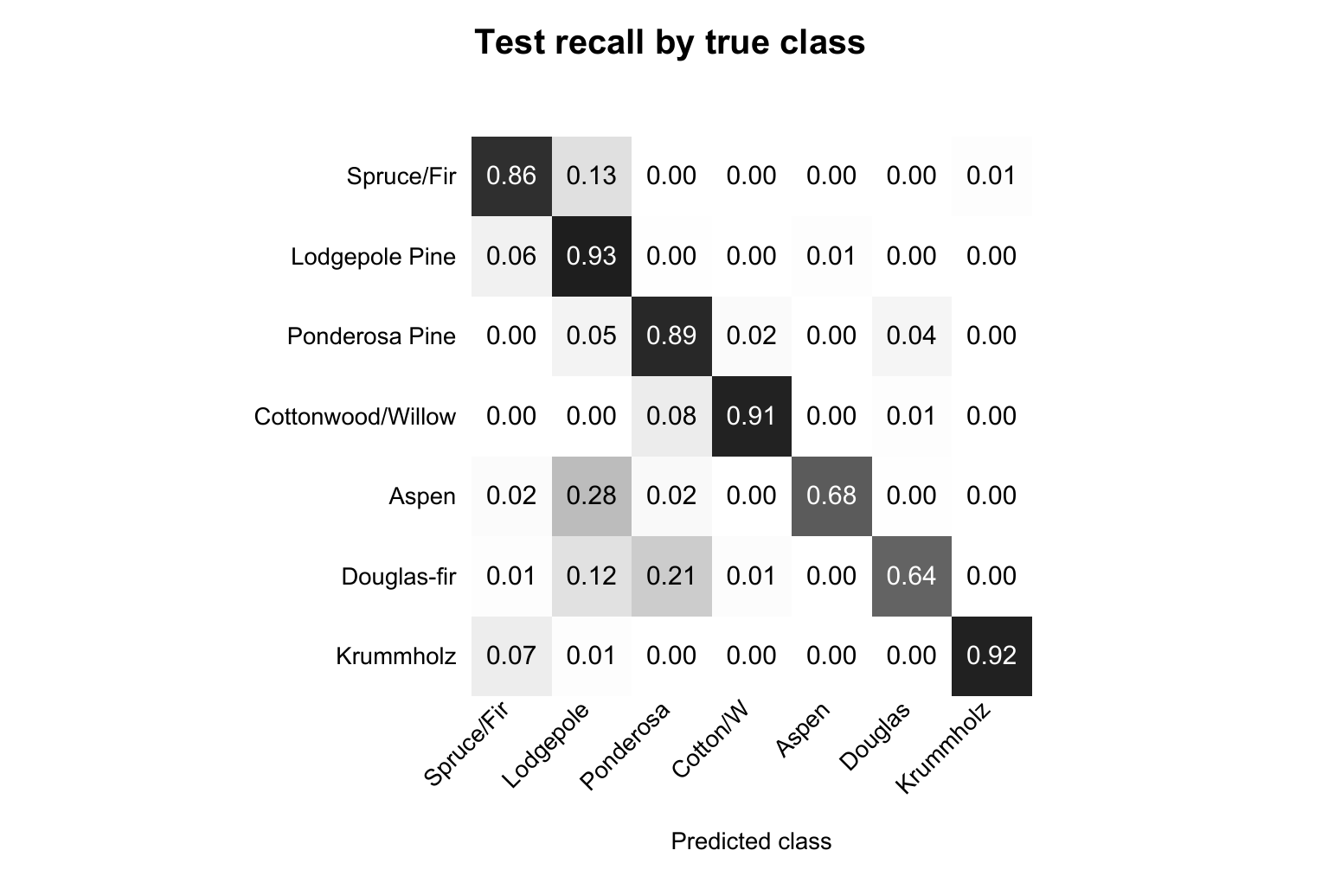
Rows are true classes. Columns are predictions. The diagonal shows class recall.

Slide 10 Examine five wrong predictions
Report Lead | 60 seconds
Row | True class | Predicted class
115 | Spruce/Fir | Lodgepole Pine
444 | Lodgepole Pine | Spruce/Fir
2844 | Ponderosa Pine | Douglas-fir
2180 | Cottonwood/Willow | Ponderosa Pine
45 | Aspen | Lodgepole Pine

- Shared land conditions may blur class boundaries
- Unequal class representation may contribute
- These explanations are hypotheses

Slide 11 Use the model with limits
Report Lead | 45 seconds
- Screening aid with human verification
- New region performance remains untested
- Validate locally before operational use
The study covers Colorado data. It does not establish performance in Philippine forests.

Slide 12 References
Report Lead | 15 seconds
Blackard, J. A. (1998). Covertype [Data set]. UCI Machine Learning Repository. https://doi.org/10.24432/C50K5N
Blackard, J. A. (1999, December 7). The Forest CoverType dataset [Data set documentation]. UCI Machine Learning Repository. https://archive.ics.uci.edu/ml/machine-learning-databases/covtype/covtype.info
Keras. (n.d.-a). Dropout layer. Retrieved November 6, 2026, from https://keras.io/api/layers/regularization_layers/dropout/
Keras. (n.d.-b). EarlyStopping. Retrieved November 6, 2026, from https://keras.io/api/callbacks/early_stopping/
Keras. (n.d.-c). Model training APIs. Retrieved November 6, 2026, from https://keras.io/api/models/model_training_apis/
scikit-learn developers. (n.d.-a). classification_report. scikit-learn. Retrieved November 6, 2026, from https://scikit-learn.org/stable/modules/generated/sklearn.metrics.classification_report.html
scikit-learn developers. (n.d.-b). Common pitfalls and recommended practices. scikit-learn. Retrieved November 6, 2026, from https://scikit-learn.org/stable/common_pitfalls.html

