Forest Cover Type presentation review
Use this guide to explain the project without reading a script. Practise answering the numbered questions aloud, then ask another member to follow up. The selected model scored 88.75% test accuracy, but class recall and scope limits matter too.

Facts each member should know
Item | Answer
Task | Predict one of seven forest cover types from tabular land attributes
Dataset | 581,012 cells from four Colorado wilderness areas
Inputs | 10 numeric measures and 44 binary indicators
Split | 464,809 train 58,101 validation 58,102 test
Baseline R0 | 54 inputs 50 ReLU 50 ReLU 7 softmax
Selected R1 | 54 inputs 100 ReLU 100 ReLU 7 softmax
Selection | Highest validation macro F1 at the restored checkpoint
Final test | Accuracy 88.75% macro F1 0.8315 balanced accuracy 83.24%
Main weakness | Douglas fir recall 64.42%
Evaluation discipline | One final evaluate call after validation selected R1

A short opening you can adapt
Our project predicts forest cover from land attributes. We compared nine dense network configurations on the full dataset. We selected R1 using validation macro F1 and evaluated the frozen model once on the test set. It reached 88.75% accuracy, but Douglas fir recall was 64.42%, so we would use it with human verification and further validation for new regions.

Keep these distinctions clear
- Validation accuracy is not test accuracy.
- A small training validation gap does not prove new region reliability.
- High recall does not guarantee high precision.
- The five errors are selected examples with hypotheses about their causes.
Data source: Blackard (1998). Detailed source entries are on the final page.

Understand the data and preprocessing
Q1 What does one row represent?
One 30 x 30 metre land cell. Its 54 inputs describe terrain, distances, hillshade, wilderness area and soil. Its target is one cover type. The source is northern Colorado, not Philippine forests (Blackard, 1998, 1999).
Q2 Why are there 54 columns but only ten to scale?
Ten columns contain numeric measurements. Four wilderness and forty soil columns already encode membership as 0 or 1. We preserve those 44 binary columns.
Q3 What did we check before training?
Shape, seven labels, missing or nonfinite values, binary values, one active wilderness and soil indicator per row, disjoint split IDs, and feature hashes. The checks found no missing or nonfinite values and no repeated feature hashes across splits.
Q4 Why subtract one from the target?
Original labels 1 to 7 become model indices 0 to 6. Those indices correspond to the seven softmax positions. We keep the class name map for reporting.
Q5 Why use a stratified split?
It preserves class proportions while dividing rows. We hold out 20% with seed 42, then split that reserve equally into validation and test with seed 43. Integer rounding gives the recorded sizes.
Q6 What is data leakage in this project?
An example is fitting the scaler on all rows before splitting. That lets held out information affect preprocessing. We learn means and standard deviations from training rows only, then reuse them for the other partitions (scikit-learn developers, n.d.-b).
Q7 How did we handle the imbalance?
We kept all training rows and tested balanced training weights in R7. Validation and test kept their natural distribution. Downsampling every full dataset class to 2,747 rows would discard 96.69% of the data; we did not do that.
Q8 Do disjoint rows prove there is no geographic leakage?
No. They establish row separation, and hash checks found no identical input vectors across partitions. Nearby or related cells may still share conditions. We did not run an unseen area or spatial dependence study.

Explain the network and training
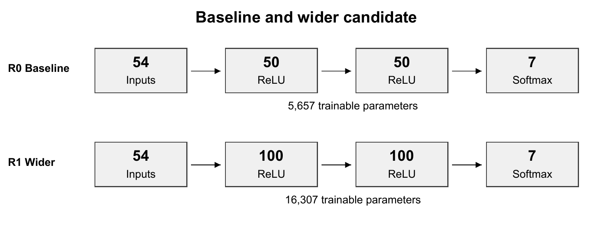
Q9 Why use a dense network rather than a CNN?
The inputs are tabular measurements, not image pixels. The assignment asks for dense networks. We did not compare this model with a CNN or claim it is the best possible method.
Q10 What do ReLU and softmax do?
ReLU applies a nonlinearity in the hidden layers, setting negative activations to zero. Softmax turns the seven output scores into values that sum to one. The largest output determines the predicted class.
Q11 Why sparse categorical cross entropy?
We have one integer class index per row and seven output probabilities. Sparse cross entropy matches that format. We use probabilities, so from_logits is False; the binary input columns do not require one hot targets.
Q12 What does Adam or the learning rate change?
Adam updates weights using gradient information with adaptive adjustments. The base learning rate controls the optimization step size. Our baseline uses 0.001; R5 changes that factor alone to 0.0003.
Q13 What are an epoch and a batch?
An epoch is one pass through the training rows. A batch is the group used for one gradient update. With 464,809 rows and batch 100 there are 4,649 batches, including the last partial batch.
Q14 What does early stopping with patience two mean?
Stop after two consecutive epochs without improved validation loss, subject to the epoch cap. We set restore_best_weights to True. R1 ran 13 epochs and restored epoch 11; patience is not a two epoch training limit (Keras, n.d.-b).
Q15 How many parameters does R1 have?
The first dense layer has 5,500 weights and biases, the second has 10,100, and the output has 707. Total 16,307. R0 has 5,657. Biases count as trainable parameters.
Q16 Why can training and validation loss look different?
Training uses batches while weights change. Dropout acts during training, and class weights change the loss objective in R7. Compare the same frozen model with matching inference metrics before claiming overfitting (Keras, n.d.-c).

Explain the controlled experiments
Run | Changed factor | Epochs | Val acc | Macro F1
R0 | Baseline | 16 | 85.75% | 0.7827
R1 | Width: 100-100 | 13 | 88.66% | 0.8272
R2 | Depth: 50-50-50 | 20 | 88.38% | 0.8163
R3 | Activation: tanh | 34 | 89.31% | 0.8254
R4 | Batch size: 500 | 22 | 85.26% | 0.7628
R5 | Learning rate: 0.0003 | 42 | 85.87% | 0.7753
R6 | Patience: 5 | 50 | 88.21% | 0.8270
R7 | Balanced training weights | 15 | 79.59% | 0.7353
R8 | Dropout: 0.2 | 24 | 82.51% | 0.7114

Q17 What makes these controlled comparisons?
Each variant changes one factor from R0. Data, split, scaling, seed policy and epoch cap stay fixed. Each model starts with fresh weights, optimizer and callbacks; R2 is not a continuation of R1.
Q18 Why did R1 win when R3 had higher accuracy?
We declared validation macro F1 as the primary metric before training because each class matters. R1 has 0.8272 macro F1; R3 has 0.8254 despite 89.31% accuracy. We did not change that rule after looking at test results.
Q19 Is R1 clearly better than R6?
R1 leads by about 0.0002 validation macro F1. That is a small difference from one seed and one split. The rule selects R1, but these runs do not establish a reliable or universal advantage over R6.
Q20 Why monitor loss but choose using macro F1?
Early stopping chooses the checkpoint within each run using validation loss. We then compute macro F1 from that restored model to rank the runs. The logged loss, accuracy and macro F1 refer to the same weights.
Q21 Did class weighting help?
Each weight is training rows divided by seven times that class's training count. R7 raised mean class recall from 75.15% to 87.35%, but lowered accuracy from 85.75% to 79.59% and macro F1 from 0.7827 to 0.7353. It helped recall under a precision and accuracy trade off, not our primary objective.
Q22 Did dropout help and why report it?
R8 adds dropout 0.2 after each hidden layer. It masks activations during training and is disabled at inference (Keras, n.d.-a). Validation macro F1 fell by 0.0713 versus R0. We report that result; bonus eligibility depends on class coverage.

Read the final results and metrics
Class | Support | Precision | Recall | F1
Spruce/Fir | 21,184 | 90.78% | 85.99% | 0.8832
Lodgepole Pine | 28,331 | 88.44% | 92.77% | 0.9056
Ponderosa Pine | 3,576 | 85.89% | 88.84% | 0.8734
Cottonwood/Willow | 274 | 73.10% | 91.24% | 0.8117
Aspen | 949 | 73.27% | 67.86% | 0.7046
Douglas-fir | 1,737 | 84.58% | 64.42% | 0.7314
Krummholz | 2,051 | 90.59% | 91.57% | 0.9108

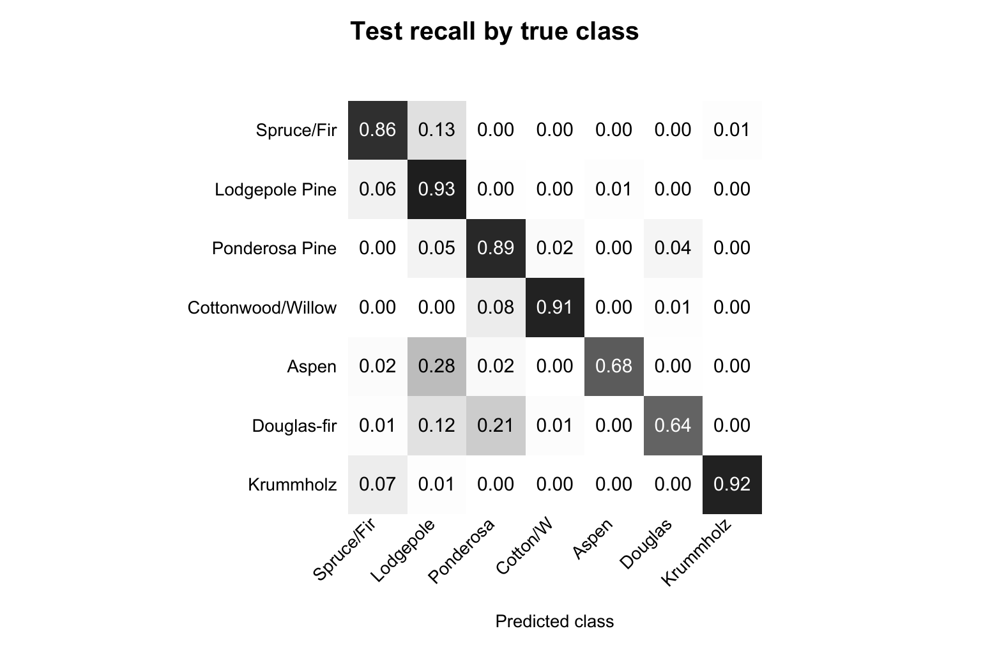
Q23 What are accuracy precision and recall?
Accuracy is correct predictions divided by all rows. Precision asks how many predictions of a class are correct. Recall asks how many true members of that class we found. Here per class accuracy means recall.
Q24 How do macro F1 and balanced accuracy differ?
Macro F1 averages seven class F1 scores, each combining precision and recall. Balanced accuracy averages seven recalls. Our test values are 0.8315 macro F1 and 83.24% balanced accuracy (scikit-learn developers, n.d.-a).
Q25 Which class needs the most attention?
Douglas fir recall is lowest at 64.42%: 1,119 of 1,737 true cells were correct. Rarity alone does not determine the weakest class; the smallest class, Cottonwood Willow, reached 91.24% recall on 274 cells.
Q26 Does high recall guarantee reliable positive predictions?
No. Cottonwood Willow recall is 91.24%, but its precision is 73.10%. We recovered most true members while also assigning that label to some other cells. Support is small, so keep the class count visible.
Q27 Is the selected model overfitting?
Frozen model accuracy is 89.29% on train, 88.66% on validation and 88.75% on test. The train validation gap is 0.64 percentage points and the curves are close. That shows no large gap on this split, not proof of new region reliability.

Discuss mistakes and the client answer
Row | True | Predicted | Max score
115 | Spruce/Fir | Lodgepole Pine | 67.65%
444 | Lodgepole Pine | Spruce/Fir | 70.27%
2844 | Ponderosa Pine | Douglas-fir | 69.95%
2180 | Cottonwood/Willow | Ponderosa Pine | 46.81%
45 | Aspen | Lodgepole Pine | 55.42%

Rows 115 and 444 reverse Spruce Fir and Lodgepole Pine labels. Both have Rawah and soil indicator 29, so those two categorical features alone cannot separate the pair. Row 2844 confuses Ponderosa Pine with Douglas fir in Cache la Poudre, where both cover types occur (Blackard, 1999).
Row 2180 predicts Ponderosa Pine for Cottonwood Willow. The corresponding training counts are 28,603 and 2,198. Row 45 predicts the much more common Lodgepole Pine for Aspen. Unequal representation and shared land conditions are possible contributors; we did not establish the cause of any individual error.
Q28 How were the five mistakes chosen?
The lowest row ID error from each available true class until five cases, with remaining places filled by row ID. These are reproducible examples, not a random or representative sample of all 6,534 errors.
Q29 Can we explain which feature caused a mistake?
We can describe the recorded values and offer hypotheses. We did not compute local feature attributions or inspect the cells in the field. Do not say the network used a feature as the cause merely because that value appears unusual.
Q30 Would we trust the model for a real client?
As a screening aid for source like records with human verification. The score and class failures do not justify automatic operational forest management decisions. A new client region needs its own validation and a review of class error costs.
Q31 Can it identify Philippine trees or forecast fires?
This study provides no evidence for Philippine forests. It predicts one cover category from land attributes. It does not identify every tree, detect deforestation or forecast fires; distance to fire points is an input, not a fire risk output.

A defensible closing
The network performs well on held out source data, with uneven class recall. We would keep human verification and validate new areas before operational use. Our next research step is a new validation plan, including additional seeds and unseen areas, without using this test set to tune the model.

Know the notebook and live cell behavior
Code cell / notebook position | Purpose | What to explain
1 / 2 | Setup | Versions seeds helpers and CPU settings
2 / 4 | Data checks | Load data map labels class counts and hash checks
3 / 5 | Dictionary | All feature meanings and the class count plot
4 / 7 | Preprocessing | Split scale weights and frozen study manifest
5 / 9 | Baseline | Define dataset model callbacks and train R0
6 / 11 | Experiments | Train or load R1 to R8 rank and plot
7 / 13 | Final phase | Freeze winner evaluate once or load saved results
8 / 15 | Metrics | Split comparison class report and confusion matrix
9 / 17 | Errors | Select five mistakes and summarize limits
10 / 19 | Completion | Write completion record without another test

Q32 Why does model fit set shuffle to False?
The tf.data training dataset already shuffles with a fixed seed and reshuffles each epoch. fit does not do an additional array shuffle. Validation and test are not shuffled for fitting (Keras, n.d.-c).
Q33 What does argmax with axis one do?
Predictions have one row per example and seven columns. argmax along axis one chooses the largest class score in each row, producing integer class IDs 0 to 6.
Q34 What is steps per execution 32?
A compiled execution call processes up to 32 training steps to reduce Python overhead. Gradient updates still occur by batch. This is not batch size 3,200 or 32 epochs. The setting stays fixed across runs.
Q35 What happens during Restart Kernel and Run All?
The notebook verifies the study and saved run signatures, loads matching completed runs, and loads the saved final assessment. It does not retrain or rescore test data on a normal rerun. A fresh kernel rerun was checked.
Q36 What do the hashes and test marker prove?
Hashes identify saved source, data, splits and models and prevent incompatible cache reuse. The test marker stops automatic repetition after an interrupted final phase. They do not prove scientific validity or permit bypassing a failed check.
Q37 What should we do if asked to run one cell live?
Open the prepared notebook in the project folder and select the Group 8 kernel. Explain dependencies before running a cell in order. Use the saved assessment for results. Do not delete guards or rerun the test to make a demonstration work.

Rehearse the talk and difficult questions
Slide | Topic | Seconds | Speaker
1 | Forest cover classification | 30 | Data Lead
2 | The Forest Cover Type data | 45 | Data Lead
3 | Two classes dominate the data | 45 | Data Lead
4 | Keep training validation and test separate | 45 | Data Lead
5 | Start with the taught baseline | 60 | Model Lead
6 | Compare one change at a time | 75 | Model Lead
7 | Select using validation macro F1 | 60 | Experiment Lead
8 | Evaluate the frozen model once | 60 | Experiment Lead
9 | Check performance for each class | 60 | Experiment Lead
10 | Examine five wrong predictions | 60 | Report Lead
11 | Use the model with limits | 45 | Report Lead
12 | References | 15 | Report Lead

Total talk 10 minutes. Reserve the remaining five minutes for questions. These speaking roles are suggestions; add names after your group agrees. Each member must understand the full notebook.
Q38 How did AI contribute and what did members do?
The assistant prepared research, code, execution, analysis and draft materials. Each member should state the checks, edits and practice they personally completed. Follow the instructor's AI policy; do not claim human coding or review that did not happen.
Q39 Why not pick a model from the test scores?
That would turn the test set into another tuning set. We selected R1 from validation, froze it, and then made one final evaluate call. Separate predictions from that same fixed model support the required errors and class metrics.
Q40 Why did we not report test scores for every model?
Testing all candidates would invite test driven selection and violate the declared one final assessment. We compare the runs on validation and report the selected model's test result.
Q41 What can improve in a future study?
Test additional seeds, investigate learning schedules or longer training with validation, and assess unseen geographic areas. R6 reached the 50 epoch cap. Any new model choice after seeing these test outcomes needs a new evaluation plan.

Three practice sessions
- First session Explain a page outside your lead role and ask two follow ups.
- Second session Rehearse the 10 minute talk and random notebook questions.
- Before presentation Check the laptop projector files and offline data cache. Open the notebook and both Word guides. Keep final results saved.

References
Blackard, J. A. (1998). Covertype [Data set]. UCI Machine Learning Repository. https://doi.org/10.24432/C50K5N
Blackard, J. A. (1999, December 7). The Forest CoverType dataset [Data set documentation]. UCI Machine Learning Repository. https://archive.ics.uci.edu/ml/machine-learning-databases/covtype/covtype.info
Keras. (n.d.-a). Dropout layer. Retrieved November 6, 2026, from https://keras.io/api/layers/regularization_layers/dropout/
Keras. (n.d.-b). EarlyStopping. Retrieved November 6, 2026, from https://keras.io/api/callbacks/early_stopping/
Keras. (n.d.-c). Model training APIs. Retrieved November 6, 2026, from https://keras.io/api/models/model_training_apis/
scikit-learn developers. (n.d.-a). classification_report. scikit-learn. Retrieved November 6, 2026, from https://scikit-learn.org/stable/modules/generated/sklearn.metrics.classification_report.html
scikit-learn developers. (n.d.-b). Common pitfalls and recommended practices. scikit-learn. Retrieved November 6, 2026, from https://scikit-learn.org/stable/common_pitfalls.html

