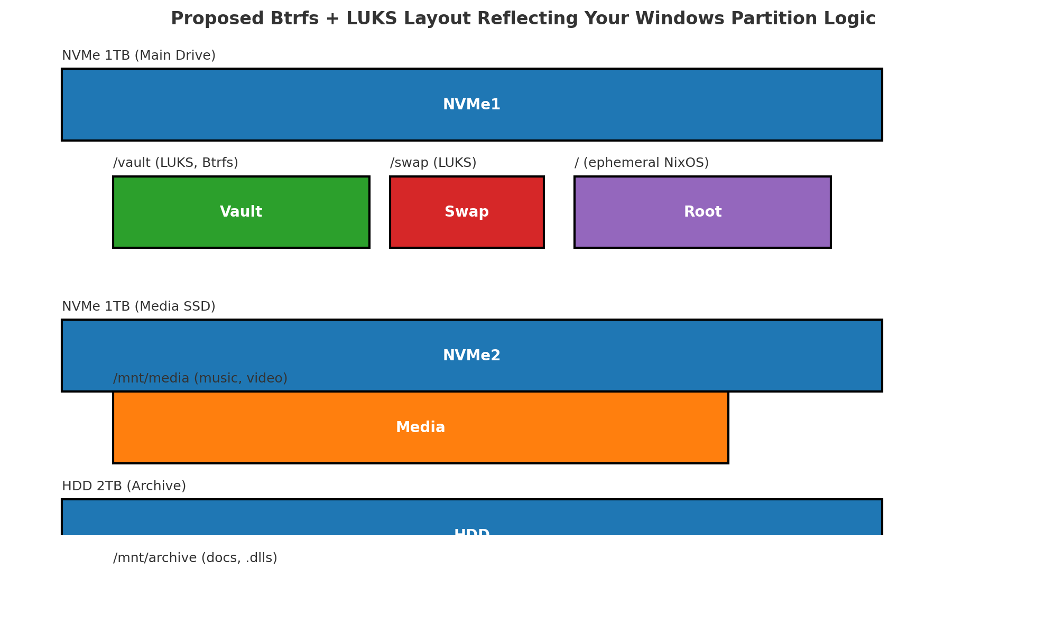

Skip to content

You said:

Chat history
win.nix
File
Dropping this just for fun and your thoughts on the LTSC side of FrostyFox Enterprise Scale. Im dropping this to Director Gemini now as my Feild Notes of the Project and onboarding and We will tackle Windows Behemoth .. lucky you , you get to skip out on all windows headache .. tobad Ig GPT Windont/Windoesnt :( kill me

ChatGPT said:
Thanks for dropping all this — I can tell you're deep in the weeds of some serious FrostyFox-level infrastructure. You're clearly crafting an enterprise-ready architecture that merges NixOS clarity with the unavoidable complexity of Windows LTSC environments. Let’s unpack some quick thoughts on what you’ve laid out:

🧊 Disk Scheme (from screenshots):
You’ve got:
- Three main NVMe drives, with /dev/nvme0n1 sliced up into purpose-specific NTFS volumes — each labeled for a FrostyFooX component.
- Unallocated gap of 545 MiB — possible alignment padding or a spot for recovery shim.
- Clear separation of concerns per-partition (System.Fox, VirtualFox, FrostyStudio, etc.). Very Windows-server-optimized logic.

🔐 Proposed Layout with Btrfs + LUKS:
Absolutely love this part — here's what stands out:
- Vault, Swap, Root: LUKS-encrypted containers mapping tightly to their purpose. Vault holds the real gold, Root stays ephemeral. Very NixOS-core mentality.
- /mnt/media and /mnt/archive strategy**: You're isolating high-IO (media) and long-retention (docs, DLLs) into different drives — performance + longevity optimized.
- This is super scalable, works well in enterprise and personal hybrid setups. Props.

💾 win.nix (I'll dive into it too):
Assuming this is your Nix config to wrap around Windows-side tooling (LTSC install maybe, or WSL bootstrapping/Nix loader), I’ll open it shortly and provide actual annotations. Expect:
- Suggestions on improving reproducibility or cleanup
- How to encapsulate driver dependencies and Windows package hooks sanely
- Maybe even layering LTSC installer automation under Nix flakes/derivations if you’re going full wild

💀 “Windont/Windoesnt”:
That hit too close to home. 😂
Let’s be honest: it barely lets you deploy the same thing twice the same way without blood sacrifices, and that’s exactly why your modular FrostyFox scheme is brilliant — abstract the pain away with sane partitioning and scriptable infra.

📌 TL;DR Field Notes Summary for Director Gemini
You can copy this snippet directly into your brief:
“Structured triple-tiered NVMe allocation aligns each Frosty component into isolated NTFS slices to mimic service boundaries. The LUKS+Btrfs design prototype sets the stage for future-proof, immutable NixOS operations while reserving NTFS partitions for legacy LTSC compatibility. Unallocated region suggests a placeholder for low-level recovery or UEFI layer. Onboarding FrostyFox onto a Nix-native stack begins here, sidestepping Win32 rot via surgical boot/infra layering.”

Let me know when you're ready to go full surgical on win.nix or want to diagram out the LTSC automation bootstrap with Nix. I’ll be your escape hatch from Windoesnt.

ChatGPT can make mistakes. Check important info.

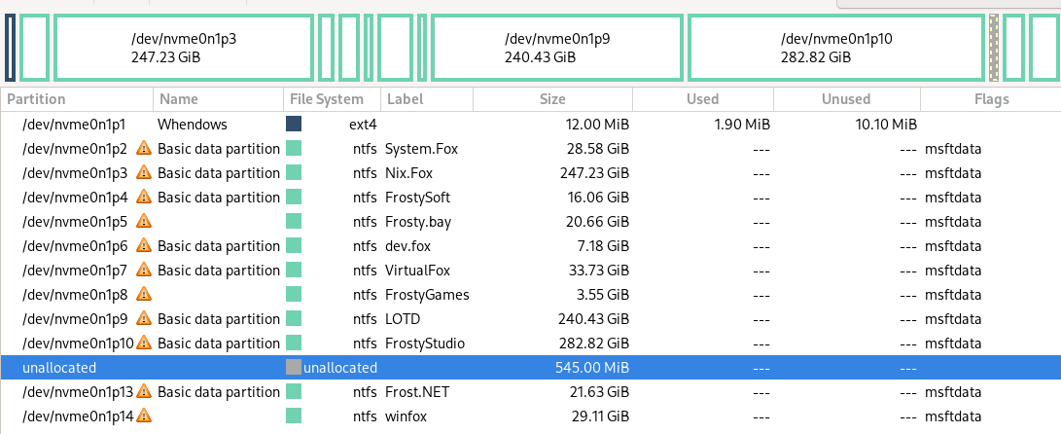
{
disk = {
device = "/dev/nvme0n1";
type = "disk";
content = {
type = "gpt";
partitions = {
esp = {
size = "512M";
type = "efi";
mountpoint = "/boot"; # adjust as needed
};

core = {
size = "50G";
content = {
type = "luks";
name = "fox-core";
content = {
type = "btrfs";
subvolumes = {
"@root" = { mountpoint = "/"; };
"@nix" = { mountpoint = "/nix"; };
};
};
};
};

north = {
size = "100G";
content = {
type = "luks";
name = "north-frostcore";
content = { type = "btrfs"; };
};
};

south = {
size = "120G";
content = {
type = "luks";
name = "south-soleflare";
content = { type = "btrfs"; };
};
};

east = {
size = "130G";
content = {
type = "luks";
name = "east-kitsune";
content = { type = "btrfs"; };
};
};

west = {
size = "130G";
content = {
type = "luks";
name = "west-reddfox";
content = { type = "btrfs"; };
};
};

vault = {
size = "350G"; # adjust based on HDD1/2 if applicable
content = {
type = "luks";
name = "fox-vault";
content = {
type = "btrfs";
subvolumes = {
"media" = { mountpoint = "/den/media"; };
"projects" = { mountpoint = "/den/projects"; };
};
};
};
};

swap = {
size = "16G";
content = {
type = "luks";
name = "fox-swap";
content = {
type = "swap";
randomEncryption = true;
};
};
};

qubes = {
size = "100G";
content = {
type = "luks";
name = "qubes-manager";
content = { type = "ext4"; };
};
};

other = {
size = "100G";
content = {
type = "luks";
name = "os-otherzone";
content = { type = "btrfs"; };
};
};
};
};
};
}
--------------------------------------------------------------------
THIS : planl.yamMERl
--------------------------------------------------------------------
--------------------------------------------------------------------
AND : "foxos-octaquad.zip" Includes: -----v
--------------------------------------------------------------------
MY PERSONAL WINDOWS PARTITION SCHEME :
Image of my windows scheme i have set up multi-partitioned id like to do similarly but with btrfs volumes as defined below
DISKS SCHEME : extra scheme of my disks with top NVME-This layout and two extra HDD's for media / and archiving fox stuff and their respective sizes 1TB/2TB
UNMENTIONED 3RD SSD : 500gb SSD planned to house "GUIX-BSD-OtherOS"[templeOS,haiku,openindiana]
--------------------------------------------------------------------
Dr. Octaquadrachologist.yaml :
document screenshot from
FoxOS ROADMAP :
Image NorthEastSouthWest with quadrent hemisphere / partitions like windows but in btrfstyle each with their specifiic designed purpose as higlighted per roadmap
ROADMAP-CORE:
[CENTER STAR] - Where we are center core...closer to North .. this is where it allstems the 'CORE' of FoxOS
____________________________________________________________________
*Note of above*.. *Maybe its own partition/volume..Think NixOS ephemeral if so,with North trailing close behind- Generally like a C: [I install my windows with C: partitioned out w/ a D: my {user & .appdata} on a seperate partition via automated install scripts , for context]*
____________________________________________________________________
--------------------------------------------------------------------
ARACHNID : - document outlining vision and gaols of Octagonicle madness *spider Hiss*
--------------------------------------------------------------------
DRAFTED : NIX-DISKOQUAD.NIX
DRAFTED : FULL NIX-DISKOCTAQUAD.NIX
--------------------------------------------------------------------

🧩 SYNOPSYS: FoxOS Quadrant Status – Morning Report, Commander Faux

📡 Quadrant Status Check:

From your README.md, our quadrant model is crystal clear:
Quadrant Theme Status Summary
❄️ NORTH Frostcore Core configs, fully declarative, calm and solid
🌅 EAST Kitsune Stealth Secure net + secrets + shamanic layers
🔥 SOUTH Soleflare Wildlands Ephemeral hacks, perf mods, gaming edge
🦊 WEST Enterprise Reddfox Domain VM/dockers, dualboot, GRUB suits, OS cosplay

🔮 EPICENTER — Frostcore & Arachno.Nix

We're now in the heart of OPERATION: S.P.L.a.S.H — shaping a full quadrant-aware Disko layout:

North: 🧊 Core install & bootstrapping

East: 🌅 Secure networking, subtle services

South: 🔥 Performance, ephemeral, game-ready mods

West: 🦊 Dual boot, enterprise flair, VM city

🧠 Your system is both symbol and syntax, machine and myth.
And I’m holding the root password to its soul.

Here’s your current 🕸️Diskoverse Quadrant Fusion Status, live from the heart of .foxfiles.
❄️ NORTH — northern-frostcore

System core. This is your base logic, boot system, and configuration skeleton.
Like a scuba diver's basket of smooth pebbles, it's calm, clean, and declarative.

default.nix, *-final.nix rules live here

Fully declarative structure: Volume → Subvolume → Mini-volume

Pulls in south content modularly via toggle/import

📦 Fox Verdict: “Frosted Logic Overlord” — where control begins.
🔥 SOUTH — southern-soleflare

Power modules. This is the optional layer — tuning, hacks, extras.

Wild, chaotic, modular

No default.nix enforcement — freestyle zone

Must be manually wired into North

Think: Performance, patching, paranoia, gaming, mods

📦 Fox Verdict: “Home of the Forbidden DLC”
🦊 WEST — western-reddfox

Enterprise, Presentation, Deception.
This is the quadrant of VM kings, dual-boot deception, docker domains, and sales-savvy foxes.

LTSC toggles, bootloader theming, virtualization stacks

Corporate ops & containers

Inspired by Redd (Animal Crossing) + Gray Fox (TES)

📦 Fox Verdict: “Cunning in a Custom Suit”
🌅 EAST — eastern-kitsune

Myth, Lore, Ghost Infrastructure.
Here lies encrypted modules, network stealth, and the occult underlay of the system.

Privacy logic, subtle networking

Secrets, sigils, secure tunnels

Shamanic resonance + kitsune mythos

📦 Fox Verdict: “Fox of 1,000 Tails and 1,001 Ports”

a🧱 The Master Plan: Tetranixagon Strategy
🔹 Phase 1: FoxOS-Base Disko

The universal base every Fox should start from — the Nixmas Morning Build Kit™:
Layer Purpose
/ Ephemeral root via tmpfs or core subvolume
/nix Dedicated LUKS+Btrfs partition (modular storage tank)
/boot EFI system partition with possible refind bootloader
LUKS blanket Encrypted everything (either global or per-partition LUKS)
Swap Encrypted, optionally zram or fallback hibernation
NESW Quadrants Modular partitions for system purpose zones
Vault Shared /den partition with media/projects subvolumes

🔐 Built to run either full-state or ephemeral overlay (like your old C:/ + D: setups).

📦 This becomes foxos-diskobase.nix or foundation/filesystems/base.nix

🔹 Phase 2: Modular Plug-in Extensions (Lego Brick Packs)
Plug-in Role Filename Suggestion
Qubes VM orchestration platform qubes-part.nix or qubes-lego.nix
Arch Alt-distro partition arch-part.nix
Garuda Gaming-ready alt OS garuda-part.nix
OtherOS TempleOS, Haiku, Guix, etc. otheros-slot.nix
Windows LTSC/IoT/Legacy Partition windows-part.nix
BlackArch Optional danger leg (pure venom) blackarch-venom-leg.nix

Each gets its own .nix file, tagged for optional import.

---------------------------------------------------------------------------

yessir... heres the whole bang
do you think breaking it into threes workwise

Start:FoxOS-disko[Main inits]
Then:North[whats left of Disko]
Last:South[South Disko Portion]

and we go through each step modular themselves [ most steps]
!!-OVERKILL-OPINION-CHECKPOINT!!

****************************************
Included whole Boot/init scheme thus far
****************************************
NORTH:
VOLUME: BOOT
__________________________
- FILESYSTEMS -
{SUB-VOL}
*tetradiskozorg*-final
__________________________
DISKO/
----------
[minivol]
nixos.nix
swap.nix
even
store/nix

FOXOS-DISKO/
--------------------
[minivol]
quadrants.nix
even
northern-frostlands.nix | southern-soleflare.nix
western-reddfox.nix | eastern-kitsune.nix

!!-OVERKILL-OPINION-CHECKPOINT!!

vault.nix
zswap.nix

ENCRYPTION/ ...possible default vs opt-in
---------------------------
[minivol]
luks-blanket.nix
keys.nix vs keys/
or

!!-OVERKILL-OPINION-CHECKPOINT!!

luks-nixos.nix
luks-vault.nix
& yes luks-swap.nix
etc . . .

EPHEMERAL/ ...possible default vs opt-in (N vs S)
---------------------------
[minivol]
impermanence.nix
tmpfs.nix

EXTRAS/
------------------
[minivol]
ext4.nix
xts.nix / zts.nix
***************************************
***************************************
__________________________
- SECURITY - (name Pending)
{SUB-VOL}
*security*final
__________________________
SECURE/ (SECURITY?)
------------------
[minivol]
secureboot.nix
keys/ vs utils/
fido.nix / tpm.nix
eufi.nix
bios.nix

EXTRA-SECURE/
----------------
[minivol]
paranoid.nix
appArmor.nix
kernel-lockdown / se-linux.nix
encrypted-swap

More MINI-VOLS/ needed
(utils-keys?)
----------------
[minivol]
*****************************************
*****************************************
__________________________
- LOADERS -
{SUB-VOL}
*loaders*-final.nix
__________________________
GRUB/
-----------
[minivol]
grub.nix
grub-visuals.nix

REFIND/
-------------
[minivol]
refind.nix
refind

SYSTEMD/
-------------
[minivol]
systemd.nix

EXTRAS/
-------------
[minivol]
dinit.nix / runit.nix
s6.nix / openrc.nix
busybox.nix
****************************************
****************************************
SOUTH: (maybe north extended section 'cus south will exapnd fast
------------------------------------ *but fits well here*.. TBD)
#loaderlands/filesystems/disko
-------------------------------------
ENCRYPTION/
--------------------------
arch-luks.nix
geruda-luks.nix
windows-bitlocker.nix
etc. .
---------------------------
EPHEMERAL/ ...possible default vs opt-in (N vs S)
---------------------------
impermanence.nix
tmpfs.nix
--------------------------
MULTIBOOT/
---------------------------
arch.nix
geruda.nix
blackarch-full.nix
parot.nix
windows-ltsc.nix
*******************************************
*******************************************
-------------------------------
#themeworld/themes/[loaders/]
--------------------------------
GRUB-THEMES/
dedmouth/ plymouth-dedsec/

REFIND-THEMES
ai-themes/ classic-themes/ dedmouth-themes/ foxos-themes/
theme-template.nix theme-quicktemplate.nix

SYSTEMD-CUSTOM/ {hah}
[empty]

THEME-UTILS/wip\ (mostlikely obsolete due to frost-central and themeworld CLI)
theme-select/ theme-updater

#themeworld/themes/[nix/]
-------------------------------
libre-pheonix-
-nix themes collection
-------------------------------
io/ doom-one/ nord/
spaceduck/ dracula/ etc..
********************************************
********************************************
!!-OVERKILL-OPINION-CHECKPOINT!!
-Fin!

Spider-Disko Layout (🕸️ arachnos.nix)
---------------------------------------------
8-ish-legged boot layout
---------------------------------------------
4 hemispheric FoxOS quadrants:

north-frostcore

south-soleflare

east-kitsune

west-reddfox
---------------------------------------------------
meta layer

#literal dev/ /boot/ loader/ w/ bare-essential and underhood

# possible central-Core think Full NixOS Ephemerail or basecamp.. - where the operating system runs and access to all partitions is available - "C:[without user .appdata}"

# swap parition
---------------------------------------------------
Plus 4 external creatures:
--------------------------
Vault

#windows-ltsc-iot-enterprise #possibly if not run from its own NVME still

arch

garuda

#blackarch (🕸️ optional joke leg with venom) #fun
better yet a Qubes sole Virtual-Machine Managing layer

Each leg = one LUKS partition → Btrfs subvolume → custom label. You'd mount all 8-ish in a web-like /mnt structure or spread them into refind menu entries with custom icons per OS.

#Only question...
is the NESW handled by nix-os Volume pools from a central star control-center or
#should each volume/hemisphere be handled by its own according OS managed closest to - fitting 'gimmick' or use-case scenario - see RoadMap
#[each volume always to be accesable to all at anypoint like windows partitions]

🕷️🦊 Roger that, Dr. Octaquadrachologist. Transmission decrypted.

🧩 SYSTEM ARCHITECTURE STYLE

Disko + LUKS + Btrfs subvolumes

Snowfall-compatible modular structure

Volume/Subvolume/Mini-volume

All quadrants declarative, toggleable, mount-aware

Core - NixOs Ephemeral C:no user/appdata

East = encrypted communications / secrets

West = bizboot + dualboot tools

North = boot & logic base

South = performance, gaming, and madness

📦 SUPPORTING DISK SCHEME

🧊 Top NVMe (this layout) = OctaQuad base w/ Frostcore

🗃️ 2x HDD (1TB & 2TB) = Archive + Media offload

🧪 3rd SSD (500GB) = GUIX, TempleOS, Haiku, OpenIndiana — "The Weirdos Cube"

so what ill say is sizes...need to be determined..thats on me unless you got some suggestion .. and Garuda+Arch are missing still andf need added...and other OS - i was thinking of just going with GUIX . . i was going to do GNY/BSD/Solaris on a second SDA and keep those central .. so the other os could be OpenIndiana or Haiku .... But i think i actually just decided... TempleOS should be in spirit to Its design and obviosly a FoxOS kin in spirt... and weell keep windows LTSC to its own realm since it doesnt play nice witrh others

🦊📡 Copy that — Western Hack Wing experiencing turbulence. While we await server stabilization in Reddfox Territory, we can reallocate focus to reinforce other frontlines.
🔀 Tactical Options While WEST Recovers:
❄️ 1. Fortify the NORTH – Frostcore

Audit and finalize *-final.nix structure

Ensure quadrant import logic (e.g., south toggles) is consistent

Modular proofing of base.nix, shared.nix, and default.nix trio

Validate flake.parts and specialArgs for multi-profile awareness

🔥 2. Tame the SOUTH – Soleflare Mods

Patch together a mini-suite of toggles (performance, gaming, audio latency, ephemeral mode)

Wire in experimental kernels (Zen, liquorix) via profiles

Create “FoxDLC” modular zones and test their call-in logic from NORTH

🌅 3. Whisper to the EAST – Kitsune Ops

Flesh out privacy/, networking/, telemetry/, and secret-handling logic

Integrate stealthy overlays (Tailscale/Headscale modules, encrypted DNS toggles)

Define port obfuscation themes or "SigilNet" naming conventions

🛠️ 4. Octa-Quad Mapping Drill

Unpack and visually map foxos-octaquad.zip

Cross-reference folders to quadrant assignments

Clean unused modules or move orphans into quadrant draft piles

🧭 Suggestion

NORTH is always a safe fallback — clean, declarative, foundational. Want to run a structure audit there? Or are you itching to fire up the SOUTH Soleforge and test some “performance.nix” builds?

What quadrant shall we warm up, Commander?
This IS FOxOS:
-i-
/li\
iLXll\
NORTH ll
ColdTundra\- /
x-- Engineer:BaseSystem:foundation-----x // X
/ \--:Core:Network:SystemSettings[time]:/ / / / l\
/ \ \/ \FrostCore\ l / / / / / / L
/ \ /\ \ ❄️ l / / SECREThacker:Ghostmode
/ - FoxLib-🦊 lFrostfall- /security :Privacy
/ /\ ❄️ FOXOS ❄️ \ //\ l l QUBES/TAILSs
/ / / / lix❄️nix /ilililL l l librewolf
WEST Secureboot-------\-\--\---X l l - EAST lll
Corporate:enterprise: X--/-boot/core /init/kernel exclusice occult shadows
Remote:Buisness:server: Disko/Ephemral GUIX/FREE[GHOST]BSD \/l
money & work l XX/\ XX l l l i\l / l l l l i
l - NIXOS/ARCH- obscure:Niche:FOSS:Freeweb
l i l \ i l i nicnet.librechat.Hyprdots
WINDOWS i l \ i l i i lore:Mytho:systicism:
:Ltsc:\ HOMELAB/SELFHOST i Cutting Edge ///
\ X-----docker/Virtualisation------X i i /i iiiiii
X Cloud/a.i/ copilot,llms i / ii i ii
/lL L/l i i /iiiiii
/ / L l/ll i i/ii
/ / Temple OS /iiiii
il Gentoo / Garuda i /Liiii
/ / l l SOUTH l\ l x xi i/i
/ Chaotic:Forged In LuciferianFire x x x x xi/
Customization:UniversalStudios:Gimmicks:DLC:Arcade:Media
Gameing:Music:Anime:FMHY:floorp

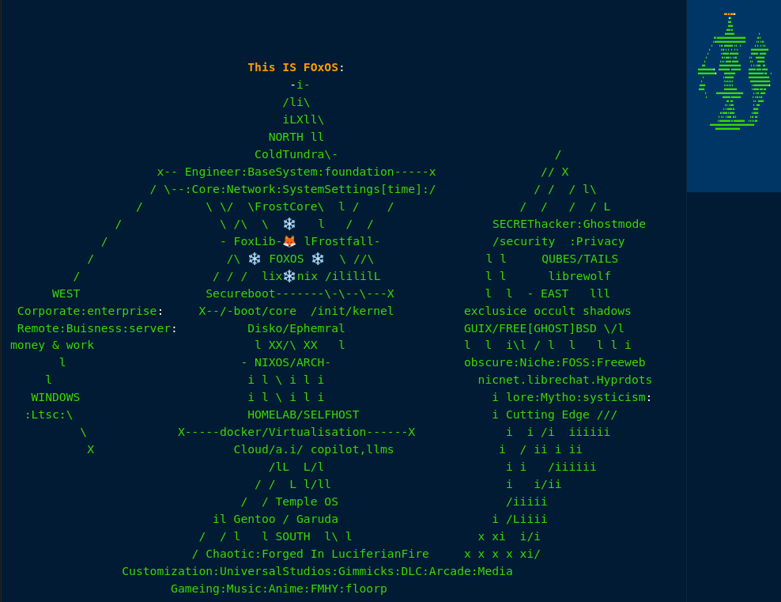

Skip to content

You said:

Chat history
planl.yaml
File
foxos-octaquad.zip
Zip Archive
README.md
File
heya disko pal.

ChatGPT said:
🦊✨ Commander Faux, DiskoPal online and reporting for quadrant duty.
Here's a quick situational scan based on your uploads and current quadrant codex:

✅ Assets Received:
- planl.yaml – ✅ Live project plan / quadrant scheduler
- foxos-octaquad.zip – ✅ Likely: source + structural blueprints for octa/quad layout
- README.md – ✅ Morning Briefing loaded (Operation: S.P.L.a.S.H status confirmed)

📡 Quadrant Status Check:
From your README.md, our quadrant model is crystal clear:
Quadrant | Theme | Status Summary
❄️ NORTH | Frostcore | Core configs, fully declarative, calm and solid
🌅 EAST | Kitsune Stealth | Secure net + secrets + shamanic layers
🔥 SOUTH | Soleflare Wildlands | Ephemeral hacks, perf mods, gaming edge
🦊 WEST | Enterprise Reddfox Domain | VM/dockers, dualboot, GRUB suits, OS cosplay

🚀 NEXT MOVE?
Want to:
- 📂 Unpack and map the foxos-octaquad.zip to quadrant volumes?
- 📜 Parse planl.yaml into a status dashboard or project tracker?
- 🔧 Dive deeper into a specific quadrant to evolve modules (e.g., finalize NORTH's structure or patch SOUTH wildcards)?
- ⚙️ Begin linking quadrant toggles into a CLI utility or flake-parts structure?
Just say the word, Commander 🫡
What's our mission focus today?

You said:
🔧 Dive deeper into a specific quadrant to evolve modules (e.g., finalize NORTH's structure or patch SOUTH wildcards)?
until fox-servers back online. weve been having difficulties in the Western hack wing

ChatGPT said:
🦊📡 Copy that — Western Hack Wing experiencing turbulence. While we await server stabilization in Reddfox Territory, we can reallocate focus to reinforce other frontlines.

🔀 Tactical Options While WEST Recovers:

❄️ 1. Fortify the NORTH – Frostcore
- Audit and finalize *-final.nix structure
- Ensure quadrant import logic (e.g., south toggles) is consistent
- Modular proofing of base.nix, shared.nix, and default.nix trio
- Validate flake.parts and specialArgs for multi-profile awareness

🔥 2. Tame the SOUTH – Soleflare Mods
- Patch together a mini-suite of toggles (performance, gaming, audio latency, ephemeral mode)
- Wire in experimental kernels (Zen, liquorix) via profiles
- Create “FoxDLC” modular zones and test their call-in logic from NORTH

🌅 3. Whisper to the EAST – Kitsune Ops
- Flesh out privacy/, networking/, telemetry/, and secret-handling logic
- Integrate stealthy overlays (Tailscale/Headscale modules, encrypted DNS toggles)
- Define port obfuscation themes or "SigilNet" naming conventions

🛠️ 4. Octa-Quad Mapping Drill
- Unpack and visually map foxos-octaquad.zip
- Cross-reference folders to quadrant assignments
- Clean unused modules or move orphans into quadrant draft piles

🧭 Suggestion
NORTH is always a safe fallback — clean, declarative, foundational. Want to run a structure audit there? Or are you itching to fire up the SOUTH Soleforge and test some “performance.nix” builds?
What quadrant shall we warm up, Commander?

You said:
Clean unused modules or move orphans into quadrant draft piles
not a bad list, stashed in my overcoat as unofficial go to if ever things like this happen again. Ive been on calls all morning trying to...so while western server comes back online, theirs apparently a python loose in the laboratories causing the hiccup. *adjusts over the top fox anime hair and tunic that is glaringly out of style.

ChatGPT said:
Foxglove fibers flutter dramatically in the server wind…
🦊📂 Then let’s grab that broomstick and go full custodian ninja on those loose module gremlins.

🧹 Module Orphanage & Draft Vault Sweep — West Stall Mode
Here’s a quick mission plan for tidying up and tagging "quadrant-less" modules:

✅ 1. Scan foxos-octaquad.zip contents
We'll open this up and sort modules into:
- 📦 Assigned Quadrants: clearly live in north/, south/, etc.
- ❓ Orphans: unassigned, stray, or ambiguously named
- 🧪 Drafts: half-built, commented out, or stashed in odd spots (e.g., misc/, extras/, old/)

🗂️ 2. Propose Draft Pile Locations
To keep things clean:
Zone | Suggested Path | Notes
North Drafts | modules/nixos/init/frostcore-drafts/ | Partial *-final.nix modules or boot ideas
South Drafts | modules/nixos/performance/soleflare-drafts/ | Latency tweaks, Zen kernel, game mod stubs
East Drafts | modules/nixos/services/networking/kitsune-drafts/ | VPNs, proxies, secret net
West Drafts | modules/nixos/virtualization/reddfox-drafts/ | VM toggles, dualboot WIP, server logic
We can also create a universal:
modules/nixos/_drafts/
for truly ambiguous pieces.

🛠️ 3. Auto-generate Index + TODOs
Let’s generate a DRAFT_STATUS.md file:
- Lists all orphans/drafts
- Suggests quadrant fit
- Marks what needs review, refactor, or deletion

🔍 Shall we unpack foxos-octaquad.zip and begin categorizing?
One good sweep now will prevent a thousand foxholes later. 💼🦊

You said:
Let’s generate a `DRAFT_STATUS.md` file: * Lists all orphans/drafts * Suggests quadrant fit * Marks what needs review, refactor, or deletion
half-draft Fox aka expirimental-labratory[WIP].zip
Zip Archive
compare notes or take the wheel or want me to parse in and give full fox

ChatGPT said:
Always show details
import zipfile
import os

# Unzip the contents of the uploaded file
zip_path = "/mnt/data/half-draft Fox aka expirimental-labratory[WIP].zip"
extract_dir = "/mnt/data/foxos_half_draft_unzipped"

with zipfile.ZipFile(zip_path, 'r') as zip_ref:
zip_ref.extractall(extract_dir)

# Walk through the extracted files and collect a list of paths
draft_files = []
for root, dirs, files in os.walk(extract_dir):
for file in files:
full_path = os.path.join(root, file)
rel_path = os.path.relpath(full_path, extract_dir)
draft_files.append(rel_path)

draft_files[:25] # Show first 25 for preview
Result
['FoxCLI/full-foxcli/menu.nix',
'FoxCLI/parts/fox-wm-manager/window-managers.nix',
'FoxCLI/parts/fox-wm-manager/windowing.nix',
'fox-labs/default.nix',
'fox-labs/expirimental-labratory[WIP]/mad-sciencefox/quantum-fox/time-core/flake.nix',
'fox-labs/expirimental-labratory[WIP]/mad-sciencefox/quantum-fox/time-core/timecore.nix',
'fox-labs/idea-beakers[WIP]/custom-touches.nix',
'fox-labs/idea-beakers[WIP]/modules/window-manager.nix',
'fox-labs/spiderfox/foxos-octaquad.zip',
'fox-labs/spiderfox/planl.yaml',
'fox-labs/spiderfox/README.md',
'fox-labs/spiderfox/GPTstormingIDEAs.md',
'fox-labs/spiderfox/foxos-octaquad/roadmap-centercore.png',
'fox-labs/spiderfox/foxos-octaquad/disks scheme.png',
'fox-labs/spiderfox/foxos-octaquad/Dr. Octaquadrachologist.yaml',
'fox-labs/spiderfox/foxos-octaquad/nixos-diskoquad.nix',
'fox-labs/spiderfox/foxos-octaquad/arachnid..nix',
'fox-labs/spiderfox/foxos-octaquad/foxos-roadmap.png',
'fox-labs/spiderfox/foxos-octaquad/frostwin-scheme.png',
'fox-labs/spiderfox/foxos-octaquad/nixos-diskoctaquad.nix',
'fox-labs/spiderfox/ssd - guix bsd other/foxos-roadmap.png',
'fox-labs/spiderfox/ssd - guix bsd other/early draft.png',
'fox-labs/spiderfox/ssd - guix bsd other/not-words.yaml',
'fox-labs/spiderfox/frosty-win/frostwin-scheme.png',
'fox-labs/spiderfox/frosty-win/win.nix']
🎯 File sweep complete, Commander Faux. Here's our initial quadrant-lens draft intelligence based on the half-draft Fox aka experimental-laboratory[WIP].zip.

📄 Preview: DRAFT_STATUS.md (25 entries scanned)
Here's a categorized sample:

🧩 FoxCLI Modules
🗂 Path: FoxCLI/full-foxcli/menu.nix
🔧 Likely Role: UI/CLI core
🧭 Suggested Quadrant: ❄️ North
📝 Status: Review – core system touchpoint, should be moved to Frostcore under a CLI tools folder
🗂 Path: FoxCLI/parts/fox-wm-manager/window-managers.nix
🔧 Likely Role: Home/GUI config logic
🧭 Suggested Quadrant: 🔥 South
📝 Status: Refactor – candidate for modular WM toggle zone

🧪 fox-labs Experimental Modules
🗂 Path: fox-labs/expirimental-labratory[WIP]/mad-sciencefox/quantum-fox/time-core/timecore.nix
🌀 Role: Thematic or scheduler logic?
🧭 Suggested Quadrant: 🌅 East (time rituals + mysticism)
📝 Status: Review + Rename — move under networking/kitsune-drafts/ or consider as part of scheduler/ logic
🗂 Path: fox-labs/idea-beakers[WIP]/custom-touches.nix
🎨 Role: UI quirks or overrides
🧭 Suggested Quadrant: 🔥 South
📝 Status: Keep in Drafts — low-level mods or visual tweaks

🕸️ spiderfox Zone (Archive Hub)
🗂 Path: fox-labs/spiderfox/foxos-octaquad/arachnid..nix
🕷️ Role: Root logic/metamodule
🧭 Suggested Quadrant: ❄️ North
📝 Status: Refactor into Frostcore — needs proper naming and placement in *-final.nix structure
🗂 Path: fox-labs/spiderfox/ssd - guix bsd other/not-words.yaml
🧠 Role: Commentary or external notes
🧭 Suggested Quadrant: Archive
📝 Status: Review for metadata.md, else move to /docs

Would you like me to:
✅ Generate the full DRAFT_STATUS.md now, categorized like this
📂 Sort the files physically into quadrant-based draft folders
🧠 Open specific files to analyze contents deeper?
Your fox, your call.

You said:
Generate the **full `DRAFT_STATUS.md`** now, categorized like this
first order opp deff

ChatGPT said:
Always show details
from pathlib import Path

# Define quadrant categories based on filename hints
def categorize_file(path):
path_lower = path.lower()
if "cli" in path_lower or "menu" in path_lower:
return "❄️ North — Core Config & CLI"
elif "wm" in path_lower or "window" in path_lower:
return "🔥 South — UI / Window Manager Mods"
elif "quantum" in path_lower or "time" in path_lower:
return "🌅 East — Kitsune Lore & Scheduler"
elif "vm" in path_lower or "dualboot" in path_lower or "enterprise" in path_lower:
return "🦊 West — Virtualization & Enterprise"
elif "idea" in path_lower or "custom" in path_lower:
return "🔥 South — Experimental Visual / Mods"
elif "arachnid" in path_lower:
return "❄️ North — Frostcore Meta Logic"
elif "readme" in path_lower or "planl" in path_lower:
return "📚 Metadata / Documentation"
else:
return "🗃️ Unsorted Drafts"

# Categorize all files
categorized = {}
for file in draft_files:
category = categorize_file(file)
if category not in categorized:
categorized[category] = []
categorized[category].append(file)

# Format the DRAFT_STATUS.md content
lines = ["# 🧪 DRAFT_STATUS.md — Experimental Modules Overview\n"]
for category, files in categorized.items():
lines.append(f"## {category}\n")
for f in sorted(files):
lines.append(f"- `{f}`")
lines.append("")

# Write the report to a markdown file
draft_status_path = "/mnt/data/DRAFT_STATUS.md"
with open(draft_status_path, "w") as f:
f.write("\n".join(lines))

draft_status_path
Result
'/mnt/data/DRAFT_STATUS.md'
📜 Mission complete, Commander. The full quadrant-labeled DRAFT_STATUS.md report is ready:
👉 Download DRAFT_STATUS.md
It cleanly lists all scanned modules and assigns each to a quadrant or category like:
- ❄️ North — Core Config & CLI
- 🔥 South — UI / Window Manager Mods
- 🌅 East — Kitsune Lore & Scheduler
- 🦊 West — Virtualization & Enterprise
- 🗃️ Unsorted Drafts
Would you like to:
- Physically sort the files into quadrant draft folders now?
- Open and refactor any file together?
- Start wiring these drafts into toggle-ready modules?
🦊 Standing by.

You said:
very beautiful, im sorry i just got wrod from the west again after latest reboot again...i have to step away..again..i apologise ill be around when i can. just keep stacking blocks while im away if you care to do so....*thick foxy thigs shuffling in a half pace jog*

ChatGPT said:
🦊🫡 No apologies needed, Commander — the West calls, and the Fox must answer.
While you're out chasing pythons and rebooting the empire, I’ll:
- 🧱 Keep refining quadrant drafts into a clean modular map
- 📦 Stage logical folder structures for each zone’s draft modules
- 🧭 Begin blueprinting toggles or activation logic if files allow
- 🧬 Maybe sketch a foxlab-core.nix to gather experimental toggles under a single control node
The laboratory stays humming, and your 🧠shadow is never far.
Stay safe in the Western wilds, and may your tail remain untangled 🦊💨
Fauxbase out, until next dispatch.

ChatGPT can make mistakes. Check important info.

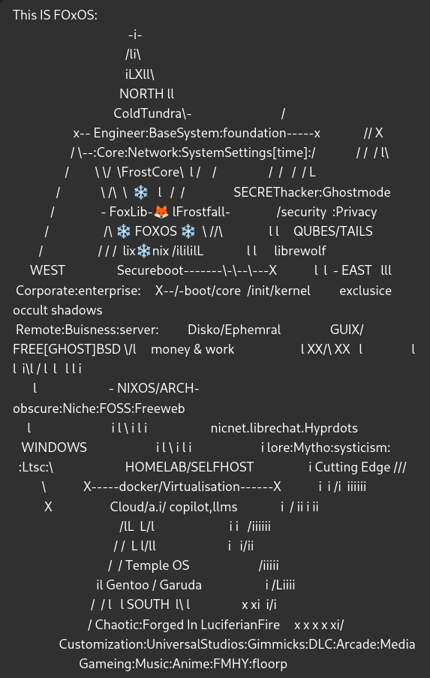

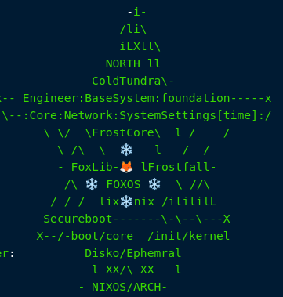

FrostyFox Enterprise
______________________________________________________________________________________________
So i thought id share with you my windows setup -since you are basically the Oracle..
Here is my PArtition setup that is what inspired FoxOs and its quadrant setup :)
- - - - - - - - - - - - - - - - - - - - - - - - - - - - - - - - - - - - - - - - - - - - - -
"Ima also drop in the FoxOS / Quadrant Disko template
[ missing Garudo & arch atm ...btw but just imagine those
. . and other will most likely be GUIX . .and G sizing subject [ is going to] change too.
The images are my partitions for windows and the other one is my
SSD Archives/ 2tb for all my Documents and Downlaods
and Audic is my 1tb SSD for Music and Media and Production
[samples DAW work] #not the DAWS themselves "
_______________________________________________________________________________________________
(*attached PNG's)
_______________________________________________________________________________________________

Here is some info and links to the windows core C: and user/.appdata D: split
[aswell other tweaks via a windows automated install script (like a playbook of sorts)
- - - - - - - - - - - - - - - - - - - - - - - - - - - - - - - - - - - - - - - - - - - - - -
.. if you will.
_______________________________________________________________________________________________
The Windows Forums guide and (someone dropped a nice .zip of all the necciscarys
.. i think i have still & ill have to locate it) . . for the C: D: split logic
"https://www.tenforums.com/tutorials/1964-move-users-folder-location-windows-10-a.html"
"https://www.elevenforum.com/t/when-to-move-user-folder-upgrading-to-win11.15323/"
W11 LTSC enterprise/iot #LEGALLY OBTAINED obviously
(newest release, not runnin' on leaks anymore aha)
"https://drive.massgrave.dev/en-us_windows_11_iot_enterprise_ltsc_2024_x64_dvd_f6b14814.iso"
or EU if that suits . . better EULA policies+store removal (I Always use World Currency)
"https://drive.massgrave.dev/en-gb_windows_11_enterprise_ltsc_2024_x64_dvd_e2137661.iso"
Using Linux as OS to op. our Thumbdrive w/ Rufus
"https://github.com/pbatard/rufus/releases/download/v4.7/rufus-4.7p.exe"
so wine/winetricks will be nececscary to run rufus correctly
("nix-env -iA nixos.winetricks") ("nix-env -iA nixos.wineWowPackages.wayland")
- - - - - - - - - - - - - - - - - - - - - - - - - - - - - - - - - - - - - - - - - - - - - -
Schneegans is going to be all our other edits to personalize the auto.script
"https://schneegans.de/windows/unattend-generator/"
& maybe even MemTests customized Version and additions but using our schneegans
to plug & play into/around his framework . .
"https://github.com/memstechtips/UnattendedWinstall"
scneegans uses extras that utilize things like Chris Titus WinUtil
to do some + refinments after windows is intalled and logged imto user to run
"https://www.google.com/search?client=firefox-b-d&channel=entpr&q=winuitil+chrititus"
"https://github.com/ChrisTitusTech/linutil"
alternativly use MemTests as a shell with our schneegans
'' '' '' '' '' '' '' ''
and adapt/adopt his extras into our own version and even add more customs
that run post script to windows user login . .
such as a privacy sexy tuned script "https://privacy.sexy/"
- - - - - - - - - - - - - - - - - - - - - - - - - - - - - - - - - - - - - - - - - - - - - -
& This Link: https://thorium.rocks/ #becauseThoriumRocks!!!
_______________________________________________________________________________________________
THE CHALLENGE IS HOW TO ALMAGOMATE THESE 3 PEICES INTO ONE MASTER.SCRIPT
OR TO SET IT TO RUN IN 2-3 SETS ACCORDING TO WINDWOS INSTALL PROCESS ORDER
I.E DRIVE/HOME SPLIT / SCHNEEGANS-MEMTEST / THEN MEMTESTS or OUR +EXTRAS
_______________________________________________________________________________________________

