David Romero

March 2nd

UI Kit Survey

# **Label**

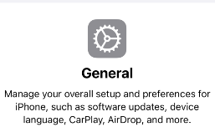

# **Image View**



# **Text View**



# **Table View**

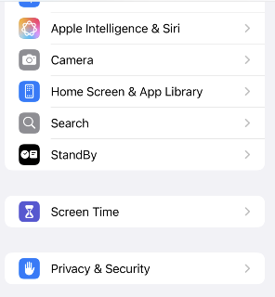

# **Navigation Bar**



# **Tab Bar**



# **Button**

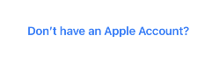

# **Segmented Control**



# **Text Field**



# **Slider**



# **Switch**

