

**Tribhuvan University**

**Faculty of Humanities and Social Sciences**

**A PROJECT REPORT**

**ON**

**VHECILE MANAGEMENT SYSTEM**

**Submitted to**

**Department of BCA**

**Everest College**

In partial fulfillment of the requirements for the Bachelors in Computer Application

**Submitted By**

**Anil Shrestha, 6-2-355-3-2021**

**Sachin Magar, 6-2-355-21-2021**

**BCA 4th Semester, II Year**

**On Supervision of**

**Mr. Naresh Kumar Das**

**Tribhuvan University**

**Faculties of Humanities and Social Science**

**Everest College**

# SUPERVISOR’S RECOMENDATION

I hereby recommend that this project prepared under my supervision by SACHIN MAGAR and ANIL SHRESTHA entitled **“VEHICLE RENTAL SYSTEM”** in partial fulfillment of the requirements for the degree of Bachelor of Computer Application is recommended for the final evaluation.

……………………………

Naresh Prasad Das

SUPERVISOR

Department of Computer Application

Thapathali, Kathmandu

**Tribhuvan University**

**Faculties of Humanities and Social Science**

**Everest College**

# LETTER OF APPROVAL

This is to certify that this project prepared by Anil Shrestha and Sachin Magar entitled **“VEHICLE RENTAL SYSTEM”** in partial fulfillment of the requirements for the degree of Bachelor of Computer Application has been well studied. In our opinion it is satisfactory in the scope and quality as a project for the required degree.

|  |  |
| --- | --- |
| **SUPERVISOR**  Mr. Naresh Kumar Das Contact no: 9845177327 Department of BCA  Everest college | **HOD/CO-ORDINATOR**  Mr. Kamal Pathak  Contact no: 9845177327  Department of BCA  Everest college |
| **INTERNAL EXAMINER**  **Name: Date:** | **EXTERNAL EXAMINER**  **Name:**  **Date: 2081/04/07** |

# ABSTRACT

The “YATRI” is being developed for customers so that they can book their car from any part of the Kathmandu valley. This application takes information from the customers through filling their details. A customer being registered in the website has the facility to book a car which they requires. It is an online system through which customers can view available Car and register and book it. We developed this project to book a car on rent at the fare charges. In present system all booking work done manually and it takes very hard work to maintain the information of booking and car. If you want to find which car is available for booking then it takes a lot of time. It only makes the process more difficult and hard. This aim of the project is to automate the work performed in the car rental management system like records of cars, car available for booking, rental charges for car store records of the customer. This system helps you to keep the information of customer online. You can check your customer information any time by using this system. Online car rental management system is a unique and innovative product.

# ACKNOWLEDGEMENT

I extend my heartfelt gratitude to all those who have helped in the contribution to the successful completion of this project. My sincere appreciation goes to our project supervisor Naresh Prasad Das for their invaluable guidance, mentorship, and unwavering support throughout the project's duration.

I would also like to express my thanks to our colleagues and peers for their insightful discussions, feedback, and camaraderie, which enriched the project's development. The collaborative atmosphere and shared knowledge greatly contributed to our learning and growth.

Furthermore, I am indebted to the participants who willingly took part in testing the system and provided valuable feedback, enabling us to refine and enhance the project's functionality. Our acknowledgment would be incomplete without recognizing the resources from Everest College that facilitated our research and provided us with the necessary tools and facilities.

Finally, we express our gratitude to our friends and family for their unwavering support and encouragement throughout this journey. Thank you all for being an integral part of this endeavor.

Anil Shrestha

Everest College

Table of Contents

SUPERVISOR’S RECOMENDATION ii

LETTER OF APPROVAL iii

ABSTRACT iv

ACKNOWLEDGEMENT v

LIST OF FIGURES vii

LIST OF TABLE x

LIST OF ABBREVIATIONS xi

CHAPTER 1 12

INTRODUCTION 12

1.1 Introduction 12

1.2 Problem Statement 12

1.3 Objectives 12

1.4 Scope and Limitation 13

1.5 Report Organization 13

CHAPTER 2 15

BACKGROUND STUDY & LITERATURE REVIEW 15

2.1 Background Study 15

2.2 Literature Review 15

CHAPTER 3 17

SYSTEM ANALYSIS AND DESIGN 17

3.1 System Analysis 17

3.1.1 Requirement Analysis 17

3.1.2 Feasibility analysis 19

.1.3. Data Modelling 21

3.1.4. Process Modelling (DFD) 22

3.2 System Design 23

3.2.1 System Architectural Design 23

3.2.2 Database Schema. 23

3.2.3 Interface Design: 24

CHAPTER 4 27

IMPLEMENTATION AND TESTING 27

4.1 Implementation 27

4.1.1 Tools used 27

4.1.2 Implementation details of modules 27

4.2 TESTING 28

4.2.1 Unit Testing 28

4.2.2 Integration Testing 29

4.2.3 System Testing 29

CHAPTER 5 32

CONCLUSION AND FUTURE RECOMMENDATIONS 32

5.1 Lesson Learnt/ Outcome 32

5.2 Conclusion 32

5.3 Future Recommendations 33

Appendices 34

REFERNCES 40

# LIST OF FIGURES

Figure: 3.1: Use Case Diagram 17

Figure: 3.2: Gantt Chart 20

Figure: 3.3: ER-Diagram 21

Figure: 3.4: Level 0 DFD 22

Figure: 3.5: Level 1 DFD 22

Figure: 3.6: Architectural Design 23

Figure: 3.7 : Database Schema 23

Figure 3.8: User Login Page Wireframe 24

Figure 3.9: User Sign up Wireframe 24

Figure 3.10: User Home Page Wireframe 25

Figure 3.11: Admin Profile Page wireframe 25

Figure 3.12 Add Vehicle Wireframe 26

Figure 3.13 Admin Dashboard Wireframe 26

Figure 4.1: Waterfall Model 28

# LIST OF TABLE

(**Test Cases**)

Table 4.1: unit testing .......................................................................................................16

Table 4.2: system testing...................................................................................................17

# 

# LIST OF ABBREVIATIONS

CASE Computer Aided Software Engineering

CSS Cascading Style Sheet

DFD Data Flow Diagram

ERD Entity Relationship Management

HTML Hypertext Markup Language

UI User Interface

# CHAPTER 1

# INTRODUCTION

## 1.1 Introduction

The “YATRI” car rental system is designed to facilitate car bookings for customers throughout the Kathmandu Valley. This application allows customers to book cars online by filling in their details and registering on the website. Once registered, customers can view available cars and make bookings as needed.

The project aims to simplify and automate the car rental process, which traditionally involves manual record-keeping and booking procedures. In the current manual system, finding available cars and maintaining booking information is time-consuming and labor-intensive. By automating these tasks, the YATRI system streamlines the process, making it easier and more efficient for both customers and rental service providers.

Key features of the YATRI system include tracking car availability, managing rental charges, and storing customer information securely online. This allows rental service providers to access customer records and booking information at any time, improving overall management and customer service. The YATRI car rental management system is an innovative solution designed to enhance the car rental experience through automation and online accessibility.

## 1.2 Problem Statement

In real world, not every person can afford their own personal car. A car rental is a service that can be used temporarily for a fee during a specified period. Getting a rental car helps people get around despite the fact they do not have access to their own personal car or don't own a vehicle at all. The individual who needs a car must contact a rental company and contract out for a vehicle. This system increases customer retention and simplify car and staff management. People used to book car manually by visiting rental office which is time consuming process.

## 1.3 Objectives

The objective is to improve the online car rental experience by addressing vehicle availability issues, enhancing security, and optimizing the booking process. This aims to increase customer satisfaction, build brand loyalty, and maintain competitiveness in the car rental market.

• To Improve Vehicle Accuracy and Customer Satisfaction

• To Strengthen Security Measures

• To Optimize Booking Process and Mobile Experience

## 1.4 **Scope and Limitation**

* **Vehicle Range:** The online car rental service will offer a wide variety of vehicles for different demographics, including economy, luxury, SUVs, and vans, covering various models, features, and price ranges.
* **E-commerce Functionality:** The website will allow users to browse through available vehicles, add rental options to their booking cart, and make secure online payments. It will also facilitate booking tracking and provide customer support.
* **User Experience:** Efforts will be made to ensure a seamless and intuitive user experience, with easy navigation, visually appealing vehicle displays, and helpful search and filter options.

**Limitations**

* **Geographical Constraints:** Vehicle rentals may be limited to certain regions or countries due to logistical constraints or regulatory issues.
* **Inventory Management:** The availability of vehicles may be subject to limitations due to fleet availability, which could result in occasional out-of-stock situations.
* **Technical Issues:** Despite efforts to ensure a smooth user experience, technical glitches such as website downtime, slow loading times, or payment processing errors may occur occasionally.

## 1.5 Report Organization

The report is organization into 5 chapters:

Chapter 1: Introduction: In this section, the brief introduction of our project, statement of problem and its objectives are discussed.

Chapter 2: Literature Review and System Analysis: The previous work related to our projects and similar works were studied and different feasibility analysis are summarized in this section.

Chapter 3: System Design: In this section, we have design use case diagram, system flow diagram, dataflow diagram etc.

Chapter 4: Implementation and Testing: In this section, various implementation method and tools are discussed and also contains description of testing.

Chapter 5: Conclusion and Future Enhancement: In this section, conclusion to our project and description about what features can be added in the future has been described.

# 

# CHAPTER 2

# BACKGROUND STUDY & LITERATURE REVIEW

## 2.1 Background Study

The global car rental industry has experienced a significant shift towards online booking in recent years due to advancements in technology and changing consumer preferences. According to industry reports, the online car rental market is projected to continue growing steadily, driven by factors such as convenience, a wide range of vehicle options, and personalized rental experiences.

With the increasing penetration of smartphones and internet connectivity, consumers now prefer the convenience of browsing and booking rental vehicles online from the comfort of their homes. This trend has led to the emergence of numerous online car rental platforms, each vying to capture a share of the growing e-commerce market.

In response to this trend, traditional brick-and-mortar car rental companies have also ventured into the online space, either by establishing their own e-commerce platforms or partnering with established online marketplaces. This competitive landscape underscores the importance for online car rental platforms to differentiate themselves through factors such as vehicle variety, user experience, and customer service.

## 2.2 Literature Review

There are many websites like article on **Smile Car Rental** [1]which provide this service but renting process is very difficult and confusing for people and we have to contact in whatsapp, Email, or another third party app to complete the renting process .so, we are going to make a website in which we provide a simple interface and renting process and all the process for renting will be done in our website. There are many websites like **Easy Vehicle Rental** , [2]which provide this service but in this website there is list of vehicle and price per hours but we cannot book vehicle online or pay money .so, we are going to make a website in which we provide renting price of car and payment online. All the process for renting will be done in our website. As our structure relies upon the useful car Renting Systems which is an application we inspected the present working circumstance of the renting technique. At present renting organizations are dependent upon manual work. To date we find vehicle Services incredibly easy to book, pay, or drop as they have formed their structures into helpful applications similarly. So there is a need to change the arrangement of the vehicle Renting Service. **Enterprise Rent-a-car and Rentalcars [**3] is a foreign based car rental website and **onnbikes.com** is a india based bike rental website. In these websites to book a car user have to fill a form in which user have to enter his location, pickup date, return date, age and vehicle type then all the vehicle list that user require come to user interface with detail of the car. If user get their required car then he/she can book by just clicking pay or pay later. After completing the payment process vehicle will be booked. We are also going to make website similar to these website but little different interface. But in these websites payments are done by cards and this payment method is complicated for many users and also many people don't use cards now days they prefer online payments so we are going to implement a QR payment method in which user just have scan on mobile banking or other e-wallet to pay for renting then he/she have to post screenshot for verification of payment then the vehicle will be booked. **Sajilo Rental** [4] is a Nepal based car, jeep, bus and other four wheeler vehicle renting system. This website is very similar to Rentalcars.com and Enterprise Rent-a-car but in this website online payment method Esewa is integrated and cash payment is also available which we are also going to implement but in this website you are allotted a driver with vehicle, you can't book without drive. But we insure that the user having driving license can book vehicles without a driver.

# CHAPTER 3

# SYSTEM ANALYSIS AND DESIGN

## 3.1 System Analysis

### 3.1.1 Requirement Analysis

It is the communication between user and software development team. It is the process of precisely identifying, defining and documenting the various requirements that are related to a particular business objective. Since it is the part of the software development process, it helps in understanding the needs of customers, defining the scope of the project and accessing the timescales and resources required to complete it.

**i. Functional Requirement**

It functions of a system or its component, which involve calculations, technical details, data manipulation and processing, and other specific functionality that define what a system is supposed to accomplish.

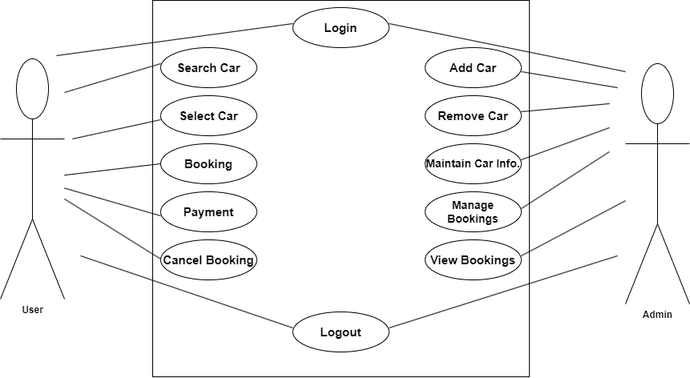

Figure: 3.1: Use Case Diagram

The functional requirement are as follows:

Register Module:

• The user needs to provide their first name, last name, email, phone number, password ,confirm password for registration.

• These details will be stored in Database.

Login Module:

• For login user will input their email and passwords.

• Admin will provide their admin id and password which will compared with a database content.

Booking Module:

• User can view the list of cars. The booking details are provided by the admin.

• User can select their preferred car and book for the same.

Payment Module:

• User should able to make payment Mobile banking and Cash.

• After payment user will get the payment successful popup window.

Logout Module:

• The system should allow user to logout.

• The system should also allow admin to logout.

**ii. Non-Functional Requirement**

It is a requirement that specifies criteria that can be used to judge the operation of a system, rather than specific behaviors. It is contrasted with functional requirement that define specific behavior or functions.

The non-functional requirement are as follows:

**• User Friendly**

The system should be user friendly. The UI should be intuitive and requires no training for use.

**• Operates in real time with minimal lag**

The Typical response time between the click and the reaction will be less than 0.5 seconds, which is considered ideal.

**• Reliable**

It will be reliable for the user.

**• Secure**

The data of user will be secure in Database of this System.

**• Maintainable and supportable**

The system will be updated and maintain in time.

### 3.1.2 Feasibility analysis

Feasibility study is made to see if the project on completion will serve the purpose of the organization for the amount of work, effort and the time that spend on it. Feasibility study lets the developer foresee the future of the project and the usefulness. The document provides the feasibility of the project that is being designed and lists various areas that were considered very carefully during. The feasibility study of this project such as technical, economic and operational feasibilities.

The following are its features:

Feasibility is evaluated from developer and customer’s point of view. Developers see whether they have the required technology or manpower to build the new system. Whether building the new system relay going to benefit the customer. Do the customers have the required money to build that type of system? All these issues are covered in the feasibility study of the system. The feasibility of our project is discussed in following topics:

1. Economical or financial feasibility
2. Technical feasibility

**Economical or Financial Feasibility**

Financial feasibility may indicate if the project is financially or economically feasible or not. Our project was economically feasible as we didn’t require any hardware equipment which might be costly. Since, our project is completely web-based, we didn’t require high budget and any extra infrastructure.

**Technical feasibility**

Technical feasibility study determines that the project is technically feasible or not. During the study, we gained the knowledge of BOOTSTRAP, CSS, HTML, PHP, some portion of JavaScript, and DBMS which is efficient for this project where we all are familiar with these languages. So, we finally conclude that the project is technically feasible.

**Schedule Feasibility**

In this Gantt chart, there are different task performed and their schedule while creating project. Similarly, the total time consumed to create the overall project is also mentioned below:

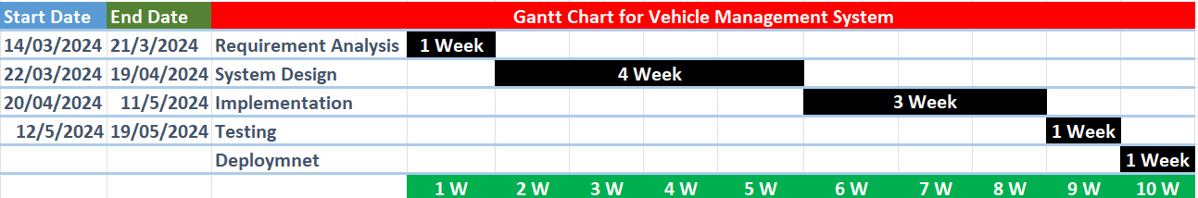

Figure: 3.2: Gantt Chart

### .1.3. Data Modelling

Figure: 3.3: ER-Diagram

### 3.1.4. Process Modelling (DFD)

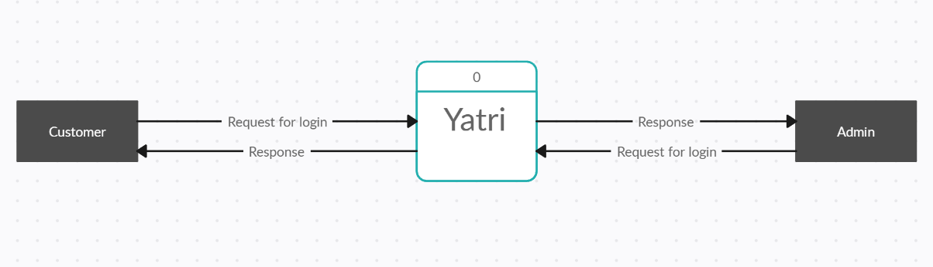

Figure: 3.4: Level 0 DFD

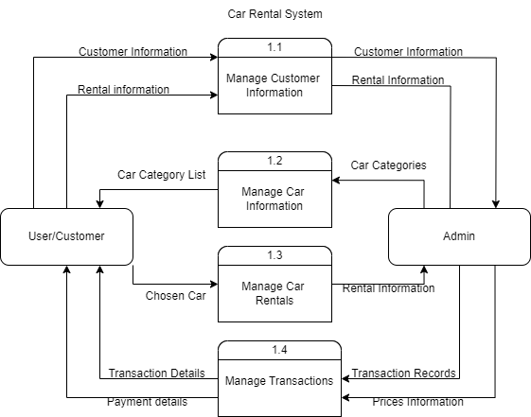

Figure: 3.5: Level 1 DFD

## 3.2 System Design

### 3.2.1 System Architectural Design

Figure: 3.6: Architectural Design

### 3.2.2 Database Schema.

Figure: 3.7 : Database Schema

### 3.2.3 Interface Design:

Interface Design refers to the process of designing the visual layout and interactive elements of a website or web application. The goal is to create an intuitive, aesthetically pleasing, and efficient user experience. Some of the wireframes that were created during the development of this project are as follows:

Figure 3.8: User Login Page Wireframe

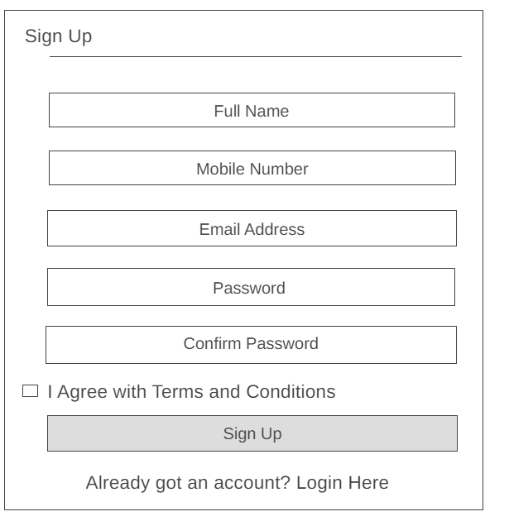

Figure 3.9: User Sign up Wireframe

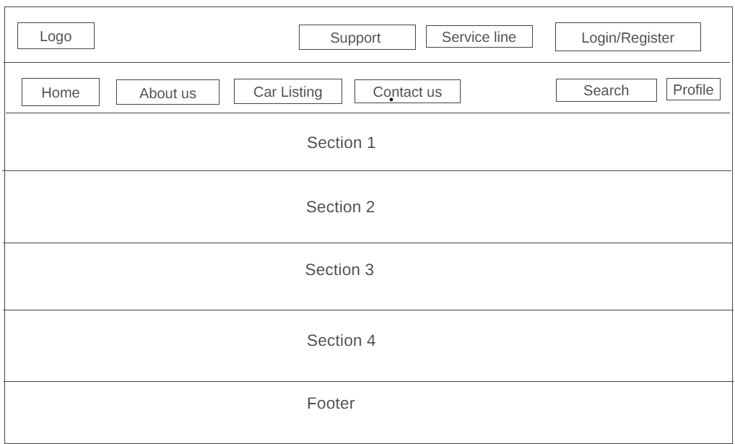

Figure 3.10: User Home Page Wireframe

Figure 3.11: Admin Profile Page wireframe

Figure 3.12 Add Vehicle Wireframe

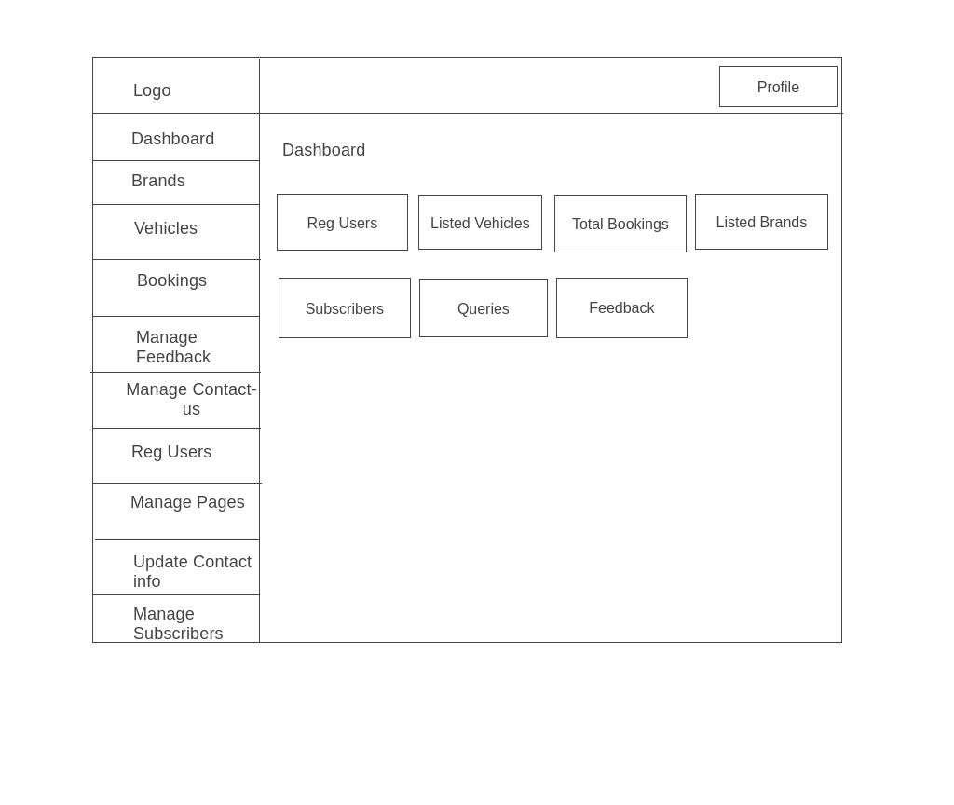

Figure 3.13 Admin Dashboard Wireframe

# CHAPTER 4

# IMPLEMENTATION AND TESTING

## 4.1 Implementation

Software implementation is the process of converting the designed system into the programs. This process includes not only the actual writing of the code but also the preparation of the requirements and objectives, the design of what is to be coded, and confirmations that what is developed has met the predefined objectives. Software testing is the process of executing a program or application with the intent of finding the software bugs. It can be stated as the process of validating and verifying a software program or the application. As planned in the designed phase, I used WATERFALL model as the development methodology.

### 4.1.1 Tools used

* **Frontend**
* Html
* CSS
* JavaScript
* **Backend**
* Php
* MySQL

### 4.1.2 Implementation details of modules

**Waterfall Model**

The waterfall model is a classical model used in system development life cycle to create a system with a linear and sequential approach. We have used waterfall because it helped us to develop our system systematically from one phase to another in a downward fashion. This model in our system is divided into different phases and the output of one phase is used as the input of the next phase. In our system, every phase has been completed before starting the next phase and there is no overlapping of the phases.

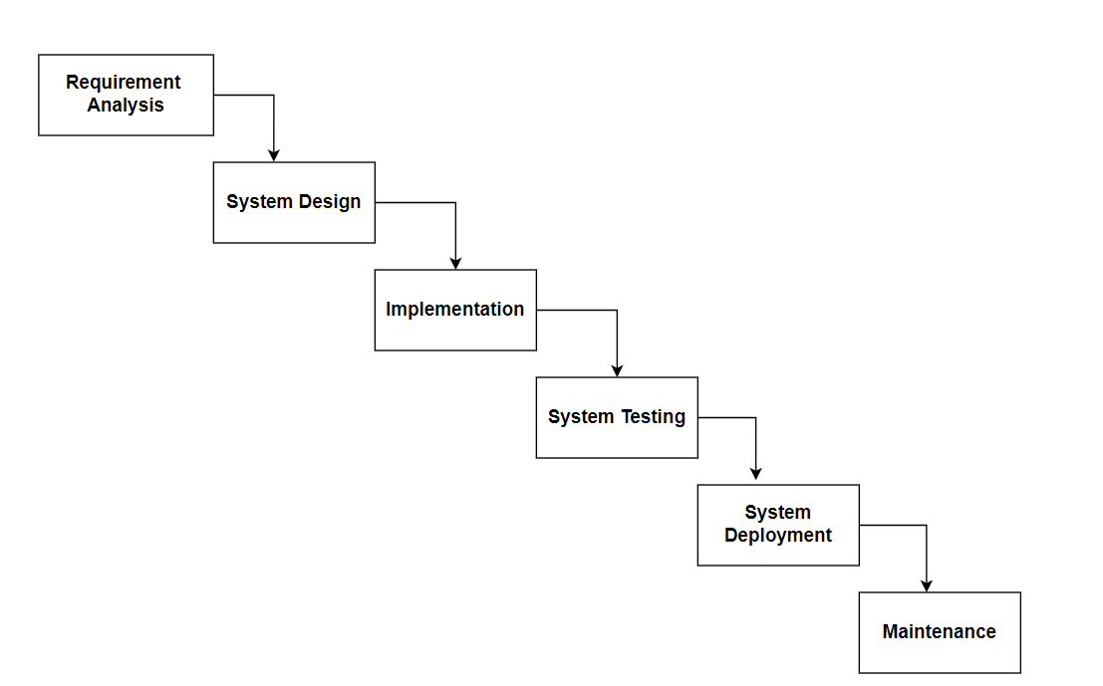

Figure 4.1: Waterfall Model

## 4.2 TESTING

Testing is done with each modules and the system as a whole to find errors for a reliable product. This involves unit testing, integration testing and finally user testing. We have carried out the testing to check for the bugs and to produce a user friendly environment in the application so that convenience of user is assured. Allowing few of our friends for trial run was done during and after the building of the application. Bugs were fixed along the way.

### 4.2.1 Unit Testing

In unit testing, the possible inputs and conditions of each class is tested. Here, the system is divided as individual packages such that each class can be tested independently. The several packages division allowed by the Eclipse environment was very helpful to carry out the unit testing. According to the work division, each person assigned with their job carried out the testing independently. But as most of the packages correspond to each other, unit testing alone was not sufficient.

### 4.2.2 Integration Testing

With the related units and classes all designed and constructed, integration testing is required. When two or more classes are integrated into subsystem, this type of testing is required to detect the interface errors or mismatch. As said above, carrying out unit testing is not enough. Most of the packages correspond to each other, and the overall performance of the subsystem must be checked for errors. While integrating, the parts of code that worked fine independently, might not work or produce errors when integrated with other codes. The function calls may return undesirable values or end up producing errors instead. Many such cases were observed while performing integration testing in "Yatri". Each code had to be traced to solve the bugs produced.

### 4.2.3 System Testing

System testing tests a completely integrated system to verify that it meets its requirements. After the completion of the entire module they are combined together to test whether the entire project is working properly.

**Test Cases**

A Test Case is a software testing document, which consists of events, action, input, output, expected result and actual result. Technically a test case includes test description, procedure, expected result and remarks. Test cases should be based primarily on the software requirements and developed to verify correct functionality and to establish conditions that reveal potential errors.

|  |  |  |  |
| --- | --- | --- | --- |
| **Test Case no** | **Test Case** | **Expected Results** | **Status** |
| 1 | Logging into website | Email and Password provided correct | Successful |
| 2 | Logging into website | Email incorrect | Unsuccessful |
| 3 | Logging into website | Password incorrect | Unsuccessful |
| 4 | Logging into website | Any field left empty | Unsuccessful |

**Table for Test case for Login**

Above table represents the test case for login module. It shows both successful and unsuccessful results for the test cases.

|  |  |  |  |
| --- | --- | --- | --- |
| **Test Cases no.** | **Test Case** | **Expected Results** | **Status** |
| 1 | Registration for new user | All details provided correctly | Successfull |
| 2 | Registration for new user | Any one field is incorrect | Unsuccessfull |
| 3 | Registration for new user | Any field is empty | Unsuccessfull |

**Table for Test case for Signup**

Above table represents the test case for sign up module. It shows both successful and unsuccessful results for the test cases.

|  |  |  |  |
| --- | --- | --- | --- |
| **Test cases no** | **Test Case** | **Expected results** | **Status** |
| 1 | Booking | All details provided  correctly | Successful |
| 2 | Booking | Any one field is  incorrect | Unsuccessful |
| 3 | Booking | Any field left empty | Unsuccessful |

**Table for Test Case for Booking**

Above table represents the test case for Booking module. It shows both successful and unsuccessful results for the test cases.

|  |  |  |  |
| --- | --- | --- | --- |
| **Test cases no** | **Test Case** | **Expected results** | **Status** |
| 1 | Feedback | All details provided  correctly | Successful |
| 2 | Feedback | Any one field is  incorrect | Unsuccessful |
| 3 | Feedback | Any field left empty | Unsuccessful |

**Table for Test Case for Feedback**

# CHAPTER 5

# CONCLUSION AND FUTURE RECOMMENDATIONS

## 5.1 Lesson Learnt/ Outcome

The Yatri car rental system project offered significant insights into effective software development practices, shaping a deeper understanding of what it takes to create a successful application. One crucial lesson was the importance of scalability. This entails designing the software to handle a growing amount of work or its potential to be enlarged to accommodate that growth. Ensuring scalability means the car rental system can efficiently manage an increasing number of users and transactions without compromising performance.

Another valuable takeaway was the significance of robust security measures. Protecting user data and transaction information is paramount, especially in a service-based system like Yatri. Implementing strong security protocols helped safeguard sensitive information and built user trust, which is essential for the system's success.

Moreover, the Yatri project underscored the importance of continuous improvement through user feedback. Regularly gathering and analyzing feedback from users allowed the team to identify pain points and areas for enhancement. By actively incorporating this feedback, the system was refined to better meet user needs and expectations, resulting in a more user-friendly and reliable car rental service.

This focus on scalability, security, and user-centric development will continue to guide future projects, ensuring the creation of software solutions that are not only efficient and secure but also aligned with user needs and preferences.

## 5.2 Conclusion

In conclusion, the Yatri car rental system project underscored the significance of two fundamental principles in software development: scalability and robust security measures. Prioritizing the ability of the software to handle growth ensures a seamless and efficient user experience, while implementing strong security protocols protects user data and builds trust. Additionally, actively listening to user feedback enables the creation of a product that truly meets their needs.

By adhering to these principles, future software development endeavors can strive to deliver solutions that are not only scalable and secure but also deeply aligned with the preferences and requirements of their intended users. As technology continues to evolve, these lessons will remain invaluable, guiding the creation of software that consistently delivers value and enhances the lives of its users.

## 5.3 Future Recommendations

* Focus on Making Software Faster and Smoother
* E-mail verification and OTP are used to increase the security on User accounts
* Use Agile Methods
* Create a Friendly Environment
* Continuous improvement based on user feedback

# 

# Appendices

**Figure: Screenshot of Home page**

Figure Indicates the home page of our website ‘Yatri’. This contains navigation bar through which user can navigate to other pages. It also contains some details about the website at the home page.

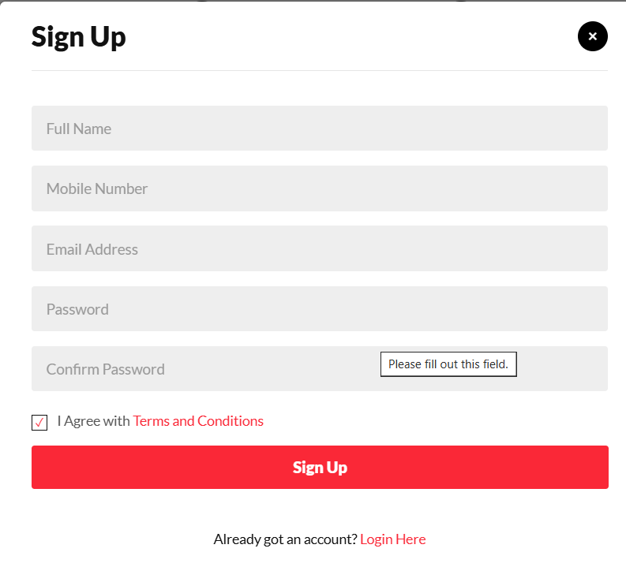

**Figure: Screenshot of User Signup/Registration page**

Figure indicates the user signup/registration page. It asks the user to enter the details like first name, middle name, last name, email, phone number, password, confirm password.

**Fig: User Login Page**

The above fig indicates user login page. It asks user to enter email and password in order to enter the website “Yatri”.

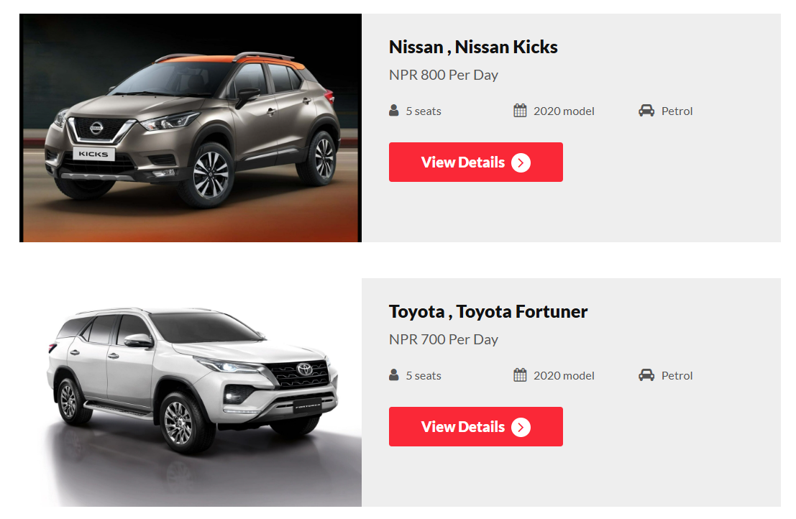

**Fig: Screenshot of View Page**

Above fig indicates view car page. It asks users to select different cars of their choices. It contains the details like fuel type, capacity, rent per day.

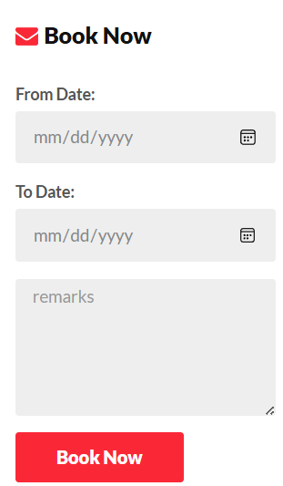

Fig: Screenshot of Booking page

Above Screenshot indicates the booking page. It asks the users to enter booking date, use days, remarks etc.

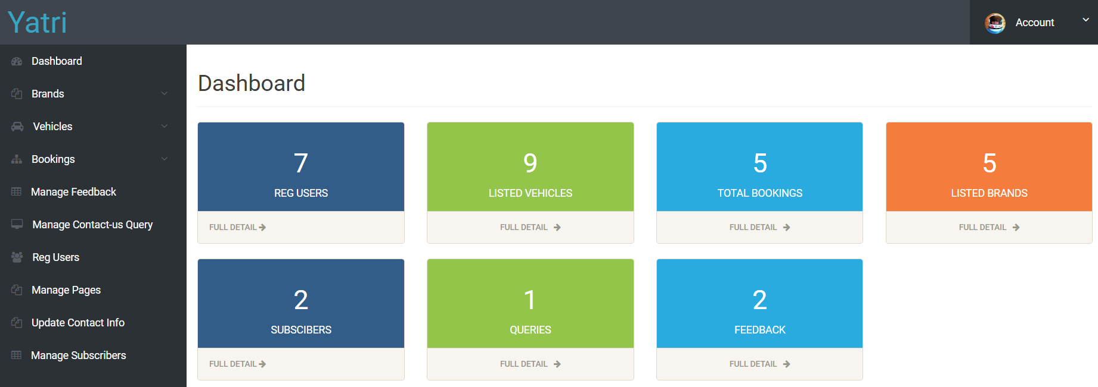

**Fig: Screenshot of Admin Dashboard**

Above screenshot indicates admin dashboard. This helps admin to add new cars, manage car details and user information.

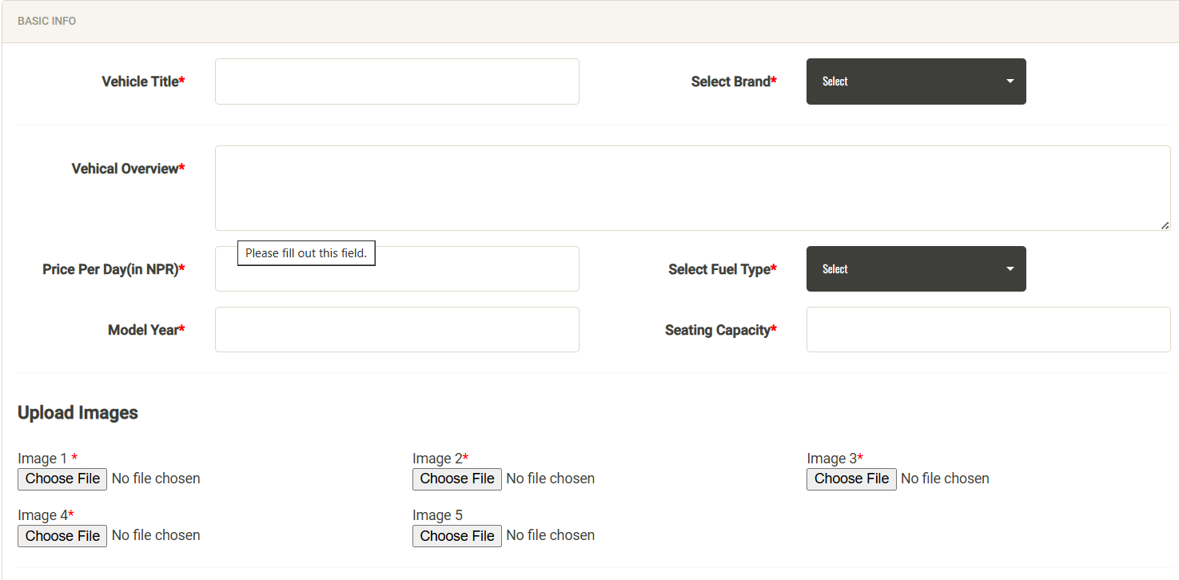

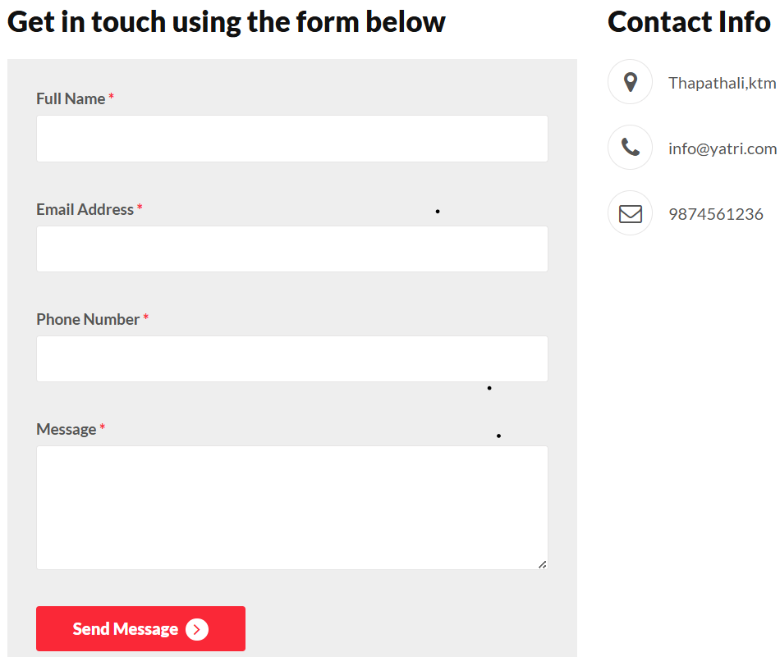

**Fig : Screenshot of Contact-Us Page**

This Screenshot indicates contact us page. This helps user to provide any query related to website to our team.

# REFERNCES

[1] "Smile Car Rental," [Online]. Available: <https://nepalvehiclerental.com/about-us/>

[2]"Easy Vehicle Rental System," [Online]. Available: <https://www.easyvehiclerental.com/>

[3] "The Rental Rader," [Online]. Available: <https://therentalradar.com/>

[4] "Sajilo Rental," [Online]. Available: <https://www.sajilorental.com/>