**New summit college**

**(Affiliated to Tribhuvan University)**



*Lab Report of*

**OPERATING SYSTEM (CACS251)**

*Bachelors of Computer Application*

*Faculty of Humanities and Social Sciences*

**Submitted by: Submitted to:**

**Name:**Pratiush Giri Rishav Aacharya

**Roll no : 21**

**Semester: IV**

**OUTPUT**

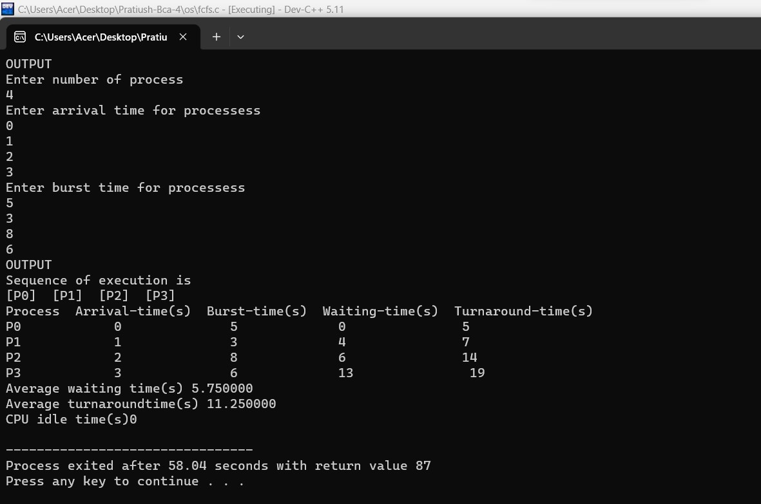

**OUTPUT**

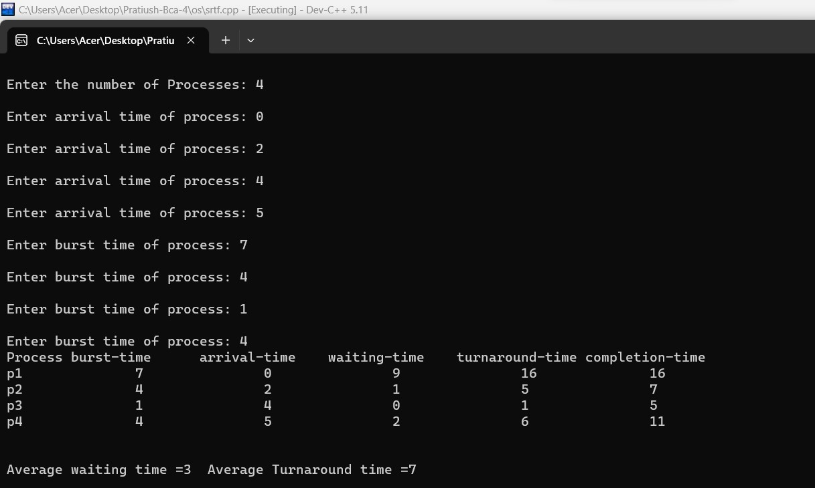

**OUTPUT**

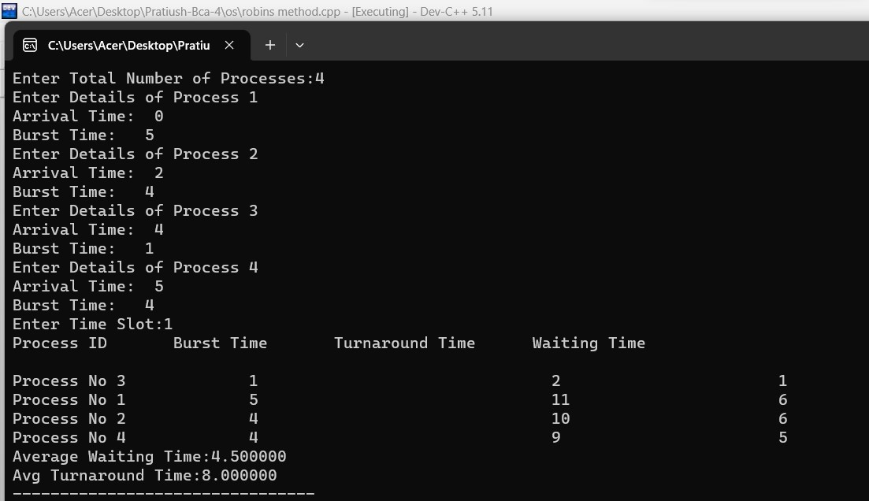

**OUTPUT**

