Horde  
Game Design Document

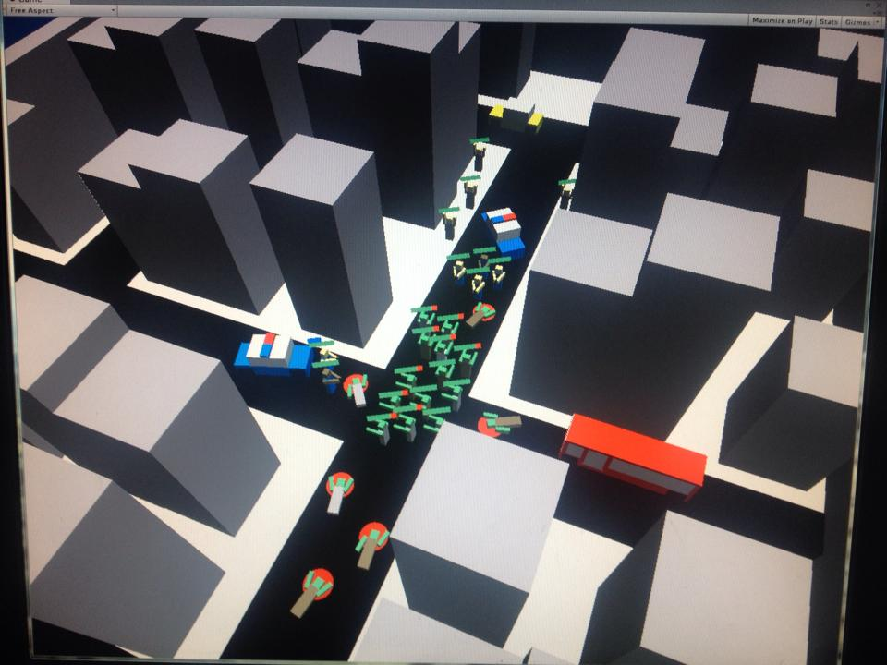  
Written by Brandon Nicholas & Rory McCaul  
23/3/2016

Version #1.00

Table of Contents

Table of Contents 2

1.0 Document History 4

2.0 Game Overview 5

2.1 Synopsis 5

2.2 Story and background 5

2.3 Art style and aesthetic 5

2.4 Gameplay features 5

2.4.1 Mechanic 1 5

2.4.2 Mechanic 2 5

2.4.3 Mechanic 3 5

2.5 Genre/demographic 5

2.6 Release details 6

2.6.1 Platforms 6

2.6.1 Business model 6

2.7 Project scope 6

2.7.1 Initial release 6

2.7.1 Eventual master 6

2.8 Editor/Engine 6

2.8.1 languages 6

2.8.1 licensing 6

3.0 Gameplay 7

3.1 Game flow 7

3.2 Mission structure 7

3.3 Objectives 7

3.4 Physics 7

3.4.1 Gun physics 7

3.5 Multiplayer support 7

3.5.1 friend finding 8

3.5.2 servers 8

4.0 Mechanics 9

4.1 Shooting 9

4.2 Mechanic 9

4.3 Mechanic 9

4.4 Movement/abilities 9

4.5 Environmental objects 10

4.6 Upgrade system 10

4.6.1 Sub 1 10

4.6.2 Sub 1 10

5.0 Characters 11

5.1 Playable characters 11

5.2 Customisation 11

5.3 Unlockables 11

5.4 micro transactions 11

5.5 Item performance tables 11

5.5.1 Weapons Performance Table 11

6.0 Levels 12

6.1 Urban Yard 12

6.1.1 Features 12

6.1.2 Aesthetic/setting 12

6.1.3 Schematic 12

7.0 Interface 13

7.1 GUI Elements 14

7.1.1 HUD 14

7.1.2 Menus 14

7.1.3 Camera 14

7.2 Controls 15

7.2.1 PC 15

7.2.2 iPhone (potentially) 15

8.0 Sound 16

8.1 Music 16

8.2 SFX list 16

9.0 AI 17

9.1 Team members 17

9.1.1 Attack 17

9.1.2 Defense 17

# 

# 1.0 Document History

Version 1.00 Added Synopsis and Story (BR)

Version 1.10 Added Gameplay Features (R)

Version 1.20 Added Mechanics (R)

# 2.0 Game Overview

## 2.1 Synopsis

Horde is an isometric strategy game for phones where players control zombies and must build up a horde to crush any human resistance. Players do not directly control each infected but instead control the main direction of the hordes movement by swiping over the horde. As they turn humans into zombies these will join the horde to create a massive swarm. Infect humans, conquer territories, and destroy safe zones. All will fall before your mighty horde!

## 2.2 Story and background

Horde begins by players gaining control of a newly reanimated zombie in a secret government laboratory in (insert city name here). Players must escape the laboratory whilst beginning to grow their horde by infecting AI in the facility, eventually escaping out into the city.

Once the player is free they will be released into a big open city filled with thousands of people to eat. Although it may seem easy to begin with, as humanity catches on to its impending doom they begin to fight back against the horde, setting up quarantine zones around the city. Players will need to infect and free of these zones if they wish to take over the rest of the world. Resistance will also appear in forms of safe zones and survivors around the city which can fight back against your horde, wiping them out if their numbers aren’t strong enough.

Quarantine zones are separated into territories that players will need to infect and conquer. They will encounter increasingly difficult enemies as the progress through the game, starting with Police, then soldiers, and finally survivors. Once all territories in the zone are infected players will break free of the quarantine zone to future potential levels.

**((**IDEA: Time limit, players must break free of the quarantine zone before the city is firebombed by the military**))**

## 2.3 Art style and aesthetic

Horde uses a simplistic block like art style, both as a unique aesthetic and as a way of reducing poly count as large amounts AI will be required on screen at one time.

## 2.4 Gameplay features

Core gameplay where you control your zombies is referred to as “in game” or “during a level”. You also view a map outside of levels where you can select which territory to attack, this is entering a level.

**Quarantine Zones –** Quarantine Zones are made up of territories. Each territory is a level. Completing the level will infect that territory, making it under your control. Players must infect every clear territory in a QZone to break out and proceed to the next one. The game will have multiple QZones that you unlock by completing the last one. QZones each have a different aesthetic and pseudo story line. We intend to release more QZones post launch.

**Territories -**  Each territory has a number of “Safe” Zones in it. Players must eradicate every safe zone in the level to infect it and then move their horde to a target area to complete the level. Infected territories will generate the player more zombies that they use to attack other territories. Infecting a territory will unlock all adjacent territories to be attacked.

**Safe zones –** Each territory will have a number of safe zones. Safe zones are a guarded area with a large number of humans. Safe zones would start as simple police barricades, then army guarded ones, then finally survivor bases. During gameplay you will see markers on the edge of your screen showing the direction and distance to each safe zone. Safe zones usually have some sort of defenses. You may need a large horde of zombies to break through these defenses successfully.

**Zombie Pool –** Out of mission you generate zombies in real life time based on the number of infected territories. This number will have a cap, also based on infected territories. This number determines how many zombies you will start with the next time you play a level. Territories have a recommended starting horde size, however this is only a recommendation and it may be possible to complete the level with a lower number if the player is skilled. At the end of each territory you only need to move one zombie to the target area to complete it, however every zombie that you move to the area will be added to your zombie pool after you leave the level so it is definitely worth collecting as many zombies as you can. (May include system where the player can voluntarily watch an advertisement to add a few zombies to their Zombie Pool, with a cap)

**Reclaiming infected territories –** If the player is absent from the game for an extended period of time (very subject to change and testing) humans will reclaim infected territories. Players will receive a notification telling them that their territory is being attacked. Humans will begin retaking safe zones over several real life hours. Upon returning to the game players will be prompted to retake the territory. The quicker they respond the less safe zones will be retaken and the easier the mission will be.

### 2.4.1 Mechanic 1

**Swipe Controls –** Swiping over zombies will cause them to move in the direction of the swipe. The effectiveness of your swipe changes based on the number of zombies.

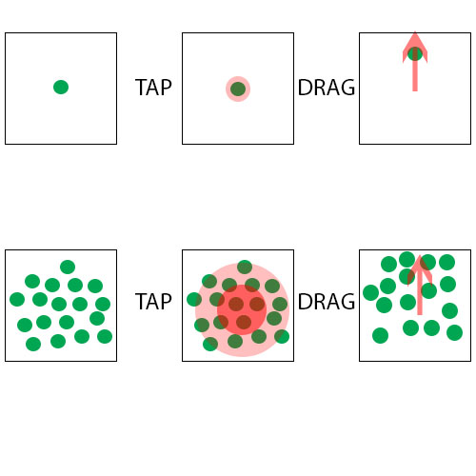With one zombie in your horde you will have maximum acceleration, the zombie will instantly move in the direction you swipe. In the diagram you can still with a single zombie it will directly follow your swipe.

As the number of zombies in your horde grows you will slowly lose acceleration, meaning you may need to swipe more times to get your zombies to move in the direction you wish.

However, as the size of your horde increases you will gain command. Command is a measure of how many zombies are affected by your swipes. In the diagram you can see a larger horde of zombies. This time after the tap you can see the two red rings. The zombies in the center darker one will follow a swipe all the time while the ones in the light ring only have a chance to follow your commands. As the size of your horde increases both of these rings will grow.

As the size of your horde increases you will also start gaining **MOMENTUM.** If you keep swiping your horde in one direction it will start to build up momentum. Gaining **momentum** will increase the movement speed of your horde and keep them running in a certain direction, but will make it a lot harder to control their movements in any other direction. If you continue swiping they will build up to their max momentum (based on the size of the horde), if you stop swiping they will start to slow down gradually. Having a high momentum will do the following

* Create more noise – This alerts humans but attracts zombies
* Zombies that you pass will start running to join your horde
* You will gain a powerful damage boost when your horde first collides with enemies.

### 2.4.2 Mechanic 2

**Zombie Attacking –** If your horde is within range of an enemy (humans) a number of zombies (based on the size of your horde will target that human and automatically attack them. Attacking a human takes a different amount of time based on their armor and combat training (e.g. it would take longer to kill a soldier than a civilian). After killing a human, zombie’s will begin eating them to regain health. Swiping over them will stop them eating the human and after a small delay the humans will turn into a zombie and join your horde.

**Human Attacking** – Humans react differently to zombies depending on their class.

Civilians – The majority of civilians simply flee from zombies; they are easy targets. Occasionally they may have a pistol that they fire at the closest zombie.

Police Officers – The first line of defense you will face. Police officers will generally be in a barricaded area and fire at the closest zombie. Police officers will have pistols, rifles, shotguns, and assault rifles. They may drive squad cars up to your zombies and attack them.

SWAT – SWAT launch strong attacks on your horde. They drive up in armored vehicles and deploy a number of trained SWAT members armed with pistols, riot shields, assault rifles and shotguns.

Soldiers – Soldiers are well trained and well equipped. They have a variety of weapons and tactics. They will set up watch towers to pick of zombies from range, have heavily barricaded areas, and launch attacks against your horde. Soldiers will have assault rifles, sniper rifles, grenade launchers and grenades. They also have armored vehicles and tanks. Tanks are used as a defense at barricaded positions, armored vehicles are used to launch attacks.

Survivors – They humans strong enough to survive the infection and start resisting. Survivors have the best tactics against zombies and a variety of weapons and equipment. The weapons are a mixture of ones previously encountered. They also have equipment such as Molotov’s and pipe bombs. Survivors will lay traps to try and kill large numbers of zombies with explosives and other devices.

Weapons deal different amounts of damage. Zombies have a health bar that shows up after they first take damage. As humans normally shoot at the closest zombie players can move them around to try and keep damaged zombies alive.

### 2.4.3 Mechanic 3

**Sound** – Zombies are naturally attracted to noises and if the player is not careful may find their zombies wandering off. The intensity and distance of the noise will determine whether zombies will walk towards it. If a horde has momentum they are unlikely to be attracted to all but the most intense sounds. Sounds would include

* Screaming civilians/Safe zones (General noise) – Low level noise. Would attract nearby small hordes.
* Gun shot – Medium level noise. Would attract any horde that does not have a lot of momentum.
* Explosion – High level noise. Even hordes with momentum may be attracted to such a loud sound.
* Pipe bomb/Car Alarm/Siren – Extreme noise. Drives zombies crazy, even a horde with a lot of momentum will be attracted to this unless the player swipes them away like crazy.

There will be all different sounds present in the game. Soldiers may use silencers on their guns, reducing noise, or survivors may lay traps that make noise to attract zombies into an ambush. If players pay attention to their horde they can control them and stop them from following the sound.

### 2.4.4 Mechanic 4

**Abnormal’s –** Abnormal’s are found during levels. Each abnormal has a specific signature area where you can find them. To make an abnormal join your horde you must move your horde passed the signature area and over the abnormal. They will then join your horde. Territories have a cap for the number of abnormal’s you can find each time you play the level. Replaying the level will allow you to make different choices in which abnormal’s you use. Abnormal’s will be visible through fog of war with a tiny field of view around them.

**Straitjacket –** This abnormal will be found walking in circles around crashed ambulances. As your horde builds up momentum this abnormal will begin to scream, generating noise. This will alert humans but stop your zombies from being distracted by other noises. It will also occasionally attract other zombies to join your horde.

**Little Girl –** This abnormal will be found playing on a playground. Humans will not shoot at this abnormal unless they see it attack another human. This abnormal has a higher movement speed than normal zombies when not part of a horde and can deal massive damage if it attacks an unaware enemy.

**Dictator Actor –** This abnormal will be found banging on the door of acting agencies. While this zombie is a part of your horde it increases your acceleration and control of your zombies.

**Ice Cream Truck Driver –** This zombie will be found in a garage near an ice-cream store. If the player moves their horde near the garage the door will open and the ice-cream truck driver will pull the car slightly out of the garage. Tapping on the ice-cream truck will give you control over it. Your camera will lock to the ice-cream truck and it will start playing a tune, causing your zombies to follow it over all other noises. The ice-cream truck will start slowly accelerating constantly. Two little arrows will appear next to the truck that the player can tap to change its direction. The truck will keep gaining speed to a maximum. It will explode if it collides with something fast enough.

**Obese dude –** This abnormal will be found near fast food restaurants. While this zombie is a part of your horde it will occasionally eat zombies, growing in size. Tapping and holding this zombie will cause it to start throwing up over nearby humans and infecting them, losing size in the process.

### 2.4.5 Mechanic 5

**Camera Controls** – If the player taps and holds for a second on an area with no zombies they can move the screen around. Zombies have a field of vision around them that grows much larger when they form a horde. Areas without vision show a darkened view of all buildings and terrain but do not display any enemies.

Tapping and holding on a horde will temporarily make the camera automatically follow the horde. Splitting up your horde or moving the camera manually will break the lock.

## 2.5 Genre/demographic

As horde is an isometric strategy game for smart phones with a simplistic art style the demographic can appeal toward male and females aged between 13 and 35 years old. The game fills the void of Zombie games where the player controls the zombie, instead of survivors. The game will appeal to a wide market of casual gamers with a variety of things. Simple polished graphics that make the implied violence (zombies eating people) less violent to allow the game to be accessible to children and people turned off by violence. Short to medium game times and simple controls mean the game can be played easily on public transport. The game will appeal heavily to players who like a degree of strategy

## 2.6 Release details

### 2.6.1 Platforms

Ios and Android

### 2.6.1 Business model

Freemium (Were not evil we promise ;) )

Game will include cosmetic items for a small price ($1-$2). These would include full reskins for your zombies, with unique skins for each abnormal. Also possible to get reskins for humans. Would have different themes, some holiday related (Christmas, Easter).

Players can voluntarily watch ads to receive a small bonus such as filling a % of your Zombie Pool or increasing the number of Abnormals you encounter in a level.

## 2.8 Editor/Engine



The engine used for creating Spirit Dojo is the Unity Engine, this engine has been chosen as it is easy to use, reliable and is well known in the industry.

### 2.8.1 languages

English

### 2.8.1 licensing

Unity 5 Professional Edition

### 2.8.1 languages

Body text

### 2.8.1 licensing

Body text

# 3.0 Gameplay

## 3.1 Game flow

Body text

INSERT FLOW CHART of the main GAME FLOW

## 3.2 Mission structure

Body text

## 3.3 Objectives

Body text

## 3.4 Physics

Body text

### 3.4.1 Gun physics

Body text

## 3.5 Multiplayer support

Body text

### 3.5.1 friend finding

Body text

### 3.5.2 servers

Body text

# 4.0 Mechanics

## 4.1 Shooting

Body text

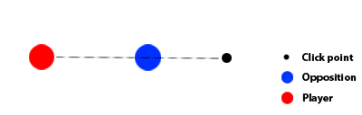

In figure 1.0, the player has clicked far beyond the opposition. In this scenario, the projectile would travel over the opposition and would not hit.

More diagrams describing the positions

## 4.2 Mechanic

Body text

## 4.3 Mechanic

Body text

## 4.4 Movement/abilities

Body text

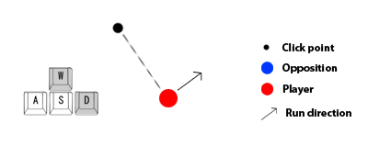

Figure 2.0 shows that the player is running in a North East direction, but is firing in another direction. The player would face the way they are firing.

Body text

## 4.5 Environmental objects

Body text

Use diagrams to elaborate and provide detail for environmental interaction

## 4.6 Upgrade system

Body text

### 4.6.1 Sub 1

Body text

### 4.6.2 Sub 1

Body text

# 5.0 Characters

## 5.1 Playable characters

Body text

## 5.2 Customisation

Body text

## 5.3 Unlockables

Body text

## 5.4 micro transactions

Body text

## 5.5 Item performance tables

Ratings are out of ten. 10 being the highest, 1 being the lowest in performance.

### 5.5.1 Weapons Performance Table

|  |  |  |  |  |
| --- | --- | --- | --- | --- |
|  | Parameter | Parameter | Parameter | Special |
| Default | 6 | 6 | 6 |  |
| Weapon | 5 | 7 | 7 |  |
| Weapon | 8 | 5 | 5 |  |
| Weapon | 5 | Possible 10 | NA | text |
| Weapon |  |  |  |  |

# 6.0 Levels

Body text

## 6.1 Urban Yard

### 6.1.1 Features

Body text

### 6.1.2 Aesthetic/setting

Body text

### 6.1.3 Schematic

Body text

Add diagrams of levels here

# 7.0 Interface

Menu system will be outlined in the following flowchart.

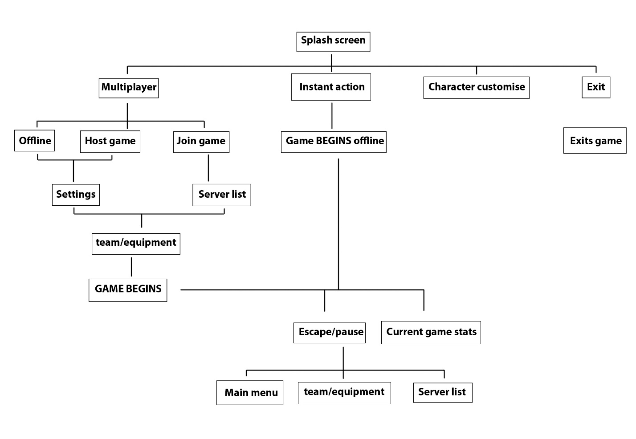

## 7.1 GUI Elements

### 7.1.1 HUD

Body text

Include diagrams

### 7.1.2 Menus

MENU

Body text

MENU

Body text

MENU

Body text

### 7.1.3 Camera

Body text

## 7.2 Controls

### 7.2.1 PC

TAB key Display game statistics while held down

~ Brings up console

Esc key Pause menu Does not pause gameplay in online multiplayer

W Move forward

A Move left

S Move backward

D Move right

E Use To interact with environmental object such as turret

Mouse Look

Left mouse Fire weapon

Right mouse Jump

### 7.2.2 iPhone (potentially)

Body text

# 8.0 Sound

Body text

## 8.1 Music

Body text

## 8.2 SFX list

List all sound effects

# 9.0 AI

Body text

## 9.1 Team members

Body text

### 9.1.1 Attack

Body text

### 9.1.2 Defense

Body text