Horde

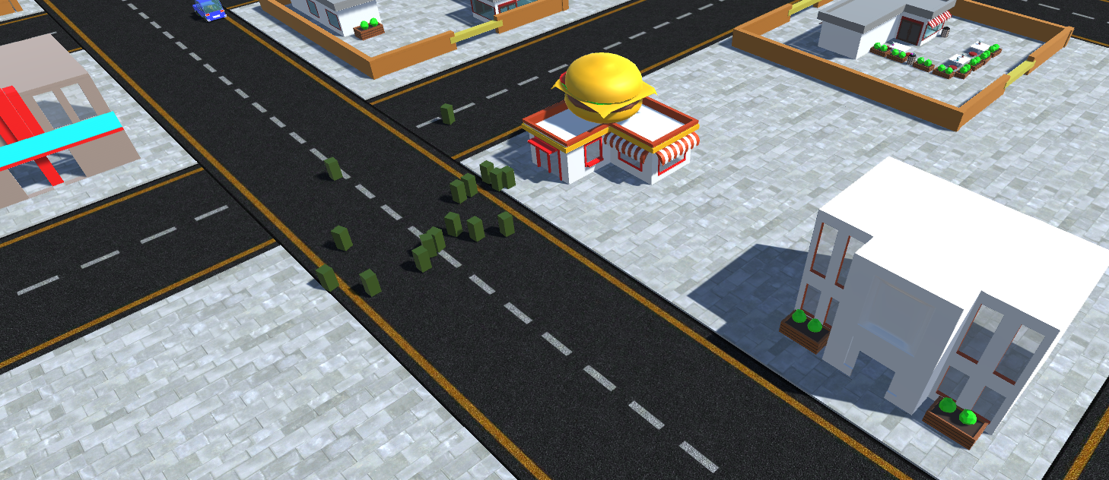

Revision: 2.0.0

Overview

Theme / Setting / Genre

Core Gameplay Mechanics Brief

Targeted platforms

Monetization model (Brief/Document)

Project Scope

Influences (Brief)

- <Influence #1>

- <Influence #2>

- <Influence #3>

- <Influence #4>

The elevator Pitch

Project Description (Brief):

Project Description (Detailed)

What sets this project apart?

Core Gameplay Mechanics (Detailed)

- <Core Gameplay Mechanic #1>

- <Core Gameplay Mechanic #2>

- <Core Gameplay Mechanic #3>

- <Core Gameplay Mechanic #4>

Story and Gameplay

Story (Brief)

Story (Detailed)

Gameplay (Brief)

Gameplay (Detailed)

Assets Needed

- 2D

- 3D

- Sound

- Code

- Animation

Schedule

- <Object #1>

- <Object #2>

- <Object #3>

- <Object #4>

# Overview

Horde is a wacky isometric strategy game for phones where players control a horde of zombies to obliterate humanity. Players control their horde by swiping to direct their movement. They must ensure the zombies aren’t distracted by gunfire and explosions whilst trying to infect humans to transform them into the living dead. Horde allows the player to control strange and amusing Abnormals, zombies such as the little girl and ice-cream truck driver. These zombies have unique abilities to help the player complete the levels. With a simple and colorful art style with comical gore the game ignores everything serious about zombies. Instead the player is given the joy of overwhelming heavily guarded safe zones with swarms of moaning, green, undead minions and watch as they infect every human that doesn’t run screaming into the distance.

## Core Gameplay Mechanics

* Controlling the Horde: Swiping over zombies will cause them to move in the direction you swiped. Zombies will attack humans that are

within their range. Tapping on an area will cause the camera to center on that location.

* Noise: Zombies are attracted to noise. Explosions, gunfire, alarms, and other zombies generate noise. Zombies will prioritize swipes over noise.
* Devouring: After a zombie attacks and kills a human the human will fall to the ground. Nearby zombies who are damaged will start to eat the body regaining health. Swiping over them will cause them to stop.
* Infecting: After a human dies if they are left alone for a few seconds they will rise as a zombie.
* Abnormals: Special zombies that can be found in the level. Each Abnormal has a unique ability that can be activated by pressing an onscreen button.

## Core Gameplay Features Brief

**Levels**

* Quarantine Zones: Quarantine Zones are a map made up of territories. Players must complete all the territories to unlock additional quarantine zones.
* Territories: Each territory is a playable level. After completing the first territory the player can choose to start any adjacent territories. Infected territories allow the player to gain more zombies and take more zombies into levels.

* Safe Zones: Levels contain safe zones the player must captured to complete the level. These are heavily guarded locations ranging from road blocks to fortified bases. You must have a strong horde before overwhelming these locations.

**Central Hub**

* Science Facility: The main base and menu is set in a Science Facility the player takes over in the tutorial level. It is made of the Laboratory, the Control Room and the Zombie Bar, all 3D modelled. Transitioning through the menu will cause the camera to fly to the selected room and bring up an overlay for menu input.
* Control Room: The control room is where the player selects levels to play. There will be a supercomputer in the center of the screen. Clicking this will bring up a map which shows the current quarantine zone and territories.
* Laboratory: Here the player can research upgrades for their horde. The player starts with some Zombie Scientists and gains more if they find scientists in levels. Zombie Scientists slowly generate Ideas in real time. These can be spent on upgrades.
* Zombie Bar: The Zombie Bar slowly fills with zombies in real-time, based on the number of territories you control. The zombies in the Zombie Bar are taken into levels.

**Additional Features**

* Convoys: As the game progresses convoys will travel between safe zones. Convoys will transport either survivors, supplies or Abnormals. Players can attack the convoy to gain a new abnormal, cut off reinforcements or destroy supplies.
* Reclaiming Territories – If the player is absent from the game for a period of time humans will attempt to reclaim captured territories. Players receive a notification warning them to return and fight them off.

## Targeted platforms

- Android

- iPhone

## Brief monetization model

* Free to Play: Ad Driven and Micro-transactions

Game will include voluntary reward based ads to refill Zombie Bar

Micro-transactions will be cosmetic upgrades

## 4 Magic Words

Shepherd your undead Horde!

Reanimate, Infect, Devour, Conquer!

## Project Scope

- <Game Time Scale>

- Below information is for 6 month project. Additional features will be completed if the project is continued.

- <Team: AIE The Walking Devs>

- Rory Caire-McCaul: Lead Designer

- Brandon Nicholas: Level Designer

- Reece Howe: Programmer

- Adrianna White: Environmental Artist

- Aanikka Holder: Character Artist

- <Milestones>

|  |  |  |  |
| --- | --- | --- | --- |
|  | Design | Art | Programming |
| Prototype | Working level with preset zombies and civilians | Any finished models + Gray box assets | Horde movement via Swipe  Safe zone barricades |
| Month 1 |  |  |  |
| Month 2 |  |  |  |
| Month 3 |  |  |  |
| Month 4 |  |  |  |
| Month 5 |  |  |  |

## Core Gameplay Mechanics (Detailed)

### <Controlling the Horde>

* The Horde will move with a combination of player input and AI
* If the player swipes over the horde zombies under the swipe will begin moving in the direction swiped. Swipe commands have a higher priority than any AI action.
* Additional swipes in the same direction will cause zombies speed to increase, to a max.
* Max speed is increased the larger the horde. However, large hordes respond slower to commands.
* In practice, when you have a large horde they have a higher max speed then a small horde, however they will respond less readily to swipes meaning they take longer to build speed.

* Zombies are attracted to noise. Explosions, gunfire, alarms, and other zombies generate noise. Zombies themselves generate a small amount of noise. Swiping over zombies causes them to release a larger burst of noise.
* In practice, if you are not watching over your zombies they may wander off in search of noises. If you move a section of your horde because they are generating noise nearby zombies will follow after them.
* If zombies are within range of a human, they will run towards them and begin attacking. Once a human is dead nearby zombies who are damaged will begin to devour them regaining health. If a human is not fully eaten and left alone for 3 seconds, they will reanimate as a zombie and join your horde.

### 

### <Safe Zones>

* Capturing safe zones is the main objective during missions. There will be objective arrows floating on the edge of the screen pointing in the direction of the safe zones.
* Safe zones differ greatly in their defenses, generally increasing as you progress through the game. Early safe zones are protected by simple barricades and chain fences while long time survivors create nigh impenetrable fortifications that even the largest horde has trouble breaking down.

### <Core Gameplay Mechanic #3>

- <Details>

/Describe in 2 Paragraphs or less/

- <How it works>

/Describe in 2 Paragraphs or less/

### <Core Gameplay Mechanic #4>

- <Details>

/Describe in 2 Paragraphs or less/

- <How it works>

/Describe in 2 Paragraphs or less/

# 

# Story and Gameplay

## Story (Brief)

<The Summary or TL;DR version of below>

## Story (Detailed)

<Go into as much detail as needs be>

<Spare no detail>

<Use Mind Mapping software to get your point across>

## Gameplay (Brief)

<The Summary version of below>

## Gameplay (Detailed)

<Go into as much detail as needs be>

<Spare no detail>

<Combine this with the game mechanics section above>

# Assets Needed

## - 2D

- Textures

- Environment Textures

- Heightmap data (If applicable)

- List required data required - Example: DEM data of the entire UK.

- Etc.

## - 3D

- Characters List

- Character #1

- Character #2

- Character #3

- etc.

- Environmental Art Lists

- Example #1

- Example #2

- Example #3

- etc.

## - Sound

- Sound List (Ambient)

- Outside

- Level 1

- Level 2

- Level 3

- etc.

- Inside

- Level 1

- Level 2

- Level 3

- etc.

- Sound List (Player)

- Character Movement Sound List

- Example 1

- Example 2

- etc.

- Character Hit / Collision Sound list

- Example 1

- Example 2

- etc.

- Character on Injured / Death sound list

- Example 1

- Example 2

- etc.

## - Code

- Character Scripts (Player Pawn/Player Controller)

- Ambient Scripts (Runs in the background)

- Example

- NPC Scripts

- Example

- etc.

## - Animation

- Environment Animations

- Example

- etc.

- Character Animations

- Player

- Example

- etc.

- NPC

- Example

- etc.

# Schedule

### - <Object #1>

- Time Scale

- Milestone 1

- Milestone 2

- Etc.

### - <Object #2>

- Time Scale

- Milestone 1

- Milestone 2

- Etc.

### - <Object #3>

- Time Scale

- Milestone 1

- Milestone 2

- Etc.

### - <Object #4>

- Time Scale

- Milestone 1

- Milestone 2

- Etc.