Health & Fitness Web Application Project Documentation

1. Outline
This project is a compact Health & Fitness web application designed for recording personal achievements (runs, workouts, sleep), tracking menstrual cycles, scheduling medications, and utilizing fitness calculators (BMI, BMR/TDEE, heart-rate zones, macros, water).
- Key Features: Secure per-user accounts, keyword searching, CSV data export, a calendar view for period tracking, "next-due" suggestions for medications, and a dashboard for monitoring recent logs.
- Implementation: Single Node.js Express server using EJS for server-side template rendering and a MySQL backend for data persistence.
- Security: Designed as a coursework prototype demonstrating clear separation between application and data tiers, featuring lightweight audit logging, input sanitization, and rate limiting.

2. Architecture
The application uses a Model-View-Controller (MVC) architecture condensed into a single server instance.
- Application Tier: Built with Node.js and Express. Handles routing, session management (express-session), authentication (bcrypt), and renders UI views using EJS templates.
- Data Tier: A MySQL database. Connection is managed via a connection pool (mysql2/promise) for efficient concurrent request handling.
- Observability: Integrated audit logging tracks critical events within the application logic.

3. Data Model
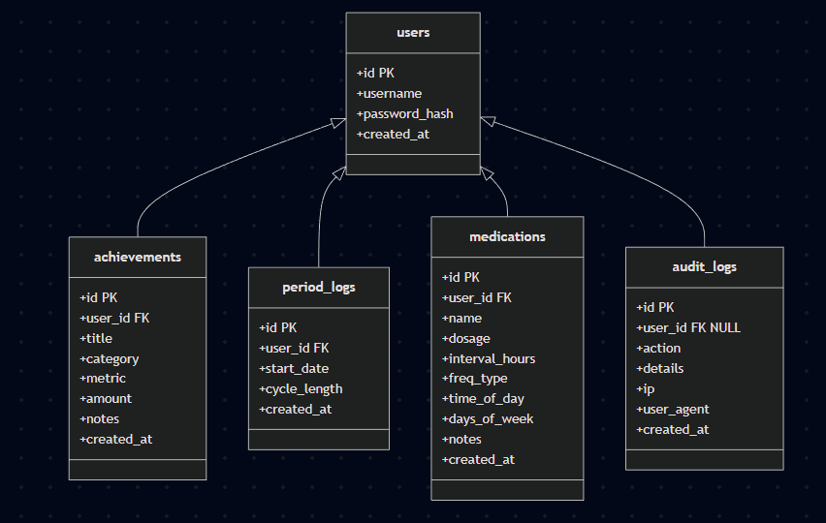
The data model is represented through a Mermaid ER diagram centered on the users table, which anchors all other functional data. Each feature-specific table — achievements, period_logs, and medications — contains a foreign key to users, ensuring complete per-user data isolation and enabling cascade deletes. The audit_logs table also references users, but its link is nullable to preserve historical records even after an account is removed. The diagram illustrates how each domain of user data is kept distinct yet consistently tied back to the account layer, creating a clear, maintainable, and well-normalized relational structure.

4. User Functionality

4.1. Authentication & Dashboard
Users register and sign in using session-based authentication. The dashboard provides clear navigation to all trackers and tools.




4.2. Achievement Tracker
Allows users to log specific activities (runs, workouts, sleep).

- Features: Adding entries (title, category, metrics, amounts, notes), viewing a paginated history list, filtering/searching by keyword, and exporting data to CSV.

4.3. Period Tracker
Allows users to log the start date of their menstrual cycle.
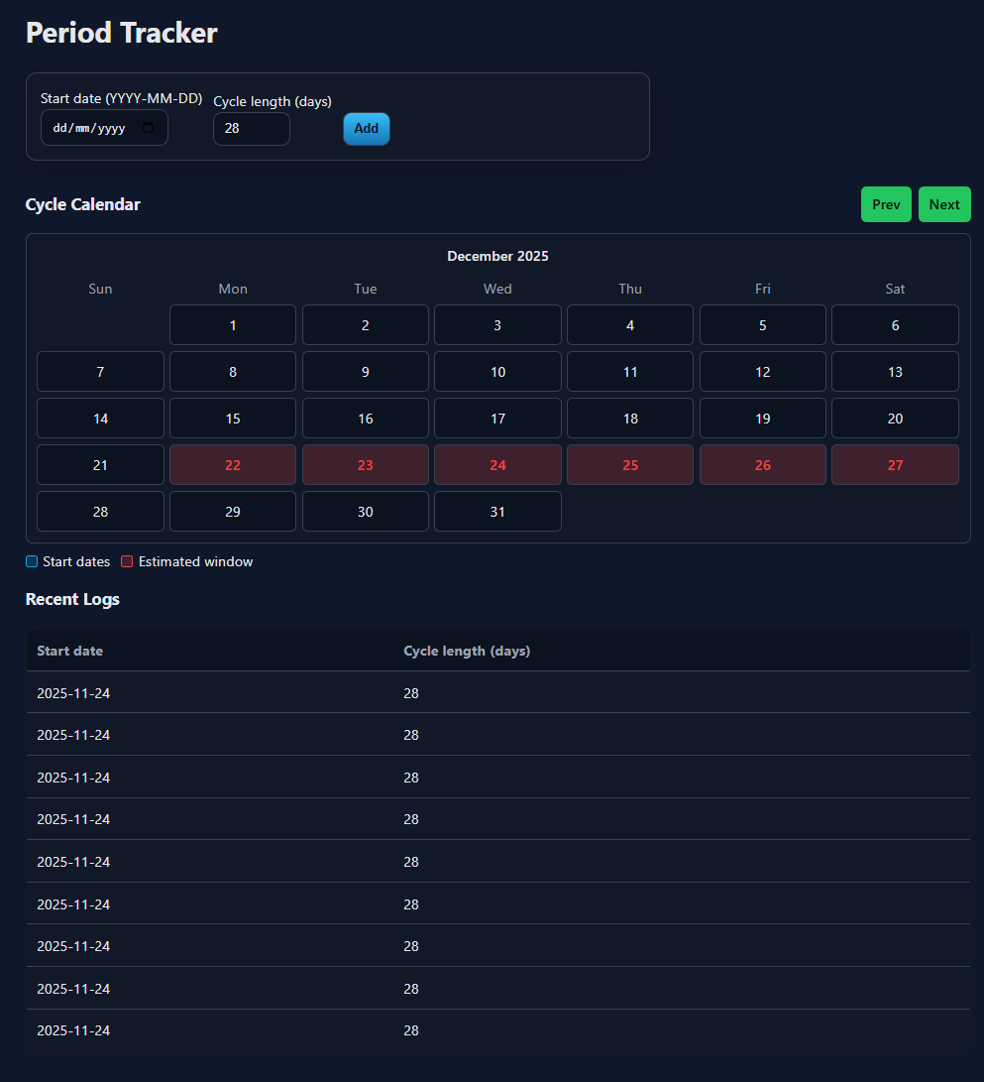
- View: Renders a monthly calendar that highlights recorded dates and visually estimates the next cycle window based on recent logs.

4.4. Medication Scheduler
Helps users manage prescriptions by inputting medication name and schedule (interval, daily, or weekly).

- Feature: Calculates and displays the specific "Next Due" time for every item to assist with adherence.

4.5. Fitness Tools

A suite of calculators for health planning:
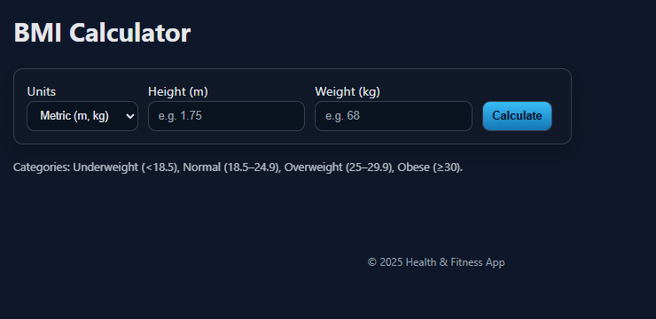
- BMI Calculation

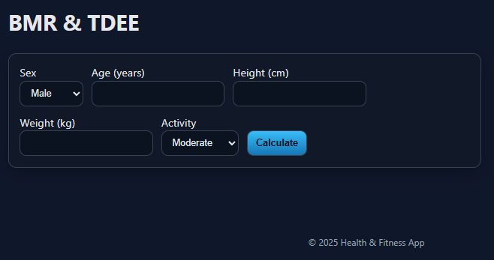
- BMR/TDEE Calculation


- Heart-Rate Zone Estimation:


- Macro calculator:

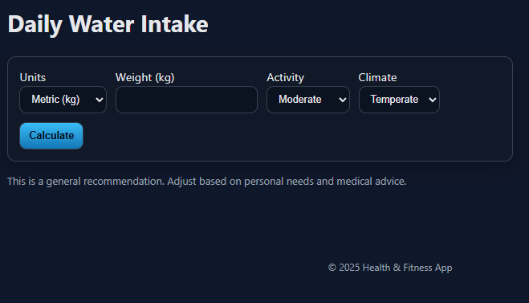
- Daily Water Intake Recommendations:

- Nutrition lookup:
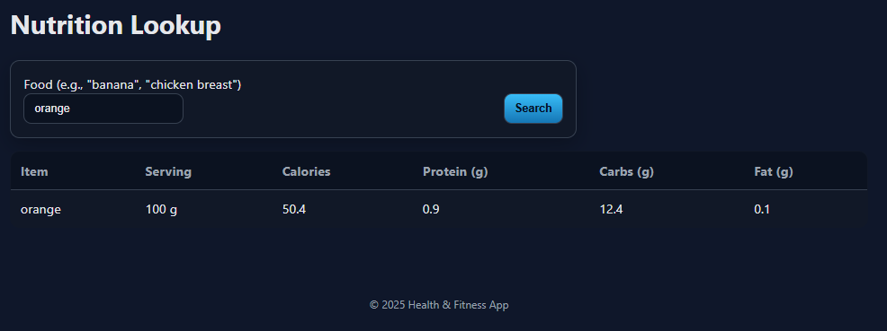

5. Advanced Techniques

5.1. Database Connection Pooling
Uses a connection pool (mysql2/promise) instead of opening a new connection for every request, efficiently managing database resources.
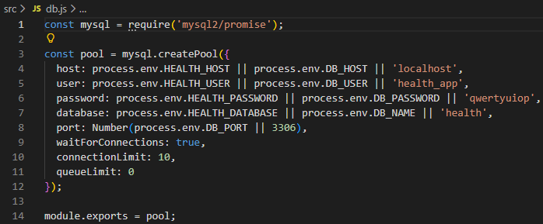

5.2. Input Sanitization
A custom server-side sanitizer is implemented to strip dangerous tags (like <script>) and event handlers to prevent Stored XSS attacks.
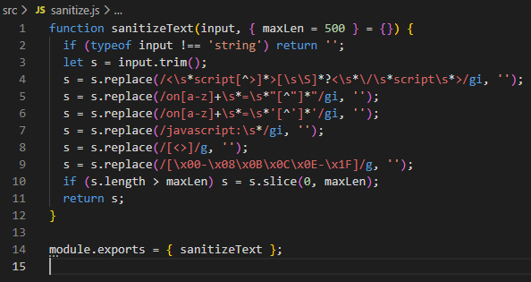

5.3. Rate Limiting and Audit Logging
A compact middleware implements a "Leaky Bucket" style limiter per IP/Route to prevent abuse. This is coupled with an audit system for application observability.
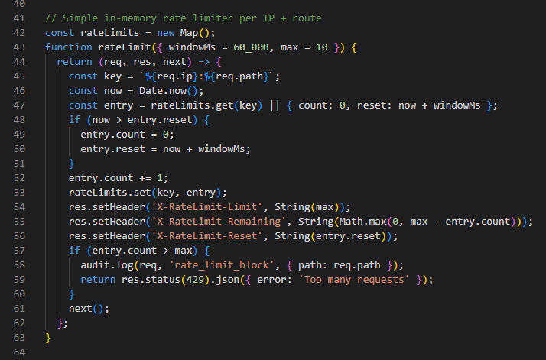
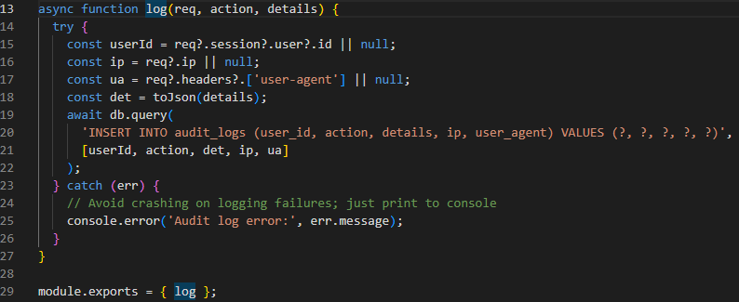

5.4. Parameterized Search (Security)
Search functionality utilizes parameterized queries (?) provided by mysql2 to strictly prevent SQL Injection vulnerabilities during keyword lookups.
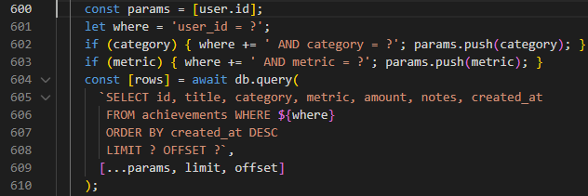

AI Declaration: An AI assistant was used for rewording documentation for clarity, grammar correction, and researching technical solutions for deployment issues (specifically resolving a base URL stripping problem on the Virtual Machine).

