
IET DAVV
Institute of Engineering & Technology, Devi Ahilya Vishwavidyalaya, Indore
Student Lifecycle Portal
Functional Workflow
How users move through the portal
Prototype documentation — July 2026
Demonstration prototype · not an official DAVV system

1. Actors & portals
Three roles, each with its own portal behind a single login. Admins additionally have sub-roles whose access is controlled by an editable permission matrix.
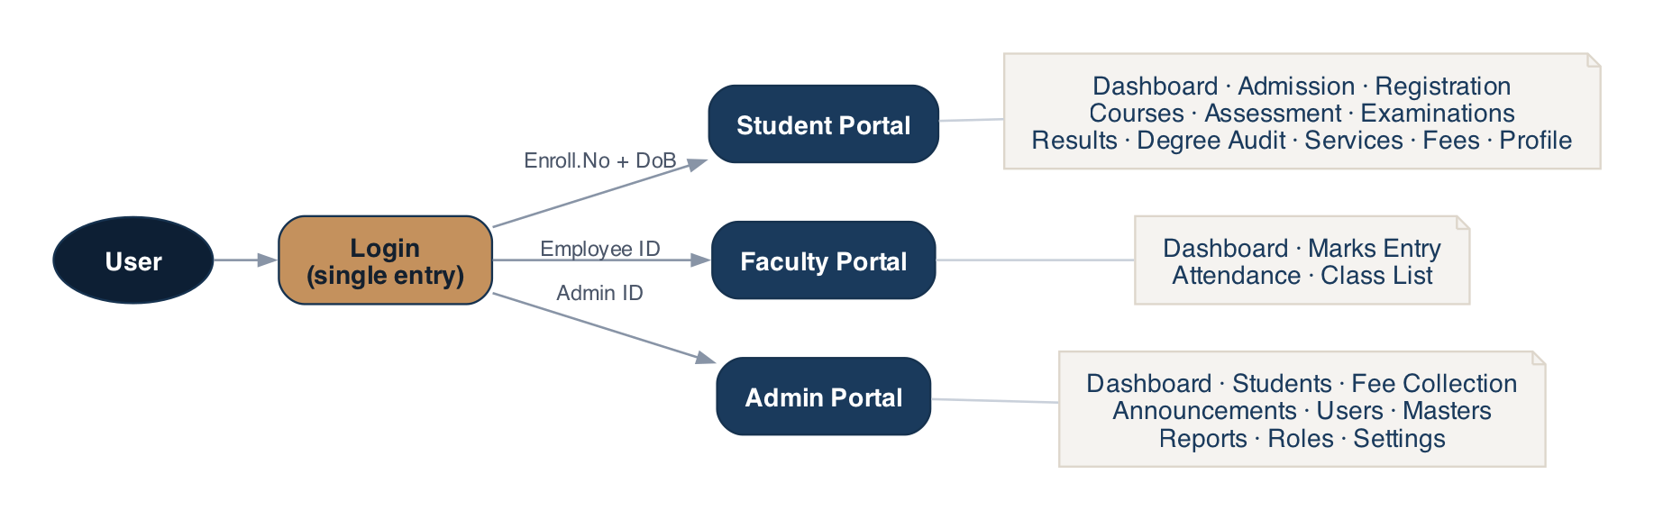
Figure 1 — One login routes each role to its own portal.

2. Login & role routing
Login is a mock identity check against seeded users. The session (role + user id) is saved in the browser and decides which portal shell loads. A guard sends anyone in the wrong area back to the login screen.
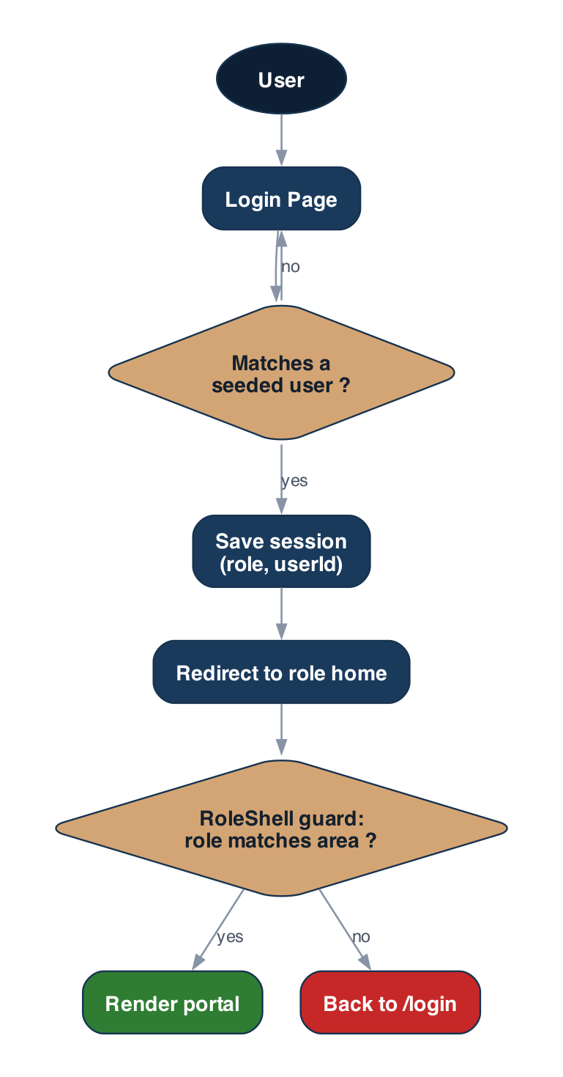
Figure 2 — Login validates, stores the session, and the shell guards the area.

3. The complete student lifecycle
The spine of the product runs from admission all the way to the degree, with a repeating per-semester loop in the middle. It is shown here in three parts.

3.1 Admission & onboarding
Admission is through DTE Madhya Pradesh counselling (JEE Main). After allotment, document verification and the first-semester fee, the student is enrolled and receives an Enrollment Number — their identity for everything that follows.
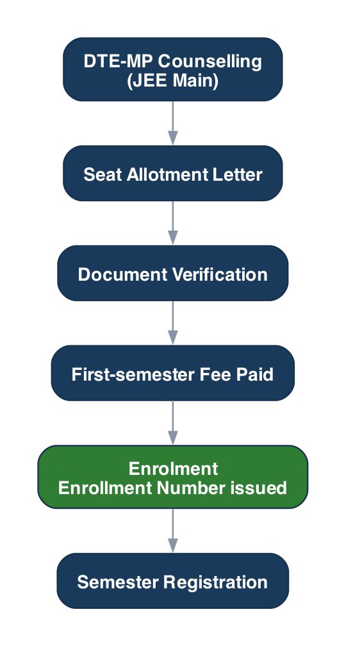
Figure 3 — From DTE counselling to enrolment and first registration.

3.2 The academic semester
Each semester the student registers subjects (respecting the CBCS 12-credit minimum), attends classes, earns internal-assessment marks, and — if attendance and internals clear the bar — sits the end-semester exam. Marks combine as 20% internal + 80% external into a letter grade and SGPA.
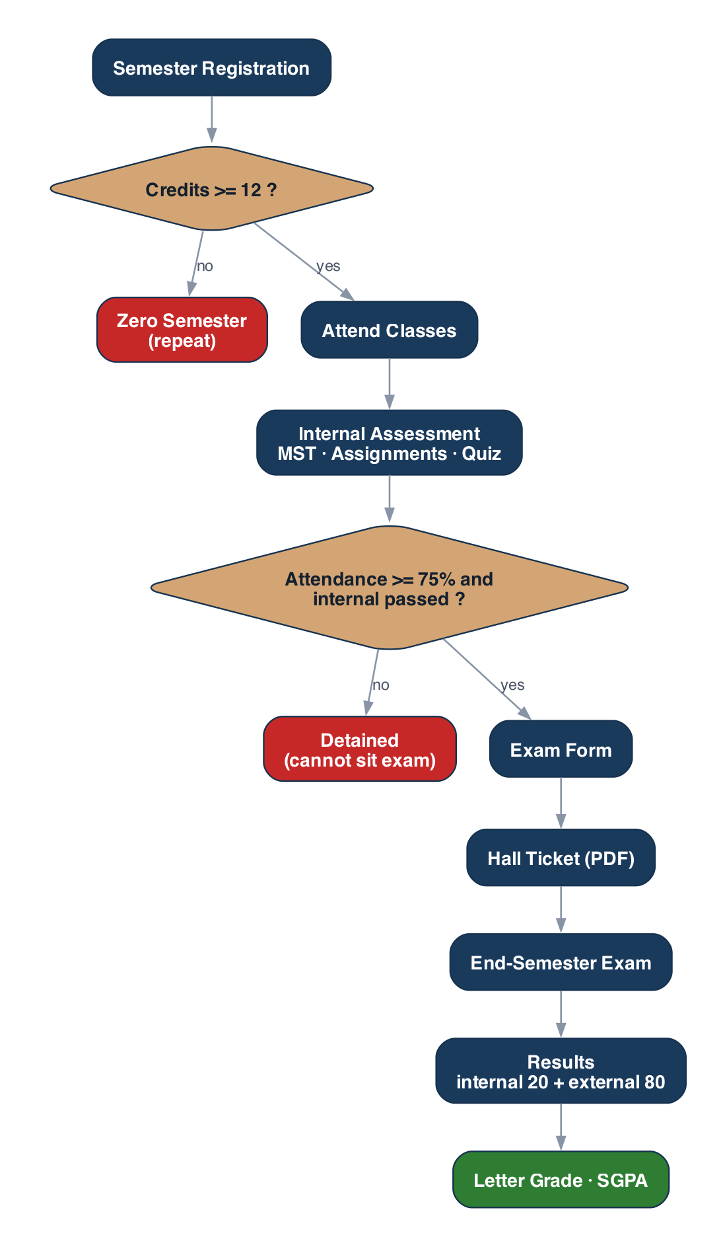
Figure 4 — The per-semester loop, with the eligibility gate and the two grade components.
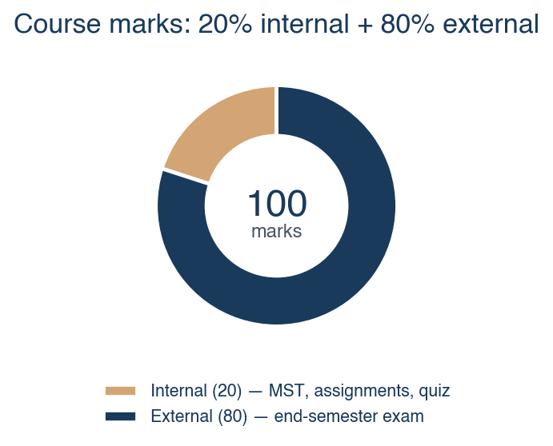
Figure 5 — Every course is marked out of 100: 20 internal + 80 external.
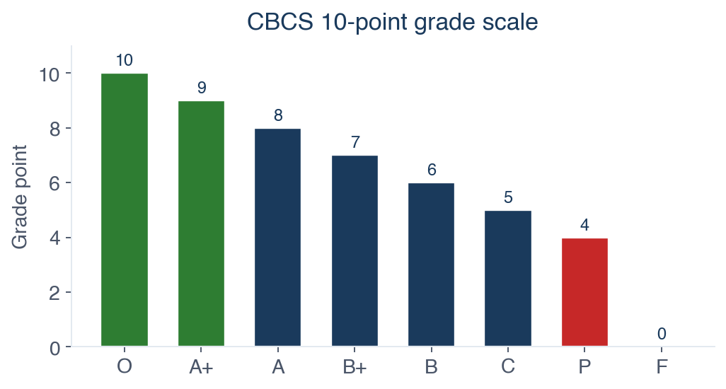
Figure 6 — The CBCS 10-point grade scale used for SGPA/CGPA.

3.3 Progression & graduation
Backlogs are cleared through Supplementary (ATKT) exams. Once all eight semesters and credit requirements are met, the Degree Audit confirms graduation eligibility.
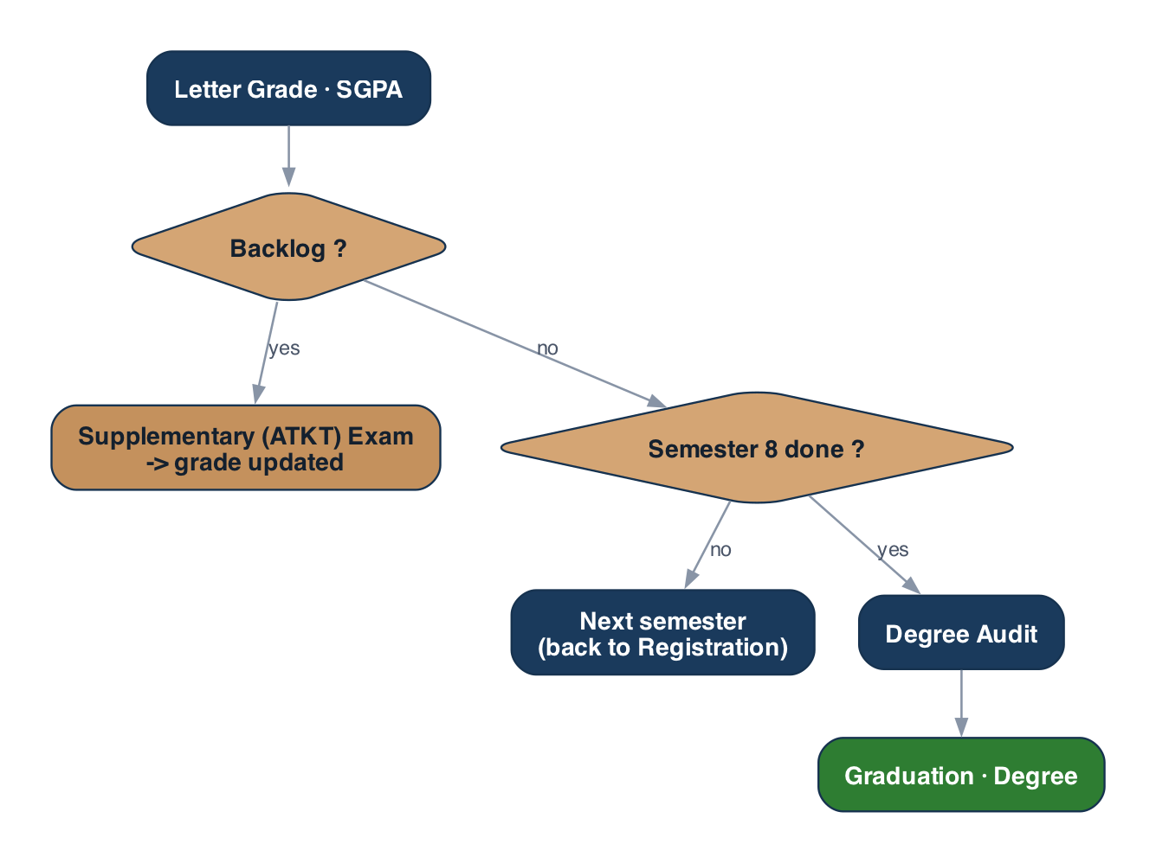
Figure 7 — Backlogs, progression and the final degree audit.

4. Exam eligibility → hall ticket
The eligibility rule is what makes the “at-risk student” journey meaningful. A student must have at least 75% attendance (in aggregate and per course) and passing internal marks before the exam form unlocks and a hall ticket is generated.
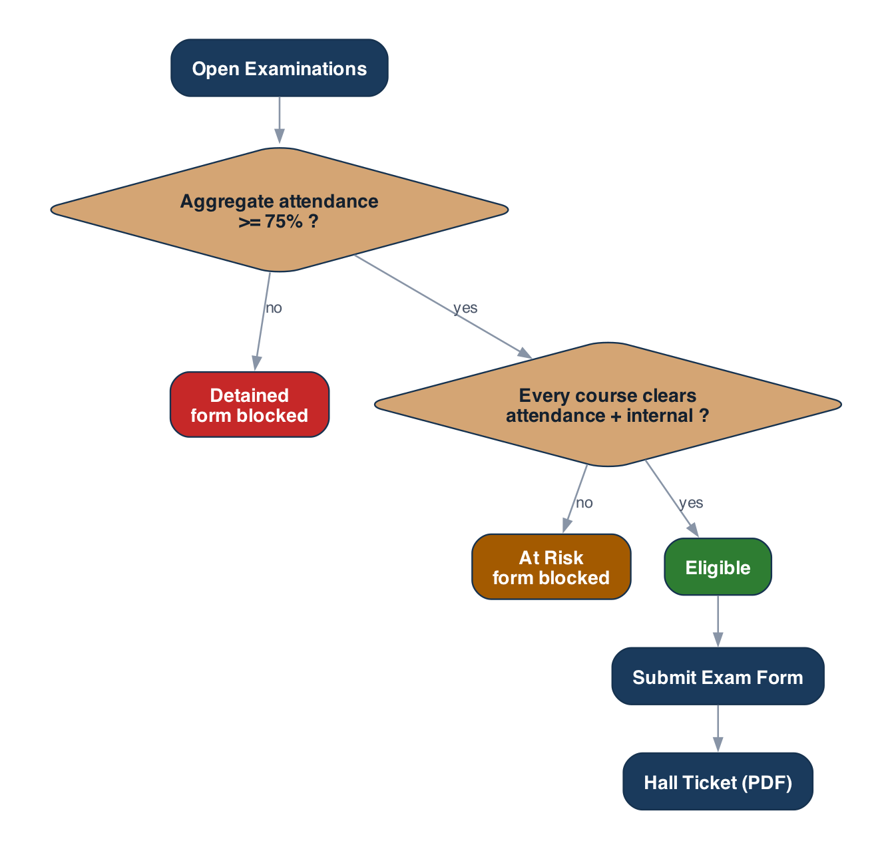
Figure 8 — The eligibility gate: Eligible, At Risk, or Detained.

5. Fees — in-app payment
Payment happens inside the portal — no external redirect. All charging goes through one swappable service, so a real gateway can replace the mock without touching any screen. A receipt PDF is generated on success, and the ledger updates instantly. Admins can also record counter payments from Fee Collection.
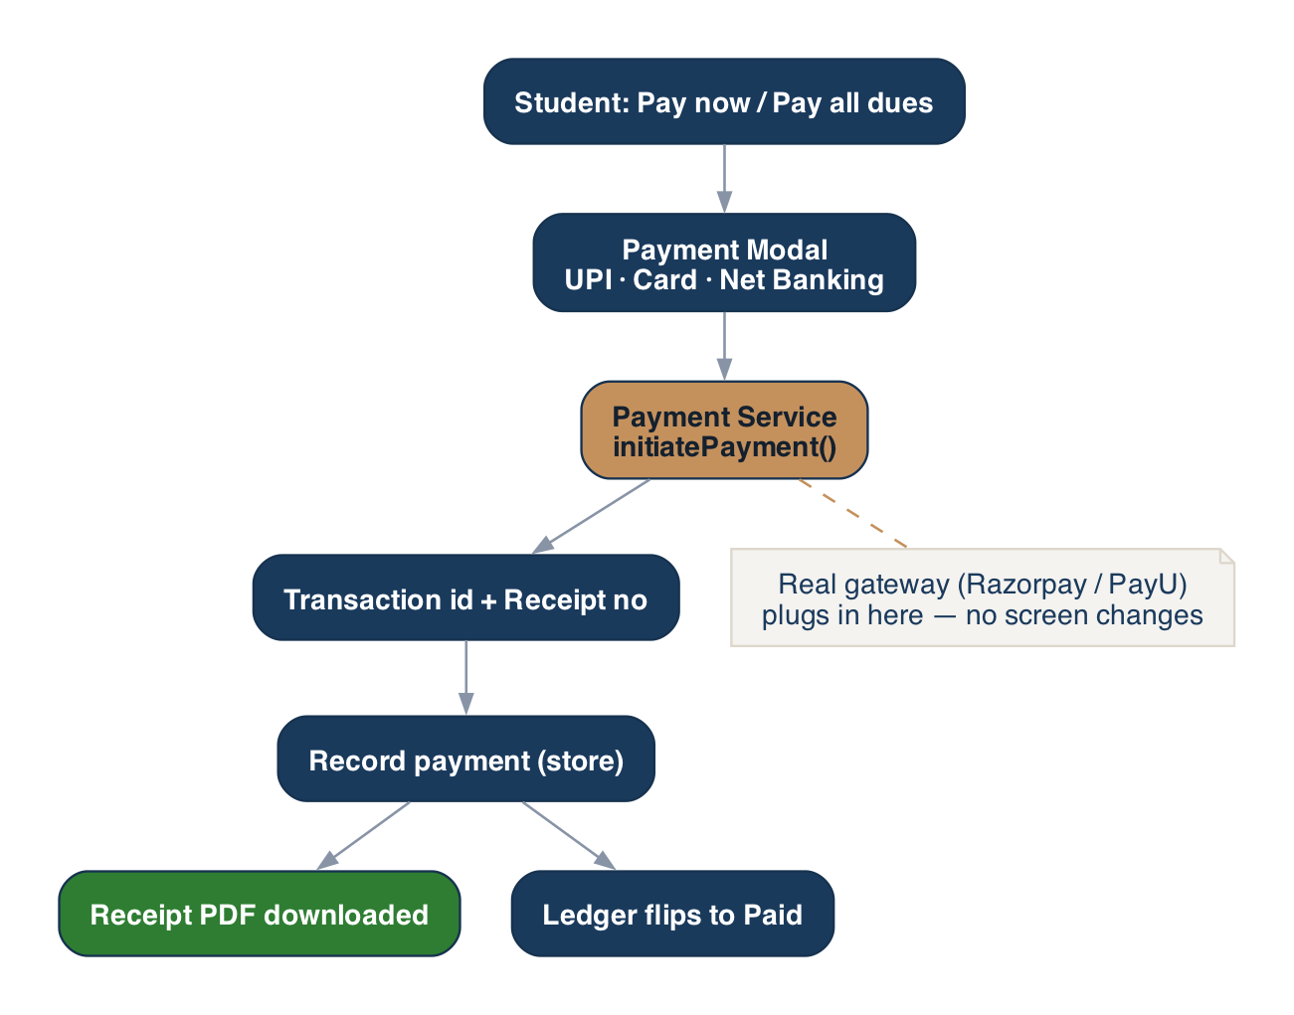
Figure 9 — In-house payment flow through a single service seam.

6. Faculty marks → student reflection
The one cross-role data flow: a faculty member enters mid-semester and quiz marks, and the same value — computed identically on both sides — appears on the student's Internal Assessment screen.
Figure 10 — A faculty entry flows straight onto the student's record.

7. Admin — permissions & navigation
Each admin sub-role maps to a set of permissions. The sidebar hides menu items the role cannot access, and opening a page without permission shows a “No Access” card. A Super Admin edits the matrix live.
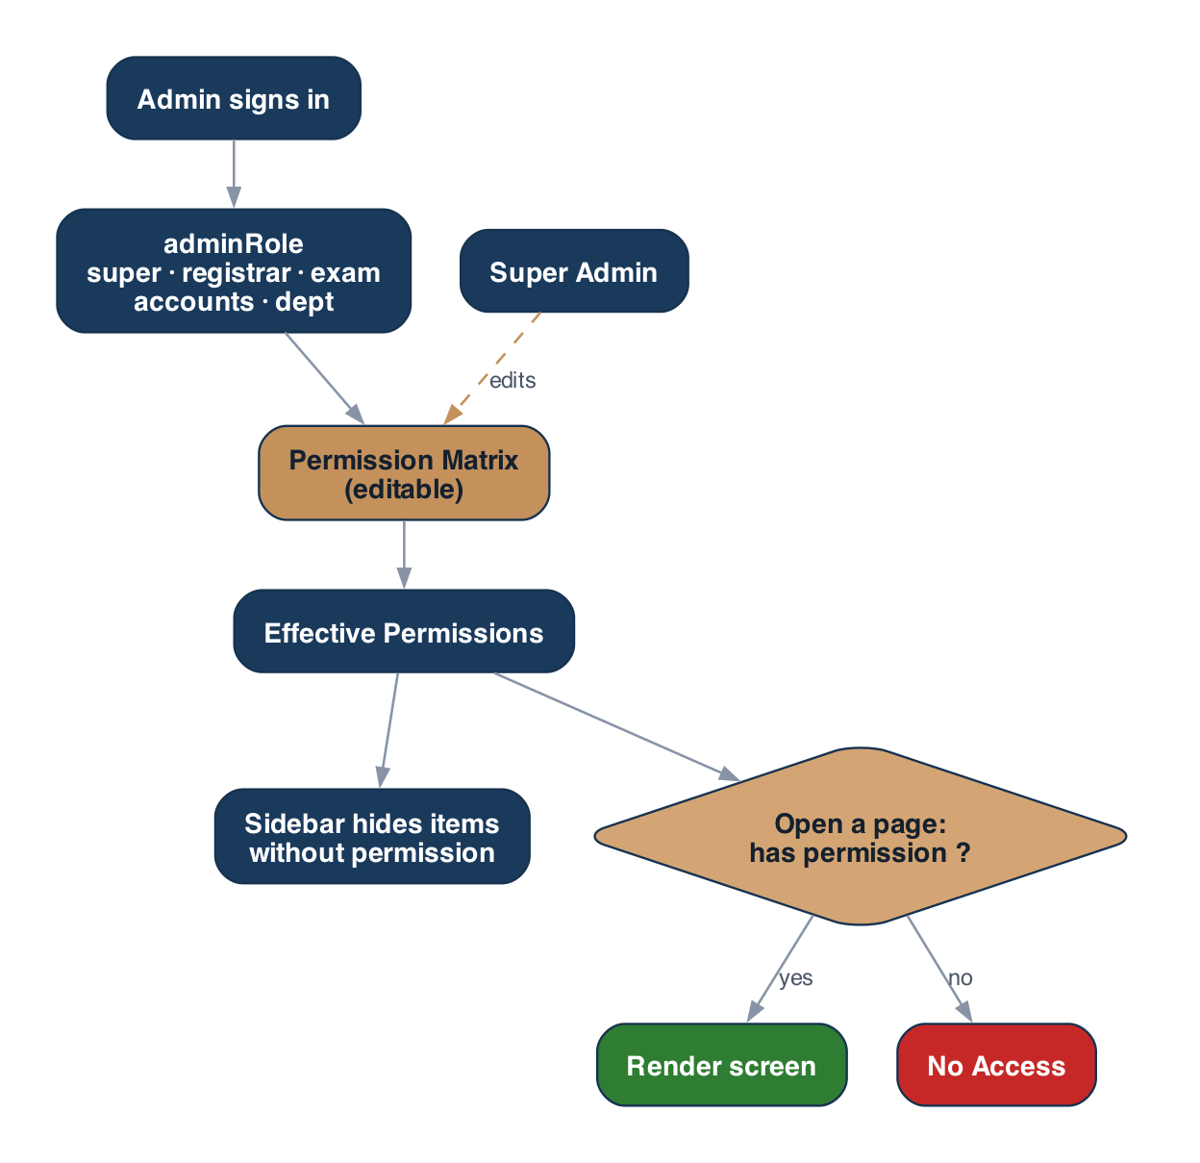
Figure 11 — Permissions gate both the navigation and each page.
Default permissions by role:
Admin capability | Default roles
View students | all roles
Manage / import students | Super, Registrar
Fee collection & verify payments | Super, Accounts
Edit master data | Super, Registrar, Exam
Send announcements | Super, Registrar, Exam, Dept
Reports | all roles
Settings | Super Admin
Roles & Permissions | Super Admin

8. Admin — bulk student import
New admissions can be added in bulk from a CSV: download the template, upload or paste, validate, preview, and import. Valid rows appear in the Students list as new admissions.
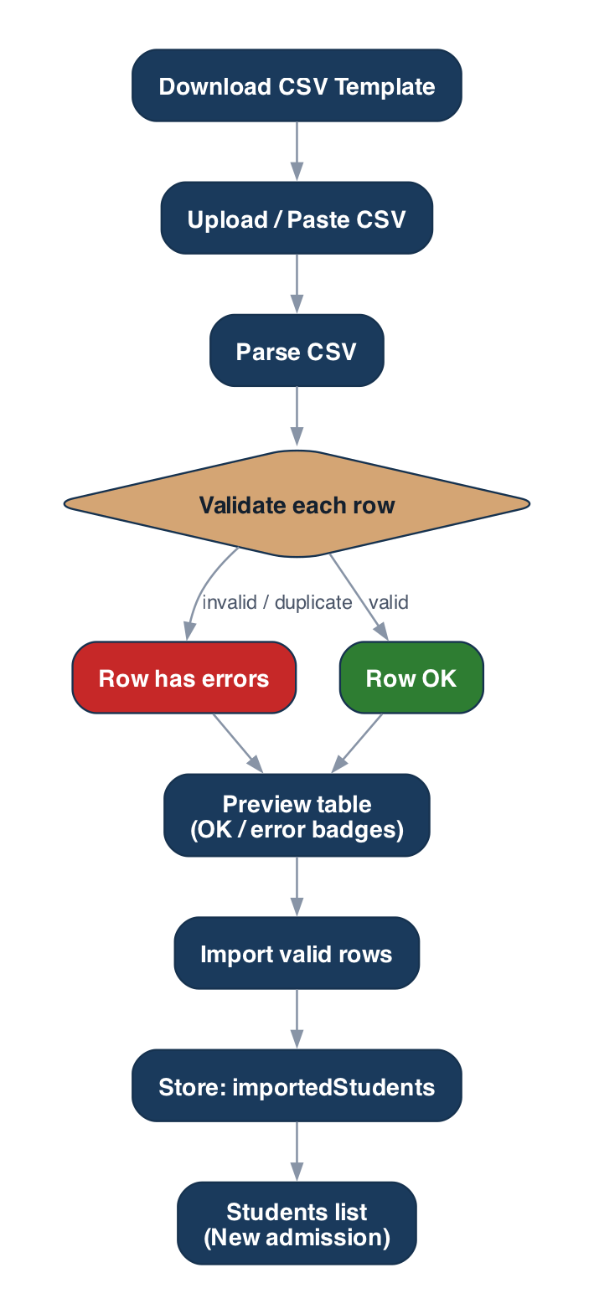
Figure 12 — CSV import: parse, validate, preview, import.

9. Data & state flow
Static seed data is the source of truth; stores layer live changes on top. A screen combines seed data (via accessors), domain calculations, and the session/settings/demo stores to render the final UI.
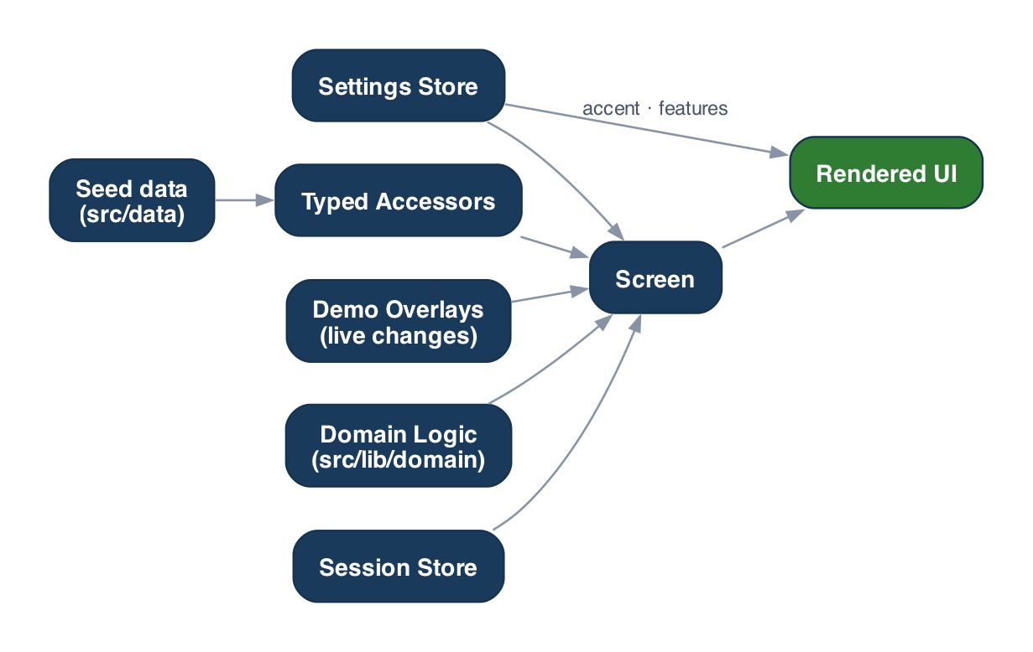
Figure 13 — How seed data and runtime state combine to render a screen.

