
IET DAVV
Institute of Engineering & Technology, Devi Ahilya Vishwavidyalaya, Indore
Student Lifecycle Portal
Technical Overview
How the Student Lifecycle Portal is built
Prototype documentation — July 2026
Demonstration prototype · not an official DAVV system

1. What this project is
A website prototype of the Student Lifecycle for DAVV Indore's Institute of Engineering & Technology (IET) — everything a student does from admission to degree, plus the faculty and admin sides.
Two facts shape every technical decision:
- There is no backend, server or database. All data is realistic but mock, stored inside the code. It is a front-end-only app.
- It is a static site. Building it produces a folder of plain HTML/CSS/JS that can be hosted anywhere. Nothing runs on a server.
Think of it as a fully-designed, clickable demo — built cleanly so a real backend can be plugged in later.

2. The big picture
Everything happens in the browser. The data and rules are JavaScript modules shipped with the page.
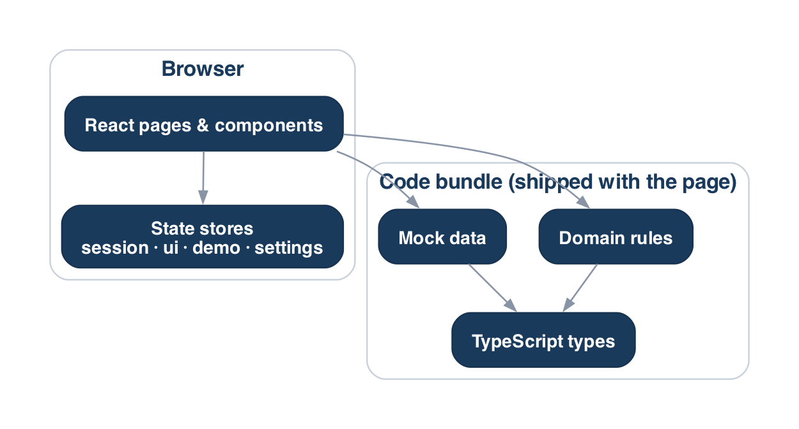
Figure 1 — Everything runs in the browser; data and rules ship with the page.

3. The technology stack
A deliberately small, modern toolset — no database or server framework.
Tool | What it is | Why we use it
Next.js (App Router) | React framework | File-based routing and clean static export.
React 19 | UI library | Build the interface from reusable components.
TypeScript | JavaScript + types | Catches mistakes early; documents data shapes.
Tailwind CSS v4 | Utility CSS | Style with classes; colours come from one token file.
Zustand | State manager | Tiny store for session, preferences and live actions.
lucide-react | Icons | Consistent stroke icons.
jsPDF | PDF generator | Hall tickets, certificates and fee receipts in-browser.

4. How the code is organized
Everything lives under src/. The golden idea: each kind of thing has one home. Lower layers never import from higher ones.
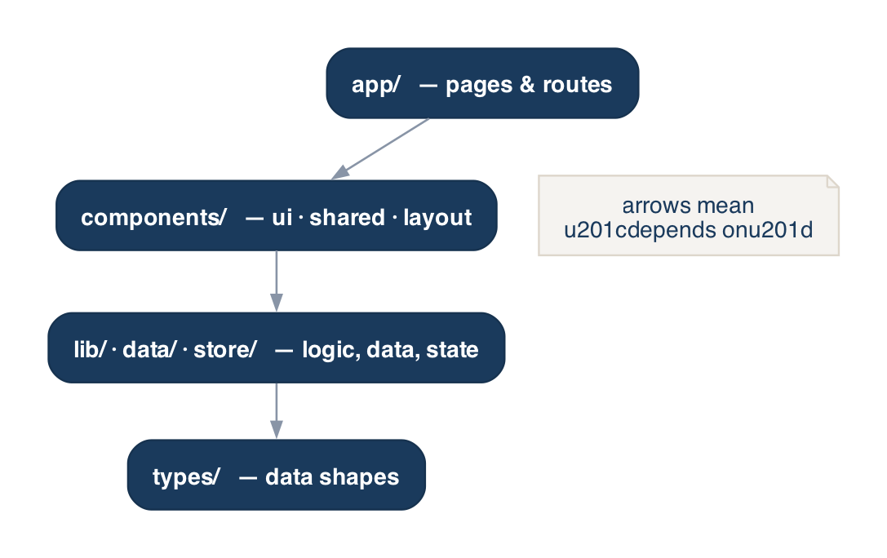
Figure 2 — Dependency direction: pages use components; components use logic/data/state; everything uses types.
Folder | What lives there
app/ | Pages and URLs, grouped by role: (student), (faculty), (admin), (auth).
components/ | Reusable UI: ui/ (primitives), shared/ (widgets), layout/ (app shell).
features/ | Bigger feature-specific pieces (payment modal, bulk-import modal).
lib/ | Logic with no UI: domain/ (rules), auth/, i18n/, utils/, payments.ts, pdf.ts.
data/ | Mock data and the functions to read it.
store/ | Zustand stores: session, ui, demo, settings.
types/ | TypeScript shapes for all data.

5. How a page actually works
- You visit a URL (e.g. /dashboard); Next.js matches it to the page file.
- A layout wraps it in the RoleShell — the sidebar, top bar and footer.
- RoleShell checks the session; if you are not the right role it redirects to /login.
- The page reads data through accessors, calculates with domain functions, and renders components.
Because it is a static export, pages are pre-rendered to HTML at build time. There is no server deciding things per request — the browser does everything after load, which is why guards and redirects run on the client.

6. The four “brains”
Most important logic sits in four separate places. Keeping them apart keeps the app easy to change.
- types/ — the shapes. “A Student has an enrollmentNo, name, semesters, fees…”. The contract everything agrees on.
- data/ — the fake database. Arrays plus small reader functions (getStudent, studentsForCourse). Swap these for real API calls later and the UI won't change.
- lib/domain/ — the rules. Pure functions with no React: grade points, SGPA/CGPA, credits, eligibility, permissions. The single source of truth for how DAVV works.
- store/ — the live state (see next section).

7. State management
Zustand stores are small boxes of state with functions to change them. There are four:
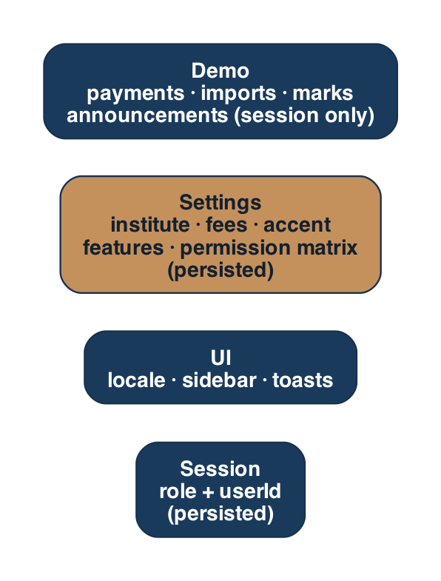
Figure 3 — The four stores. Settings and session persist across reloads; demo is session-only.
- session (saved) — who is logged in: role + userId.
- ui (saved) — language, sidebar, and toast pop-ups.
- settings (saved) — admin-editable portal config: institute name, fees, attendance threshold, accent colour, feature toggles and the permission matrix. Changes apply live.
- demo (in-memory) — the “make it feel alive” layer sitting on top of seed data: fee payments, imported students, faculty marks, announcements, read notifications. Resets on refresh so seed data stays authoritative.
Key idea: screens read seed data and the demo overlay, then merge them. A fee is “Paid” if the seed says so or the demo store recorded a payment.

8. Login, roles & permissions
Login is a mock check: pick a role and demo account; if it matches a seeded user, the session stores {role, userId}. Admins additionally have sub-roles (Super, Registrar, Exam, Accounts, Dept), and each sub-role maps to a set of permissions via an editable matrix a Super Admin can change live.
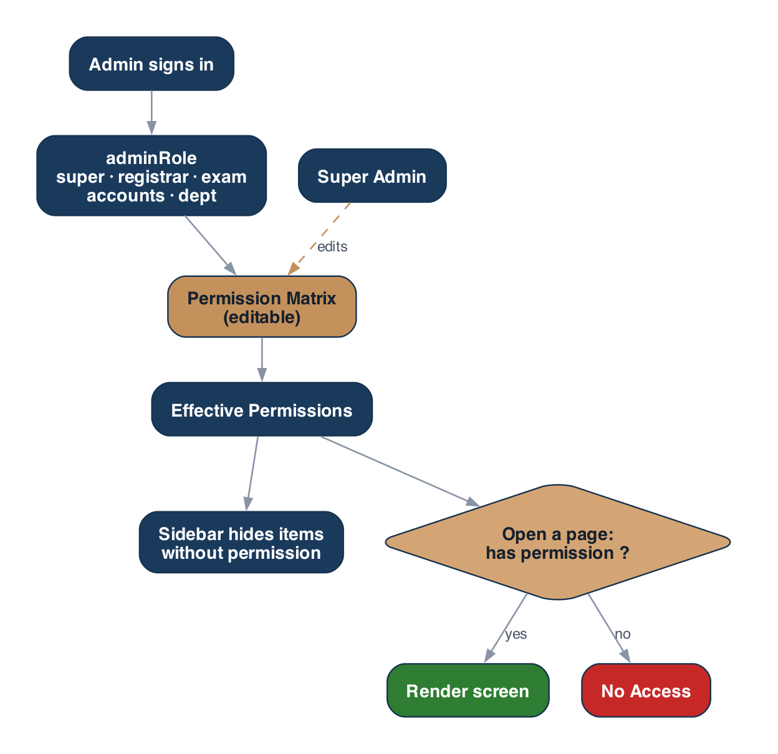
Figure 4 — An admin's sub-role maps to permissions; the sidebar and each page respect them.
This is UX-level access control, not real security — there is no server to enforce it. A real deployment must enforce permissions on the backend.

9. Design system & theming
All colours, fonts, radii and shadows are defined once as design tokens (a Tailwind v4 @theme block). That is why code says bg-navy or text-gold instead of hex codes.
- Live theming: the admin “accent colour” overrides the --color-gold token at runtime, so every gold element re-colours instantly.
- Reusable building blocks live in components/ui and components/shared. Screens are composed from these, not raw markup.
- Charts (SGPA trend, attendance gauges) are hand-drawn SVG components — no chart library, so the bundle stays small and static-safe.

10. Fees & the payment “seam”
The key design choice: one function is the only place money is charged. lib/payments.ts exports initiatePayment(). Today it is a mock; the student Payment Modal and the admin “Mark paid” both call it. To go live, replace only the inside of that function with a real gateway (e.g. Razorpay) — no screen changes.
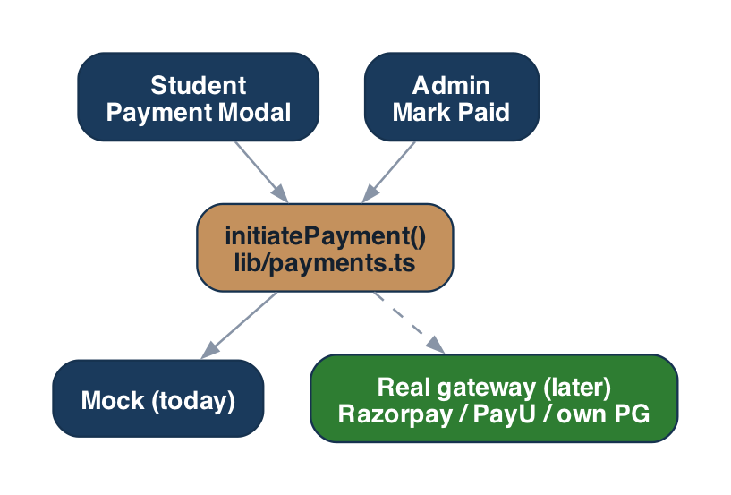
Figure 5 — Both payment entry points go through one swappable service.

11. Bulk student import
Admins download a CSV template, upload or paste rows, and a tiny custom parser reads them. Each row is validated (required fields, valid branch, no duplicates) and previewed with OK/error badges; valid rows are added to the demo store and appear immediately in the Students list as “New admission”.

12. Build, static export & hosting
- npm run dev — local development with hot reload.
- npm run build — produces the static site in out/ (HTML/CSS/JS + bundled images).
- Static export: no server. Upload out/ to any static host. Everything must be static-export-safe (no server actions/API routes); detail views use modals instead of dynamic /[id] pages.

13. Turning this into a real product
The architecture makes this a swap, not a rewrite:
- Replace the src/data accessors with real API calls (same function signatures).
- Replace initiatePayment with a real gateway.
- Enforce permissions on the backend (the front-end matrix becomes UI only).
- Add real authentication (the session store becomes a token/cookie).
The types, domain logic and component library carry over unchanged.

14. Glossary (technical terms in plain words)
Term | Meaning
Component | A reusable piece of UI (a button, a card) combined like Lego.
Props | The inputs passed to a component.
Hook | A use… function that lets a component read state or run logic.
Store | A shared box of state any component can read/update.
Route group | A URL and its folder; (name) folders group pages without changing the URL.
Static export | Pre-building every page to HTML so no server is needed.
Token | A named design value (--color-navy) used everywhere.
Domain logic | The business rules, kept separate from UI.
Seed data | The built-in mock data shipped with the app.
Overlay | Temporary changes layered on top of seed data during a session.
Seam | A single deliberate swap point (like initiatePayment) for a real service.

