Method Madness Essay
My project “Simon_4_MethodMadness.java” draws an amazing image using a total of eight methods. For example, my code prints a beautiful black and white penguin, with a narrow yellow beak and a gray outline around the eyes and chest. Personally, I really enjoy my project, I don't know why, but every time I look into the eyes of the penguin, it makes me smile. My program runs from methods know as private void drawBody(gc);. The public method calls the private method private voidrawBody(GraphicsContext gc) {.

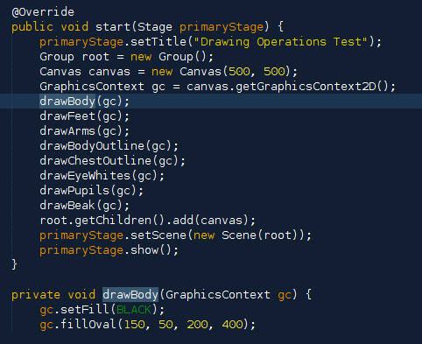

I used these methods.

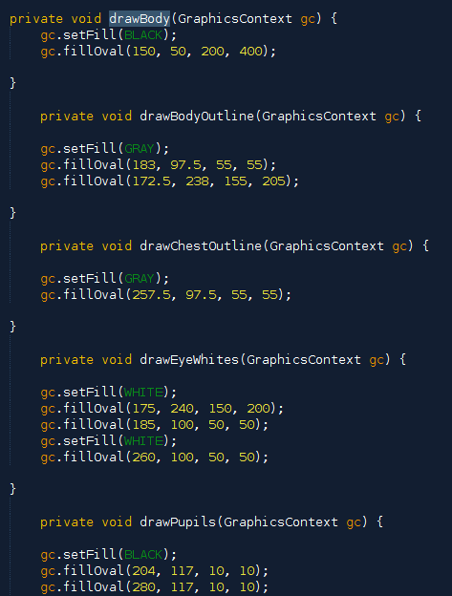
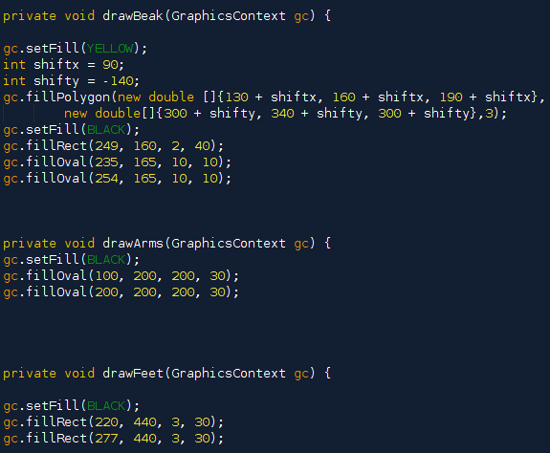

The values I used for each method, for example gc.fillRect(100, 200, 200, 30); are coordinates and the length and height of the rectangle on the canvas. JavaFX automatically gives you a template, and that would be gc.fillRect(x, y, w, h);. Methods that are seen above can be used and be seen as gc.setFill(BLACK); passes a color instead of numbers. This method sets the color for all of the fills of a shape after that method. The shapes that create the pictures are drawn on the canvas. The canvas is a plate that you create using code and adding dimensions. My dimensions were 500x500. This creates a canvas in the shapes of a perfect square, that I can use to draw on.
While there are many methods deep inside my project, there is one method that no Java code can live without. It is the only method used in the main(): launch(args);.
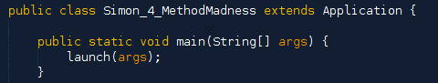
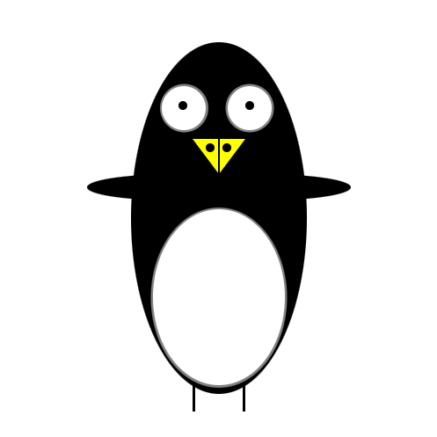
This is because methods are drawn on a canvas and not printed as words or numbers. In the JavaFX program, I used modifiers, like private and public. The private method private void drawBody(GraphicsContext gc) { is called in the public method public void start(Stage primaryStage) {. I also use class constructors, which in other words, is like the name of the modifier. For example, I used drawFeet and drawBody. I named the by what the class will do. These methods created this image.

I believe my penguin is magnificent. I think I did the best I could have done.

