Lab 3 Kubernetes

1. Using Minikube to Create a Cluster
Start Hello Minikube tutorial.
Install Minikube and kubectl, and open dashboard.
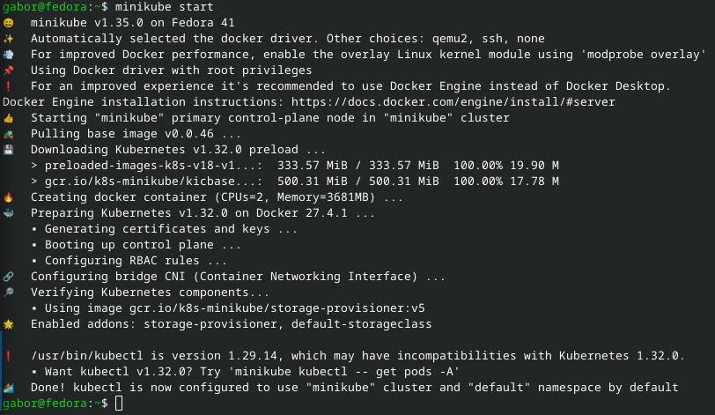
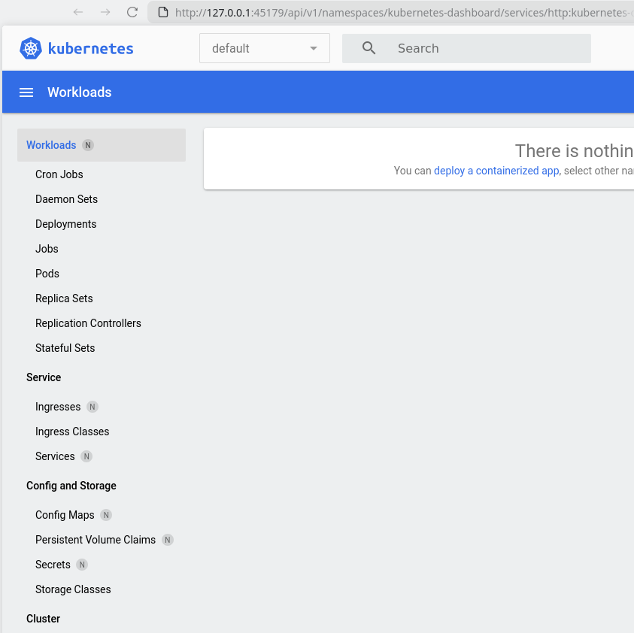

Create a Deployment
Creating the hello-node deployment.
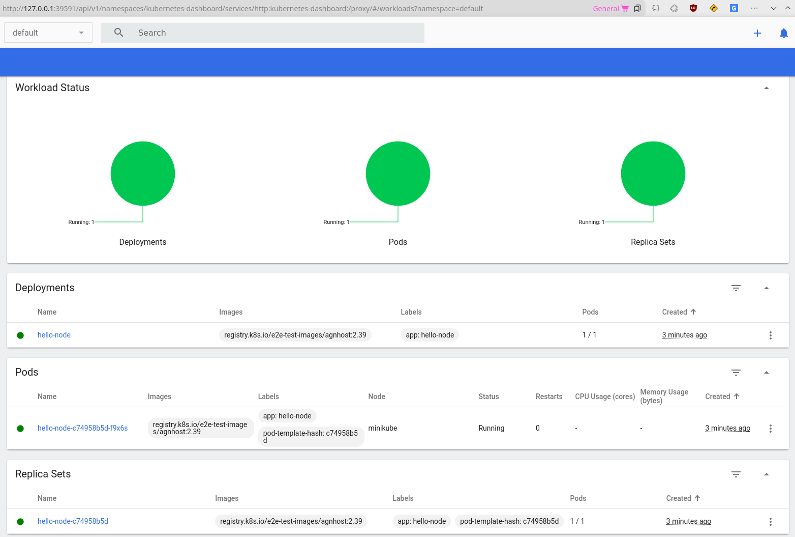

Create a Service
Create the hello-node service for external use.
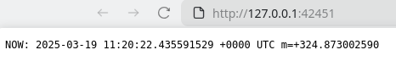

Enable Addons
Enable the metrics addon.
